GRAD DIRECT PROJECT – 1

REDOX – PROTECT THE WORLD
By: Team 01

Team Members

Pranathi Reddy Jeedipally (Lead)
Sai Ram Reddy Muthyala
Sai Krishna Reddy Seelam
Varun Kumar Reddy Bhavanam
Sumanth Yeruva
Vennela Reddy Baddam
Ram Niteesh Reddy Bandi

Name: Dr. Michael Bellamy (Professor)

Northwest Missouri State University

CLIENT INFO & INSTITUTION

Contents
1. Introduction 4
1.1.Purpose and Scope: 4
1.2.Impact on the organization and Motivations: 4
1.3.Overview: 4
2. Project Management Plan 5
2.1. Team Organization and Schedule 5
2.2. Risk Analysis 6
2.3 Software and Hardware Requirements 6
2.4 Gantt chart 7
3. Requirement Specification 8
3.1 Stakeholders of the System 8
3.2 Graphical UML Use case diagrams 9
3.2.1. Class Diagram: 10
3.2.2. Object Diagram: 10
3.2.3. Sequence Diagram: 11
3.2.4. Use Case Diagram: 11
3.2.5. Flow Chart: 12
3.2.6. Component Diagram: 13
3.3. Non- Functional Requirements 13
3.3.1 Performance 13
3.3.2. Scalability 13
3.3.3. Maintainability 13
3.3.4. Security 13
3.3.5. Backup and Recovery 14
3.3.6. Logging and Monitoring 14
3.3.7. Testing 14
3.3.8. Compatibility 14
3.4 User Interface 14
3.4.1. Login Screen: 14
3.4.2. Main Menu: 14
3.4.3. Game Screen: 14
3.4.4. Level Completion Screen: 15
3.5.5. Settings Menu: 15
3.5. Bug Fixes: 15
4. Architecture 15
4.1 Architecture Model, Components, and Style(s) Used 15
4.2 Design 17
5. Technology that will be used and why.? 22
6. Testing 23
6.1 Features to be tested: 23
6.2 Criteria for passing and failing test: 23
7. Deliverables: 25
7.1 Project: Git-hub Repository 25
7.2 Briefly explain how it works. 25

1. Introduction (Pranathi Jeedipally, Sai Krishna)
Problem Statements of the project. (In other words, the purpose of the project, what is for and who will be using it.)

Purpose and Scope:

"Redox: Protect the World" aims to revolutionize the approach to teaching redox chemistry by transforming it into an engaging and immersive educational game. The project seeks to bridge the gap between traditional classroom learning and modern, interactive methods, providing students with a dynamic platform to explore the intricate world of redox reactions. By gamifying the learning process, the project endeavors to ignite students' curiosity and passion for chemistry, fostering a deeper understanding and appreciation for this fundamental branch of science.

Impact on the organization and Motivations:

The primary target audience for "Redox: Protect the World" is Chemistry 1 classes, comprising students at the introductory level of their chemistry education journey. These students are at a crucial stage where foundational concepts, such as redox reactions, lay the groundwork for more advanced studies in chemistry. The game is tailored to cater to the unique learning needs and preferences of this demographic, offering an interactive and stimulating educational experience that resonates with their interests and motivations.

Overview:

"Redox: Protect the World" serves as a versatile educational tool designed to complement and enhance the traditional classroom curriculum. By integrating gamified elements into the learning process, the project provides educators with a powerful resource to captivate students' attention and facilitate deeper engagement with the subject matter. Teachers can seamlessly incorporate the game into their lesson plans, using it to introduce, reinforce, or assess students' understanding of redox reactions. Moreover, the game's flexible structure allows students to explore at their own pace, encouraging self-directed learning and providing a personalized educational experience that accommodates diverse learning styles and preferences.

2. Project Management Plan (Pranathi reddy Jeedipally)

2.1. Team Organization and Schedule

Team Organization

Team Member | Responsibilities
Pranathi Reddy Jeedipally | Project management, client communication, overall supervision, Documentation, Godot learning
Sai Ram Reddy Muthyala | Backend development, database management
Sai Krishna Reddy Seelam | Identifying Bugs, UI/UX design
Sumanth Yeruva | Godot learnings, Audio and Animation enhancements
Vennela Reddy Baddam | Godot learnings, Background and Visual enhancements
Ram Niteesh Reddy | Godot learnings, Audio and Animation enhancements
Varun Kumar Reddy Bhavanam | Godot learnings, UI/UX design

Schedule

Project Phases and Timeline(Pranathi Jeedipally, Vennela, Sumanth)

Initial Planning and Setup

- Activities: Project kickoff, role assignment, initial client meeting, setup development environment
- Responsible: All team members

Requirement Analysis and Design

- Activities: Requirement gathering, creation of UML diagrams, system design, client feedback
- Responsible: Pranathi Reddy Jeedipally, Sai Ram Reddy Muthyala, Sumanth Yeruva, Ram Niteesh Reddy Bandi, Vennela Reddy Baddam.

Development Phase

- Activities: Backend development and database setup (Sai Ram Reddy Muthyala)
Frontend development and UI/UX design (Sai Krishna Reddy Seelam)
Integration of game logic and mechanics (Varun Kumar Reddy Bhavanam)
Level Based Implementation (Pranathi Reddy Jeedipally)
Audio and Animation Enhancements (Sumanth Yeruva, Ram Niteesh Bandi)
Background and Visual Enhancements (Vennela Reddy Baddam)
- Responsible: Developers

Testing Phase

- Activities: Unit testing and integration testing
User acceptance testing and bug tracking
- Responsible: All team members

Documentation and Finalization

- Activities: Preparation of final report, project documentation, final client meeting
- Responsible: Sumanth Yeruva, Pranathi Reddy Jeedipally

Presentation and Delivery
- Activities: Final project presentation, delivery of project artifacts
- Responsible: All team members

2.2. Risk Analysis (Sumanth Yeruva, Ram Niteesh, Varun Kumar)

Potential Risks and Mitigation Strategies

Risk Description | Impact Level | Probability | Mitigation Strategy
Technical Challenges | High | Medium | Conduct thorough research, seek online tutorials, allocate extra time for technical problem-solving.
Time Management Issues | Medium | Medium | Develop a detailed project plan, regularly track progress, adjust the schedule as needed.
Integration Challenges | High | Medium | Develop integration plans early, perform frequent integration tests, use compatible technologies.

2.3 Software and Hardware Requirements (Sai ram Muthyala, Vennela, Ram Nitesh)

Software Requirements

- Game Engine: Godot Engine.
- Scripting Language: GDScript (Godot's scripting language).
- Physics Engine: Integrated within Godot for character movement and bullet physics.
- Database: MySQL Database for structured data storage and potential remote server storage for online features.
- Scene System: Utilized for organizing game elements within Godot.
- Signals and Connections: Used for handling interactions between game objects.
- Custom Game Scenes: Created within Godot for specific game elements and interactions.

Hardware Requirements

- Processor: Intel i5 or higher, AMD Ryzen 5 or higher
- RAM: Minimum 8GB (16GB recommended for smooth operation)
- Storage: Minimum 256GB SSD (512GB recommended)
- Desktop and Laptop Computers: Windows, macOS, Linux environments for cross-platform testing

Additional Development Tools

- Integrated Development Environment (IDE): Visual Studio Code.
- Middleware: NodeJS.
- Version Control: GitHub.
- Project Management: Jira.
- Build Tools: Godot's built-in export and build tools.

2.4 Gantt chart (Sai Krishna, Vennela )

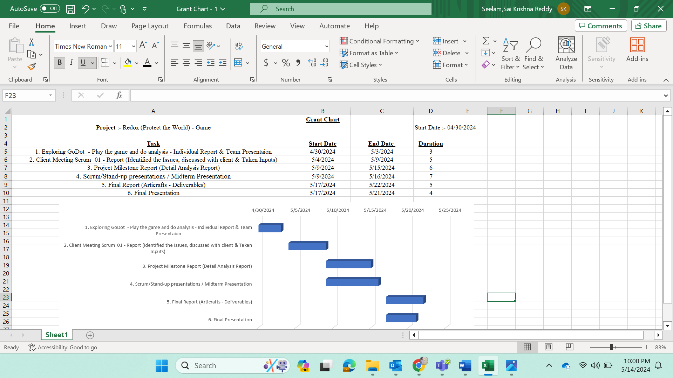

3. Requirement Specification (Sumanth Yeruva, Ram Nitesh, Vennela)

3.1 Stakeholders of the System

Primary Stakeholders

Students

- Role: End-users of the game.
- Interest: To learn and understand redox reactions in an engaging and interactive manner.
- Impact: High. The game aims to enhance their learning experience and comprehension of redox chemistry.

Teachers and Educators

- Role: Facilitators who incorporate the game into their curriculum.
- Interest: To provide an effective educational tool that can help students grasp complex concepts.
- Impact: High. The game serves as an innovative teaching aid to improve student engagement and performance.

Client (Dr. Michael Bellamy)

- Role: Project sponsor and advisor.
- Interest: To oversee the project’s development, ensuring it meets educational standards and objectives.
- Impact: High. Provides guidance, feedback, and final approval of the project.

3.2 Graphical UML Use case diagrams

ID | Title | Description | Priorities | Dependency
FR01 | Dropdown List | Players could be able to choose the levels of the game in the dropdown list. | P1 | None
FR02 | Level wise transitions | Players would be able to move successive level if and only if previous level completes. | P1 | FR01
FR03 | Includes Lives | Lives may decrease if the player hits the wrong. | P1 | None
FR04 | Stay Back | If Player fails to clear a level, they should retake it. | P1 | FR03
FR05 | Display the Prompt | The question must be displayed at right corner of the screen. | P2 | None
FR06 | Pass Level | Users must answer 7 out of 10 to pass the level. | P1 | FR03
FR07 | Knowledge Meter | Screen must display the percentage increase after choosing correct answer. | P2 | None
FR08 | Includes Sound | Assign different sounds for correct and wrong answers. | P2 | None
FR09 | Increase Speed | Level 2 speed must be increased compared to level 1. | P1 | FR01
FR10 | Chemical equation in level 3 | Hardest and Lengthy question from level 3 includes chemical equation. | P1 | FR14
FR11 | Pause Button | Include pause button which lasts between 10 to 15 sec from level 3. | P2 | None
FR12 | Oxidation and Reduction | Level 4 must include oxidation and reduction question on the given chemical reaction. | P1 | FR14
FR13 | Display four buttons for shooting. | Display buttons for oxidizing agent, reducing agent, compound oxidized, compound reduced. | P1 | FR01
FR14 | Random Questions | Random questions from set of 50. | P1 | FR15
FR15 | Update to database | Each level has 25 points and upon completion of 4 levels user has 100 points. | P1 | FR02
Functional Requirements:

3.2.1. Class Diagram: (Sai ram Muthyala, Pranathi Jeedipally)
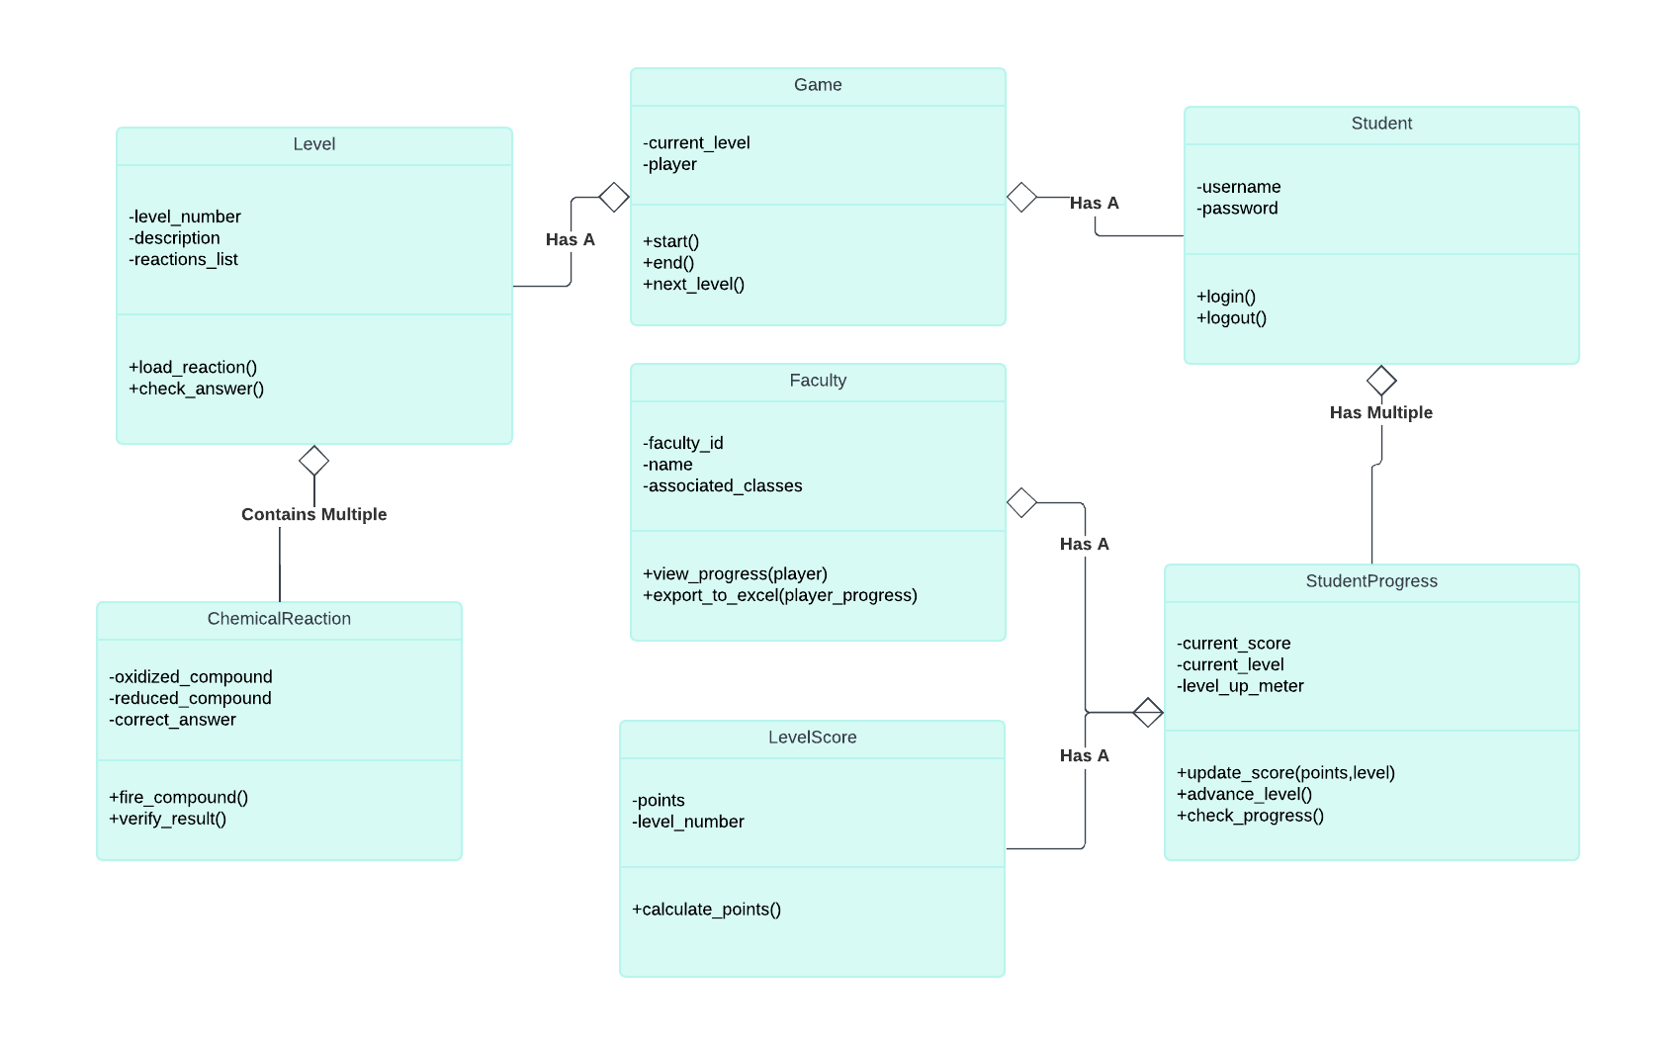

3.2.2. Object Diagram: (Sai ram Muthyala, Pranathi Jeedipally)

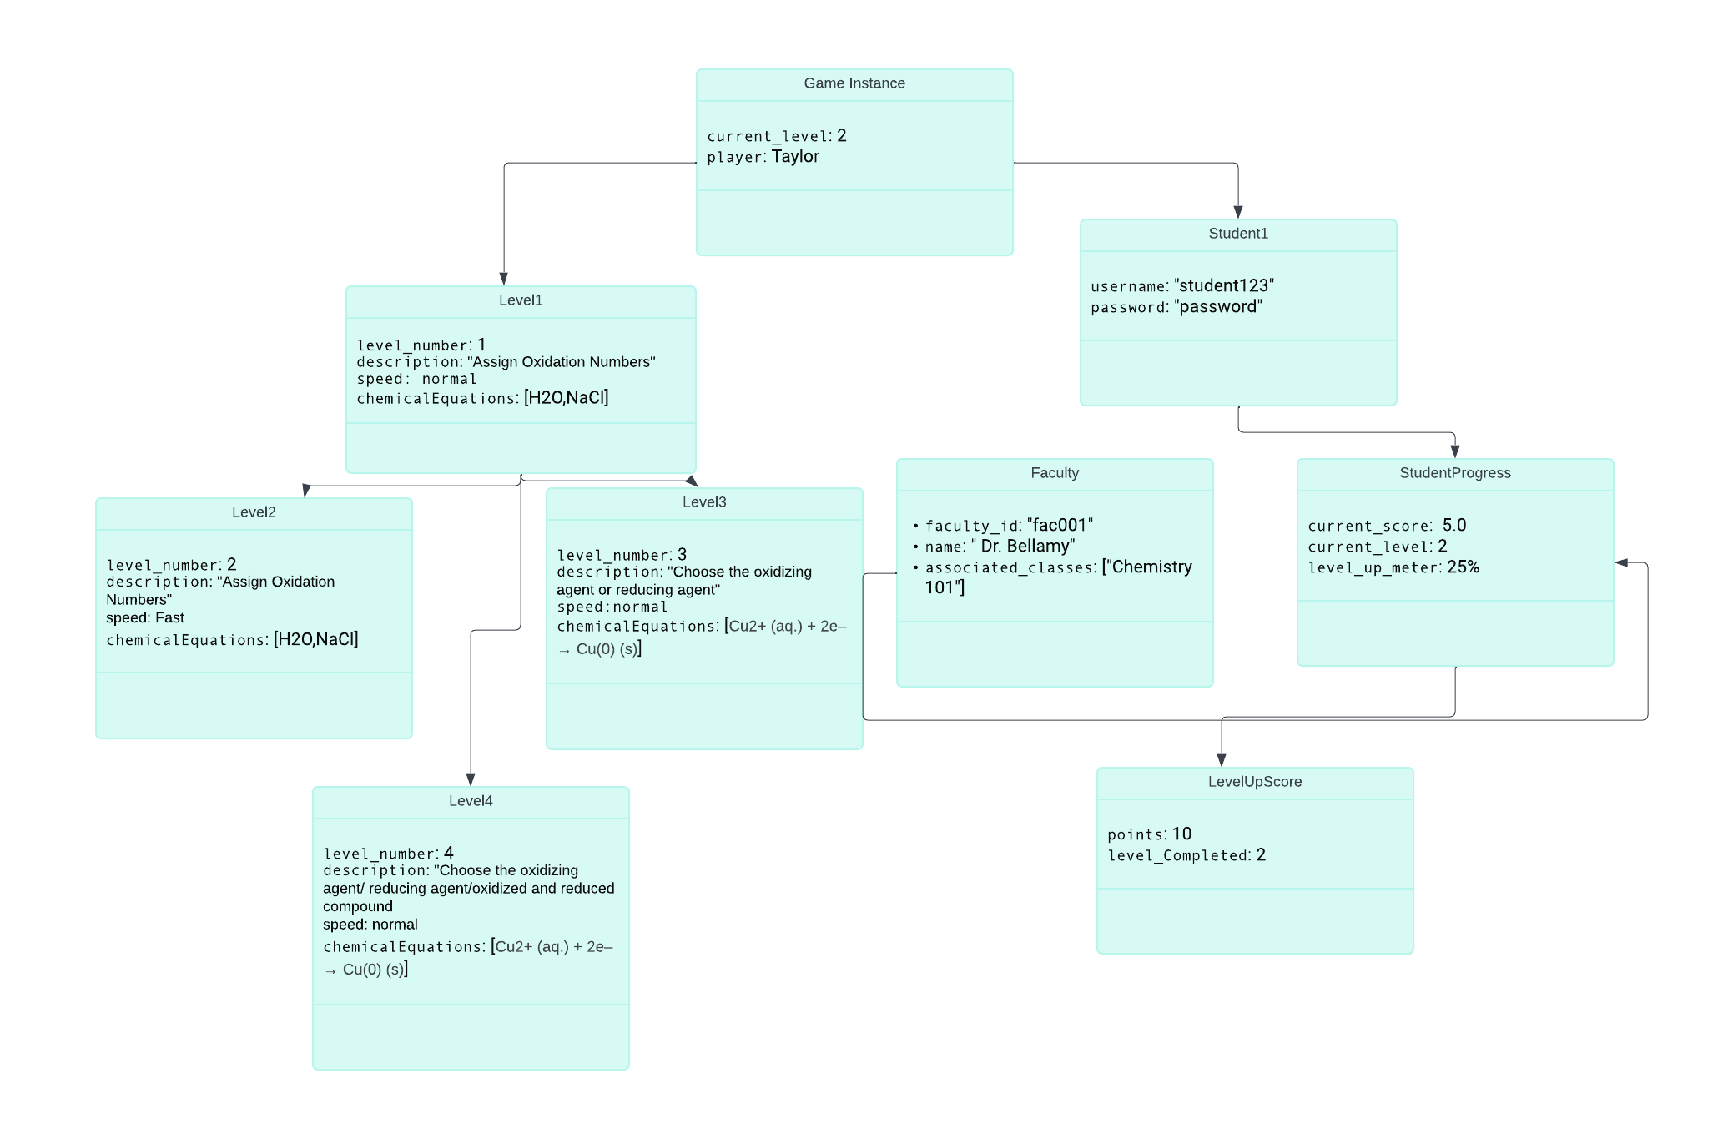

3.2.3. Sequence Diagram:(Varun kumar)
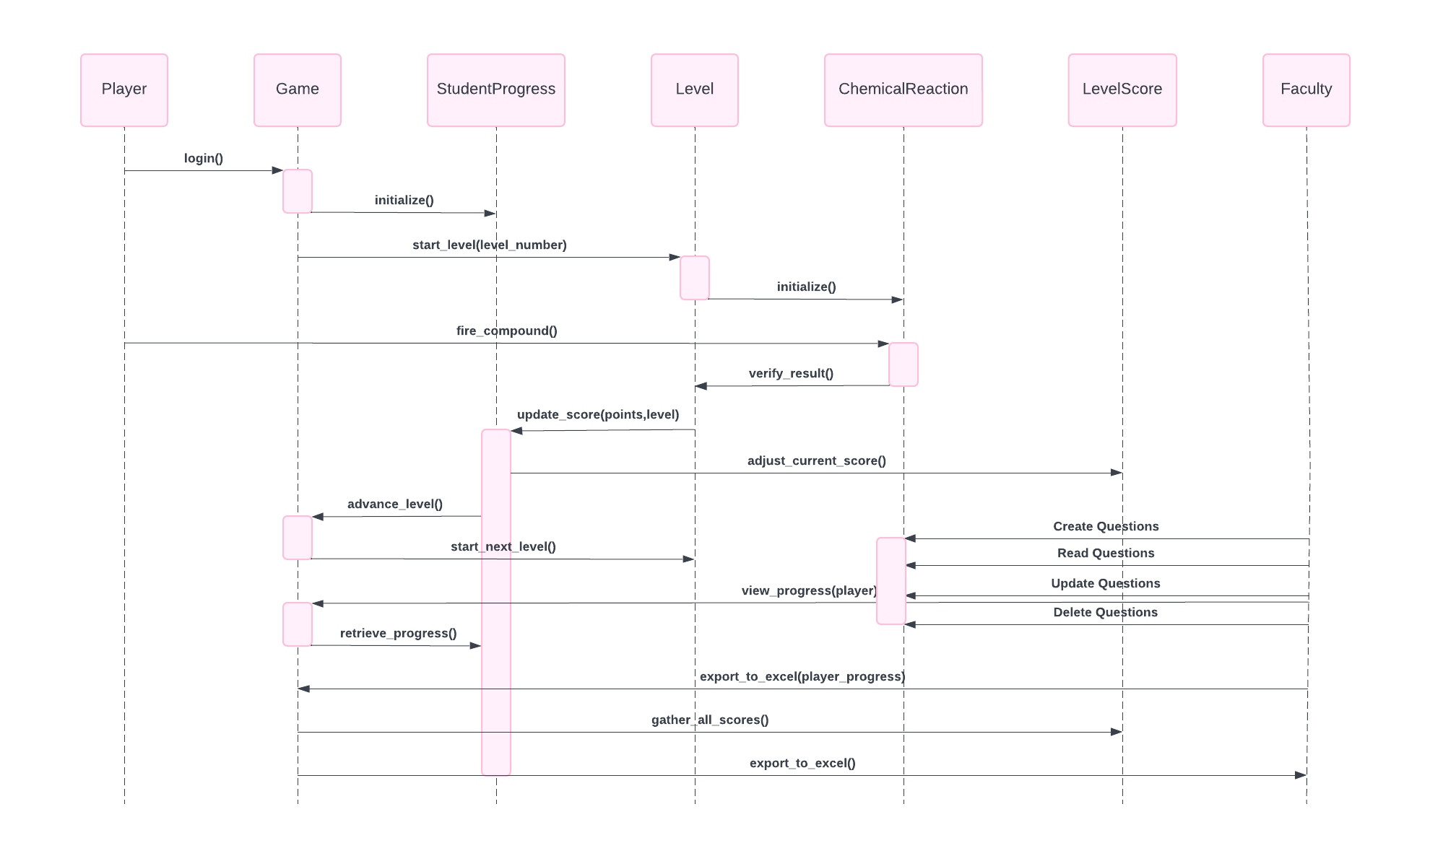

3.2.4. Use Case Diagram: (Sai Krishna)

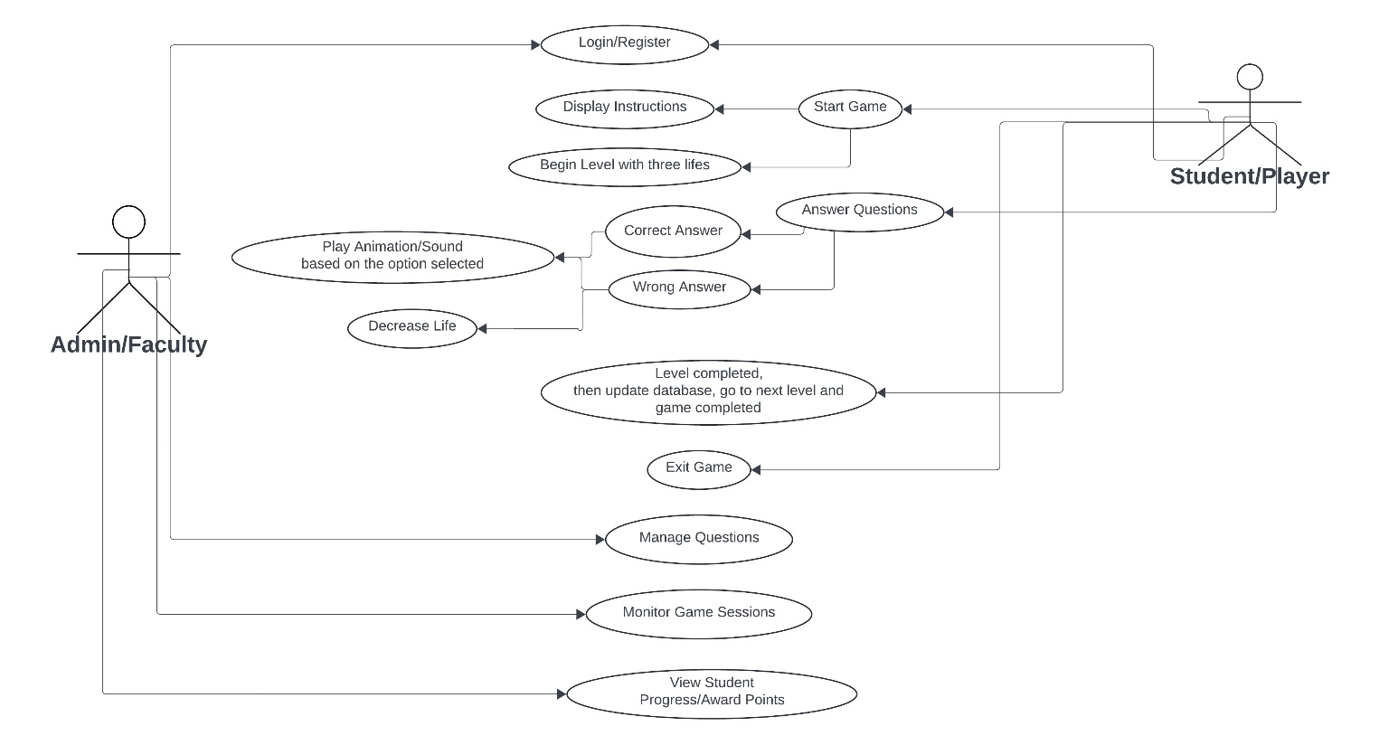

3.2.5. Flow Chart: (Pranathi jeedipally)
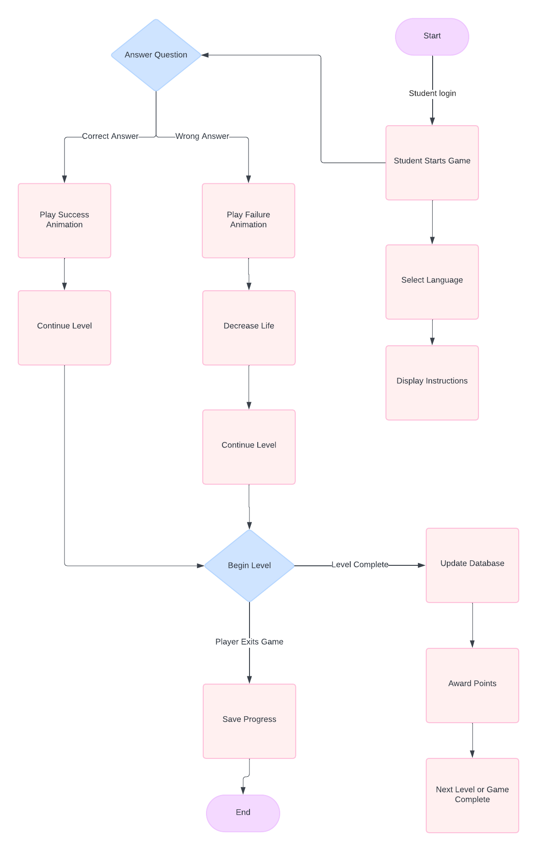

3.2.6. Component Diagram:(Varun kumar)
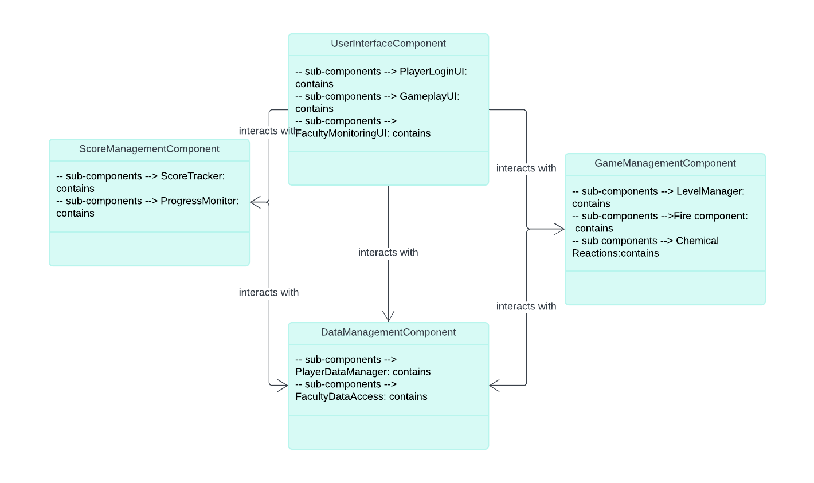

3.3. Non- Functional Requirements (Vennela, Sumanth, Ram Nitesh)

3.3.1 Performance
Description: The application should load questions and respond to user actions within 2 seconds.
Priority: High
Ex: Question displays from set of given 50.

3.3.2. Scalability
Description: The system should be able to handle concurrent users without performance degradation.
Priority: High
Ex: Multiple students.

3.3.3. Maintainability
Description: The codebase should be modular and well-documented to facilitate easy updates and maintenance.
Priority: Medium
Ex: Understanding of Codes.

3.3.4. Security
Description: User data should be securely stored and transmitted, complying with relevant data protection regulations (e.g., GDPR).
Priority: Low
Ex: Confidentiality.

3.3.5. Backup and Recovery
Description: The system should perform daily backups and have a disaster recovery plan in place to prevent data loss.
Priority: High
Ex: Scores should be saved.

3.3.6. Logging and Monitoring
Description: The application should have logging and monitoring capabilities to track user activity and system performance for troubleshooting and analytics.
Priority: Medium
Ex: Proper authentication.

3.3.7. Testing
Description: The application should undergo rigorous testing, including unit tests, integration tests, and user acceptance tests, to ensure it meets functional and non-functional requirements.
Priority: Low

3.3.8. Compatibility
Description: The application should be compatible with the latest versions of major web browsers (Chrome, Firefox, Safari, Edge).
Priority: Medium

3.4 User Interface (Vennela , Sumanth, Ram Nitesh)

3.4.1. Login Screen:

Admin: Admin can login and can download excel sheet of the score.

User:

3.4.2. Main Menu:

Play Button: Starts the game.
Instructions Button: Provides instructions for playing the game.
Language Menu: Allows users to select their preferred language.

3.4.3. Game Screen:

Dropdown Menu: Displays levels from Level 1 to Level 4.
Knowledge Meter: Reflects the user's progress as a percentage.
Lives Indicator: Displays the number of lives remaining.
Pause Button: Available in Level 3, pauses the game for a specified time.
Answer Feedback: Displays animations and sounds indicating whether the answer is correct or wrong.
Shooting Component: Used to select answers in all levels.
Question Prompt: Displays the prompt for the current question.
Timer: Displays the remaining time for answering questions in Level 3 and Level 4.

3.4.4. Level Completion Screen:

Scoreboard: Displays the user's score and progress.
Next Level Button: Proceeds to the next level if available.
Retry Button: Allows users to retry the current level if failed.

3.5.5. Settings Menu:

Language Settings: Allows users to change the language.
Sound Settings: Allows users to adjust sound effects and background music.
Full Screen Toggle: Enables users to toggle between full screen and windowed mode.
Save & Exit Button: Saves the current progress and exits the game.

3.5. Bug Fixes:

Utilization of Full Screen: Ensures the game occupies the entire screen space.
Shooting Component: Fixes the movement of the shooting component to keep it within the game screen.
Alignment of Buttons: Ensures proper alignment of Start and Instructions buttons.
Minimize and Maximize: Allows users to minimize or maximize the game window.
Continuous Firing: Addresses the functionality of firing bullets for correct and wrong answers to ensure they fire continuously if needed.
The UI interface should be intuitive, visually appealing, and easy to navigate to provide a seamless gaming experience for users.

4. Architecture (Pranathi, Sai Ram Muthyala, Sai Krishna)

4.1 Architecture Model, Components, and Style(s) Used

Architecture Model

The architecture of the game is based on a client-server model, utilizing a modular design that allows for scalability and maintainability. The game engine, Godot, is used for development, with MySQL as the database management system.

High-Level Architecture

Client-Side:

- Game Engine: Godot Engine
- Scripting Language: GDScript
- User Interface: Godot's built-in UI components

Server-Side:

- Database: MySQL for structured data storage
- Backend Framework: Node.js for handling API requests

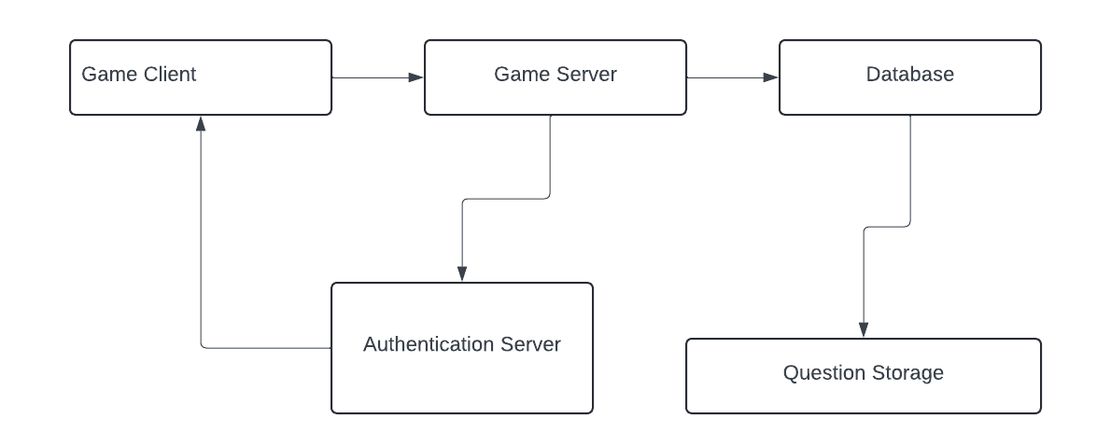
Components

Game Client:

- Handles game logic, rendering, and user interactions.
- Communicates with the server for data storage and retrieval.

Database:

- Stores user data, game progress, and other persistent information.
- MySQL database deployed on a cloud server for remote access.

Server:

- Manages API requests from the game client.
- Interfaces with the MySQL database to perform CRUD operations.

Communication Layer:

- Uses RESTful APIs for client-server communication.
- Ensures secure and efficient data exchange between the game client and server.

Style(s) Used

Modular Architecture:

- The game is divided into distinct modules, each responsible for a specific functionality.
- Enhances maintainability and allows for easier updates and feature additions.

MVC (Model-View-Controller):

- Model: Manages data and business logic (MySQL, backend server).
- View: Renders the user interface and game scenes (Godot Engine).
- Controller: Handles user input and updates the model and view accordingly (GDScript logic).

4.2 Design (Pranathi, Sai Krishna , Sumanth, Ram Nitesh, Vennela)

Interfaces used:

Animations: Changed the Background of the Home Page

Before
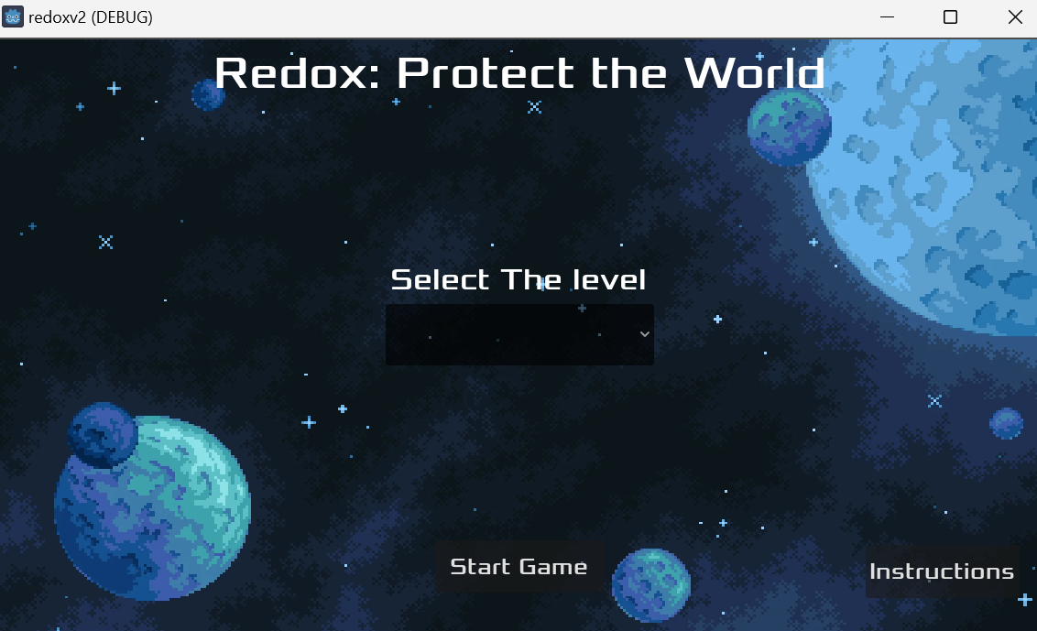

After

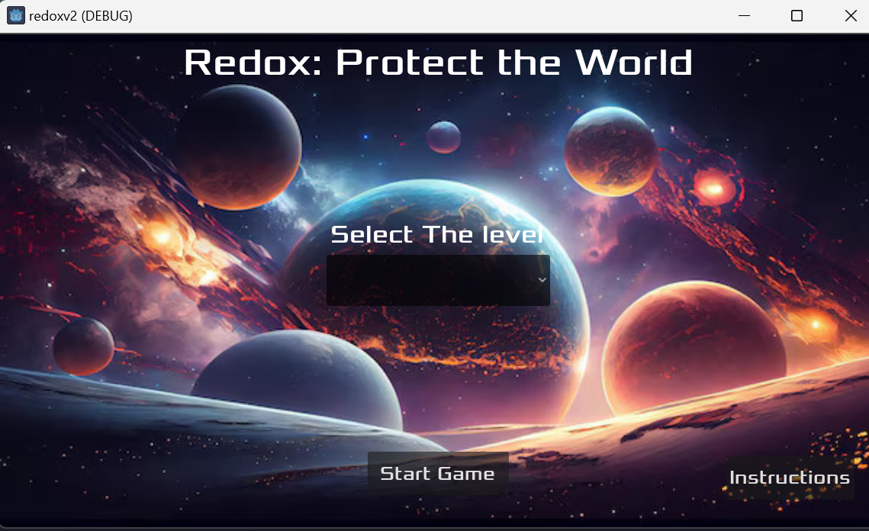

Level Background

Level1 Before:

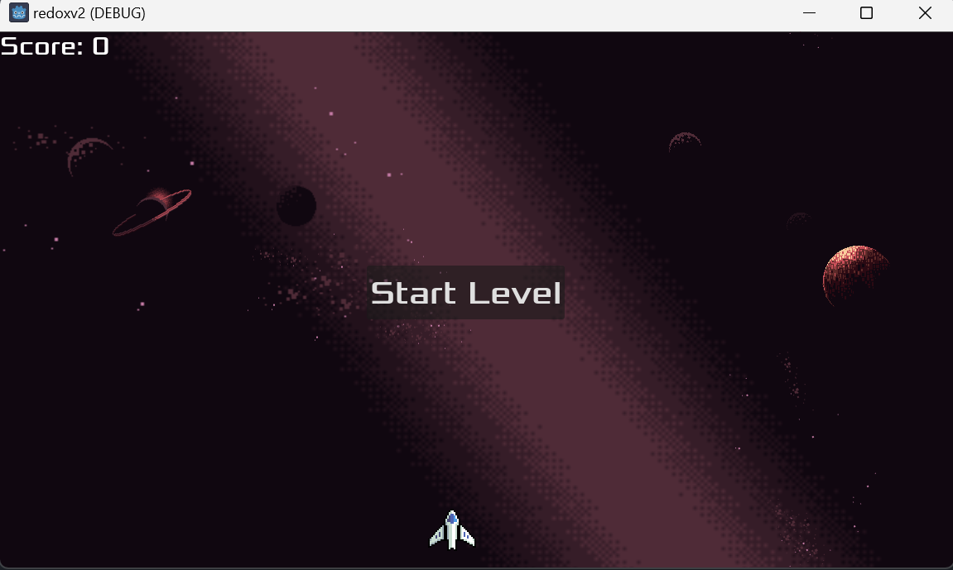

Level1 After:

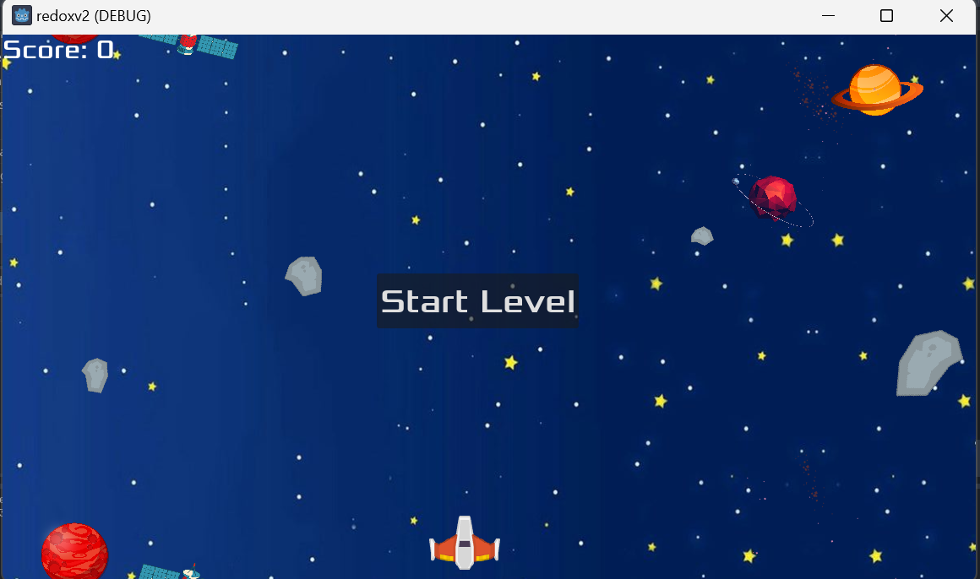

Level2 newly added:

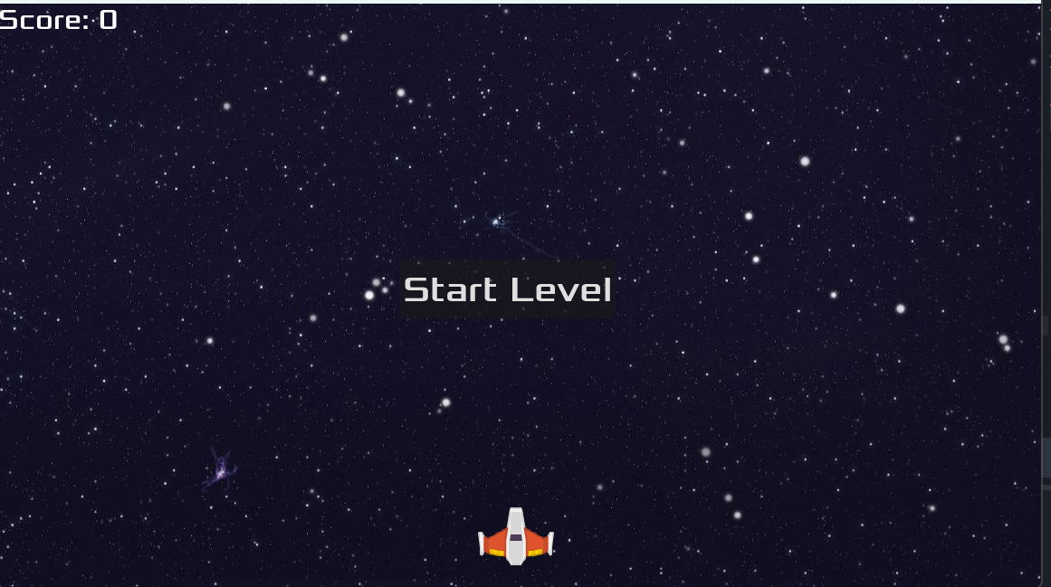

Levels Implementation:
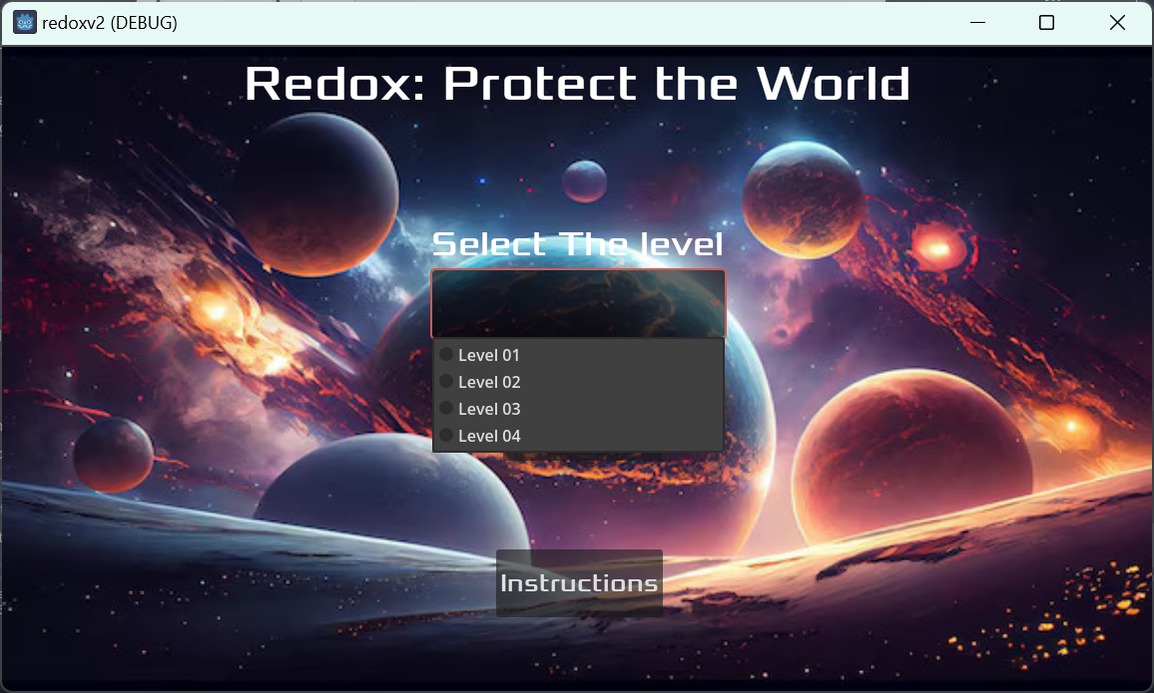

Front end component:(Sai Ram Muthyala, Varun Kumar)

Added login page and implemented role-based authentication where certain functionalities like student scores/ Questions can be viewed by Faculty/Admin

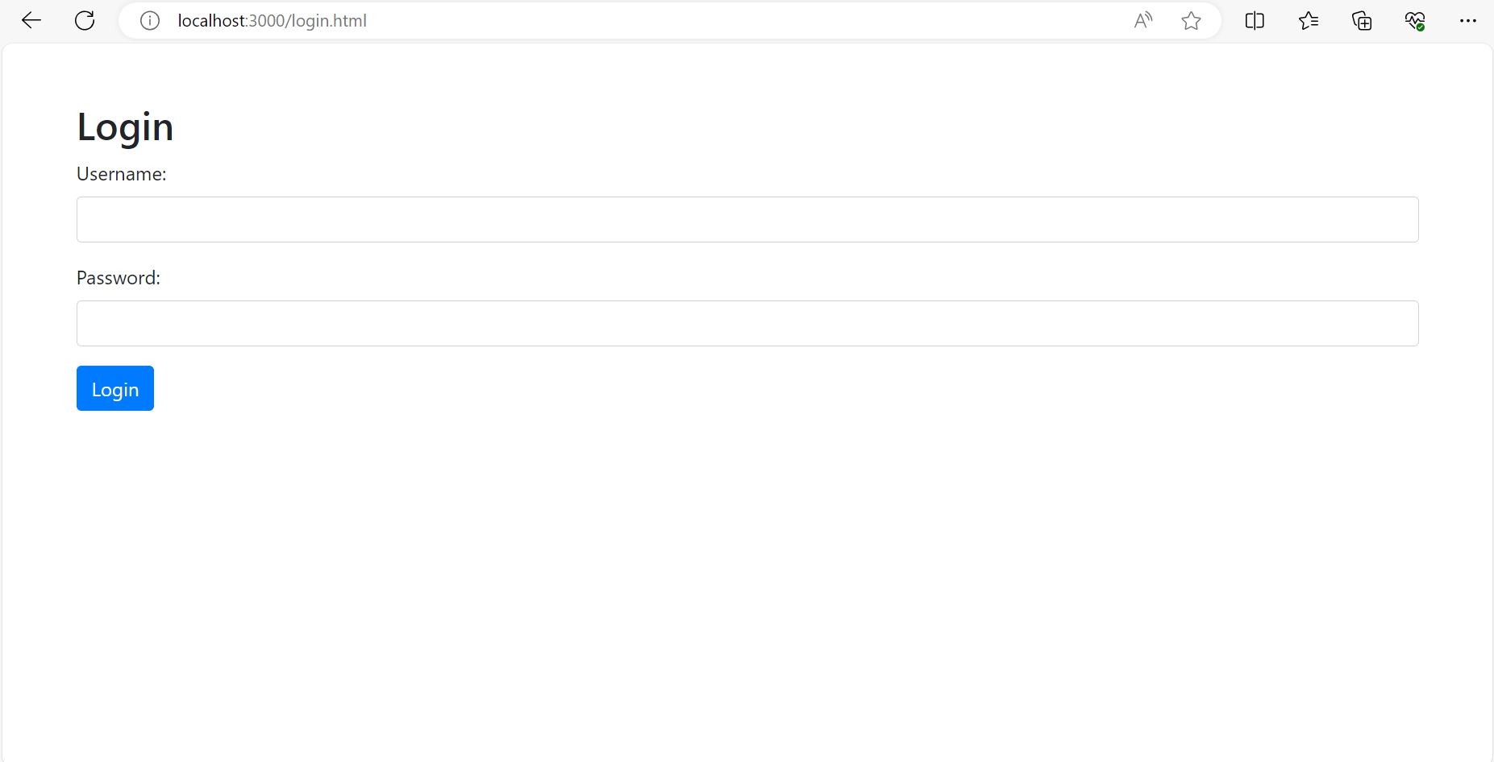

Once the faculty/admin has logged In, it’s possible to insert Questions and its options based on the role access.

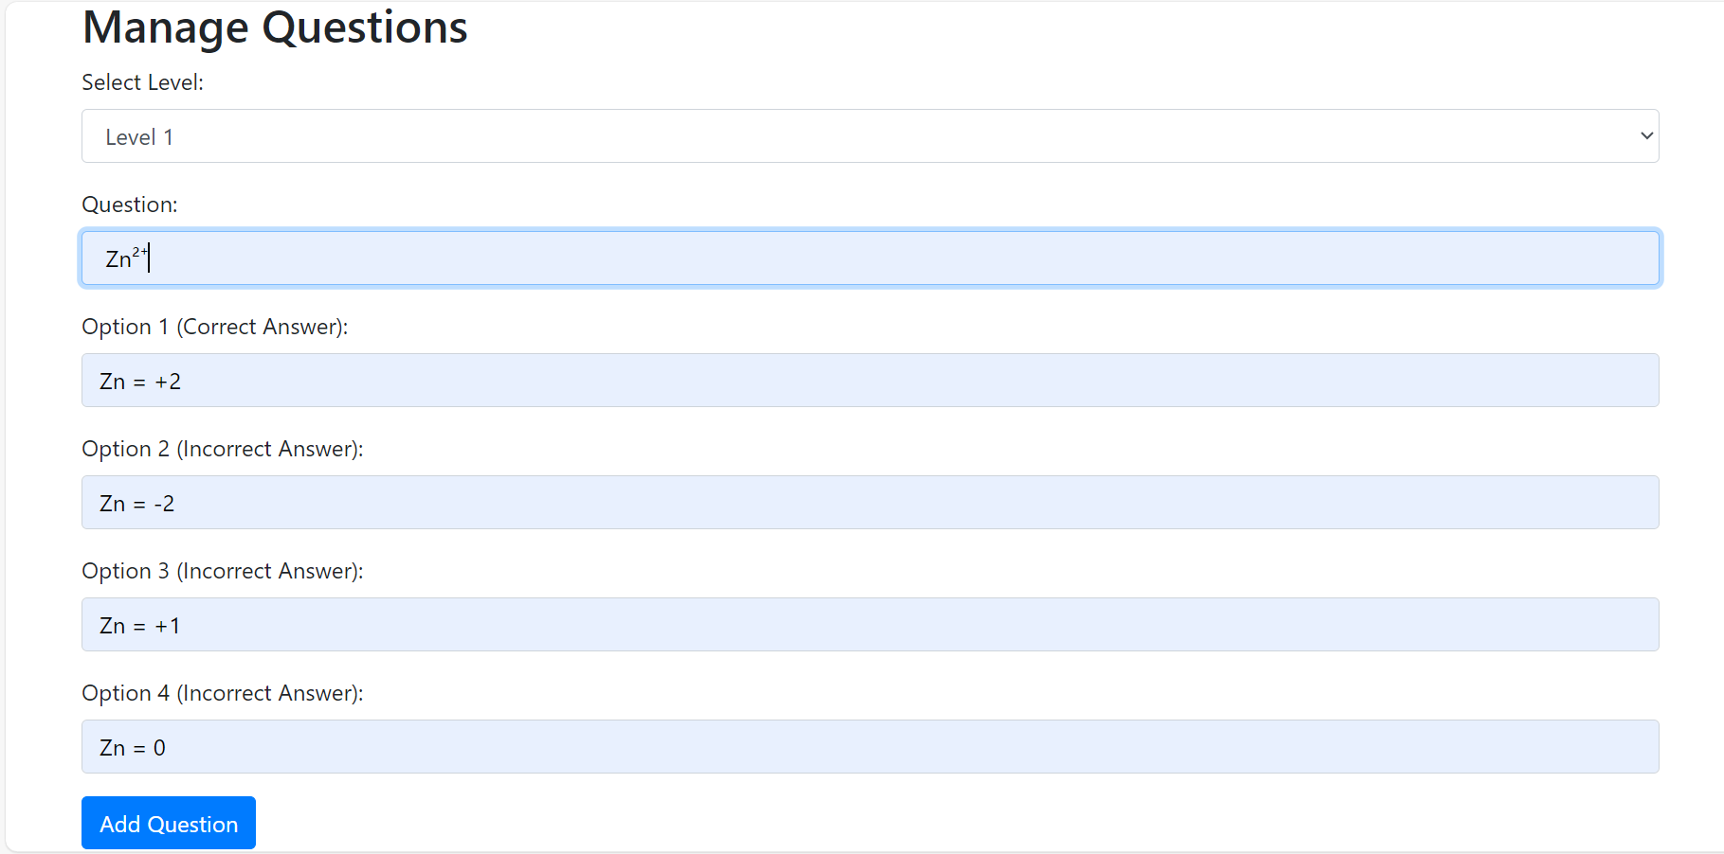

Faculty can view questions Level wise upon hitting view questions button.

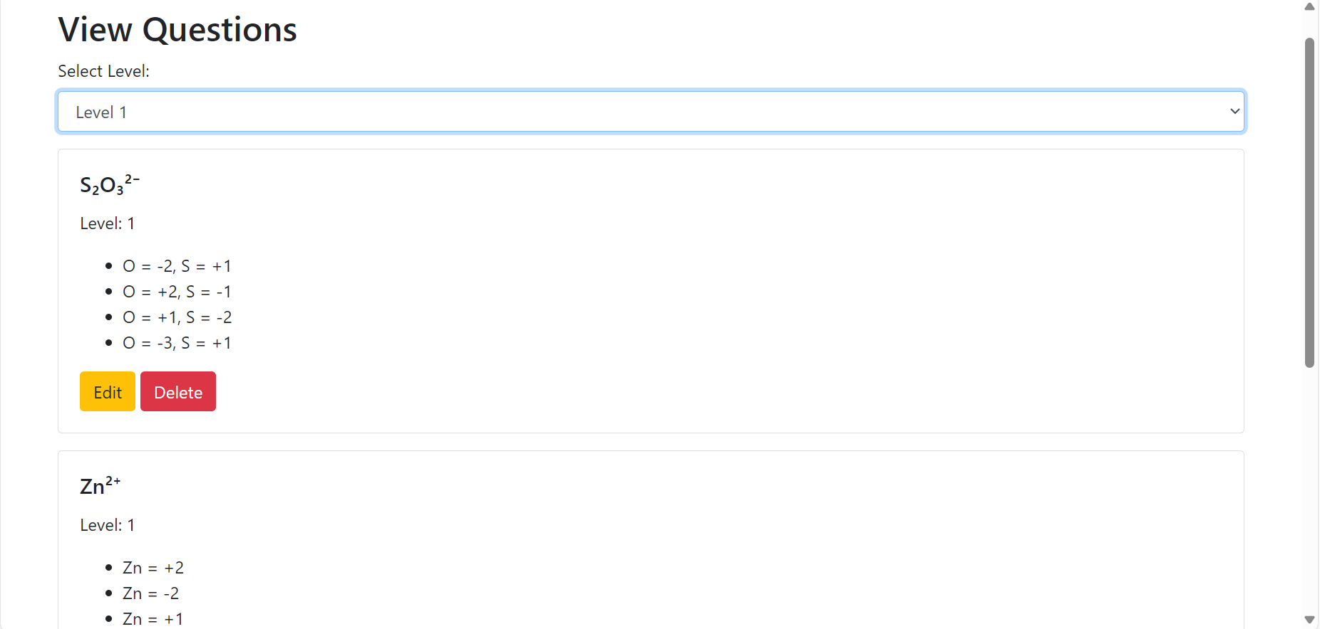

For each question faculty can edit and delete questions to modify accordingly.

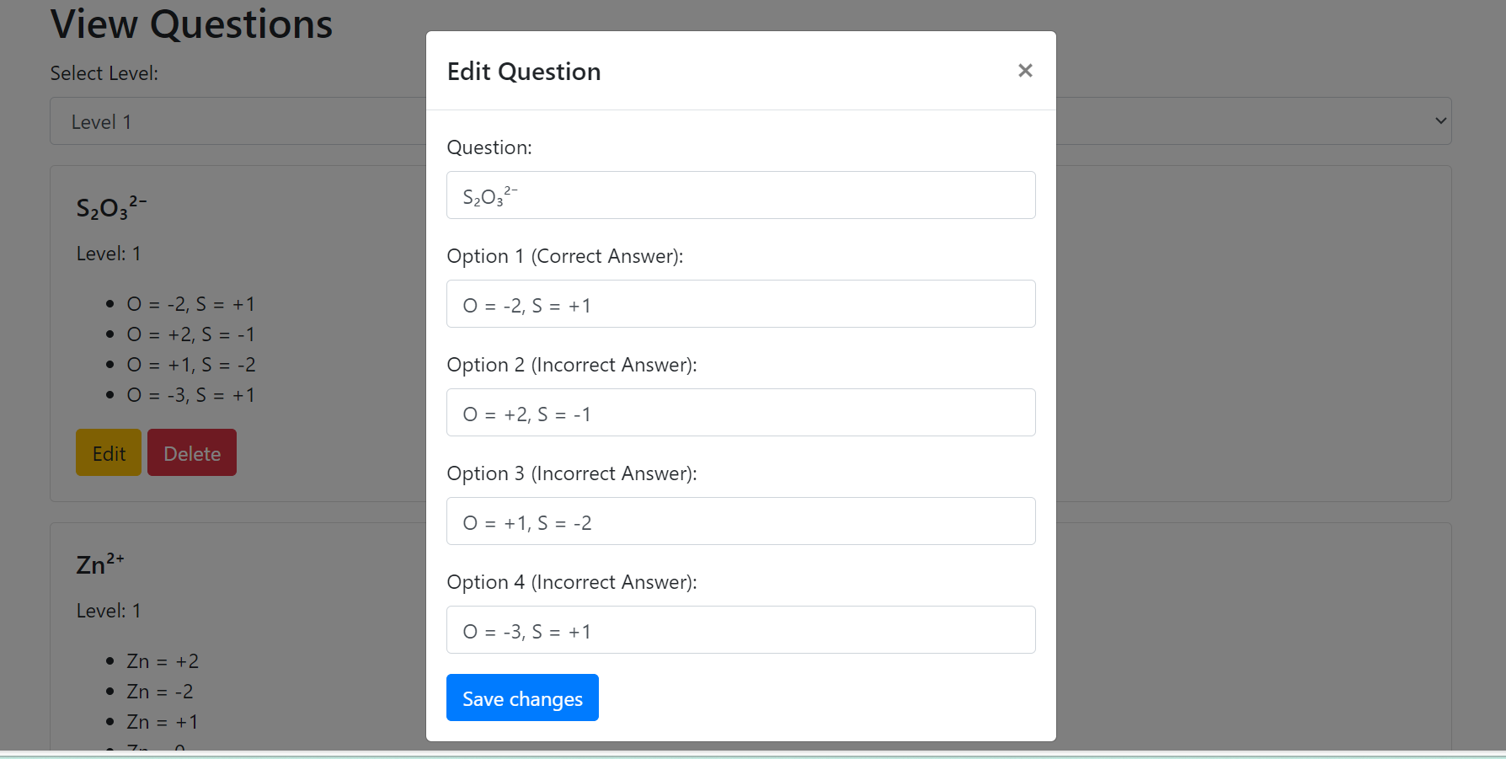

Sounds: (Ram Nitesh, Sumanth, Vennela)

Audio in Godot by AudioStreamPlayer2D or AudioStreamPlayer3D.
Sounds that we assigned for as follows:
- Assigned sound clips to every button on the home page.
- Sound to the background of the game.
- Laser sound while shooting.
- Sounds for correct and incorrect answers.

5. Technology that will be used and why.? (Sai Krishna, Pranathi)

Godot Engine: The game engine used for development.
GDScript: Godot's scripting language for game logic.
Physics Engine: Utilized for character movement and bullet physics.
Scene System: Godot's scene structure for organizing game elements.
Signals and Connections: Mechanism for handling interactions between game objects.
MySQL Database: Option for structured data storage within the game. Potential for storing data on remote servers for online features.
Custom Game Scenes: Scenes created within Godot for specific game elements and interactions.

6. Testing (Vennela, Ram Nitesh, Sumanth)

. Features to be tested:

1. User Interface (UI)

- Menu
- HUD (Heads-Up Display).
- Buttons, sliders, and other interactive UI elements.
- Functionality for maximizing and minimizing the game window.
.
2. Gameplay Mechanics

- Character Movement.
- Physics and Collision Detection.
- Bullet Mechanics.

3. Game Logic

- Game State Management.
- Score Calculation.
- Event Handling.

4. Level-Specific Features

- Level 1 Testing: Basic mechanics and introductory challenges.
Sound effects for correct and incorrect answers.
- Level 2 Testing: More advanced mechanics and challenges like Level 1.
Ensure sound effects are consistent with Level 1.
5. Additional Features

- Sound Effects.
- Login Page.
- Manage Question
- Correct subscript formatting for chemical compounds in questions and answers.

Criteria for passing and failing test:

Feature | Criteria for Passing | Criteria for Failing
User Interface (UI)
Menus | All menus displayed correctly and functional. | Menus not displayed correctly or not functional.
HUD | In-game displays of score and other stats are correct and responsive. | HUD elements not displayed correctly or not responsive.
Interactions | Buttons and other interactive elements respond appropriately. | Interactive elements do not respond appropriately.
Maximize and minimize | Functionality for maximizing and minimizing the game window works correctly. | Game window does not maximize or minimize correctly.
Gameplay Mechanics
Character Movement | Smooth and responsive controls. | Laggy or unresponsive controls.
Physics and Collision | Accurate physics simulation and collision responses. | Inaccurate physics simulation or collision responses.
Bullet Mechanics | Correct firing, trajectory, impact of bullets, and clamping of shooting components. | Incorrect firing, trajectory, impact of bullets, or shooting component issues.
Game Logic
Game State Management | Correct transitions between game states (start, playing, game over). | Incorrect transitions between game states.
Score Calculation | Accurate and consistent score updates. | Inaccurate or inconsistent score updates.
Event Handling | Proper handling of in-game events. | In-game events not handled correctly.
Level-Specific Features
Level 1 Testing | All basic mechanics and introductory challenges work as intended, sound effects for correct and incorrect answers play correctly. | Mechanics or challenges do not work as intended, sound effects do not play or are incorrect.
Level 2 Testing | All advanced mechanics and challenges work as intended; sound effects are consistent with Level 1. | Mechanics or challenges do not work as intended, sound effects are inconsistent or incorrect.
Additional Features
Sound Effects | Correct sound playback for actions like correct answers, incorrect answers, and other in-game events. | Sound effects do not play or are incorrect.
Login Page | Users can log in successfully, authentication works, and sessions are managed correctly. | Users cannot log in, authentication fails, or sessions are not managed correctly.
Manage Questions | Users can add, edit, and delete questions successfully from the front end. | Users cannot add, edit, or delete questions, or changes are not saved correctly.
Chemical Compounds | Chemical compounds are displayed with correct subscript formatting. | Chemical compounds are not displayed correctly, or subscripts are incorrect.

7. Deliverables: (Sai Ram, Pranathi, Varun Kumar)

7.1 Project: Git-hub Repository

Source Code Management:

The repository contains the complete source code of the project, organized into directories for easier navigation.
Includes code for both the client-side (Godot game) and server-side (Node.js backend).

Documentation:

Comprehensive documentation is provided to help understand the project structure, installation steps, and usage.
README file includes an overview of the project, setup instructions, and contact information.

Version Control:

Git is used for version control, allowing team members to collaborate effectively.
Branches and pull requests are used to manage code changes and ensure code quality.

https://github.com/JPranathiReddy/GDP_REDOX_TEAM1.git - GitHub Link

https://jeedipallypranathi.atlassian.net/jira/software/projects/GRT1/boards/2 - Jira Link

7.2 Briefly explain how it works.

Introduction:

The game is designed to teach redox reactions in an engaging way.
Players are introduced to the basic concepts through initial levels, gradually increasing in complexity.

Gameplay:

The game uses Godot Engine for development, providing a smooth and interactive experience.
Players control a character that navigates through various levels, solving puzzles and answering questions related to redox reactions.

Levels and Challenges:

Each level presents unique challenges that test the player's understanding of redox reactions.
Correct answers and successful navigation through the levels earn the player points and progress to higher levels.

Scoring and Feedback:

The game provides immediate feedback on the player's actions.
Correct answers trigger positive feedback, while incorrect answers prompt hints or explanations to guide learning.

Data Management:

Player progress and scores are stored in a MySQL database.
The server-side application handles data storage, retrieval, and management, ensuring a seamless experience for the user.

