

Group members:

KrishnaSai Reddy Patil

Pranav Jaipurkar

Aman Geetey

Tigist Shibeshi

Yili Zhang

Vijayadhaarani Vijayaarunachalam

**Techno-Tidbits**

Contents

**1. Product Description** **4**

1.1 Product Vision 4

1.2 Business Requirements 4

1.3 Users and Other Stakeholders 4

1.4 Project Scope 4

1.5 Assumptions 7

1.6 Constraints 7

**2. Functional Requirements** **8**

2.1 Use Case Diagram 8

2.2 Functional features derived from the use cases 8

2.3 Bi-directional traces between features and use cases 11

2.4 Entity Relationship diagram 12

**3. Non-Functional Requirements** **13**

3.1 Abuse Case Model - Using UML Use Case Diagram 13

3.2 Bidirectional trace between Security Scenarios and Abuse cases 14

3.3 Abuse case description **14**

3.3.1 Theoretical Update Abuse case description  14

3.3.2 UML Activity Diagram  15

3.3.3 Utility tree  16

3.3.4 Quality Attribute Tree 17

# 

# 

# **1. Product Description**

Techno Tidbits is an online learning platform (or community) that offers free courses for students, professional adults to upskill and improve job-related skills. This platform allows professionals to sign up as instructors to tutor and help others in their area of expertise.

## **1.1** **Product Vision**

It aims to share knowledge among people. While there are many e-learning websites that offers courses for money, this platform facilitates people to both teach and learn for free. Students can enroll in a certification course and gain a certificate upon its successful completion.

## **1.2** **Business Requirements**

1. Techno Tidbits should be ready before 2nd December 2019.

2. In an effort to showcase the knowledge gained from the subject “Software Design and Implementation”

## **1.3** **Users and Other Stakeholders**

1. Students

2. Instructors

3. System Administrator

## **1.4 Project Scope**

Scope of the project should include courses, assignments and related materials.

External entities are the following:

**Student**:

The student will interact with the system in the following ways:

F1 – Sign in/ Sign up

F2 – Modify profile

F3 - Search for courses

F4 - See Courses details

F5 - Add, drop courses

F6 - View dashboard.

F7 - View, Download assignments.

F8 - Upload documents in response to assignments.

F9 - Take quiz, exams

F10 - View other profiles

F11 - Send or receive messages to/from instructor or students.

F12 - Seek help from the admin

**Instructor**:

The instructor will interact with the system in the following ways:

F13 – Sign in / Sign up

F14 – Modify their profile

F15 - Search for courses

F16 – Seek permission to teach courses

F17 - Modify the course content

F18 - See all students enrolled in the course.

F19 - Create, edit, delete assignments and quiz.

F20 - Send or receive messages to/from students.

F21 - Seek help to the admin

**Administrator**:

The administrator will interact with the system in the following ways:

F22 - Add, remove courses.

F23 - Add, Modify, remove course content, quiz

F24 - Grant, Decline permission to teach courses.

F25 - Revoke permission to teach course

F26 - Add, delete students.

F27 – Add, delete instructor.

F28 - Assist with issues

**System Context Model**

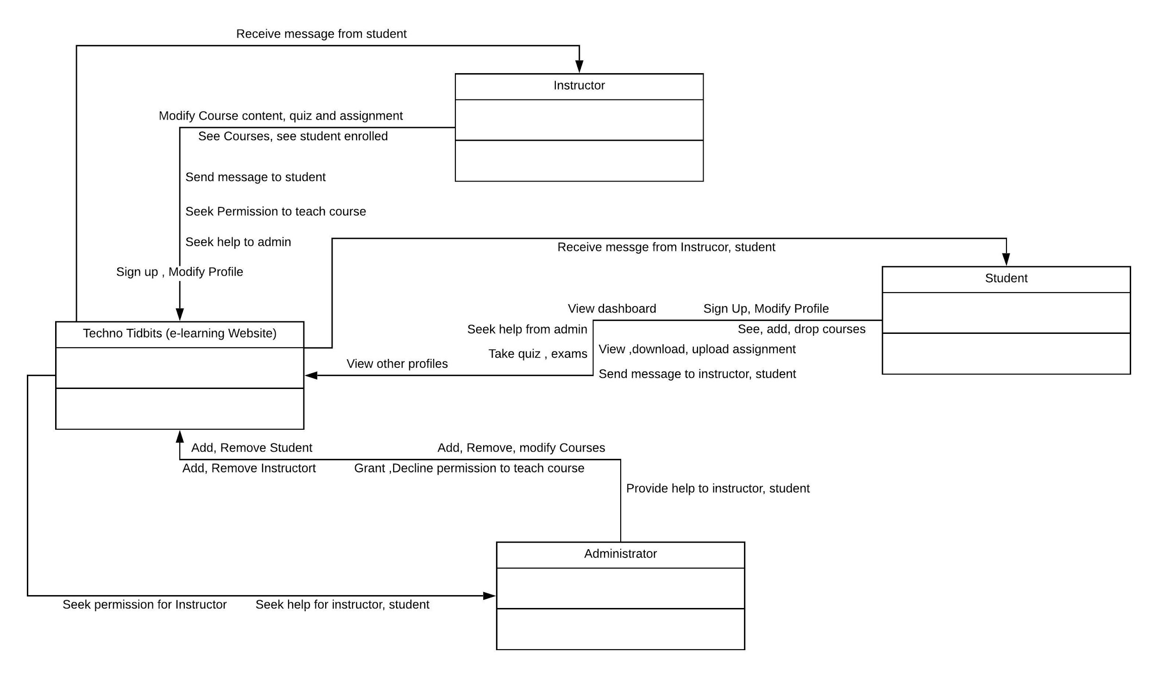

## **1.5 Assumptions**

We have made the following assumptions for this project:

1. All courses are already listed in the system.

## **1.6 Constraints**

1. System should be developed as a web application.

2. System should be ready for demo before Dec 2nd 2019.

3. Development team should contain only assigned member.

**2. Functional Requirements**

## **2.1 Use Case Diagram**

## **2.2 Functional features derived from the use cases**

|  |  |  |  |  |  |
| --- | --- | --- | --- | --- | --- |
| **User role/perspective** | **Feature Name** | **Feature brief description** | **Feature utility (importance) to the users**  **(Low = 1, Medium = 2, High = 3)** | **Estimated Feature development difficulty or risk (Difficult or high risk = 1, Medium difficulty or risk = 2, Rather easy and low risk = 3)** | **Feature priority score (utility * difficulty)** |
| Student | Sign in/ Sign up | Student can register for the first time and can sign in thereafter  which would let system to store data by having unique identity for each user | 3 | 1 | 3 |
|  | Modify Profile | can update details such as phone,email when changed | 2 | 1 | 2 |
|  | Dashboard | Student can see courses completed,active courses | 3 | 2 | 6 |
|  | Search for course | Student can search for a course | 3 | 2 | 6 |
|  | Course Details | Student can find instructor name, syllabus, modules,  Assignments,Quizzes and Grades on selecting of course | 3 | 3 | 9 |
|  | Enroll for Course | Student can activate the course, by doing so he can get  all the latest updates and discussions on the course | 2 | 1 | 2 |
|  | De Register for Course | Student can de-register for the course | 2 | 1 | 2 |
|  | Start Quiz | student can find quiz under each course and can start when he/she is ready | 3 | 2 | 6 |
|  | submit | Student can submit assignment/quiz once done for evaluation | 3 | 2 | 6 |
|  | Download | Student can download documents,videos | 2 | 1 | 2 |
|  | Upload | student can upload documents | 3 | 2 | 6 |
|  | Message | student can message to instructor or post in the discussion forum | 3 | 2 | 6 |
|  | help | student can click on help if he/she faces any issues/need help with the system | 3 | 2 | 6 |
|  |  |  |  |  |  |
| Instructor | Sign in/ Sign up | Instructor can register for the first time and can sign in thereafter  which would let system to store data by having unique identity for each user | 3 | 1 | 3 |
|  | Modify Profile | can update details such as phone,email when changed | 2 | 1 | 2 |
|  | Dashboard | Instructor can see all their courses | 3 | 2 | 6 |
|  | Search for course | Instructor can search for a course from a list of courses | 2 | 2 | 4 |
|  | Course Details | Instructor can see all students enrolled for the course | 3 | 2 | 6 |
|  | Modify Course Content | Instructor can update the course syllabus,Modules,Assignments and quiz | 3 | 3 | 9 |
|  | Message | Instructor can message to Students or post in the discussion forum | 3 | 2 | 6 |
|  | help | Instructor can click on help if he/she faces any issues/need help with the system | 3 | 2 | 6 |
|  | Request Access | Instructor can request admin to grant Instructor access for a course | 3 | 1 | 3 |
|  |  |  |  |  |  |
| Admin | Add/Remove user | Admin can add/Remove student/Instructor from the course | 3 | 2 | 6 |
|  | Assist with issues | Admin can assist student/instructor with any of their issues such as login,  access to courses,updating content | 3 | 3 | 9 |
|  | Add/Modify Courses | Admin can add new courses, update or delete courses or course content | 3 | 2 | 6 |
|  | Grant Access | Admin can grant access to an instructor/student to a course | 3 | 1 | 3 |
|  | Revoke Access | Admin can revoke access to an instructor/student to a course | 3 | 1 | 3 |

## **2.3 Bi-directional traces between features and use cases**

|  |  |  |  |  |  |  |  |  |  |  |  |
| --- | --- | --- | --- | --- | --- | --- | --- | --- | --- | --- | --- |
| **Use Case name -->**  **Feature name |**  **v** | Login to the system | See Courses Registered/  completed | Search for  Courses Available | Enroll for a new course/  Drop existing course | View Instructor/  Student Details | View Course Details,  Grades,Assignments,  Instructor Name | Add/Update  Course Content | Download/upload  content | Start/submit  quiz/Assignment | Message Student/  Instructor | Face any  issue |
| Sign in/ Sign up | X |  |  |  |  |  |  |  |  |  |  |
| View/Modify Profile |  |  |  |  | X |  |  |  |  |  |  |
| Dashboard |  | X |  |  |  |  |  |  |  |  |  |
| Search |  |  | X | X |  | X | X | X | X |  |  |
| See Course Details |  |  |  | X |  | X | X | X | X |  |  |
| Enroll for Course |  |  |  | X |  |  |  |  |  |  |  |
| Drop Course |  |  |  | X |  |  |  |  |  |  |  |
| Start Quiz |  |  |  |  |  |  |  |  | X |  |  |
| Submit quiz/assignment |  |  |  |  |  |  |  |  | X |  |  |
| Download |  |  |  |  |  |  |  | X |  |  |  |
| Upload |  |  |  |  |  |  | X | X |  |  |  |
| Message |  |  |  |  |  |  |  |  |  | X |  |
| Help |  |  |  |  |  |  |  |  |  |  | X |
| Modify Course Content |  |  |  |  |  |  | X |  |  |  |  |

**2.4 Entity Relationship Diagram:**

The Entity Relationship (ER) Diagram of the “Techno Tidbit” shows “entities” such as administrator, instructor , student , course , grade, dashboard, etc . The diagram depicts the relationships of elements within these entities .

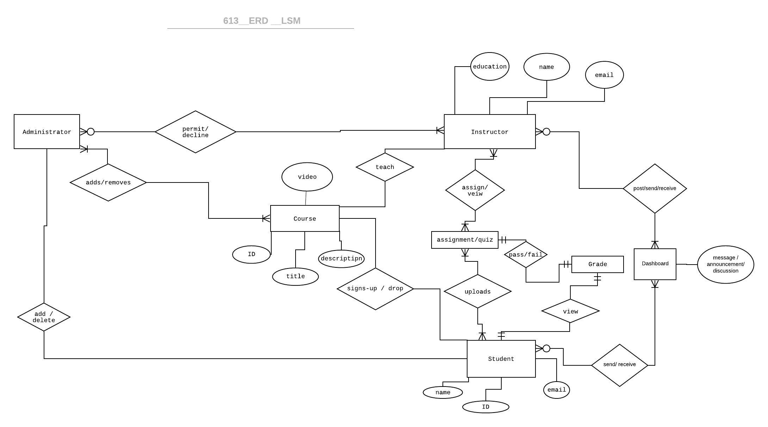

# 

# 

# 

# 

# **3. Non-Functional Requirements**

## **3.1 Abuse Case Model - Using UML Use Case Diagram**

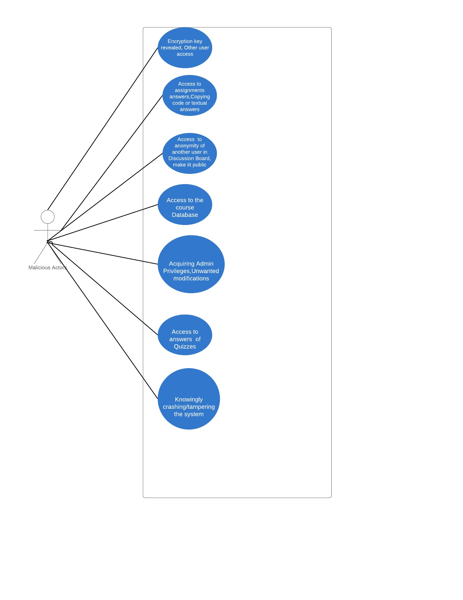

## **3.2 Bidirectional trace between Security Scenarios and Abuse cases**

|  |  |  |  |  |  |  |  |
| --- | --- | --- | --- | --- | --- | --- | --- |
| **Abuse Case name -->**  **Security scenario name |**  **v** | Encryption Key Access | Assignment Answers Known | Anonymous key Identification | Access to the course database | Admin access | Access to answers of quizzes | Knowingly tampering/crashing the system |
| Plagiarism |  | X |  | X | X | X | X |
| Data Tampering |  | X | X | X | X | X |  |
| Unauthorized Access | X | X | X | X | X | X |  |
| Hacking attack | X | X | X | X | X | X | X |
| Loss of anonymity | X |  | X | X |  |  |  |

## **3.3 Abuse case description**

### **3.3.1 Malicious User update the system database with wrong information :**

Updating study material, exam/assignment questions and hence enhancing the quality of courses is one of the most important aspects of our product. Abuse case for an update can be an event in which a malicious user has access to course database. Malicious user could then add incorrect study materials, delete/modify course content and the person could also post the assignment/quiz answers of the course on public forums. In such cases, admin should be able to block his access to the system and if the person has already done some changes then admin should be able to revert those changes and update quiz/assignments.

### **3.3.2 UML Activity Diagram for Encryption key revealed :**

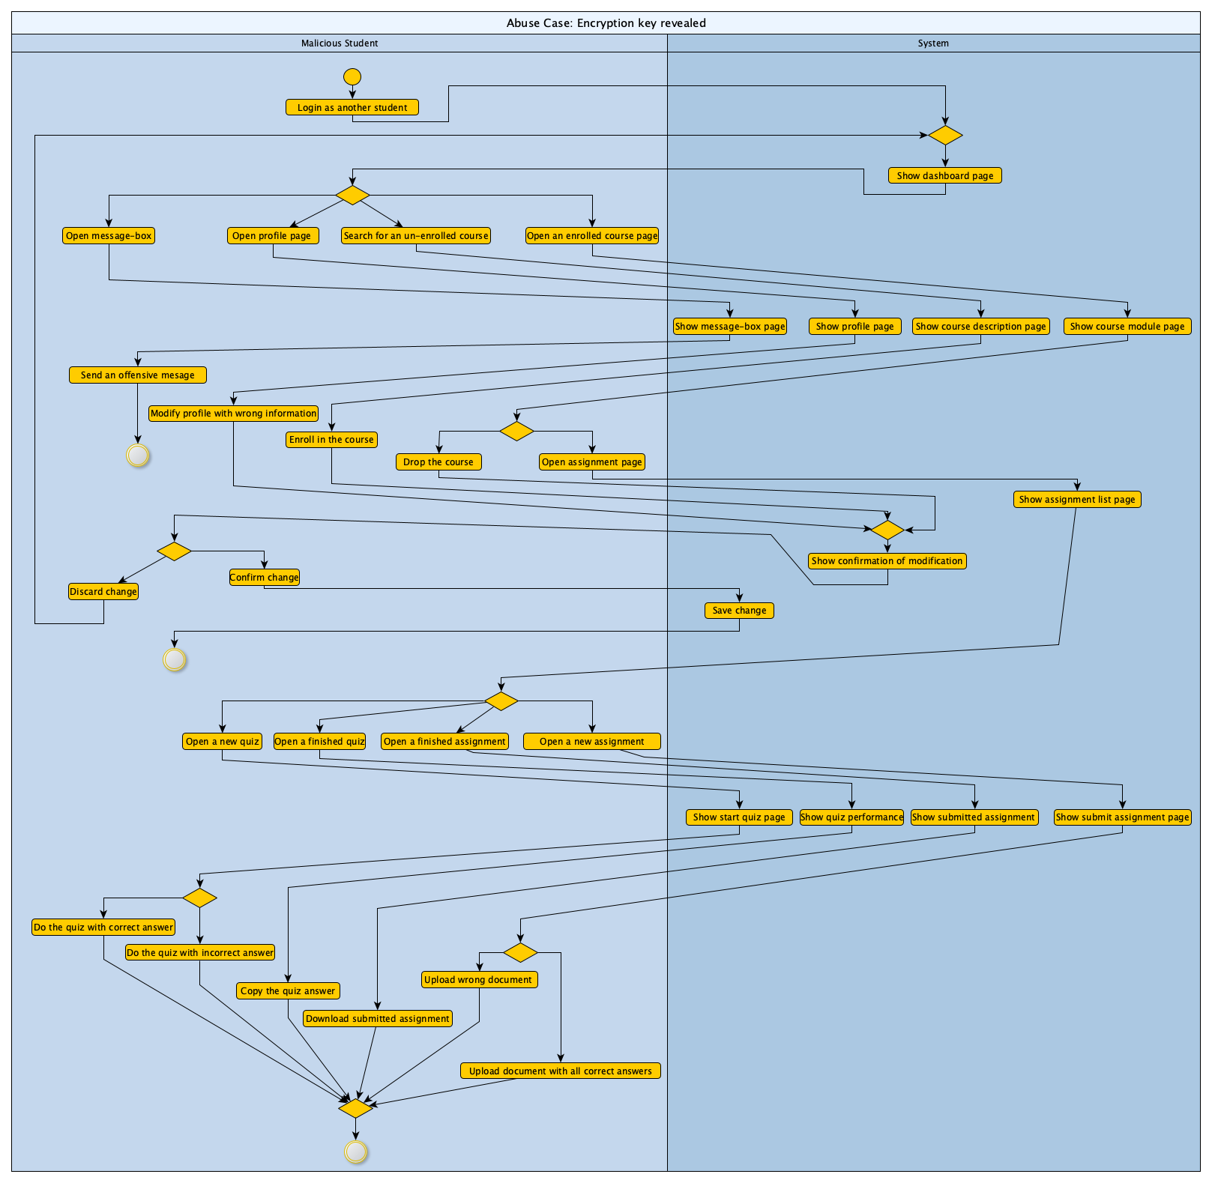

### **3.3.3 Utility tree :**

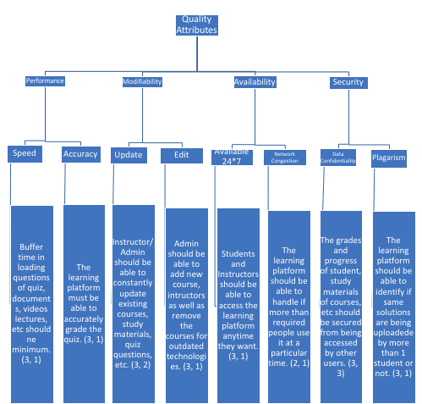

**Utility tree description :**

The utility tree diagram for “Techno Tidbits” has been drawn with the quality attributes of performance, modifiability, availability and security. Speed and accuracy are the use cases for performance; update and edit are the use cases for modifiability; time slots and network congestion are the use cases for availability; data confidentiality and plagiarism are the use cases for security. Number in the form of (x, y) are assigned to branch; x would represent the utility and y would represent the difficulty in implementing the task for that utility. 1, 2 and 3 would stand for low, medium and high respectively. Priority score; product of x and y, is calculated and we came up with *data confidentiality* and *update* as the most important use cases with priority scores 9 and 6 respectively. We have come up with UML activity diagram for data confidentiality in section 3.3.2 and have theoretically described the malicious user abuse case in section 3.3.1.

**3.3.4 Quality Attribute Tree:**

|  |  |  |  |  |  |
| --- | --- | --- | --- | --- | --- |
| **Quality attribute** | **Quality Scenario name** | **Quality Scenario brief description** | **Quality Scenario utility (importance) to the users**  **(Low = 1, Medium = 2, High = 3)** | **Estimated Quality Scenario development difficulty or risk (Dificult or high risk = 1, Medium difficulty or risk = 2, Rather easy and low risk = 3)** | **Scenario priority score (utility * difficulty)** |
| Performance | Speed | Buffer time in loading questions of quiz, documents, videos lectures, etc should be minimum. | 3 | 1 | 3 |
| Performance | Accuracy | The learning platform must be able to accurately grade the quiz. | 3 | 1 | 3 |
| Modifiability | Update | Instructor/Admin should be able to constantly update existing courses, study materials, quiz questions, etc | 3 | 2 | 6 |
| Modifiability | Edit | Admin should be able to add new course, instructors as well as remove the courses for outdated technologies. | 3 | 1 | 3 |
| Availability | Time Slots | Students and Instructors should be able to access the learning platform anytime they want. | 3 | 1 | 3 |
| Availability | Network Congestion | The learning platform should be able to handle if more than required people use it at a particular time. | 2 | 1 | 2 |
| Security | Data Confidentiality | The grades and progress of student, study materials of courses, etc should be secured from being accessed by other users. | 3 | 3 | 9 |
| Security | Plagiarism | The learning platform should be able to identify if similar solutions are being uploaded by more than 1 student or not. | 3 | 1 | 3 |