FieldGrade Machine-Control System
Preliminary Architecture, Safety Concept, Protocol and Implementation Plan
Version 0.1 — 14 July 2026

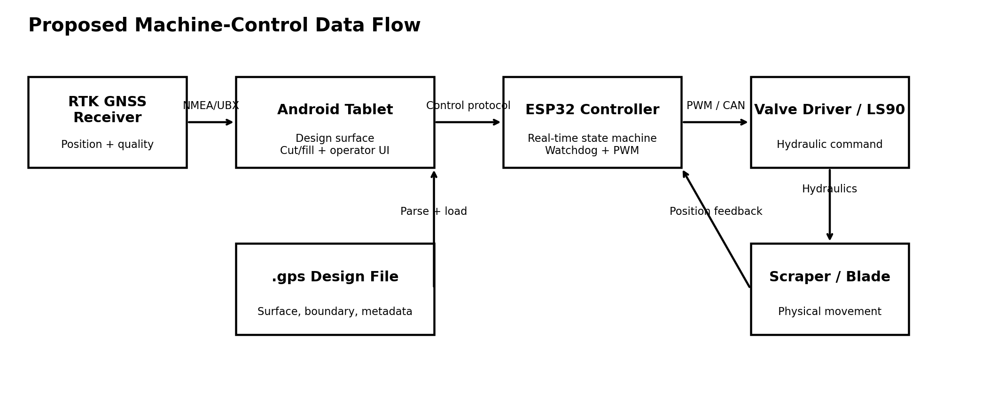

1. Executive summary
This document defines a first implementation for a land-levelling and ditch-control system that uses an Android tablet for operator interaction and design calculations, while a dedicated ESP32 controller performs deterministic hydraulic output, watchdog handling and fail-safe neutral control. The aim is to learn from established products without copying their software, screen layouts, code, trade dress or proprietary file formats.
The operator interface is intentionally simple: a large cut/fill map, a large signed correction value, AUTO, rebench, nudge up, nudge down, grade, and clear GNSS/controller status. Advanced functions remain inside settings.

2. Current status of the uploaded design file
The uploaded object named “sp6b.gps 2” is not the underlying design payload. It is an Apple NSKeyedArchiver/File Provider metadata object. It is 3,212 bytes long, but its metadata states that the original file is approximately 1,034,240 bytes. Consequently, no reliable surface, boundary or grade information can be extracted from this upload. The actual file must be re-uploaded from local storage, preferably after confirming it opens offline and has a size close to 1 MB.
The code package therefore includes a parser interface and a diagnostic inspector, but does not pretend to know the proprietary .gps schema.

3. Functional scope
- Import a supported design file and display its surface and field boundary.
- Read corrected GNSS position and quality from a supported receiver.
- Calculate current design elevation, measured tool elevation and signed cut/fill.
- Provide manual raise/lower, hold, nudge and rebench functions.
- Provide AUTO correction subject to RTK quality, speed, controller state and operator enable.
- Log position, design elevation, measured elevation, correction, output, GNSS state and faults.
- Keep all real-time hydraulic safety functions in the dedicated controller.

4. System architecture

The tablet is supervisory. It computes the requested correction and presents the map. The controller is authoritative for the physical output. This division prevents an Android pause, Bluetooth interruption or application crash from leaving a valve energized.

5. End-to-end data flow
1. Design load: The tablet opens the actual .gps file, identifies its format, validates checksums/structure, reads the design surface and boundary, and converts all coordinates into a project coordinate system.
2. GNSS input: The receiver supplies position, height, fix type, correction age and accuracy. Position is time-stamped and transformed into the design coordinate system.
3. Tool-point model: A calibrated antenna-to-cutting-edge offset and machine attitude model produce the estimated blade/scraper elevation at the control point.
4. Cut/fill calculation: The application interpolates the design elevation under the control point. Cut/fill equals design elevation minus measured tool elevation, with the sign convention fixed in configuration and clearly shown to the operator.
5. Supervisory control: When AUTO is enabled and all interlocks pass, the tablet converts cut/fill into a bounded signed target request. Manual commands bypass the automatic calculation but not the safety interlocks.
6. Controller command: The tablet transmits versioned, sequenced, checksummed commands at 20–50 Hz.
7. Hydraulic output: The ESP32 validates each command, applies timeout, deadband, slew-rate and maximum-duty limits, then drives raise or lower output. Any fault returns immediately to neutral.
8. Feedback and logging: The controller returns output and fault state. The tablet displays status and writes a timestamped log for troubleshooting and job records.

6. Operator interface
Area | Element | Behaviour
Main map | Cut/fill surface and machine symbol | Occupies roughly 75–80% of the display.
Primary value | Large signed cut/fill number | Readable at a glance; unit always visible.
AUTO | Large toggle | Requires valid RTK, controller connection and operator enable.
Nudge | Up / down | Applies a small configurable vertical offset.
Rebench | Single action | Re-establishes the local reference after confirmation.
Status | RTK, controller, fault, logging | Uses text and icons; colour is never the only indicator.
Settings | Protected secondary screen | Calibration, valve tuning, offsets, file details and diagnostics.

7. Safety concept
- Normally-neutral outputs: no valid command means zero hydraulic command.
- Independent physical emergency-stop input wired to the controller.
- 250 ms command timeout by default, configurable only within a validated range.
- Boot, brownout, malformed frame, CRC failure, stale sequence and internal watchdog reset all force neutral.
- Mutually exclusive raise/lower outputs, plus dead time when changing direction.
- Controller-side maximum duty, slew rate and output ramp-down.
- AUTO is inhibited without a sufficiently good GNSS fix or when correction age/accuracy exceeds limits.
- Commissioning mode uses reduced output and requires a deliberate operator action.
- All final hydraulic parameters require machine-specific testing and professional safety review.

8. Communication protocol
Prototype transport is newline-delimited JSON over USB serial or Bluetooth SPP at 115200 baud. The protocol is versioned and includes a sequence number, enable state, mode, target correction, manual request and CRC-16/CCITT. The controller replies with acknowledgement, state, output, voltage, emergency-stop status and fault code. The detailed field definition is supplied in CONTROL_PROTOCOL.md.

9. Software architecture
- Design-file module: format detection, parser adapters, surface interpolation and boundary queries.
- GNSS module: receiver transport, message parser, fix-quality model and coordinate transformation.
- Geometry module: machine offsets, control point and tool elevation.
- Control module: cut/fill, nudge, deadband, enable logic and bounded request generation.
- Transport module: connection lifecycle, framing, CRC, sequence handling and status decode.
- UI module: map, primary values, controls, alarms and diagnostics.
- Logging module: immutable timestamped samples and export.

10. Implementation roadmap
Phase 1 — Bench prototype: Compile Android and ESP32 skeletons; connect over USB serial; validate neutral, timeout and manual output with no hydraulics connected.
Phase 2 — Real file parser: Obtain the actual sp6b.gps payload; identify format from evidence; implement parser and golden-file tests.
Phase 3 — GNSS and map: Integrate the chosen receiver, coordinate transformation and field visualization.
Phase 4 — Dry hydraulic commissioning: Connect to a protected test rig, verify polarity, neutral, limits, emergency stop and fault paths at reduced output.
Phase 5 — Field manual mode: Operate manual control with logging and independent spot checks.
Phase 6 — Closed-loop AUTO: Tune deadband and response progressively, beginning at low speed and conservative authority.
Phase 7 — Production hardening: Signed builds, configuration backup, audit logs, environmental testing, EMC review and machine-specific installation documentation.

11. Acceptance tests
- Controller output is neutral within 250 ms of communication loss.
- E-stop forces neutral regardless of tablet command.
- Raise and lower outputs can never be active simultaneously.
- Application refuses AUTO with invalid GNSS quality or stale data.
- Known design points return the expected interpolated elevation within the selected tolerance.
- Cut/fill sign and unit are confirmed against a surveyed reference.
- Every command, output and fault is timestamped in the log.
- Restarting either device leaves the system disabled until the operator deliberately re-enables it.

12. Deliverables in this package
This package contains the design document, protocol specification, Android Kotlin skeleton, ESP32 PlatformIO firmware skeleton, a controller simulator, a file inspector and protocol tests. It is a foundation for engineering development, not a field-certified machine-control product.

Appendix A — Information still required
- The actual sp6b.gps file bytes.
- GNSS receiver brand/model and output protocol.
- Tablet model, Android version and preferred physical connection.
- Valve/driver electrical specification, including command type, current, frequency and neutral behaviour.
- Machine geometry and antenna-to-tool offsets.
- Available sensors: blade position, pressure, inclination or feedback voltage.
- Preferred units, cut/fill sign convention and nudge increment.
- Country and machine-safety requirements for the intended deployment.

