Jupyter 扩展备份与恢复完整教程
pkill -f vscode-server
一、备份（第一次配置时执行）

1. 确认 Jupyter 扩展已安装并正常工作：在 VSCode 中打开一个 .ipynb 文件，确认能正常选择 kernel 并运行代码。

2. 找到扩展安装目录，在平台终端执行：
ls /root/.vscode-server/extensions/ | grep jupyter
应该看到类似 ms-toolsai.jupyter-2025.9.1 的文件夹。

3. 打包备份：
cd /root/.vscode-server/extensions/
tar -czf /inspire/hdd/project/fdu-aidake-cfff/public/jinqi/jupyter-backup.tar.gz ms-toolsai.jupyter-* ms-toolsai.jupyter-renderers-* ms-toolsai.vscode-jupyter-cell-tags-* ms-toolsai.vscode-jupyter-slideshow-*

4. 验证备份成功：
ls -lh /inspire/hdd/project/fdu-aidake-cfff/public/jinqi/jupyter-backup.tar.gz
应该显示约 16MB。

5. 同时备份到本地电脑（可选）：
在本地 PowerShell 执行：
scp -P 31086 root@ssh-qz.cfff.fudan.edu.cn:/inspire/hdd/project/fdu-aidake-cfff/public/jinqi/jupyter-backup.tar.gz C:\Users\24300\Desktop\

二、恢复（当 Jupyter 扩展消失时执行）

1. 确认备份文件存在：
ls -lh /inspire/hdd/project/fdu-aidake-cfff/public/jinqi/jupyter-backup.tar.gz

2. 解压备份到用户扩展目录：
cd /root/.vscode-server/extensions/
tar -xzf /inspire/hdd/project/fdu-aidake-cfff/public/jinqi/jupyter-backup.tar.gz

3. 复制到内置扩展目录（关键步骤）：
cp -r /root/.vscode-server/extensions/ms-toolsai.jupyter-2025.9.1 /root/.vscode-server/cli/servers/Stable-e7fb5e96c0730b9deb70b33781f98e2f35975036/server/extensions/
cp -r /root/.vscode-server/extensions/ms-toolsai.jupyter-renderers-1.3.0 /root/.vscode-server/cli/servers/Stable-e7fb5e96c0730b9deb70b33781f98e2f35975036/server/extensions/
cp -r /root/.vscode-server/extensions/ms-toolsai.vscode-jupyter-cell-tags-0.1.9 /root/.vscode-server/cli/servers/Stable-e7fb5e96c0730b9deb70b33781f98e2f35975036/server/extensions/
cp -r /root/.vscode-server/extensions/ms-toolsai.vscode-jupyter-slideshow-0.1.6 /root/.vscode-server/cli/servers/Stable-e7fb5e96c0730b9deb70b33781f98e2f35975036/server/extensions/

4. 重启 VSCode Server：
pkill -f vscode-server

5. 重新连接：选择Redownload Window
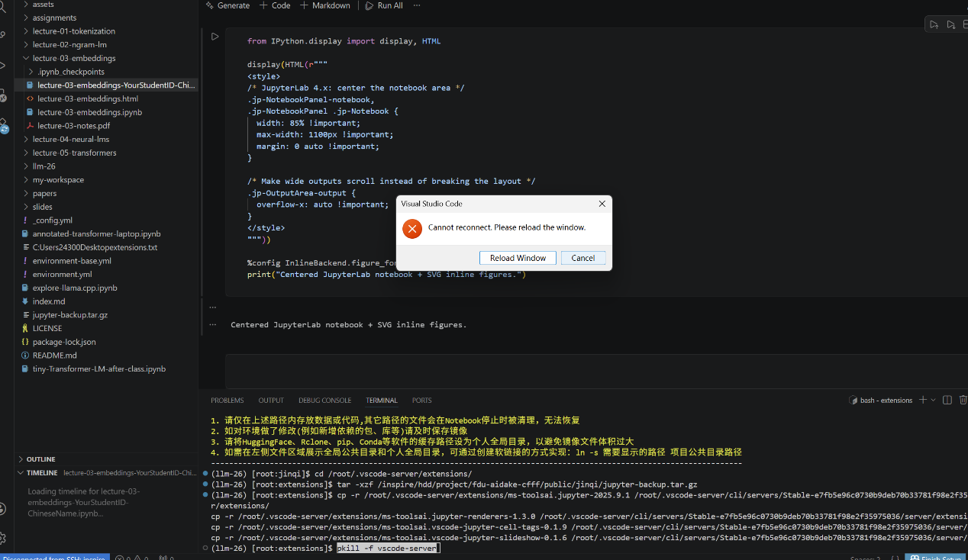

6. 验证：打开一个 .ipynb 文件，看右上角是否有 llm-26 或 Python 3 的 kernel 选项。

