**Lab Task-1**

**Problem 1: Write a C# program to determine whether a given year is a leap year or not.**

**Ans:**

using System;

using System.Collections.Generic;

using System.Linq;

using System.Text;

using System.Threading.Tasks;

namespace Task_1_Problem_1

{

class Program

{

static void Main(string[] args)

{

Console.Write("Enter a year: ");

int year = Convert.ToInt32(Console.ReadLine());

if ((year % 4 == 0 && year % 100 != 0) || (year % 400 == 0))

{

Console.WriteLine(year + " is a Leap Year.");

}

else

{

Console.WriteLine(year + " is NOT a Leap Year.");

}

}

}

}

**Output:**

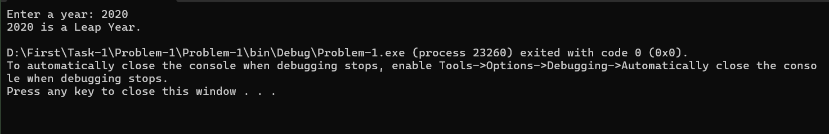

**Problem 2: Write a C# program that takes three integer numbers as input and determines the largest.**

**Ans:**

using System;

using System.Collections.Generic;

using System.Linq;

using System.Text;

using System.Threading.Tasks;

namespace Problem_2

{

class Program

{

static void Main(string[] args)

{

Console.Write("Enter first number: ");

int num1 = Convert.ToInt32(Console.ReadLine());

Console.Write("Enter second number: ");

int num2 = Convert.ToInt32(Console.ReadLine());

Console.Write("Enter third number: ");

int num3 = Convert.ToInt32(Console.ReadLine());

int largest;

if (num1 >= num2 && num1 >= num3)

{

largest = num1;

}

else if (num2 >= num1 && num2 >= num3)

{

largest = num2;

}

else

{

largest = num3;

}

Console.WriteLine("The largest number is: " + largest);

}

}

}

**Output:**

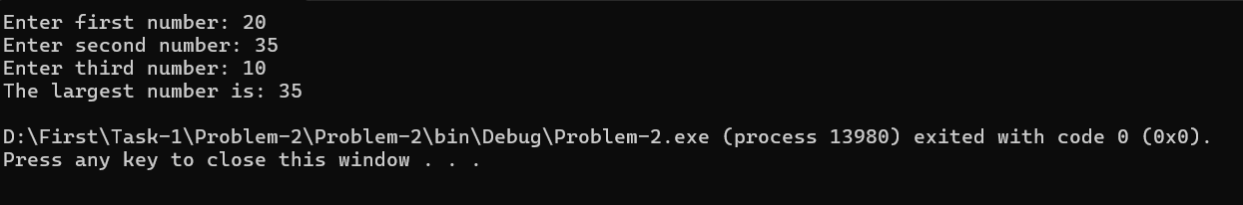

**Problem 3: Write a C# program that take an integer array from the user and find the second largest number and display the value if possible.**

**Ans:**

using System;

using System.Collections.Generic;

using System.Linq;

using System.Text;

using System.Threading.Tasks;

namespace Problem_3

{

class Program

{

static void Main(string[] args)

{

Console.Write("Enter the number of elements: ");

int size = Convert.ToInt32(Console.ReadLine());

if (size < 2)

{

Console.WriteLine("Need at least two numbers to find the second largest.");

return;

}

int[] numbers = new int[size];

Console.WriteLine("Enter the numbers:");

for (int i = 0; i < size; i++)

{

Console.Write($"Element {i + 1}: ");

numbers[i] = Convert.ToInt32(Console.ReadLine());

}

var sortedUnique = numbers.Distinct().OrderByDescending(n => n).ToList();

if (sortedUnique.Count < 2)

{

Console.WriteLine("There is no second largest number (all numbers are equal).");

}

else

{

Console.WriteLine("The second largest number is: " + sortedUnique[1]);

}

}

}

}

**Output:**

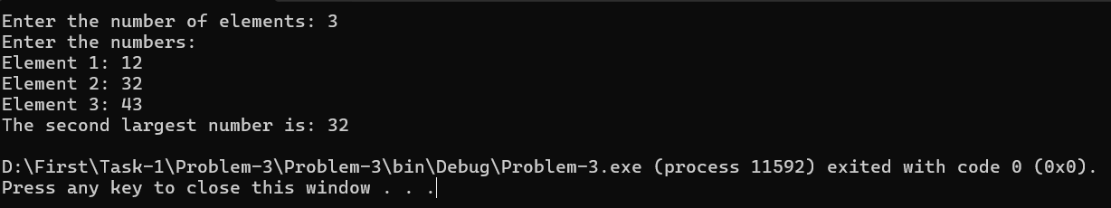

**Problem 4: Write a C# program that print the longest word from a given sentence.**

**Ans:**

using System;

using System.Collections.Generic;

using System.Linq;

using System.Text;

using System.Threading.Tasks;

namespace Probler_4

{

class Program

{

static void Main(string[] args)

{

Console.Write("Enter a sentence: ");

string sentence = Console.ReadLine();

string[] words = sentence.Split(new char[] { ' ', ',', '.', '!', '?' }, StringSplitOptions.RemoveEmptyEntries);

string longestWord = "";

int maxLength = 0;

foreach (string word in words)

{

if (word.Length > maxLength)

{

maxLength = word.Length;

longestWord = word;

}

}

Console.WriteLine("The longest word is: " + longestWord);

}

}

}

**Output:**

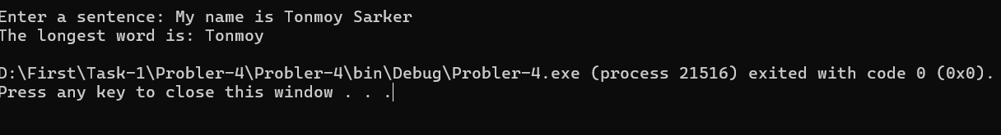

**Problem 5: Write a C# program that will search an element from a given array.**

**Ans:**

using System;

using System.Collections.Generic;

using System.Linq;

using System.Text;

using System.Threading.Tasks;

namespace Problem_5

{

class Program

{

static void Main(string[] args)

{

Console.Write("Enter the number of elements in the array: ");

int size = Convert.ToInt32(Console.ReadLine());

int[] arr = new int[size];

Console.WriteLine("Enter the elements of the array:");

for (int i = 0; i < size; i++)

{

Console.Write($"Element {i + 1}: ");

arr[i] = Convert.ToInt32(Console.ReadLine());

}

Console.Write("Enter the number to search: ");

int searchValue = Convert.ToInt32(Console.ReadLine());

bool found = false;

for (int i = 0; i < size; i++)

{

if (arr[i] == searchValue)

{

Console.WriteLine($"Number {searchValue} found at position {i + 1}.");

found = true;

break;

}

}

if (!found)

{

Console.WriteLine($"Number {searchValue} not found in the array.");

}

}

}

}

**Output:**

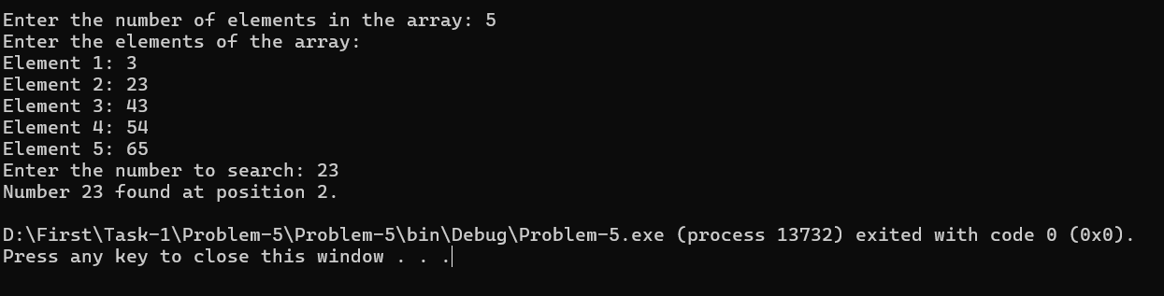

**Problem 6: Write a C# program that counts the occurrences of duplicate elements within a given array.**

**Ans:**

using System;

using System.Collections.Generic;

using System.Linq;

using System.Text;

using System.Threading.Tasks;

namespace Problem_6

{

class Program

{

static void Main(string[] args)

{

Console.Write("Enter the number of elements in the array: ");

int size = Convert.ToInt32(Console.ReadLine());

int[] arr = new int[size];

Console.WriteLine("Enter the elements of the array:");

for (int i = 0; i < size; i++)

{

Console.Write($"Element {i + 1}: ");

arr[i] = Convert.ToInt32(Console.ReadLine());

}

Dictionary<int, int> counts = new Dictionary<int, int>();

foreach (int num in arr)

{

if (counts.ContainsKey(num))

{

counts[num]++;

}

else

{

counts[num] = 1;

}

}

Console.WriteLine("\nDuplicate elements and their counts:");

bool foundDuplicate = false;

foreach (var item in counts)

{

if (item.Value > 1)

{

Console.WriteLine($"{item.Key} appears {item.Value} times");

foundDuplicate = true;

}

}

if (!foundDuplicate)

{

Console.WriteLine("No duplicate elements found.");

}

}

}

}

**Output:**

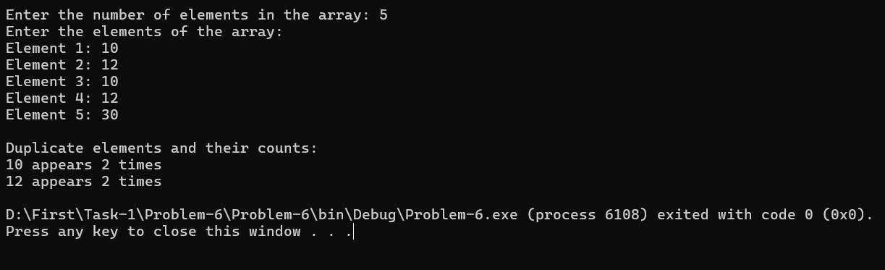

**Problem 7: Write a C# program that print all the longest word from a given**

**sentence.**

**Ans:**

using System;

using System.Collections.Generic;

using System.Linq;

using System.Text;

using System.Threading.Tasks;

namespace Problem_7

{

class Program

{

static void Main(string[] args)

{

Console.Write("Enter a sentence: ");

string sentence = Console.ReadLine();

string[] words = sentence.Split(new char[] { ' ', '.', ',', '!', '?', ';', ':' }, StringSplitOptions.RemoveEmptyEntries);

int maxLength = 0;

List<string> longestWords = new List<string>();

foreach (string word in words)

{

if (word.Length > maxLength)

{

maxLength = word.Length;

longestWords.Clear();

longestWords.Add(word);

}

else if (word.Length == maxLength)

{

longestWords.Add(word);

}

}

Console.WriteLine("\nLongest word(s):");

foreach (string word in longestWords)

{

Console.WriteLine(word);

}

}

}

}

**Output:**

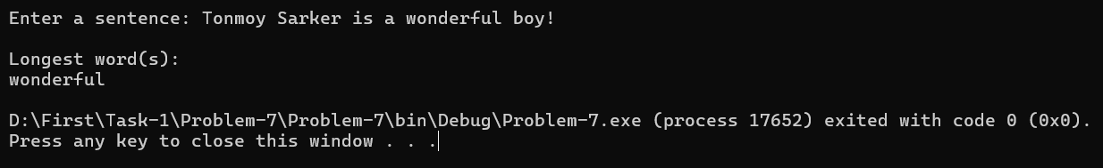

**Problem 8: Write a C# program to accept a coordinate point in an XY coordinate system and determine in which quadrant the coordinate point lies.**

using System;

using System.Collections.Generic;

using System.Linq;

using System.Text;

using System.Threading.Tasks;

namespace Problem_8

{

class Program

{

static void Main(string[] args)

{

Console.Write("Enter the X coordinate: ");

double x = Convert.ToDouble(Console.ReadLine());

Console.Write("Enter the Y coordinate: ");

double y = Convert.ToDouble(Console.ReadLine());

if (x > 0 && y > 0)

{

Console.WriteLine("The point is in Quadrant I.");

}

else if (x < 0 && y > 0)

{

Console.WriteLine("The point is in Quadrant II.");

}

else if (x < 0 && y < 0)

{

Console.WriteLine("The point is in Quadrant III.");

}

else if (x > 0 && y < 0)

{

Console.WriteLine("The point is in Quadrant IV.");

}

else if (x == 0 && y == 0)

{

Console.WriteLine("The point is at the Origin.");

}

else if (x == 0)

{

Console.WriteLine("The point lies on the Y axis.");

}

else if (y == 0)

{

Console.WriteLine("The point lies on the X axis.");

}

}

}

}

**Output:**

