**Analysis**

When we first met with Alfred, his idea for an application was very broad and simple. He more or less wanted a simple character bio screen and an animation showing someone how to brush their teeth. During the first meeting, we decided that we were going to bulk up the project a bit, and add a few more components to it. In the end we decided that we were going to have a total of 5 components in the application.

The first thing we agreed to add was a main screen. This would basically act as a hub to get everywhere within the program. We also, while trying to figure out what would be on the main screen, suggested that since his comic and the magazine his comic would be in was bilingual that there should be a button to change the languages.

When we first sat down the main thing that Alfred wanted was a reminder for kids to brush their teeth. After finishing up the main screen, we came back to that idea. Alfred suggested two times that would be adjustable and we agreed that it could easily be done.

After those two, we came to his original idea of the character bios. We let Alfred come up with the entire idea for this one. He told us exactly what he wanted out of the biographies and we told him what could be done and what couldn’t be done. We decided on simple card based biographies that would flip over showing either the background of the character or the entire character itself.

After the bio there was nothing else that Alfred had in mind, so we had to beef up the program a little bit. We decided that one of the things that we should add is a timer for kids to know how long they should brush their teeth. We then realized we needed to add more re-playability. We pitched an idea of having the user earn credits of sorts to unlock more characters in the biographies. This would keep the users coming back to the app.

We then decided that if there was going to be any reusability in the app that there would need to be games. We came up with two games and pitched them to Alfred. The first being a story-karma type game. We gave Alfred the basic gist of the game. It would have a good and a bad choice and each one you picked would work towards a different ending. We made sure that we did not cross any lines with the moral choices we might use.

Before coming up with the second game, we agreed that the project still had very little re-playability. So we decided to add a game inspired by Flappy Birds. On this piece of the program everyone added an idea of their own. To make sure that it was going to be able to be completed, we only wrote down the necessary things that would make the game fun.

Alfred also stated that he wanted there to be some sort of education within the app and all the games. For this we came up with fake loading screens. These “loading screens” would show a small factoid about dental health. We came up with at least 20 ideas to put into each screen.

**Design Diagrams**

**Block diagram**

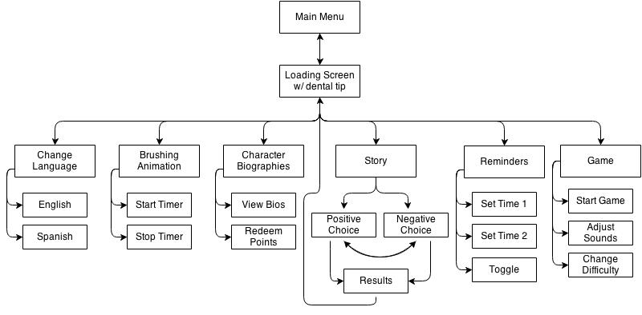

**Use Cases**

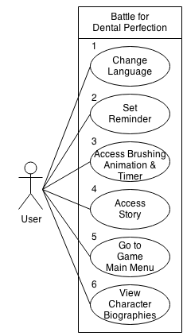

**Use case ID: 1**

Use case name: Change language

Summary of use case:

The user can go to the screen to change the language of the program.

Actors: User

Preconditions:

The user has loaded up the application and they are on the main screen.

Successful scenario:

The user is then taken to the screen that will allow them to change the language options.

Alternative scenario:

The touch is not recognized and nothing happens.

The page fails to load and the user is sent back to the main screen.

The app freezes and the program closes.

Post conditions:

The user is now on the change language screen.

**Use case ID: 2**

Use case name: Set Reminder

Summary of use case:

The user can go to the set reminders page.

Actors: User

Preconditions:

The user has loaded up the application and they are in the main menu.

Successful scenario:

The user has been taken to the set reminders page.

Alternative scenario:

The program freezes and the app closes.

The function is not found and the program goes back to the main menu.

The touch is not recognized and nothing happens.

Post conditions:

The user is now in the set reminder page.

**Use case ID: 3**

Use case name: Access animation and brushing timer

Summary of use case:

The user can go to the animation and brushing timer page.

Actors: User

Preconditions:

The user has loaded up the application and they are in the main menu.

Successful scenario:

The user has been taken to the animation and brushing timer page.

Alternative scenario:

The program freezes and the application closes.

The function is not found and the program goes back to the main menu.

The touch is not recognized and nothing happens.

Post conditions:

The user is now in the animation and brushing timer.

**Use case ID: 4**

Use case name: Access Story

Summary of use case:

The user can go to the story main menu.

Actors: User

Preconditions:

The user has loaded up the application and they are in the main menu.

Successful scenario:

The user has been taken to the story main menu page.

Alternative scenario:

The program freezes and the application closes.

The function is not found and the program goes back to the main menu.

The touch is not recognized and nothing happens.

Post conditions:

The user is now in the story main menu.

**Use case ID: 5**

Use case name: Go to game main menu

Summary of use case:

The user can go to the game main menu.

Actors: User

Preconditions:

The user has loaded up the application and they are in the main menu.

Successful scenario:

The user has been taken to the game main menu page.

Alternative scenario:

The program freezes and the application closes.

The function is not found and the program goes back to the main menu.

The touch is not recognized and nothing happens.

Post conditions:

The user is now in the game main menu.

**Use case ID: 6**

Use case name: View character Biographies

Summary of use case:

The user can go to the character Biographies page.

Actors: User

Preconditions:

The user is in the main menu.

Successful scenario:

The user is taken to the character biographies page.

Alternative scenario:

The program freezes and the application closes.

The function is not found and the program goes back to the game main menu.

The touch is not recognized and nothing happens.

Post conditions:

The user is now in the character biographies page.

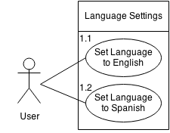

**Use case ID: 1.1**

Use case name: Set language to English

Summary of use case:

The user can change the language of the program to English.

Actors: User

Preconditions:

The user has loaded up the application and they in the change language settings.

Successful scenario:

The language of the program will set to English.

Alternative scenario:

The program is already in English and nothing happens.

The function is not found and the program stays in the previous language.

The touch is not recognized and nothing happens.

Post conditions:

The language of the program is now set to English and the user exits back to the main menu.

**Use case ID: 1.2**

Use case name: Set language to Spanish

Summary of use case:

The user can change the language of the program to Spanish.

Actors: User

Preconditions:

The user has loaded up the application and they in the change language settings.

Successful scenario:

The language of the program will set to Spanish.

Alternative scenario:

The program is already in Spanish and nothing happens.

The function is not found and the program stays in the previous language.

The touch is not recognized and nothing happens.

Post conditions:

The language of the program is now set to Spanish and the user exits back to the main menu.

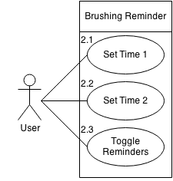

**Use case ID: 2.1**

Use case name: Set Time one

Summary of use case:

The user can set the first time to remind him to brush his teeth.

Actors: User

Preconditions:

The user has clicked the set reminder button from the main menu and is now on the set reminder page.

Successful scenario:

The first reminder time has been set and notifies the user of the change. The program changes the first time to the user’s specific time

Alternative scenario:

The change time function is not found and the time doesn’t change.

The touch is not recognized for the change time 1 button and the time does not come up.

The touch is not recognized for the time selection and the time is continued to be displayed.

Post conditions:

The time has been selected and the user has been notified of the change and the user is back on the set reminder page.

**Use case ID: 2.2**

Use case name: Set Time two

Summary of use case:

The user can set the second time to remind him to brush his teeth.

Actors: User

Preconditions:

The user has clicked the set reminder button from the main menu and is now on the set reminder page.

Successful scenario:

The second reminder time has been set and notifies the user of the change. The program changes the second time to the user’s specific time

Alternative scenario:

The change time function is not found and the time doesn’t change.

The touch is not recognized for the change time 2 button and the time does not come up.

The touch is not recognized for the time selection and the time is continued to be displayed.

The time is the same as the first time and does not set.

Post conditions:

The time has been selected and the user has been notified of the change and the user is back on the set reminder page.

**Use case ID: 2.3**

Use case name: Toggle reminders

Summary of use case:

The user can set to have the reminders either on or off.

Actors: User

Preconditions:

The user has clicked the set reminder button from the main menu and is now on the set reminder page.

Successful scenario:

If the toggle button is set to on, the user clicks the button and the reminders are turned off.

If the toggle button is set to off, the user clicks the button and the reminders are turned on.

Alternative scenario:

The touch is not recognized and nothing happens.

The function is not found and nothing happens

Post conditions:

The button has been pressed and either the reminders have been set to on or off and the user remains on the set reminders page.

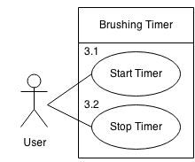

**Use case ID: 3.1**

Use case name: Start timer

Summary of use case:

The user can start the timer which will start the animation.

Actors: User

Preconditions:

The user pressed the brushing timer and animation button and is now on the page.

Successful scenario:

The button was pressed and the timer and animation are now going.

Alternative scenario:

The timer fails to start.

The animation fails to start.

The touch is not recognized and nothing happens.

Post conditions:

The timer and animation are now going and at 2 minutes the timer and animation will stop.

**Use case ID: 3.2**

Use case name: Stop timer

Summary of use case:

The user can stop the timer which will stop the animation.

Actors: User

Preconditions:

The user pressed the start timer button and the animation and timer are going.

Successful scenario:

The button was pressed and the timer and animation are now stopped.

Alternative scenario:

The timer fails to stop.

The animation fails to stop.

The timer was already stopped so nothing happens.

The touch is not recognized and nothing happens.

Post conditions:

The timer and animation are now stopped and the user is on the brushing and animation page.

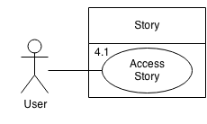

**Use case ID: 4.1**

Use case name: Access Story

Summary of use case:

The user can start the story game.

Actors: User

Preconditions:

The user is in the story main menu and presses the start story button.

Successful scenario:

The user has started the story.

Alternative scenario:

The program freezes and the application closes.

The function is not found and the program stays in the story main menu.

The touch is not recognized and nothing happens.

Post conditions:

The user is now playing the story game.

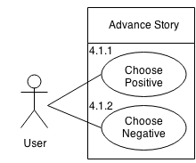

**Use case ID: 4.1.1**

Use case name: Choose positive.

Summary of use case:

The user can choose the positive choice of the story.

Actors: User

Preconditions:

The user is playing the story game.

Successful scenario:

The user has chosen the positive story choice.

Alternative scenario:

The function is not found and nothing happens.

The touch is not recognized and nothing happens.

Post conditions:

The user has chosen the positive choice, the points have been added to the total, and the next screen is shown. If it is the final screen, based on the amount of points, the ending is shown.

**Use case ID: 4.1.2**

Use case name: Choose Negative.

Summary of use case:

The user can choose the negative choice of the story.

Actors: User

Preconditions:

The user is playing the story game.

Successful scenario:

The user has chosen the negative story choice.

Alternative scenario:

The function is not found and nothing happens.

The touch is not recognized and nothing happens.

Post conditions:

The user has chosen the negative choice, the points have been added to the total, and the next screen is shown. If it is the final screen, based on the amount of points, the ending is shown.

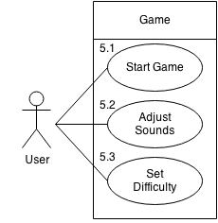

**Use case ID: 5.1**

Use case name: Start game

Summary of use case:

The user can start the game.

Actors: User

Preconditions:

The user is in the game main menu.

Successful scenario:

The game loads up and the user can start playing.

Alternative scenario:

The program freezes and the application closes.

The function is not found and the program goes back to the game main menu.

The touch is not recognized and nothing happens.

Post conditions:

The user is now playing the game.

**Use case ID: 5.2**

Use case name: Adjust sounds

Summary of use case:

The user can toggle the sound on or off.

Actors: User

Preconditions:

The user is in the game main menu.

Successful scenario:

If the sound is toggled on, then the sound will be set to off.

If the sound is toggled off, then the sound will be set on.

Alternative scenario:

The function is not found and the program goes back to the game main menu.

The touch is not recognized and nothing happens.

Post conditions:

The sound has been set to on or off and the user is still on the game main menu

**Use case ID: 5.3**

Use case name: Set difficulty

Summary of use case:

The user can set the difficulty to easy, medium or hard.

Actors: User

Preconditions:

The user is in the game main menu.

Successful scenario:

If the game is set to easy, then the difficulty will change to medium.

If the game is set to medium, then the difficulty will change to hard.

If the game is set to hard, them the difficulty will change to easy.

Alternative scenario:

The function is not found and the program goes back to the game main menu.

The touch is not recognized and nothing happens.

Post conditions:

The difficulty has been set and the user is still on the game main menu.

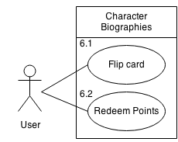

**Use case ID: 6.1**

Use case name: Flip card

Summary of use case:

The user flip the character card to either show the full bio or the full character

Actors: User

Preconditions:

The user is in the character biographies page.

Successful scenario:

If the card is showing the full bio, then the card will flip to show the full character.

If the card is showing the full character, then the card will flip to show the full bio.

Alternative scenario:

The program freezes and the application closes.

The function is not found and the program does nothing.

The touch is not recognized and nothing happens.

Post conditions:

The card is now flipped to show an opposite side.

**Use case ID: 6.2**

Use case name: redeem points

Summary of use case:

The user can redeem points to unlock characters.

Actors: User

Preconditions:

The user is in the character biographies page

Successful scenario:

The user redeems his points to unlock the next character.

Alternative scenario:

The user does not have enough credits, in which the program notifies the user.

The function is not found and the program goes back to the game main menu.

The touch is not recognized and nothing happens.

Post conditions:

The user has either redeemed his points or has been notified that he has not earned enough credits.

**Class Diagrams**

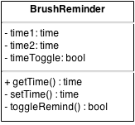 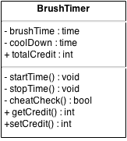

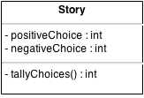 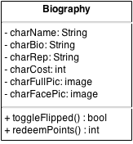

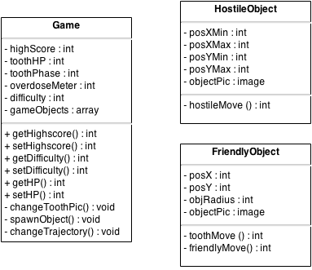

**Sequence Diagrams**