**Requirements**

**A. Plain English description**

We were contacted by Mr. Alfred Martinez to create an app for his concept The Battle for Dental Perfection. His goal is to provide a created universe where the characters he created uphold good dental practices, morals, and general wellbeing. He started with a loose concept in mind for the app that was only his characters with a biography. After collaborating, we have settled on a more robust app for Android initially to use his concepts.

This app will include a multitude of functions. The first one being a brushing reminder that will notify the user to go brush their teeth based on pop up notifications that occur at user-specified times. Next, there will be a character biography screen that will display his created characters while supplying their name, biography, and dental issue/aid that they represent. Also, a timer with an animation will be included to aid the user by providing a visual cue as to how to brush properly and a clock to ensure they brush for the recommended amount of time. Additionally, a short story outlining the main characters and non-centric characters dealing with real life issues and dental problems. Finally, a game will be included that takes inspiration from Flappy Birds while adding additional difficulty and inserts dental related art and themes. In between each section there will be a false loading screen that will display factoids about dental care and hygiene. All these sections will be accessible through a main hub screen.

The hub screen will consist of the Battle for Dental Perfection logo, the five buttons to lead to the 5 different sections, and an options menu to change between English and Spanish text for the app.

The brushing reminder section will include two windows. The first window displays the two currently selected times. Next to each time, there will be a change button that will take the user to a time changer so they can modify the alarm to fit their schedule.

The character biographies screen will act as if each character is a card. The unflipped side shows the character in full with their name at the bottom. On tapping the card, it will flip and show a more detailed description of the character. These details include their full title and name, biography, and what they represent within the universe. A few cards will be accessible initially, the rest are earned by using the brushing timer over a long period of time. This is to ensure people keep coming back to the app.

The brushing animation and timer will consist of a background picture of teeth that start yellowed but become whiter as the two minute timer counts down on the user’s activation. While the timer runs, a brush will be performing circular motions along the teeth to reinforce the proper way to brush. On completion, the user is given a “credit”. On reaching a certain number of credits, the user can use these to unlock a character biography card. This acts as an incentive to keep using the app. This animation can be played as many times as a user wishes, but credit will only be given twice a day. This is to prevent cheating of the system to unlock content without doing the activity.

The short story will involve characters within the universe, both the heroes and villains and normal civilians. The story will be told through panels that the user interacts with. Each panel will have a good and bad choice to be made. These choices will involve both dental related issues but also moral issues. At the end of the story, a tally will be made of the ratio between good and bad choices. Depending on the outcome, an end screen will summarize the user’s performance.

The game will mimic Flappy Birds in that it is simple but challenging; easy to learn but hard to master. We chose to imitate this game since it became wildly popular to people of all age groups. Mr. Martinez wishes his app to be used by as many people as possible, so having a game of this nature will draw people in. The base Flappy Birds game had a bird that traveled in a descending arc at all times. On tapping the bird, it shot upwards in an arc slightly then resumed dropping. By timing these taps, the user had to navigate a set of randomly generated obstacles. We are modifying this concept by adding difficulty levels and new art assets. When navigating to the game from the hub, a main menu will be shown. This screen will show the user’s high score, the difficulty setting, and a button to start the game. Instead of a bird, the player will control a tooth that starts out pristine. The user will also have an amount of errors they can make before the game ends (“hit points: HP”). As the tooth loses HP from hitting obstacles (junk foods) it will begin to decay. The user can restore HP by causing the tooth to run into dental related icons placed randomly in the game or “good” food up to a point. Good food will restore 1 HP after X amount are gathered, but going over this will cause HP loss due to natural sugars, acid, etc.. The game will scroll left to right at a steady pace. The difficulty settings will alter the amount of HP the user starts with. As the level progresses, the obstacles come more swiftly. The goal is to make a high score.

**B. Functional vs. Non-Functional**

**Functional**

From the main menu, the user will be taken to one of the five main sections within the app. From here, each section will provide some kind of aid, stimulation, or education on proper dental care. The timer section will use notifications to alert the user of brushing times, as well as let the user change these times. The story section will take the user though a story by using button taps to progress the story. The brushing animation will provide a set time for the user to follow as well as provide a visual on how to brush properly. The biography section will give details on the characters and provide some animations. Finally, the game will provide a reason to keep opening the app through its challenge and easy play style.

**Non-Functional**

Majority of the app is focused on UI elements and manipulation, so we will ensure that performance does not drop across the app. Most of this app is aimed at children and their parents to reinforce brushing habits at a young age, though anyone is free to use all parts of the app. The game is meant to keep people coming back to the app even if they don’t need to brush at the moment. Even if the game is the only section opened by the user, they will still receive dental health information through the loading screens we will put in.

**C. Structured**

1. The mobile application should allow the user to set the time of the two brushing reminders
   1. The reminders can be set at any time from 12a.m. to 11:59 p.m.
   2. Each reminder will make a notification pop up on the phone
   3. Once the notification is checked, the app should direct to the brushing timer
2. The mobile application should allow the user to access the brushing timer
   1. The timer will begin at 2 minutes and count down
      1. The user will press the start button and the timer will start
   2. The timer will display a set of teeth that will start yellow and become progressively white
   3. The timer will lock the start button after each use for 8 hours
3. The mobile application should allow the user to change the language of the app from English to Spanish and from Spanish to English
4. The mobile application should allow the user to open the character bios
   1. The character bios will be split into their own sections
      1. Each section will be intractable and will flip over to show the full character bio
5. The mobile application should allow the user to open the flappy game
   1. The game will have 3 difficulty settings
      1. User can select easy, medium, or, hard
   2. After the user presses start, they will need to tap the screen to begin
      1. Each tap thereafter will keep the player afloat
   3. The user must avoid all junk food objects
      1. If the user touches a junk food object they will lose health
         1. Easy mode will reduce 10-20% health
         2. Medium mode will reduce 30-40% health
         3. Hard mode will reduce 50% health]
   4. The user can try to grab power-ups
      1. If the user grabs certain power-ups they will regain health
         1. Easy mode
            1. Toothbrush
            2. Mouthwash
            3. Floss
         2. Medium mode
            1. Toothbrush
            2. Mouthwash
            3. Floss
         3. Hard Mode
            1. Toothbrush
            2. Mouthwash
            3. Floss
   5. The user can grab good foods, but only so many before they become a hindrance
   6. The object is to get a high score
   7. The user will be able to write their initials as high scores
6. The mobile application should allow the user open the Karma game
   1. Once started the user can select two choices for each slide
      1. One choice will give the player good karma
      2. The other choice will give the player bad Karma
   2. Once the game is over there will be an ending
      1. More good Karma will play the good ending.
      2. More bad Karma will play the bad ending.

**D. Diagrams**

**Flowchart**

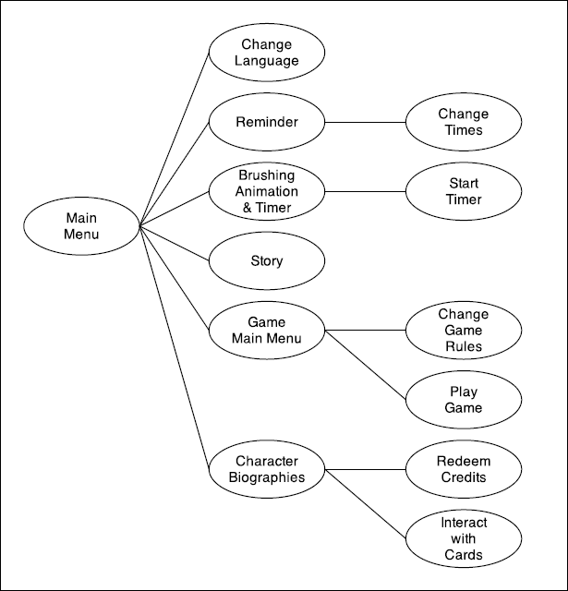

**Notes on visualization**