**THE STATE UNIVERSITY OF ZANZIBAR**

**(SUZA)**



**DEPARTMENT OF COMPUTER SCIENCE AND INFORMATION TECHNOLOGY**

**COURSE NAME: WEB TECHNOLOGY**

**COURSE CODE: INF 2215**

2019 / 2020

**TITLE:** LIBRARY MANAGEMENT SYSTEM

**STATEMENT OF PROBLEM**

Library Management System is system that allow user to borrow a book in manually way, so it taking a lot of time for transaction like borrowing a book or return a book and also for searching of members and books,. Another difficult is that to know how many books have been borrowed and how many are available. Currently it takes a day to verify all records.

**PROPOSED SOLUTION**

The proposed system will be an automated LIBRARY MANAGEMENT SYSTEM **(LMS)**. In this Application user will be able add members, add Books, Search member, search Books, update information , edit information , borrow and return a book in short period of time.

**Benefits of Solution include:**

* User Friend UI
* Less Error
* Search Capability
* Quick Process

**PROJECT SCOPE**

This project will operate within SUZA Campus

**OJECTIVES**

**Main Objectives**

The Main objective of this project is create Library Management system that will help Managing and controlling of Books in library.

**Specific Objectives**

1. Establish system that will help analyze all books
2. Understand which book are borrowed and which are return
3. Determine quantity of books in easy.
4. Calculate fine for late return
5. Enable students book and return books

**RESOURCE REQUIREMENT**

**Hardware & Software**

* Computer
* Internet Connection
* Software
* Xampp (PHP&MySQL)
* Atom/Notepad++

**PROJECT PROTOTYPE**

Dashboad.html

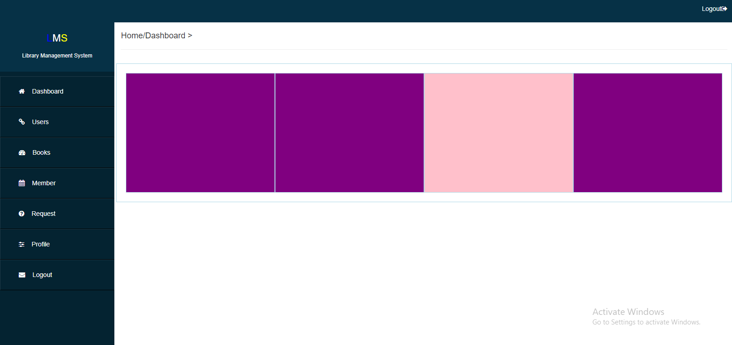

Index.html/login

