Arduino Potentiometer Reader

Purpose: This is a simple project tasked to read the input of a potentiometer and print the output to the serial monitor

Components: Arduino Uno, Wiring, 0-10KΩ Potentiometer

Image:
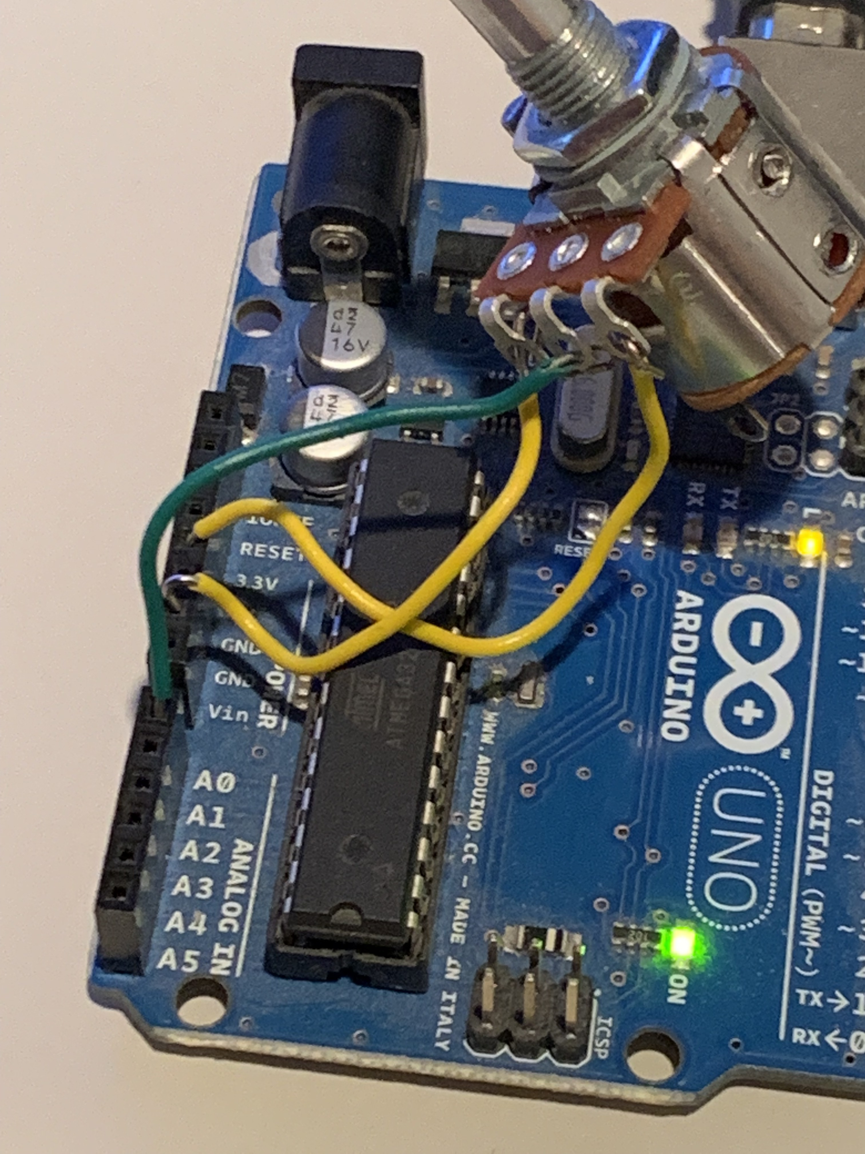

Code: The code for this project can be found here and also the schematic idea was taken from the following link: https://www.arduino.cc/en/Tutorial/AnalogReadSerial

