Answer the questions below with respect to the following ERD of a simple real estate company.

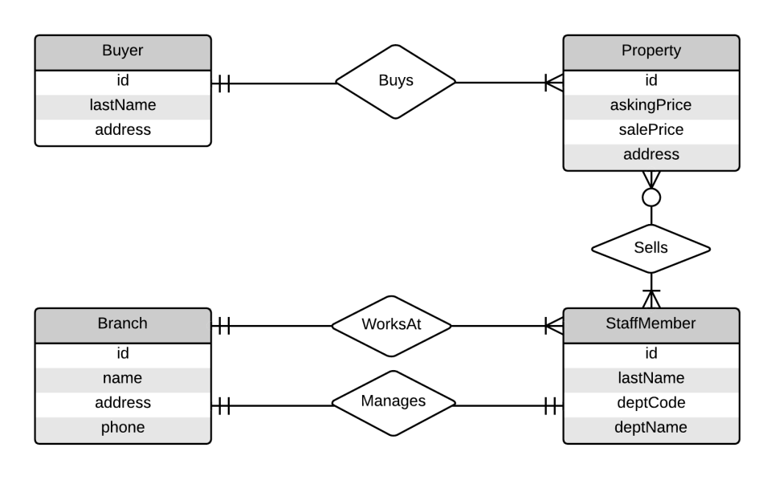

1. Write sentences (in English) to describe the all of relationships of a **Staff Member** in the diagram, including relevant cardinality.

There is always one (and possibly many) StaffMembers who always WorksAt (exclusively one) Branch.

There is always one (and exclusively one) StaffMember who always Manages (exclusively one) Branch.

There is always one (and possibly many) StaffMembers who may Sell one (and possibly many) Properties.

1. Write sentences to describe the all of relationships of a **Property** in the diagram, including relevant cardinality.

One (and possibly many) Properties may be sold by at least one StaffMember

At least one (and possibly many) Properties are always bought by (exclusively one) Buyer.

1. Can the total of all **Property** sales for an individual **Staff Member** be calculated? If so, how? If not, why not?

No, because the selling of Property may be done by multiple Staff Members for any one property.

1. Can a **Branch** have no more than one **Staff Member**s in it? Why or why not?

Yes, while only one Staff Member can Manage a Branch, at least one other Member is required to WorkAt the Branch. It is impossible to have the Branch with less than 2 Staff Members (one who Manages, and one who WorksAt)

1. Can a **Buyer** buy several **Properties**? Why or why not?

Yes, exclusively one Buyer is allowed to Buy at least one Property.

1. In *directly* converting the ERD to a set of relations, one of the converted entities would ***not*** result in a 3NF relation. Which entity is this? What would you have to do to make it 3NF?

StaffMember: deptCode and deptName should be separated into another Entity, Department, for which any StaffMember WorksAt, and any Branch Owns.