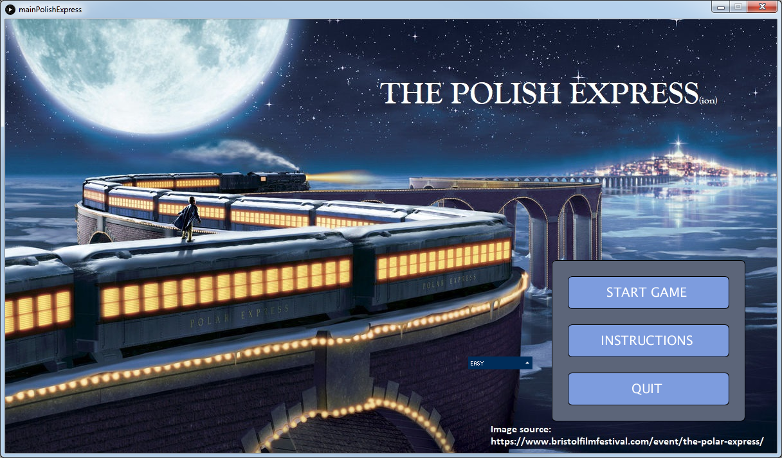

**ENEL 683 Design Project**

**“The Polish Expression(ion)”**

Jason Long

00966925

December 9, 2019

Overview

The purpose of this game is to practice and improve floor planning using translation from a Polish Expression (PE) to clustered floorplan. Players are given a PE and a stack of labelled blocks. These both appear on the train icon. The train moves along the track toward a hole where a bridge must be built. The user clicks and drags blocks into the bridge grid template in the middle of the screen (it was too difficult to try and hit the moving target) per the PE and must complete all placement correctly before the train arrives at the bridge. There are 5 bridges per level. Each level is increasingly difficult in speed and/or size of the bridges to solve.

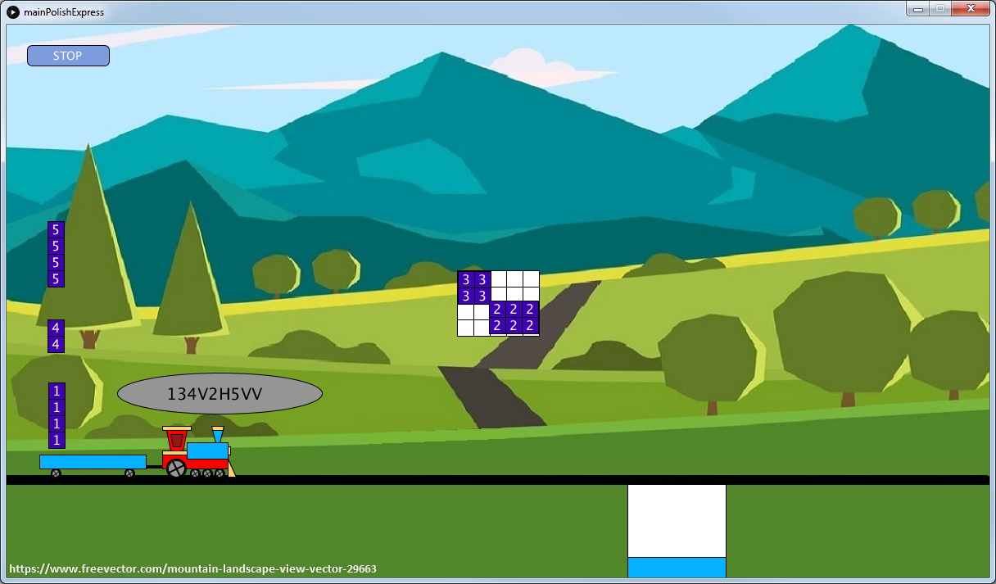

With an infinite amount of time and an infinite number of monkeys typing code, I envision this game to evolve into a complete training tool covering all aspects of ENEL 683. Similar to the old-school style of Super Mario Brothers, the player would be presented with a map with areas (train stations?) representing a different part of the course. Activities/games would be created within the train theme to teach and exercise each element of the course as the train progressed through the map toward some final destination where everything comes together and out pops integrated circuits. A fab could actually be the destination station and the train could bring all the supplies it gained on the trip to make the ICs.

The complete game map would include a stop at each of the activities and players would work their way to the final destination. The ultimate goal is that the player would experience a complete design process where each achievement would link together to become a final design. After each station, a car could be added to the train to represent the chunk of the design that was complete. All the different activities would be mini games in themselves. The Polish Express(ion) in its current form would become just one piece (the floor planning piece, obviously) of the overall mission. If all stations had quality games, with algorithms to generate infinite, scalable activities, and with everything linked together, this could be a solid tool used in the course or related courses.

With a bit of experience and a lot more time, more focus could be put on the algorithm portion of this project compared to very onerous task of making graphics work. By providing the game engine (pun intended), a lot of the overhead is removed and future work can focus on algorithms. For this version in particular, I would like to create algorithms to automatically generate floor plan references and the associated PE. In the work that I did complete in designing and implementing the classes, I started to see some of the relationship that are present in floorplans and PEs. With more experience here, I would be able to advance to higher level knowledge in the algorithm development and application.

Design Reflection

Creating a reasonable quality game is a huge challenge, which I found is highly limiting to this design project. I had a grand vision for what I wanted the game to be, but the amount of effort to get there was disproportional to the value for this course which was rather frustrating. Without a lot of artistic strength, trying to make graphics is painfully slow. I was able to reference some existing graphics for static images but had to draw the dynamic elements on my own (and they’re not exactly impressive). Hours were burned doing simple things like making wheels turn.

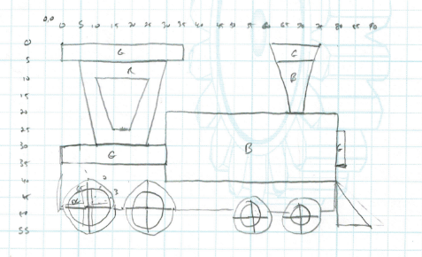

**Reflection Question 1**

The focus of the game is to practice floor planning by traversing a Polish Expression. Working with the PE and associated data structures and algorithms provided a lot of practice and insight into the relationships involved. I think there is much more that could be done beyond what I implemented but given the overhead of the game programming and only basic knowledge in the course content, this was what I could do.

**Reflection Question 2**

As with all designs I do, mapping out the design flow and storyboarding the development is a regular (and essential) practice. The high-level view of the game screens translated easily into states that could be individually coded and tested. I also plan out data structures and object interaction which are essential to understand before writing code. The final design matched my initial planning exactly. The implementation of the slicing tree was limited by what Processing / Java / me could accomplish. I designed it as linked list but ended up implementing it as a series of arrays. This allowed me to more easily use the debugger to verify operation and was an easier way to generate the seed data for the game.

**Reflection Question 3**

Finding time to work on a project that is not aligned with my research focus combined with an absolutely hectic schedule this term was indeed a challenge. I put in about 40 hours to the project overall in small bursts when I could.

**Reflection Question 4**

I don’t find peer feedback on a project like this very useful. If this was a game design course with more opportunity and time to produce a quality product, I think feedback would be useful. At all feedback points, I already new what I still had to do. I’m not used to presenting “customers” with work that is in progress – I avoid this in real-life engineering, so forcing it in class was contradictory to my ingrained process. It was nice to see that people appreciated the idea. Perhaps it would have been better overall if my schedule had allowed me to be present for the first feedback session on the concept, and to be further ahead in development at the demonstration points. That being said, the other projects that I tried during the demonstration all seemed to suffer the same level of incompleteness and obvious deficiencies that mine had, so it did seem like anyone was really ready for feedback.

In the end, I was happy with the amount of effort I put in and I think the quality of the project is high given all of the constraints. Of course a lot more could have been accomplished had I worked with a partner or small group, but I find this detracts from the value of school projects where I’m hoping to maximize my learning. In this case, I don’t think I would have missed anything by working with someone, but I didn’t realize that before I was well in. Working with other students is also very difficult with my schedule this term.

**Reflection Question 5**

The requirement of a graphics-based game is a nice idea, but the amount of overhead coding that is necessary and totally unrelated to the course topic was extremely prohibitive. So many times during the project I wondered why in the world I was spending my time doing what I was doing. Even right now I should be studying for the final exam but am instead thinking about why my blocks are not clicking and dragging as well as I would like.

I would have liked to code all of the algorithms that we reviewed in class and focused on improving them or finding ways to automatically generate data to feed them. I would have liked to cross the bridge (pun intended again) from the basic hand-solvable problems that we worked on in class, to solving much larger problems to see what designers actually face in real-world application.

One possibility would be to start with an existing game engine or library that could be built on instead of writing from scratch. Some seed ideas would be helpful since it is very difficult to come up with a solid idea about a topic on which you have very little knowledge. I noticed that almost all of the games developed in the class were very trivial and debatably useful, which suggests some more guidance would be helpful.

I would also like to see the whole project at the beginning of the course to know what was coming up (Phase 1 and Phase 2). Splitting it up into smaller labs would have been helpful.

Survey questions

Strongly Disagree (1), Disagree (2), Neutral (3), Agree (4), Strongly Agree (5)

Using a visual-based language made programming more engaging for me: 1

The project management planning helped keep me on track with the project: 3

The project flexibility encouraged my creativity: 1

The project flexibility encouraged my entrepreneurial thinking: 1

The project flexibility increased my stress level: 5

The alpha testing helped with the design process: 2

The project expectations were clear: 4

The project assessment was clear: 4