CS50x

Lecture 0 – Scratch
- How binary numbers are represented.
- 8 bits = 1 byte.
- ASCII and Unicode give the binary representations of characters and numbers.
- Pseudocode is an informal way of programming description that does not require any strict programming language syntax or underlying technology considerations. It is used for creating an outline or a rough draft of a program. Pseudocode summarizes a program's flow but excludes underlying details.
- Functions, arguments. Return values.
- Conditionals, If/Else.
- Booleans, True/False.
- Loops
Project Requirements
- Your project must use at least two sprites, at least one of which must not be a cat.
- Your project must have at least three scripts total (i.e., not necessarily three per sprite).
- Your project must use at least one conditional, at least one loop, and at least one variable.
- Your project must use at least one custom block that you have made yourself (via Make a Block), which must take at least one input.
Lecture 1 – C
- See labs and assignments.
- Remember to change directories if not finding the file you’re trying to run.
Lecture 2 – Arrays
- Debugging, use debug50 with program name to start debugger.
- In C variables only exist inside the last set of curly braces. For example, in loops or functions, the variable should be declared at the top of the loop, not inside the loop braces.
- Ensure data types are correct, for int and float. If printing a float at least one number must be assigned as a float.
- Arrays, declaring arrays Eg. int scores = [3]; Gives an array of size 3, scores[0] = … etc.
Can loop through and get the elements as user inputs using for loop.
- Strings,
Lecture 3 – Algorithms
- Data structures can be used to create your own data type.
- For sorting data. Selection sort, Bubble sort. About the same in time to solve.
- Recursion,
- Merge sort, more efficient than selection and bubble sort.

sort1 uses: Bubble sort
random5000 = 0.114s
random10000 = 0.324s
random50000 = 7.810s
reversed5000 = 0.076s
reversed10000 = 0.264s
reversed50000 = 6.911s
sorted5000 = 0.023s
sorted10000 = 0.076s
sorted50000 = 1.479s
How do you know? This algorithm worked fastest through the sorted arrays.

sort2 uses: Merge sort
random5000 = 0.047s
random10000 = 0.046s
random50000 = 1.578s
reversed5000 = 0.52s
reversed10000 = 0.059s
reversed50000 = 1.467s
sorted5000 = 0.043s
sorted10000 = 0.041s
sorted50000 = 1.152s
How do you know? This algorithm was fastest through the random number arrays.

sort3 uses: Selection sort
random5000 = 0.052s
random10000 = 0.182s
random50000 = 4.063s
reversed5000 = 0.067s
reversed10000 = 0.144s
reversed50000 = 3.607s
sorted5000 = 0.064s
sorted10000 = 0.159s
sorted50000 = 4.230s
How do you know? Similar time taken for different file sizes of different types.

Runoff
- Representing candidates, who has been eliminated. Struct with these fields.
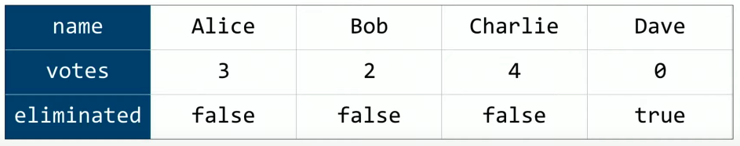

Lecture 3 – Memory
- Hexadecimals,

