**MEASURE ENERGY CONSUMPTION**

Phase : 2

**INNOVATIVE TECHNIQUES:**

* Ensemble methods and deep learning architectures are powerful techniques that can significantly enhance the accuracy and robustness of prediction systems.

1. **Ensemble Methods**:
   * **Random Forest**:
     + **Explanation**: Random Forest is an ensemble learning method that combines multiple decision trees to make predictions. It's particularly effective at handling complex interactions between features.
     + **Application**: In the context of energy consumption prediction, Random Forest can be used to model the relationships between various factors (e.g., temperature, time of day) and energy usage.
   * **Gradient Boosting (e.g., XGBoost, LightGBM)**:
     + **Explanation**: Gradient boosting algorithms sequentially train weak learners (usually decision trees) to correct the errors of the previous models. This leads to a highly accurate and robust predictive model.
     + **Application**: XGBoost and LightGBM are popular choices due to their speed and effectiveness in handling large datasets with complex features.
   * **Voting Classifiers/Regresors**:
     + **Explanation**: Voting methods combine the predictions from multiple models to produce a final prediction. This can lead to better generalization and accuracy.
     + **Application**: For energy consumption prediction, different models (e.g., Random Forest, Support Vector Machines, Neural Networks) can be combined using techniques like hard/soft voting to improve prediction accuracy.

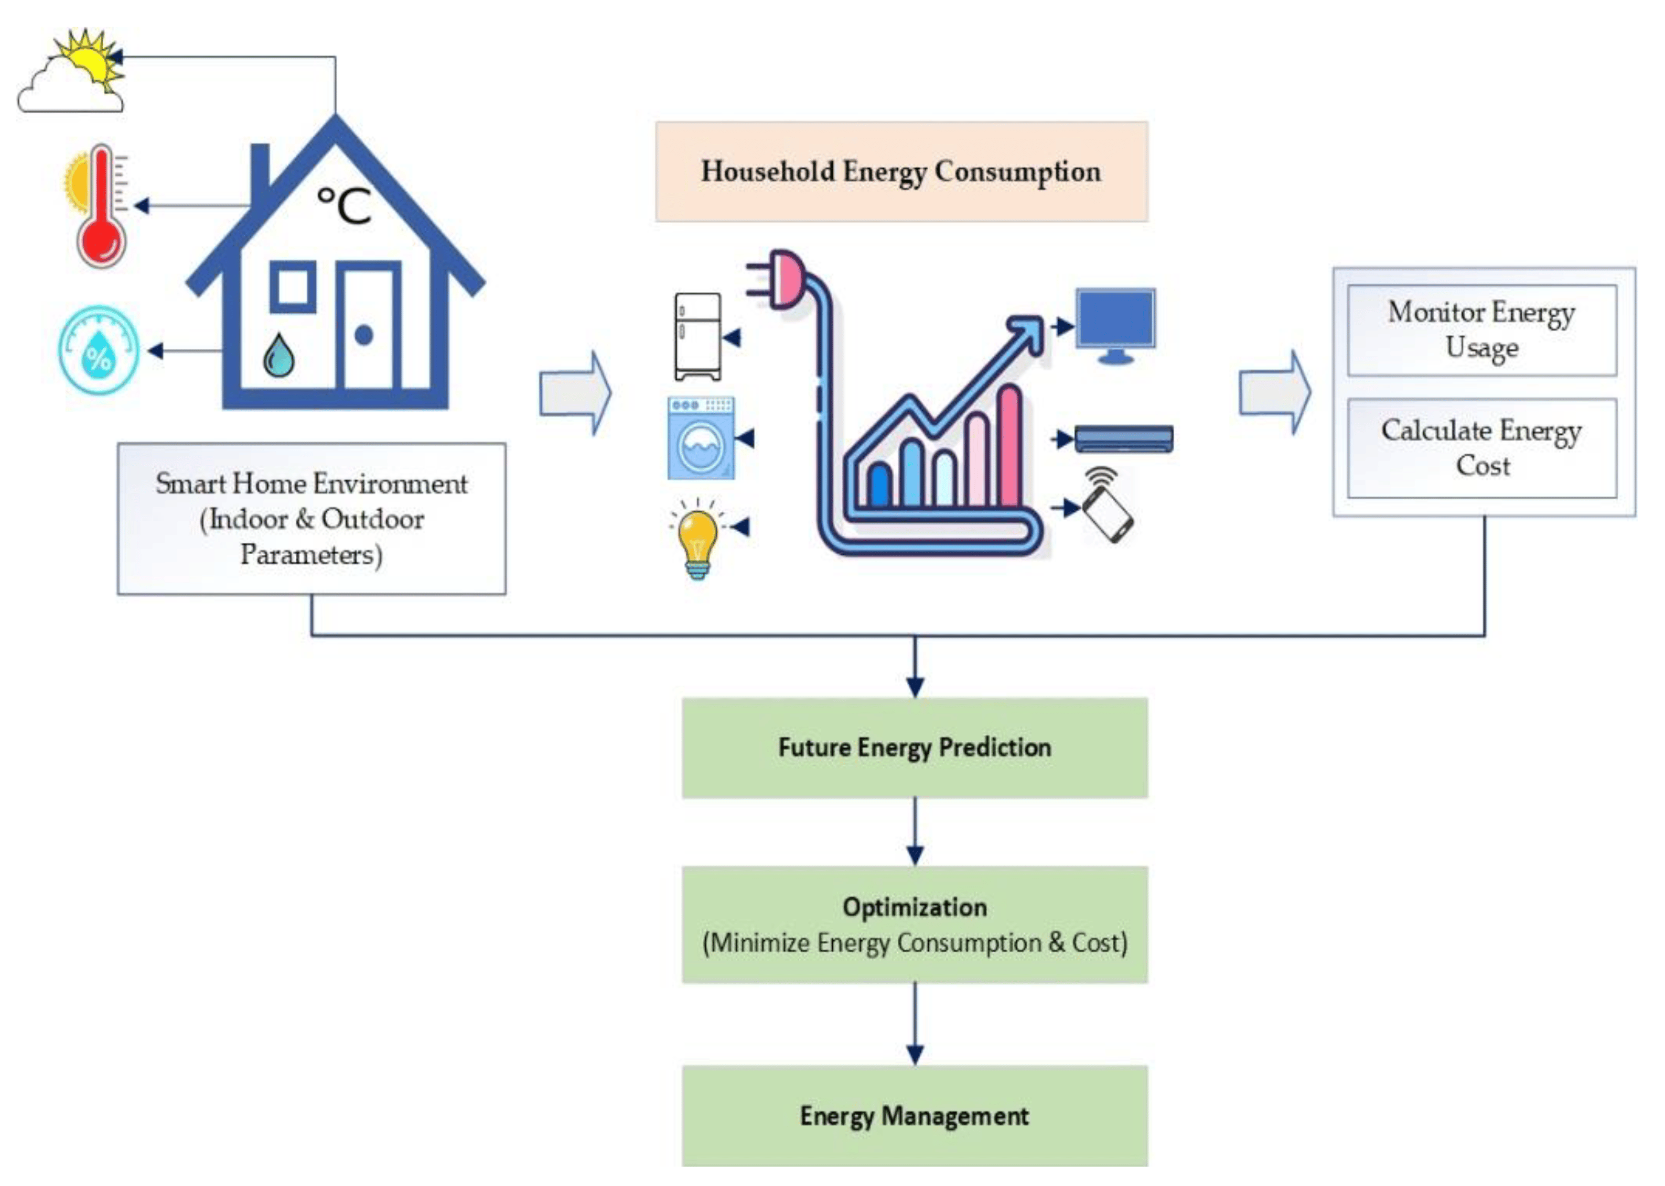

1. **Deep Learning Architectures**:
   * **Convolutional Neural Networks (CNNs)**:
     + **Explanation**: While commonly used in image processing, CNNs can be adapted for time series data by treating the time steps as channels. This can be useful for extracting relevant patterns in the data.
     + **Application**: In the context of energy consumption, CNNs can be applied to analyze temporal patterns and dependencies.
   * **Recurrent Neural Networks (RNNs)**:
     + **Explanation**: RNNs are designed to handle sequential data and are well-suited for time series analysis. They can capture long-term dependencies in the data.
     + **Application**: RNNs can be used to model energy consumption patterns over time, considering factors like seasonality, trends, and other time-dependent features.
   * **Long Short-Term Memory Networks (LSTMs)**:
     + **Explanation**: LSTMs are a specialized type of RNN that are capable of capturing long-range dependencies. They are particularly effective in time series forecasting tasks.
     + **Application**: LSTMs can be used to model complex relationships in energy consumption data, especially when there are non-linear and dynamic patterns.
   * **Transformer Models**:
     + **Explanation**: Originally designed for natural language processing tasks, transformers have shown promise in handling sequential data. They excel at capturing global dependencies and patterns.
     + **Application**: Transformers can be adapted for energy consumption prediction by considering the time series data as a sequence of events.

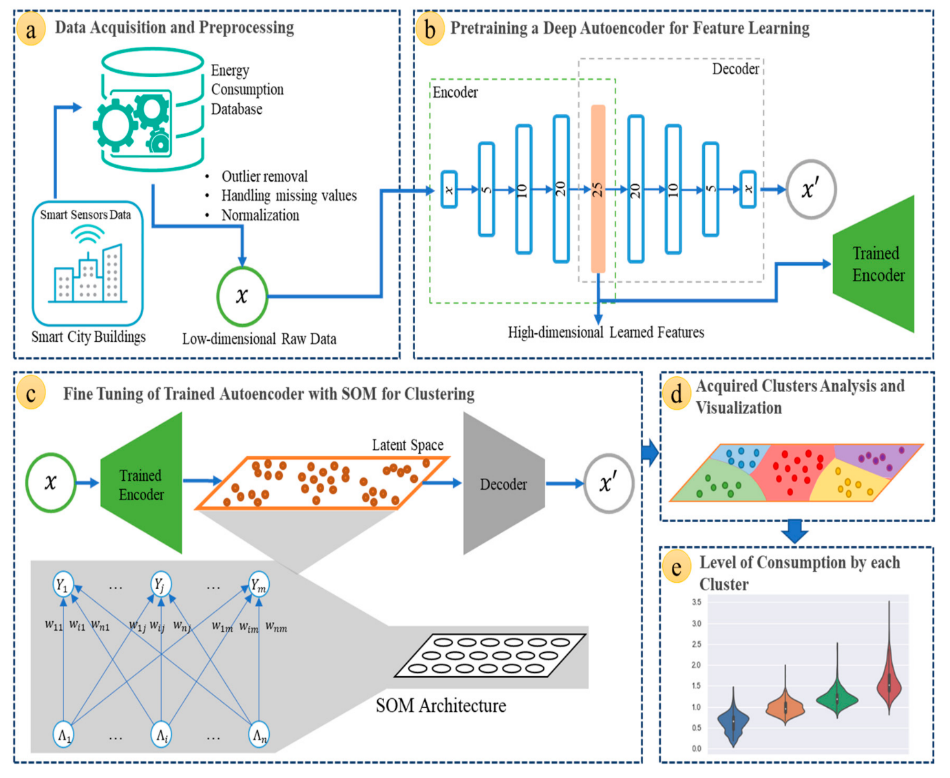

**TIME SERIES ANALYSIS:**

* Predicting future energy consumption patterns is crucial for efficient resource allocation and sustainable energy management. Innovative techniques like time series analysis and machine learning models have been instrumental in improving the accuracy of such predictions.
* **Time Series Analysis**:
  + **ARIMA (AutoRegressive Integrated Moving Average)**: ARIMA is a widely used time series forecasting method that models the relationship between past observations and future values. It's especially effective for stationary time series data.
  + **Exponential Smoothing Methods**: Techniques like Holt-Winters' method and exponential smoothing models are useful for capturing trend and seasonality in time series data.
  + **Seasonal Decomposition of Time Series (STL)**: STL decomposes a time series into seasonal, trend, and residual components, making it easier to model and forecast each component separately.
  + **Prophet**: Developed by Facebook, Prophet is an open-source forecasting tool designed to handle time series data with strong seasonal patterns.
  + **Long Short-Term Memory (LSTM)**: Although primarily used in deep learning, LSTM networks can be applied to time series data to capture complex temporal dependencies.

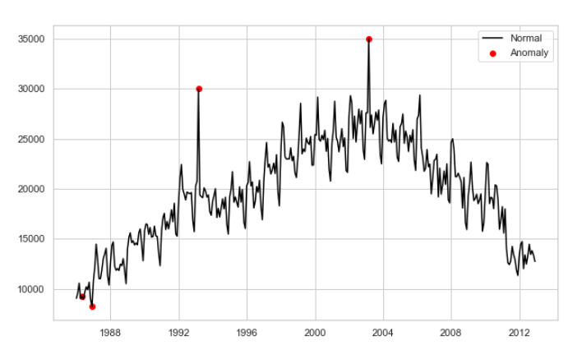

**Machine Learning Models**:

* + **Regression Models**: Linear regression, polynomial regression, and support vector regression can be used to model energy consumption as a function of various parameters like temperature, time of day, day of the week, etc.
  + **Random Forest and Gradient Boosting**: These ensemble learning methods are effective for handling complex interactions between different features affecting energy consumption.
  + **Neural Networks**: Multi-layer perceptrons (MLPs) can be used for regression tasks to capture non-linear relationships in the data.
  + **XGBoost and LightGBM**: These gradient boosting algorithms are known for their speed and accuracy in handling large datasets and complex features.
  + **Recurrent Neural Networks (RNNs)**: Similar to LSTM, RNNs can be used for time series data and can capture sequential dependencies.

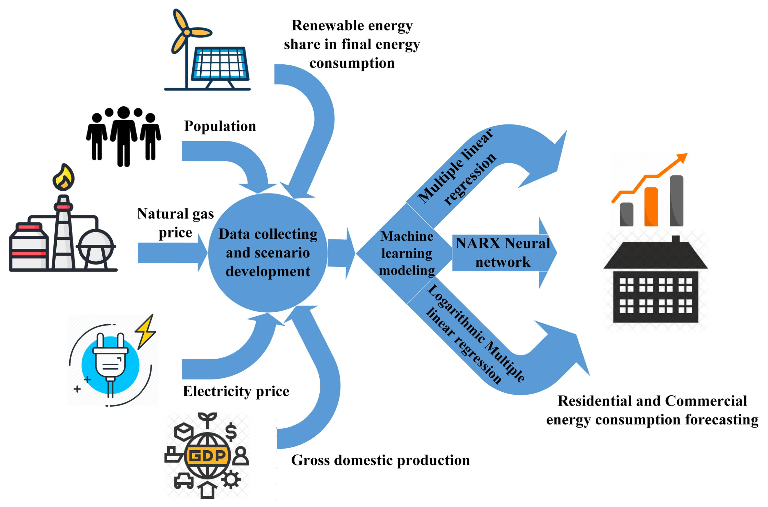

* **Feature Engineering**:
  + Incorporate weather data (temperature, humidity, etc.), time of day, day of the week, holidays, and special events as features. These factors often have a significant impact on energy consumption.
* **Data Preprocessing**:
  + Handle missing values, outliers, and perform data normalization or standardization to prepare the data for modeling.

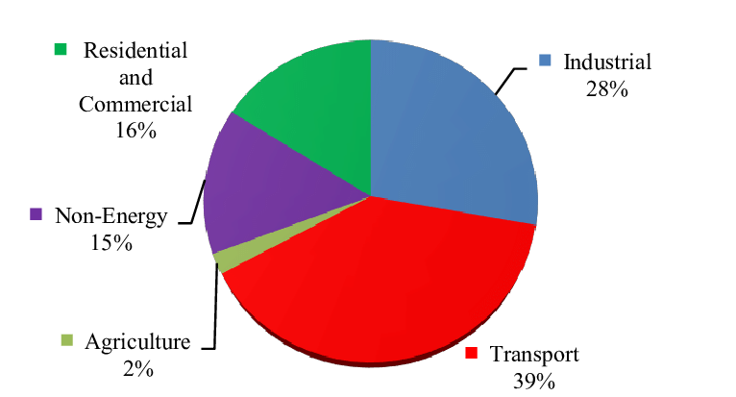

* **Cross-Validation**:
  + Use techniques like k-fold cross-validation to assess the performance of the models and avoid overfitting.
* **Hyperparameter Tuning**:
  + Optimize the parameters of the chosen models to improve their predictive power.
* **Model Evaluation**:
  + Utilize metrics such as Mean Absolute Error (MAE), Mean Absolute Percentage Error (MAPE), Root Mean Square Error (RMSE), etc., to evaluate the performance of the models.

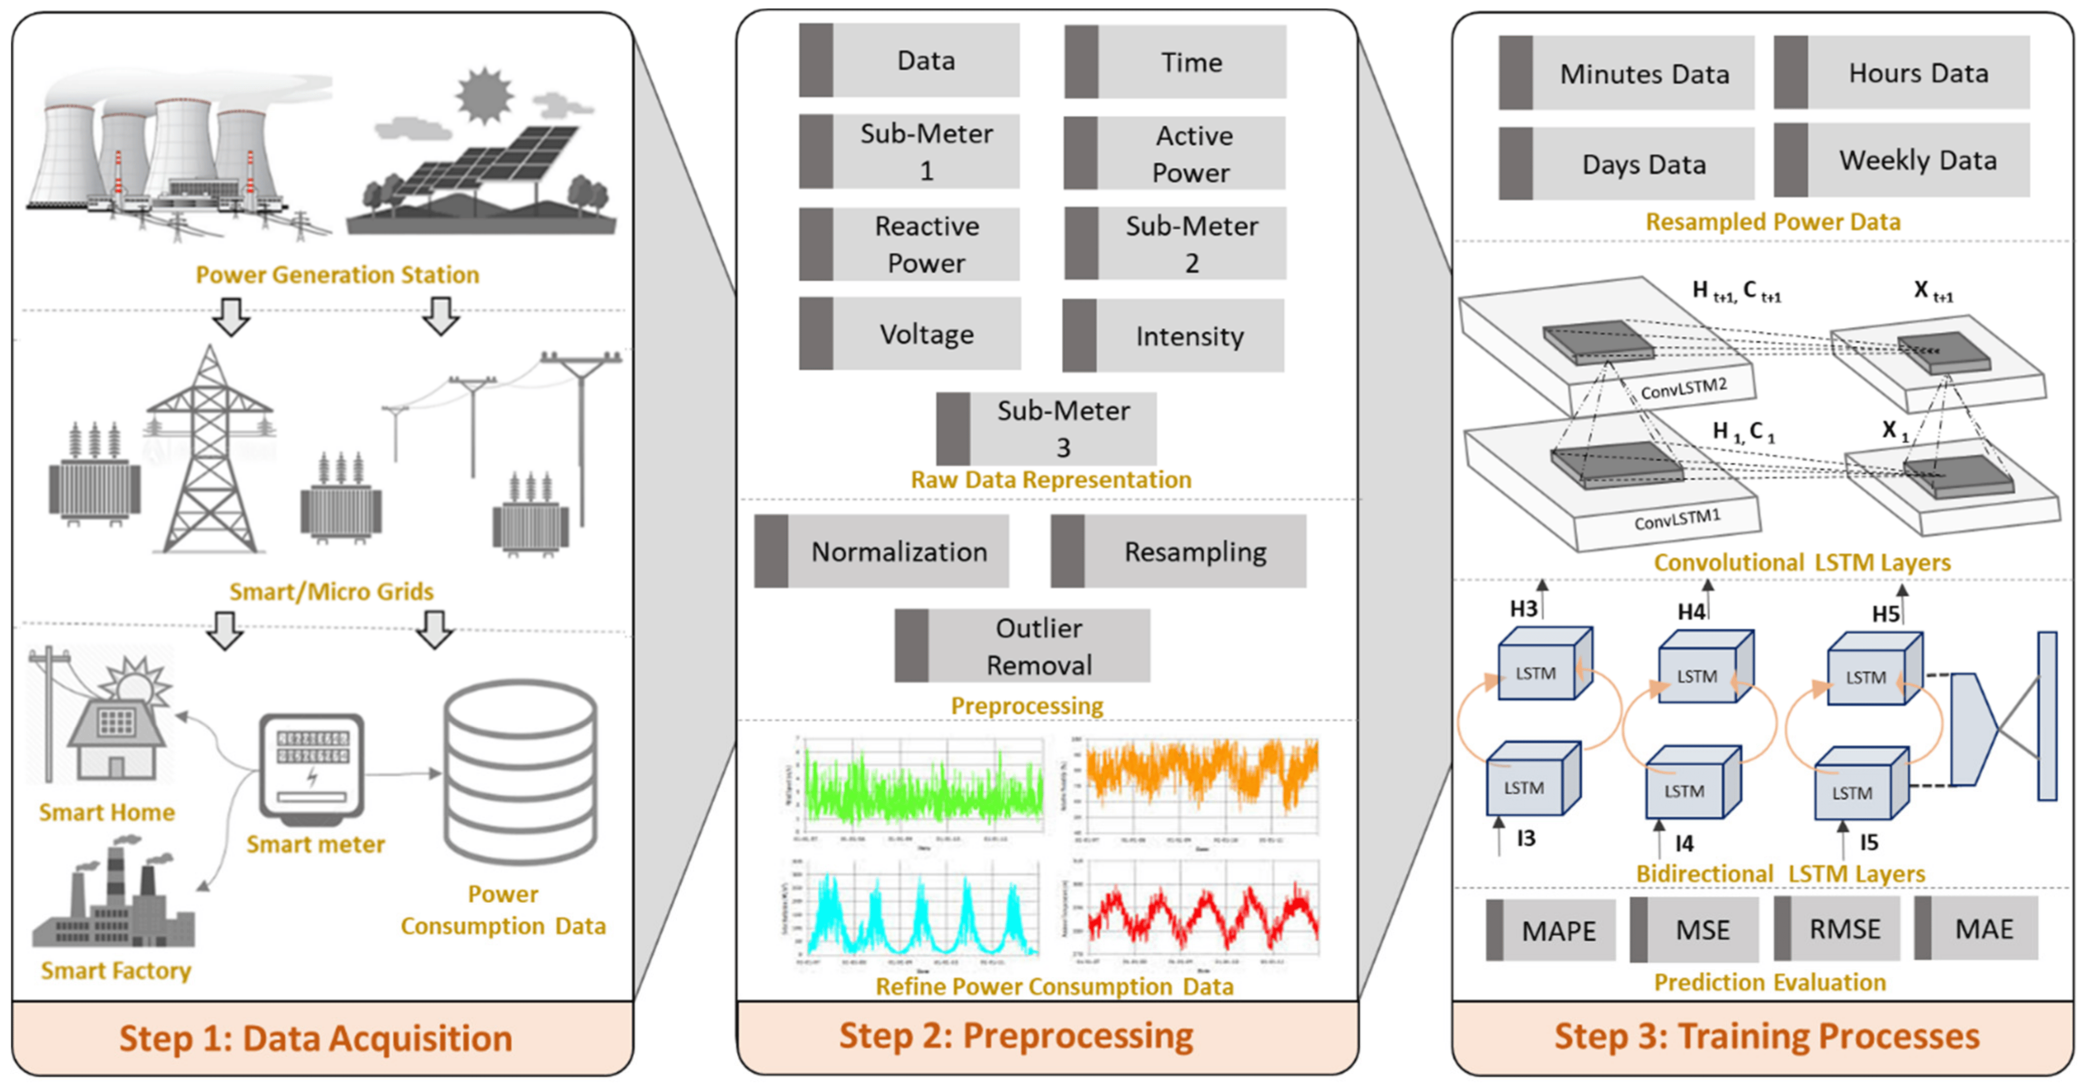

* **Continuous Monitoring and Updating**:
  + As new data becomes available, retrain the models to ensure they stay accurate over time.

**CONCLUSION:**

* These techniques, when applied judiciously and with proper tuning, can significantly improve the accuracy and robustness of energy consumption prediction systems. It's important to note that the choice of technique should be based on the specific characteristics of the data and the problem at hand. Additionally, ensembling methods and deep learning architectures can also be combined to further enhance prediction performance.

Top of Form