**Measure Energy consumption**

**Project Definition:**

The project is to develop and implement an automated approach to collect, analyse, and visualize energy consumption data for better decision-making.

**Problem Statement:**

The measurement of energy consumption is critical in understanding and optimizing energy usage in various sectors, including manufacturing sites, homes, commercial buildings, and transportation. However, the manual collection and analysis of energy consumption data can be time-consuming and error-prone. Therefore, there is a need for an automated approach to collect, analyse and visualize energy consumption data for better decision-making.

**Design Thinking:**

* Data Source: Identify an available dataset containing energy consumption measurements.
* Data Preprocessing: Clean, transform, and prepare the dataset for analysis.
* Feature Extraction: Extract relevant features and metrics from the energy consumption data.

**Phases of the development:**

Phase 1: Problem Definition and Design Thinking

Phase 2: Innovation

Explore innovative techniques such as time series analysis and machine learning models to predict future energy consumption patterns.

Phase 3: Development Part 1

Initiate the development process by selecting a suitable dataset and preparing it for analysis.

Phase 4: Development Part 2

Continue the development by analysing the energy consumption data and creating visualizations.

Phase 5: Project Documentation & Submission

**Dataset used:**

[**https://www.kaggle.com/datasets/robikscube/hourly-energy-consumption**](https://www.kaggle.com/datasets/robikscube/hourly-energy-consumption)

**In this we are using DAYTON_hourly dataset for our project.**

**Data Preprocessing:**

* Importing necessary libraries.
* Import the dataset (DAYTON_hourly).

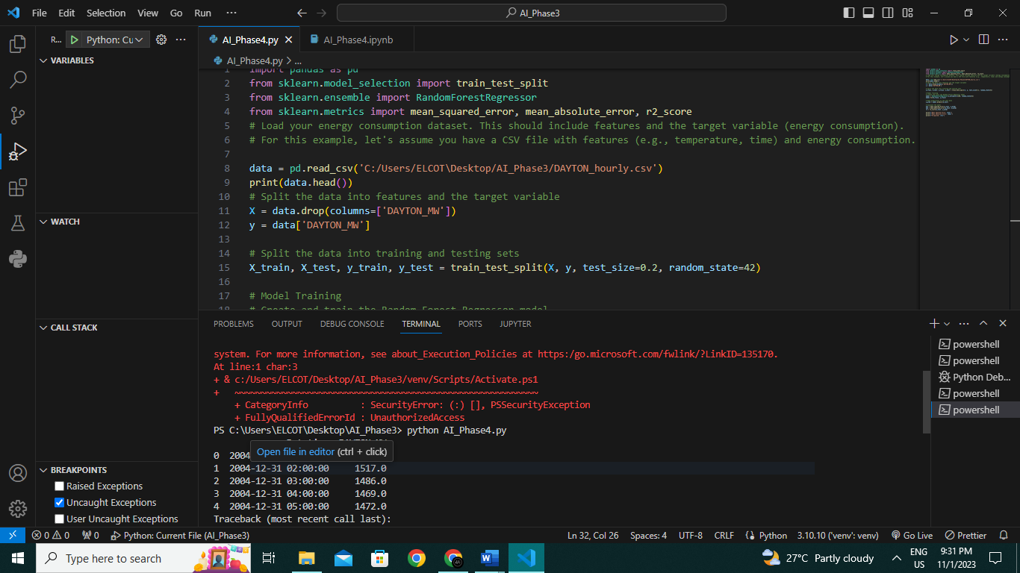

**Feature extraction:**

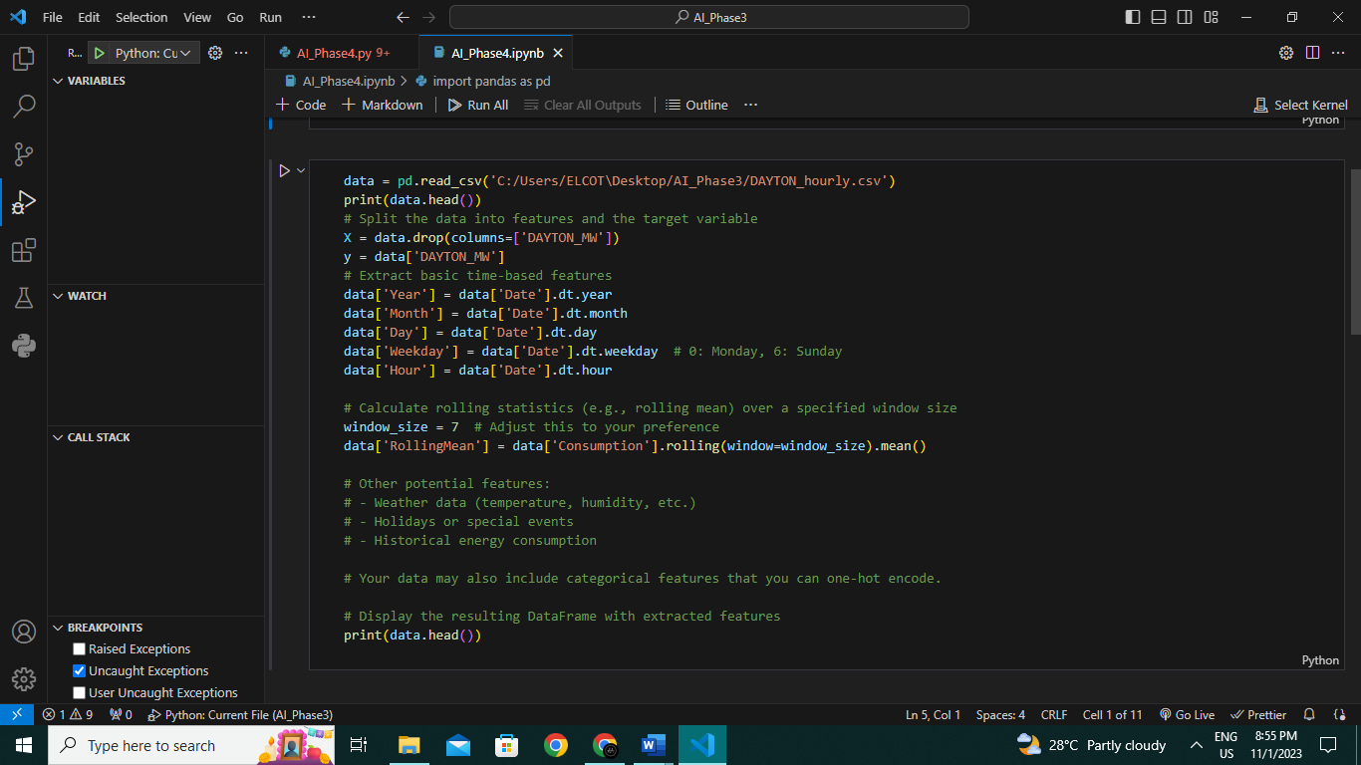

**MEAN SQUARE AND ABSOLUTE ERROR:**

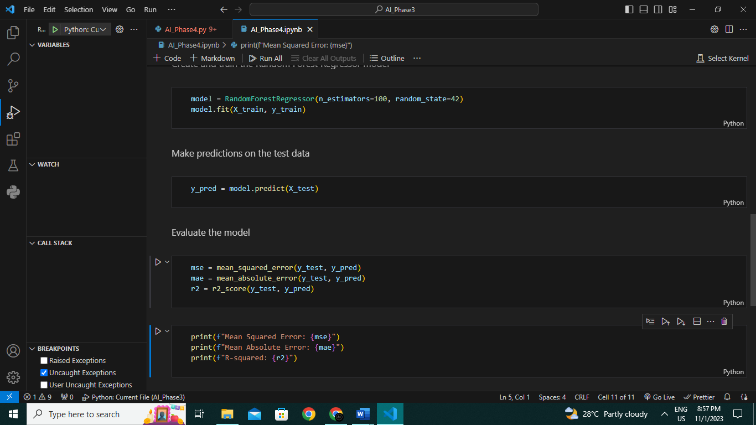

**Conclusion:**

The aim is to develop and implement an

automated approach to collect, analyse, and visualize energy consumption data for better decision-making.

The project embarked on the development and implementation of an automated system tailored for collecting, analysing, and visualizing energy consumption data. By leveraging the formidable Random Forest algorithm, the initiative aimed to bolster the accuracy and efficacy of the analytical process.

In the analytical phase, the Random Forest algorithm emerged as a standout choice due to its proficiency in handling intricate relationships within the data. Through the training process on historical data, the model gained insights into patterns and correlations, which it effectively utilized to make precise predictions on unseen data.

The automated nature of the system ushered in not only efficiency gains but also real-time monitoring and decision-making capabilities. This proves vital in environments where swift adjustments can yield significant energy savings.

In conclusion, the project successfully delivered an automated system for collecting, analyzing, and visualizing energy consumption data.