AquaWise
Smart Water Conservation and Awareness Portal
Software Engineering Deliverables
Use-case diagram · Use-case specifications · ER diagram · DFD Level 0 and Level 1
Web Programming Laboratory — Semester 5
K J Somaiya
Mapped to UN SDG 6: Clean Water and Sanitation

Team: Jaineel, [teammate name]
Date: 22 September 2026

Contents
1. UML use-case diagram
2. Use-case specifications (6 key use cases)
3. ER diagram (MongoDB collections)
4. Data-flow diagrams: Level 0 and Level 1
5. Viva explanation of the use-case diagram
Appendix A. PlantUML source — use-case diagram
Appendix B. Source and image files

All diagrams are derived from the AquaWise Requirements Specification (FR, actor and data-model sections). Identifiers such as FR-C3 or FR-S12 refer to that document.

1. UML use-case diagram
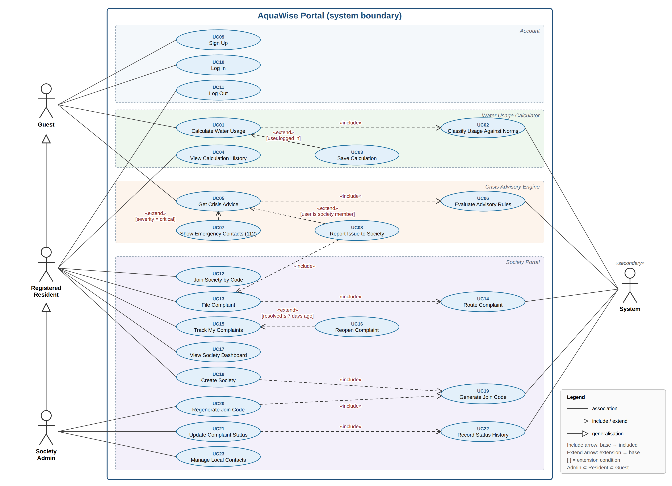
Figure 1. AquaWise use-case diagram — 4 actors, 23 use cases in 4 subsystems, with include, extend and generalisation relationships.

1.1 Actors
Actor | Type | Description
Guest | Primary | Any visitor who is not logged in. Uses the calculator and advisory, and can sign up or log in.
Registered Resident | Primary (specialises Guest) | Logged-in user. Inherits all Guest use cases; can create/join a society, file and track complaints, view the dashboard.
Society Admin | Primary (specialises Resident) | Resident who created the society. Inherits all Resident use cases; updates complaint status, manages contacts, regenerates the join code.
System | Secondary | The AquaWise server acting automatically: classifies usage against norms, evaluates advisory rules, routes complaints, generates join codes, records status history.

Note: the requirements document also defines a System Admin (a seeded demo account). It is left out of this diagram, as specified for this deliverable; its permissions are a superset of Society Admin.

1.2 Use-case catalogue
ID | Use case | Primary actor | Relationships
UC01 | Calculate Water Usage | Guest | Includes UC02; extended by UC03
UC02 | Classify Usage Against Norms | System | Included by UC01
UC03 | Save Calculation | Resident | Extends UC01 [user logged in]
UC04 | View Calculation History | Resident | —
UC05 | Get Crisis Advice | Guest | Includes UC06; extended by UC07, UC08
UC06 | Evaluate Advisory Rules | System | Included by UC05
UC07 | Show Emergency Contacts (112) | Guest | Extends UC05 [severity = critical]
UC08 | Report Issue to Society | Resident | Extends UC05 [society member]; includes UC13
UC09 | Sign Up | Guest | —
UC10 | Log In | Guest | —
UC11 | Log Out | Resident | —
UC12 | Join Society by Code | Resident | —
UC13 | File Complaint | Resident | Includes UC14
UC14 | Route Complaint | System | Included by UC13
UC15 | Track My Complaints | Resident | Extended by UC16
UC16 | Reopen Complaint | Resident | Extends UC15 [resolved ≤ 7 days ago]
UC17 | View Society Dashboard | Resident | —
UC18 | Create Society | Resident | Includes UC19
UC19 | Generate Join Code | System | Included by UC18, UC20
UC20 | Regenerate Join Code | Society Admin | Includes UC19
UC21 | Update Complaint Status | Society Admin | Includes UC22
UC22 | Record Status History | System | Included by UC21
UC23 | Manage Local Contacts | Society Admin | —

2. Use-case specifications
The six use cases below cover all three graded functionalities plus authentication and complaint handling. Step numbers in alternate and exception flows refer to the main flow.

UC01 — Calculate Water Usage
ID | UC01
Name | Calculate Water Usage
Actor | Guest (inherited by Resident and Society Admin); secondary: System
Preconditions | • User is on the Calculator page. No login is required.  • Formula constants version is loaded (formulaVersion "1.0").
Main flow | 1. User opens the Calculator page.  2. System shows the form pre-filled with default values and their sources (FR-C2).  3. User enters adults, children, city type, bathing mode and shower details, toilet type, washing-machine loads and type, garden area, tap-running minutes, tap type, dripping taps and, optionally, litres received per day.  4. User clicks Calculate.  5. System validates every field against the allowed ranges (FR-C12).  6. System computes litres per activity with the Section 7.2 formulas, the household total and per-capita use in lpcd (FR-C3, FR-C4).  7. System performs UC02 Classify Usage Against Norms: assigns the band and over-use / under-supply flags (FR-C6 to FR-C8).  8. System displays the activity chart and table, band, norm compared against, and the top 3 saving tips with litres saved (FR-C5, FR-C9).
Alternate flows | • A1 (step 3): User keeps the defaults; flow continues at step 4.  • A2 (step 3): User enters litres received per day; at step 7 the supply check adds "Under-supply vs JJM norm" or "Supply below estimated need".  • A3 (step 8): User is logged in → extension UC03 Save Calculation: server recomputes, stores a CalculatorLog and shows "Saved to history" (FR-C10, FR-C11).  • A4 (step 8): User edits any input → flow returns to step 4.
Exception flows | • E1 (step 5): A value is missing, non-numeric or out of range → field-level message; no result shown; focus moves to the first invalid field.  • E2 (step 5): Adults = 0 or adults + children > 30 → "Household must have 1–30 members, at least 1 adult".  • E3 (A3): Server or database unavailable → result stays on screen (computed on the client); message "Could not save — try again".
Postconditions | • Result with band and flags is displayed.  • For logged-in users, one CalculatorLog is stored; nothing is stored for guests.

UC05 — Get Crisis Advice
ID | UC05
Name | Get Crisis Advice
Actor | Guest (inherited by Resident and Society Admin); secondary: System
Preconditions | Advisory rules (14 rules, D5) are loaded on the server.
Main flow | 1. User opens the Advisory page.  2. System lists the 5 problem types: leakage, no supply, unsafe drinking water, low pressure, contamination (FR-A1).  3. User selects a problem type.  4. System asks the 1–3 trigger questions for that type (FR-A2).  5. User answers and submits.  6. System performs UC06 Evaluate Advisory Rules: checks rules from most to least severe and picks the first match (FR-A7).  7. System shows the severity, the numbered steps in stored order and the contacts with numbers and when to call (FR-A3, FR-A4).  8. User optionally prints or copies the steps (FR-A9).
Alternate flows | • A1 (step 7): Severity is critical → extension UC07 Show Emergency Contacts: red banner with 112 (FR-A5).  • A2 (step 7): User is a logged-in society member → contacts come from their Society record, and a "Report this to my society" button is shown → extension UC08 opens UC13 File Complaint pre-filled with category, severity and rule ID (FR-A8).  • A3 (step 5): User goes back and changes an answer → flow returns to step 6.
Exception flows | • E1 (step 6): No rule matches the answers → system shows the lowest-severity rule for that type plus 112, and logs the case for review.  • E2 (step 6): Rules cannot be loaded → "Advisory temporarily unavailable" with the 112 emergency number.  • E3 (A2): A Guest clicks "Report" → redirected to UC10 Log In.
Postconditions | • Guidance and contacts are displayed.  • Nothing is stored unless the user continues to UC08.

UC10 — Log In
ID | UC10
Name | Log In
Actor | Guest
Preconditions | • User has a registered account with isActive = true.  • User is not already logged in.
Main flow | 1. User opens the Login page.  2. User enters email and password.  3. User submits the form.  4. System checks both fields are present and the email is well-formed.  5. System finds the user by lower-cased email.  6. System compares the password with the stored bcrypt hash.  7. System regenerates the session ID, stores userId and role in the session (D6) and sets an httpOnly cookie (NFR-S2).  8. System updates lastLoginAt.  9. System redirects: society member → Society Dashboard; no society yet → Join / Create Society page. The navbar shows role-specific links.
Alternate flows | • A1 (step 1): User is already logged in → redirected straight to the dashboard.  • A2 (step 9): User was sent to Login from a protected page → returned to that page after login.
Exception flows | • E1 (step 5 or 6): Email not found or password wrong → HTTP 401 with the generic message "Invalid email or password" (does not reveal which).  • E2 (step 3): 5 failed attempts from one IP in 15 minutes → HTTP 429 "Too many attempts, try again later" (NFR-S4).  • E3 (step 5): isActive = false → HTTP 403 "Account deactivated".  • E4 (step 4): Empty or malformed field → client-side validation message; request not sent.
Postconditions | An authenticated session exists for 2 hours; later requests carry the session cookie.

UC12 — Join Society by Code
ID | UC12
Name | Join Society by Code
Actor | Registered Resident
Preconditions | • User is logged in.  • User.society is null (not yet in a society).
Main flow | 1. User opens the Join Society page.  2. User enters the 6-character join code, flat number and wing.  3. User submits.  4. System validates the code format (6 characters, A–Z and 2–9) and flat number.  5. System looks up an active society with that joinCode.  6. System shows the society name and area for confirmation.  7. User confirms.  8. System sets user.society, flatNo and wing, and increments society.memberCount.  9. System redirects to the Society Dashboard (UC17).
Alternate flows | • A1 (step 2): Code typed in lower case → system converts it to upper case.  • A2 (step 7): User cancels → nothing is saved; user returns to the Join page.
Exception flows | • E1 (step 5): No society has that code, or the code was regenerated → "Invalid or expired join code".  • E2 (precondition): User already belongs to a society → HTTP 409 "You are already a member of <society name>".  • E3 (step 4): Flat number empty or has invalid characters → field-level error.  • E4 (any step): Session expired → redirected to UC10 Log In.
Postconditions | User is linked to exactly one society and can now file complaints and view its dashboard.

UC13 — File Complaint
ID | UC13
Name | File Complaint
Actor | Registered Resident (also Society Admin); secondary: System
Preconditions | User is logged in and is a member of a society.
Main flow | 1. User opens New Complaint.  2. User selects category, severity and location, and enters title and description.  3. User submits.  4. System validates all fields (title 5–80, description 10–1000 characters, enum values).  5. System generates the next complaint number, e.g., AQW-2026-0001 (FR-S10).  6. System performs UC14 Route Complaint: picks the first society contact whose categories include the complaint category, and stores a snapshot in assignedContact (FR-S12).  7. System saves the complaint with status "active", society and filedBy taken from the session, and the first statusHistory entry (null → active).  8. System shows the complaint number and the assigned contact’s name and phone; dashboard counts update.
Alternate flows | • A1 (step 1): Started from UC08 → category, severity and advisoryRuleId are pre-filled; user may change severity.  • A2 (step 6): No contact handles the category → complaint is routed to the society admin.
Exception flows | • E1 (step 4): Validation fails → field-level errors; form content is kept.  • E2 (step 3): Request body names a different society → ignored; society is always taken from the session (HTTP 403 if the user has none).  • E3 (step 7): Database write fails → HTTP 500 "Could not file complaint — try again"; form content is kept.
Postconditions | • One complaint exists in D3 with status active and a routed handler.  • It appears on the society dashboard and in the filer’s My Complaints list.

UC21 — Update Complaint Status
ID | UC21
Name | Update Complaint Status
Actor | Society Admin; secondary: System
Preconditions | • User is logged in with role society_admin.  • The complaint belongs to the admin’s society and is not resolved.
Main flow | 1. Admin opens the Society Dashboard and filters the list by status or category.  2. Admin opens a complaint.  3. System shows details, status history and the allowed next statuses.  4. Admin selects the next status (active → in_progress, or in_progress → resolved) and writes a note.  5. Admin submits.  6. System checks the transition is allowed and the note is not empty.  7. System performs UC22 Record Status History: appends {from, to, by, note, at} to statusHistory (FR-S14).  8. System updates the status; for "resolved" it sets resolvedAt.  9. Dashboard counts refresh; the filer sees the new status in UC15 Track My Complaints.
Alternate flows | • A1 (step 4): Admin resolves an active complaint directly (active → resolved is allowed).  • A2 (after step 9): Filer reopens within 7 days (UC16) → status returns to active, resolvedAt is cleared, and it reappears in the admin’s active list.
Exception flows | • E1 (step 6): Transition not allowed (e.g., resolved → in_progress) → HTTP 400 "Invalid status change".  • E2 (step 2): Complaint belongs to another society → HTTP 403.  • E3 (step 6): Note is empty → field-level error.  • E4 (step 5): Status changed since the page loaded → HTTP 409 "Complaint was updated — reload".
Postconditions | • Complaint has the new status and one new, unchangeable history entry.  • Dashboard counts match the database.

3. ER diagram (MongoDB collections)
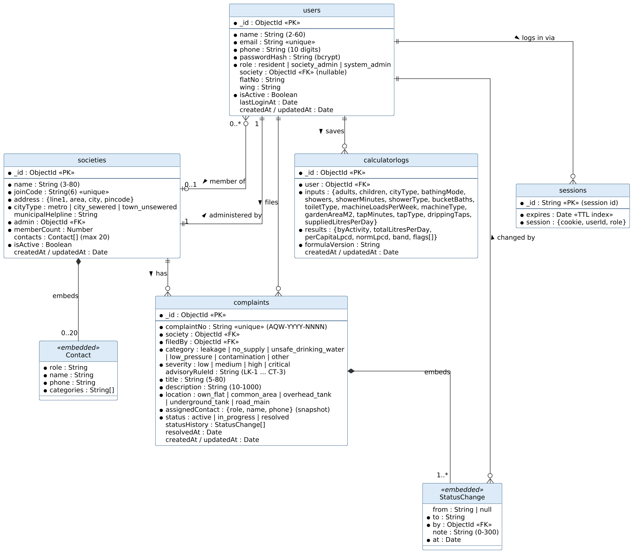
Figure 2. AquaWise ER diagram — 5 collections and 2 embedded sub-documents, crow’s-foot notation.

3.1 Relationships
Relationship | Cardinality | How it is stored
User — member of — Society | Many users : 0 or 1 society | users.society (ObjectId ref)
Society — administered by — User | 1 : 1 | societies.admin (ObjectId ref)
Society — has — Complaint | 1 : many | complaints.society (ObjectId ref)
User — files — Complaint | 1 : many | complaints.filedBy (ObjectId ref)
User — saves — CalculatorLog | 1 : many | calculatorlogs.user (ObjectId ref)
User — logs in via — Session | 1 : many | sessions.session.userId (connect-mongo)
Society — embeds — Contact | 1 : 0..20 | societies.contacts[] (embedded array)
Complaint — embeds — StatusChange | 1 : 1..many | complaints.statusHistory[] (embedded array)
StatusChange — changed by — User | many : 1 | statusHistory[].by (ObjectId ref)

Design notes
- Contacts and status history are embedded because they are always read with their parent and never queried alone; everything else is referenced so each collection stays small and indexable.
- assignedContact is copied into the complaint at filing time, so editing a society contact later does not rewrite old complaints.
- The sessions collection is created automatically by connect-mongo for express-session; a TTL index on expires removes old sessions. It is shown here because it is a real collection in the database.
- Unique indexes: users.email, societies.joinCode, complaints.complaintNo. Query indexes: complaints {society, status, createdAt}, calculatorlogs {user, createdAt}.

4. Data-flow diagrams

4.1 Level 0 — context diagram
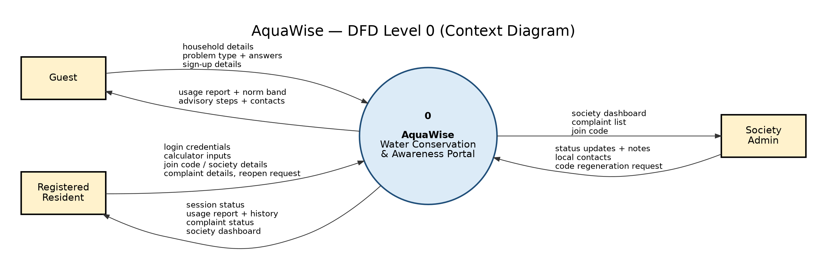
Figure 3. DFD Level 0: the whole portal as one process (0) exchanging data with three external entities.
The context diagram treats AquaWise as a single process. Guests send household details and problem descriptions and receive usage reports and advisory steps. Residents add credentials, society joining and complaints, and receive their history, complaint status and the dashboard. The Society Admin sends status updates and contacts, and receives the complaint list and join code.

4.2 Level 1
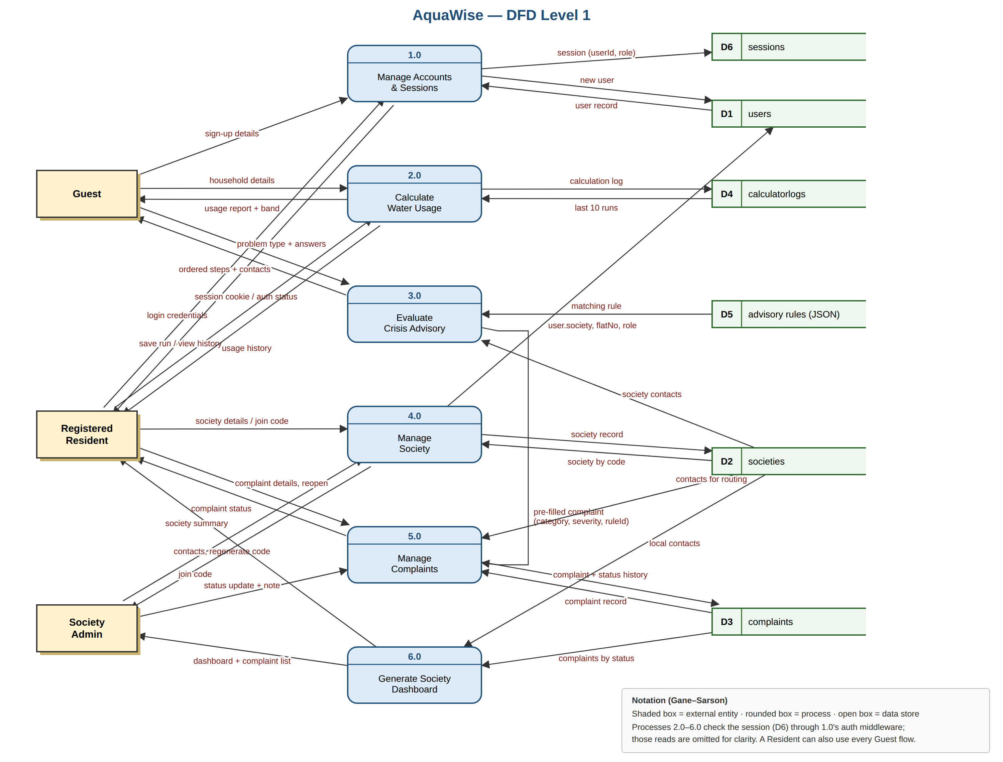
Figure 4. DFD Level 1: process 0 decomposed into 6 processes and 6 data stores (Gane–Sarson notation).

4.3 Level 1 processes and data stores
Process | What it does | Stores used
1.0 Manage Accounts & Sessions | Sign-up, login, logout; hashes passwords; creates and destroys sessions; auth middleware for all other processes. | D1 users, D6 sessions
2.0 Calculate Water Usage | Applies the usage formulas, classifies lpcd into a band, saves runs for logged-in users and returns history. | D4 calculatorlogs
3.0 Evaluate Crisis Advisory | Matches problem type + answers to one of 14 rules; returns ordered steps and contacts; can pre-fill a complaint. | D5 advisory rules, D2 societies
4.0 Manage Society | Creates societies, generates/regenerates join codes, joins members, maintains local contacts. | D2 societies, D1 users
5.0 Manage Complaints | Files, routes, updates, reopens complaints and records status history. | D3 complaints, D2 societies
6.0 Generate Society Dashboard | Counts complaints by status and lists them with local contacts. | D3 complaints, D2 societies

D1–D4 and D6 are MongoDB collections; D5 is the advisory rules JSON file (FR-A6). For readability, the session checks that processes 2.0–6.0 make through 1.0 are not drawn as separate arrows. The Level 1 flows balance with Level 0: every Level 0 input and output appears at Level 1.

5. Viva explanation of the use-case diagram
This use-case diagram shows what each kind of user can do in AquaWise. The big box is the system boundary: everything inside it is a feature of our portal, and the stick figures outside are the actors.
A Guest is anyone who has not logged in. A Guest can calculate household water usage, get crisis advice, sign up and log in. A Registered Resident is a Guest who has logged in, so the hollow-triangle arrow shows that the Resident inherits every Guest feature. On top of that, a Resident can create or join a society, file complaints, track them and view the society dashboard. The Society Admin inherits everything a Resident can do, and can also update complaint status, manage local contacts and regenerate the join code.
The System actor stands for work our server does automatically, with no person involved: classifying usage against norms, evaluating advisory rules, routing complaints and recording status history.
The dashed arrows show how use cases connect. An include arrow means a step always happens; for example, filing a complaint always includes routing it to the right person. An extend arrow means an optional step that happens only under a condition: a calculation is saved only if the user is logged in, and the 112 emergency contacts appear only when the severity is critical.
(219 words, about 1.5 minutes spoken)

Appendix A. PlantUML source — use-case diagram
Paste into plantuml.com or the PlantUML plugin for VS Code to edit. PlantUML lays the diagram out automatically, so the rendered layout differs from Figure 1; the actors, use cases and relationships are the same.
@startuml AquaWise_UseCase
' AquaWise — UML Use-Case Diagram (edit and re-render with PlantUML)
left to right direction
skinparam shadowing false
skinparam defaultFontName Helvetica
skinparam defaultFontSize 12
skinparam packageStyle rectangle
skinparam actorStyle awesome
skinparam usecase {
BackgroundColor #EAF4FB
BorderColor #1F6F9F
ArrowColor #333333
}
skinparam rectangle {
BorderColor #1F6F9F
BackgroundColor #FFFFFF
}
actor "Guest" as Guest
actor "Registered\nResident" as Resident
actor "Society\nAdmin" as Admin
actor "System" as Sys <<secondary>>
Guest <|-- Resident
Resident <|-- Admin
rectangle "AquaWise Portal" as Portal {
rectangle "Account" as Acc {
usecase "UC09 Sign Up" as UC09
usecase "UC10 Log In" as UC10
usecase "UC11 Log Out" as UC11
}
rectangle "Water Usage Calculator" as Calc {
usecase "UC01 Calculate\nWater Usage" as UC01
usecase "UC02 Classify Usage\nAgainst Norms" as UC02
usecase "UC03 Save\nCalculation" as UC03
usecase "UC04 View Calculation\nHistory" as UC04
}
rectangle "Crisis Advisory Engine" as Adv {
usecase "UC05 Get Crisis\nAdvice" as UC05
usecase "UC06 Evaluate\nAdvisory Rules" as UC06
usecase "UC07 Show Emergency\nContacts (112)" as UC07
usecase "UC08 Report Issue\nto Society" as UC08
}
rectangle "Society Portal" as Soc {
usecase "UC12 Join Society\nby Code" as UC12
usecase "UC13 File\nComplaint" as UC13
usecase "UC14 Route\nComplaint" as UC14
usecase "UC15 Track My\nComplaints" as UC15
usecase "UC16 Reopen\nComplaint" as UC16
usecase "UC17 View Society\nDashboard" as UC17
usecase "UC18 Create\nSociety" as UC18
usecase "UC19 Generate\nJoin Code" as UC19
usecase "UC20 Regenerate\nJoin Code" as UC20
usecase "UC21 Update\nComplaint Status" as UC21
usecase "UC22 Record Status\nHistory" as UC22
usecase "UC23 Manage Local\nContacts" as UC23
}
}
' --- Guest (inherited by Resident and Admin) ---
Guest --> UC09
Guest --> UC10
Guest --> UC01
Guest --> UC05
' --- Registered Resident ---
Resident --> UC11
Resident --> UC04
Resident --> UC12
Resident --> UC18
Resident --> UC13
Resident --> UC15
Resident --> UC17
' --- Society Admin ---
Admin --> UC20
Admin --> UC21
Admin --> UC23
' --- include (base always performs the included behaviour) ---
UC01 ..> UC02 : <<include>>
UC05 ..> UC06 : <<include>>
UC08 ..> UC13 : <<include>>
UC13 ..> UC14 : <<include>>
UC18 ..> UC19 : <<include>>
UC20 ..> UC19 : <<include>>
UC21 ..> UC22 : <<include>>
' --- extend (optional behaviour; arrow points to the base use case) ---
UC03 .> UC01 : <<extend>>\n[logged in]
UC07 .> UC05 : <<extend>>\n[severity = critical]
UC08 .> UC05 : <<extend>>\n[society member]
UC16 .> UC15 : <<extend>>\n[resolved <= 7 days]
' --- System: secondary actor performing automated steps ---
UC02 --> Sys
UC06 --> Sys
UC14 --> Sys
UC19 --> Sys
UC22 --> Sys
@enduml

Appendix B. Source and image files
File | Contents
images/AquaWise_UseCase.png | Use-case diagram (Figure 1)
images/AquaWise_ER.png | ER diagram (Figure 2)
images/AquaWise_DFD_Level0.png | DFD Level 0 (Figure 3)
images/AquaWise_DFD_Level1.png | DFD Level 1 (Figure 4)
source/use_case.puml | PlantUML source, use-case diagram
source/er_diagram.puml | PlantUML source, ER diagram
source/dfd_level0.dot | Graphviz source, DFD Level 0
source/AquaWise_UseCase.svg, AquaWise_DFD_Level1.svg | Vector originals of Figures 1 and 4 (editable in Inkscape or draw.io)

