AquaWise
UI Design Specification
Bootstrap 5.3 · Google Fonts (Manrope + Inter) · 7 screens × desktop and mobile × 4 states
Web Programming Laboratory — Semester 5, K J Somaiya
Team: Jaineel, [teammate name]
Version 1.0 · 22 September 2026

Contents
1. Design principles
2. Colour palette and contrast
3. Typography
4. Spacing, grid and breakpoints
5. Component styling rules
6. Screens: Home · Calculator · Crisis Advisory · Conservation Tips · Report a Problem · Society Dashboard · Login / Signup
7. Component inventory (React)
8. Figma build steps
Appendix A. Using aquawise.css
Appendix B. Files delivered

How to read the wireframes: pink numbered markers match the numbered rows in each screen’s annotation table. Markers are not part of the UI. Every wireframe is a real Bootstrap 5.3 page rendered in a browser at 1440 px and 390 px, so each layout is achievable with Bootstrap’s grid and components. Names, phone numbers and complaint data are sample data.

1. Design principles
- Calm, not alarming. Deep blue and white carry the brand. Red appears only for danger and errors, so it keeps its meaning.
- Numbers first. Every screen leads with the figure that matters (litres per person, complaint counts) in a large tabular numeral.
- Never colour alone. Every band, status and severity pairs colour with a text label and an icon, so it reads without colour vision.
- Bootstrap-native. Only Bootstrap 5.3 grid, utilities and components, themed through CSS variables in one file (aquawise.css). No custom JS widgets.
- Mobile is a first-class layout. Every screen is designed at 390 px as well as 1440 px, with 44 px touch targets for inputs and 40 px for buttons.

2. Colour palette and contrast
A blue/teal “clean water” palette on white and a cool blue-grey surface. All ratios below were computed with the WCAG 2.1 relative-luminance formula, not estimated. Targets: 4.5:1 for normal text (AA), 3:1 for large text and UI boundaries (WCAG 1.4.11).
Group | Token | Hex | Role | AA check
Brand | primary | #0A5DA8 | Primary buttons, links, focus ring, active nav | Text on white 6.68:1 ✓ · with #FFFFFF 6.68:1 ✓
Brand | primary-dark | #084A87 | Hover/active, text on blue tints | Text on white 8.98:1 ✓ · with #FFFFFF 8.98:1 ✓
Brand | primary-subtle | #E7F1FB | Selected cards, info alerts, nav hover | Text #084A87 on it 7.85:1 ✓
Brand | secondary | #0E7C86 | Teal: secondary buttons, advisory accents | Text on white 4.95:1 ✓ · with #FFFFFF 4.95:1 ✓
Brand | secondary-subtle | #E3F4F5 | Tip and advisory icon tiles | Text #0B5F67 on it 6.51:1 ✓
Brand | accent | #1BB3CF | Aqua: decoration only (waves, ticks) | Decorative only (text on it: ink 6.94:1 ✓)
Brand | hero | #0B3B66 | Hero band, footer, auth panel | Text #FFFFFF on it 11.46:1 ✓
Semantic | success | #1E7F4F | Within norm, resolved, saved | Text on white 5.00:1 ✓ · with #FFFFFF 5.00:1 ✓
Semantic | success-subtle | #E6F4EC | Resolved badge, savings badge | Text #155D38 on it 6.97:1 ✓
Semantic | warning | #F2B01E | Over-use / under-supply fills | Text #0F1B2A on it 9.09:1 ✓
Semantic | warning-subtle | #FFF4DB | Active badge, over-use alert | Text #7A4A00 on it 6.85:1 ✓
Semantic | danger | #C62828 | Critical, errors, 112 actions | Text on white 5.62:1 ✓ · with #FFFFFF 5.62:1 ✓
Semantic | danger-subtle | #FDECEC | Emergency strip, error alerts | Text #A11F1F on it 6.73:1 ✓
Neutral | ink | #0F1B2A | Headings, key numbers | Text on white 17.35:1 ✓ · with #FFFFFF 17.35:1 ✓
Neutral | body | #344456 | Body text | Text on white 9.97:1 ✓ · with #FFFFFF 9.97:1 ✓
Neutral | muted | #5B6B7E | Help text, captions | Text on white 5.46:1 ✓ · with #FFFFFF 5.46:1 ✓
Neutral | input-border | #7B8A9C | Form control borders | UI border 3.52:1 ≥ 3 ✓
Neutral | border | #D5DEE8 | Card and divider lines | Decorative dividers only
Neutral | surface | #F4F8FC | Page background | Text #0F1B2A on it 16.26:1 ✓
Neutral | white | #FFFFFF | Cards, navbar, inputs | Text #0F1B2A on it 17.35:1 ✓

Why these colours
- Primary #0A5DA8: A deep water blue that reads as trustworthy and civic rather than playful. 6.7:1 on white, so it works for both text links and filled buttons with white text.
- Secondary #0E7C86: A teal that sits next to the blue as “clean water”. It separates advisory and tips content from core actions. 4.9:1 with white text.
- Accent #1BB3CF: A bright aqua for decoration only: hero waves, check marks on dark backgrounds, chart ticks. At 2.5:1 on white it is never used for text or as the only indicator.
- Hero #0B3B66: Deep navy for the hero band, auth panel and footer. It anchors pages and gives white text 11.5:1 contrast.
- Semantic colours: Success green, warning amber and danger red each come in a solid and a subtle tint with a darker text colour. All subtle-tint pairs exceed 6.5:1.
- Neutrals: Blue-grey neutrals, not pure grey, so the whole UI feels cool and watery. Muted text is 5.5:1 on white. Input borders are 3.5:1 to meet the 3:1 non-text rule.

Colour rules
- Colour is never the only signal: every band, status and severity also has a word and an icon.
- Red (danger) is reserved for emergencies, critical severity, destructive actions and errors.
- Text on a tinted background always uses that family’s dark shade (e.g. #7A4A00 on #FFF4DB).
- Accent aqua (#1BB3CF) is never text and never the only indicator (2.5:1 on white).
- Page background is #F4F8FC; cards are white. Muted text on the page background is still 5.1:1.

Usage band colours (Calculator)
Band | lpcd | Colour token | Icon (Bootstrap Icons) | Presentation
Critical under-supply | < 20 lpcd | danger (solid) | exclamation-octagon-fill | Solid red badge, white text
Under-supply | 20–54 | warning-subtle | arrow-down-circle | Amber alert: “Below the 55 L JJM norm”
Basic | 55–99 | primary-subtle | info-circle | Blue badge: meets minimum, below WHO optimal
Within norm | 100–N | success-subtle | check-circle-fill | Green badge
Over-use | N+1–200 | warning-subtle | arrow-up-circle-fill | Amber alert with litres above the norm
Severe over-use | > 200 | danger-subtle | exclamation-triangle-fill | Red alert: above the IS 1172 upper limit

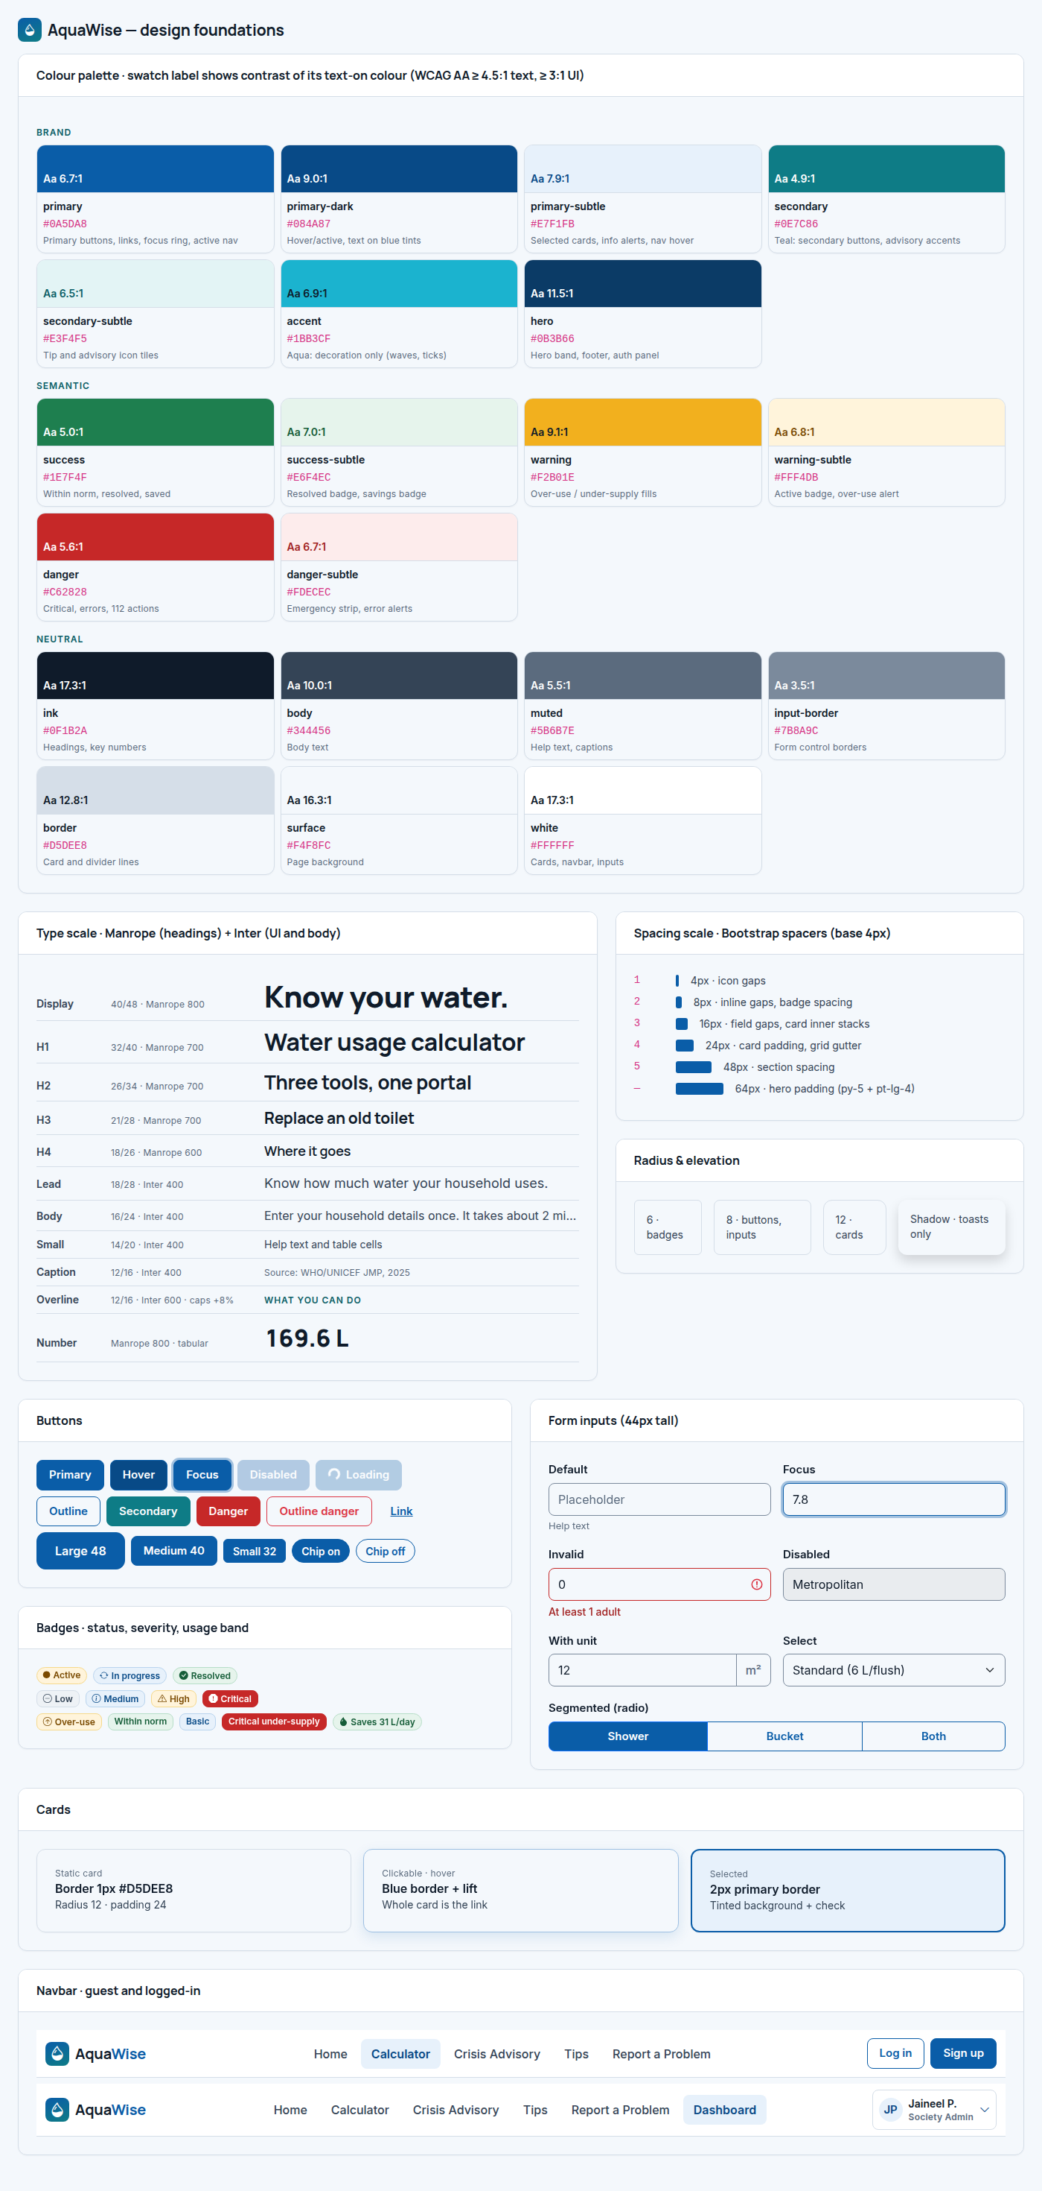
Figure 1. Design foundations: palette with contrast, type scale, spacing, radius, buttons, inputs, badges, cards and navbar.

3. Typography
Pairing: Manrope for headings and key numbers, Inter for everything else. Both are free Google Fonts. Manrope’s rounded, geometric shapes feel modern and a little “fluid” without being playful; Inter is built for screens and stays readable at 12–14 px in tables and forms. Both have tabular numerals.
Embed: <link href="https://fonts.googleapis.com/css2?family=Inter:wght@400;500;600&family=Manrope:wght@600;700;800&display=swap" rel="stylesheet"> — six weights, about 150 KB total.
Role | Size / line (px) | Font | Weight | Tracking | Use
Display | 40 / 48 | Manrope | 800 | -1% | Hero headline only (.display-5). 32/40 below 576 px.
H1 | 32 / 40 | Manrope | 700 | -1% | One per page: page title. 26/34 on mobile.
H2 | 26 / 34 | Manrope | 700 | -1% | Section titles. 22/30 on mobile.
H3 | 21 / 28 | Manrope | 700 | -1% | Card titles, empty-state titles.
H4 | 18 / 26 | Manrope | 600 | -1% | Sub-sections inside cards, form section titles.
Lead | 18 / 28 | Inter | 400 | 0 | Intro paragraph under a hero or page title.
Body | 16 / 24 | Inter | 400 | 0 | Default text. Never smaller for paragraphs.
Label | 15 / 22 | Inter | 600 | 0 | Form labels, button text.
Small | 14 / 20 | Inter | 400 | 0 | Table cells, secondary lines, help text (13 px).
Caption | 12 / 16 | Inter | 400 | +2% | Sources, timestamps, chart axes. Muted colour.
Overline | 12 / 16 | Inter | 600, caps | +8% | Section eyebrows, category labels. Teal-dark colour.
Number | varies | Manrope | 800, tabular | 0 | Key figures (169.6 L, counts). Tabular so digits align.

Rules: one H1 per page; never skip heading levels; body text never below 16 px; line length 60–75 characters (max-width ≈ 42rem for prose); sentence case everywhere except overlines.

4. Spacing, grid and breakpoints
Spacing uses Bootstrap’s default spacer scale (base 1rem = 16 px). No custom spacers are needed.
Spacer | Value | Bootstrap classes | Use
0 | 0 | .p-0 .m-0 | Resets
1 | 4 px | .gap-1 .me-1 | Icon-to-text gaps
2 | 8 px | .gap-2 .mb-2 | Button groups, badge rows, label-to-input
3 | 16 px | .g-3 .mb-3 | Form field gaps, list items, small cards (p-3)
4 | 24 px | .g-4 .p-4 .mb-4 | Card padding, grid gutters, gaps between cards
5 | 48 px | .py-5 .mb-5 | Vertical space between page sections

Breakpoint | Min width | Container | Layout behaviour
xs | < 576 px | 100% − 24 px | Phones (design at 390). One column; tables become cards; navbar collapses.
sm | ≥ 576 px | 540 px | Large phones. Buttons sit side by side.
md | ≥ 768 px | 720 px | Tablets. 2–3 column card grids; complaints show as a table.
lg | ≥ 992 px | 960 px | Laptops. Navbar expands; forms and results sit side by side (7/5 or 8/4).
xl | ≥ 1200 px | 1140 px | Desktops. Dashboard detail panel joins the list (8/4).
xxl | ≥ 1400 px | 1320 px | Design width 1440. Max content width 1320.

Grid: Bootstrap 12-column grid, gutter 24 px (.g-4) between cards and 16 px (.g-3) between form fields. Radius: 6 px badges, 8 px buttons and inputs, 12 px cards and modals. Elevation: shadows only on toasts, the hero preview card and hovered clickable cards.

5. Component styling rules
All rules are implemented in aquawise.css (Appendix A) by overriding Bootstrap 5.3 CSS variables, so the standard Bootstrap classes pick up the theme.

Cards
Property | Rule
Base | .card — white, 1 px #D5DEE8 border, radius 12 px, shadow 0 1px 2px rgba(15,27,42,.04)
Padding | 24 px (card-body). Compact list cards use .p-3 (16 px).
Header | .card-header — white, Manrope 700 16 px, 16 × 24 px padding, bottom border
Clickable | Add .aw-card-link: hover gives border #9DBFE2 and shadow 0 6px 18px rgba(10,93,168,.12). The whole card is one link or button.
Selected | .aw-card-selected: 2 px primary border, primary-subtle background, check icon top right.
Do / don’t | Do keep one primary action per card. Don’t nest cards more than one level, and don’t put shadows on static cards.

Buttons
Property | Rule
Sizes | Large 48 px (.btn-lg, 16 px text), default 40 px (15 px text), small 32 px (.btn-sm, 14 px). Radius 8 px. Font weight 600.
Primary | .btn-primary — #0A5DA8 fill, white text; hover #084A87; active #073C6E; disabled #8FB3D6. One per view region.
Secondary | .btn-outline-primary for secondary actions (Print, Save to history). .btn-secondary (teal) sparingly.
Danger | .btn-danger only for 112 calls and destructive actions. .btn-outline-danger for the secondary emergency link.
Tertiary | .btn-link for Reset, Cancel, Skip.
Focus | Visible 3 px ring rgba(10,93,168,.35) on :focus-visible. Never remove outlines.
Loading | Keep the label, prepend .spinner-border-sm, set disabled, change text to a verb in -ing (“Submitting…”).
Icons | Bootstrap Icons, 16 px, 8 px before the label (.me-2 on lg, .me-1 otherwise).

Form inputs
Property | Rule
Height | 44 px min (.form-control, .form-select). Border #7B8A9C (3.5:1). Radius 8 px.
Label | Always visible above the field (.form-label, Inter 600 15 px, ink). No placeholder-only labels.
Help text | .form-text below, 13 px muted. Show units and defaults with their source here.
Units | Use .input-group with .input-group-text on the right (L, m², min, +91 on the left).
Focus | Border #0A5DA8 + 3 px focus ring.
Invalid | .is-invalid: red border, Bootstrap icon, .invalid-feedback message in #A11F1F. On submit, an alert above the form summarises errors with links to fields.
Choice | ≤ 4 options → segmented .btn-group of .btn-check radios. 5+ options → .form-select. Yes/no questions in Advisory → .form-check radios.
Validation timing | Validate on blur and on submit, never on every keystroke. The server re-validates (NFR-V1).

Badges
Property | Rule
Shape | .badge, 12 px Inter 600, radius 6 px. Status badges are .rounded-pill; severity badges are square-ish.
Status | Active = warning-subtle + filled dot; In progress = primary-subtle + arrow-repeat; Resolved = success-subtle + check. Classes .aw-badge-active/-progress/-resolved.
Severity | Low = neutral grey; Medium = blue tint; High = amber tint + triangle; Critical = solid red + octagon. Classes .aw-sev-*.
Rule | Every badge has an icon and a word. Tints use the dark text colour of their family (≥ 6.5:1).

Navbar
Property | Rule
Structure | .navbar.navbar-expand-lg.aw-navbar.sticky-top — white, 64 px min height, 1 px bottom border.
Brand | Logo mark (32 px gradient tile, droplet-half icon) + “AquaWise” in Manrope 700 with “Wise” in primary.
Links | Centred (.mx-auto). Inter 500 16 px. Hover: primary text on primary-subtle pill. Active: primary-dark, 600, subtle pill + aria-current="page".
Right side | Guest: “Log in” (outline) + “Sign up” (primary). Logged in: avatar button with name and role (role hidden below xl) opening a dropdown: Profile, My society, Log out.
Role logic | Dashboard link appears only when logged in. Society admin sees the same links; admin-only actions live on the dashboard.
Mobile | Collapses at < 992 px to a hamburger that opens .offcanvas-end with the same links stacked (48 px rows) and the auth buttons full width.

Alerts, toasts and emergency elements
Property | Rule
Inline alert | .alert with subtle tint + dark text + leading icon. Used for pre-fill notices, over-use results and form error summaries.
Toast | .toast bottom-right (desktop) or top (mobile), 6 px coloured left border, auto-hide after 5 s except errors.
Emergency strip | .aw-emergency: danger-subtle background, 6 px red left border, 112 as a tel: link. Shown on Home, Advisory, Report and in every critical result.
Skeletons | .aw-skeleton blocks at the size of the real content. Used for any load over 300 ms; spinners only inside buttons.

6. Screens
Each screen has: purpose and access, desktop layout (1440), mobile layout (390), the annotated desktop wireframe, the mobile wireframe, an annotation table, a states table and a states board. Clean versions without markers are in images/screens/ for rebuilding in Figma.

6.1 Home
Route | Access | Purpose
/ | Everyone | Explain AquaWise in one screen and send people to one of the three tools. Guests are the main audience.

Desktop layout (1440). 12-column container (1320). Hero: 6 / 5 columns with a 1-column offset — copy on the left, product preview card on the right, wave divider below. Stats: three 4-column cards. Features: three 4-column cards. How it works: one full-width card with three 4-column steps. Emergency strip: full width. Tips: three 4-column cards. Footer: 4 / 2 / 2 / 4.
Mobile layout (390). Everything stacks in one column. The hero buttons go full width and stack. The preview card sits under the hero copy. Stat, feature and tip cards stack with 24 px gaps. Emergency strip buttons wrap. The footer’s two link columns sit side by side (col-6).

Annotations
# | Element | Component | Behaviour and details
1 | Navbar (guest) | AppNavbar | Home active. Log in / Sign up on the right. Collapses to hamburger < 992 px.
2 | Hero band | HeroSection | Navy #0B3B66, overline “UN SDG 6”, display headline, lead paragraph, SVG wave in surface colour.
3 | Hero calls to action | Button | Primary: “Calculate my usage” (btn-light on navy). Secondary: “Water emergency? Get steps” (btn-outline-light) → Advisory.
4 | Product preview | UsagePreviewCard | Static example result (169.6 L, Over-use, gauge, top 3 bars). Not interactive; labelled “Example household”.
5 | Stats row | StatCard ×3 | Big number + one line + source caption. Numbers from the requirements doc (WHO/UNICEF 2025, NITI Aayog 2018, CPHEEO).
6 | Feature cards | FeatureCard ×3 | Icon tile, title, one sentence, text link. Whole card is clickable (.aw-card-link).
7 | How it works | StepList | Three numbered steps: Measure, Understand, Act.
8 | Emergency strip | EmergencyStrip | Red-tinted strip with “Open Crisis Advisory” and “Emergency 112” (tel:112).
9 | Tips teaser | TipCard (compact) ×3 | Top three tips with “Saves …” badge; “All tips” link to Tips.
10 | Footer | AppFooter | Brand, tool links, society links, emergency numbers (112, BMC 1916), sources link.

States
State | What the user sees
Default (guest) | As rendered. Log in / Sign up in navbar.
Logged in | Navbar shows Dashboard + avatar menu. If the user has no society, a blue info alert under the navbar: “Join with a code to report problems.”
Loading | Static page: no loading state of its own. During route changes a 3 px primary progress bar runs along the top.
Error | Offline: amber banner under the navbar (“You are offline. The calculator and advisory still work…”) with Retry. Page content stays.
Empty | Not applicable: all content is static.

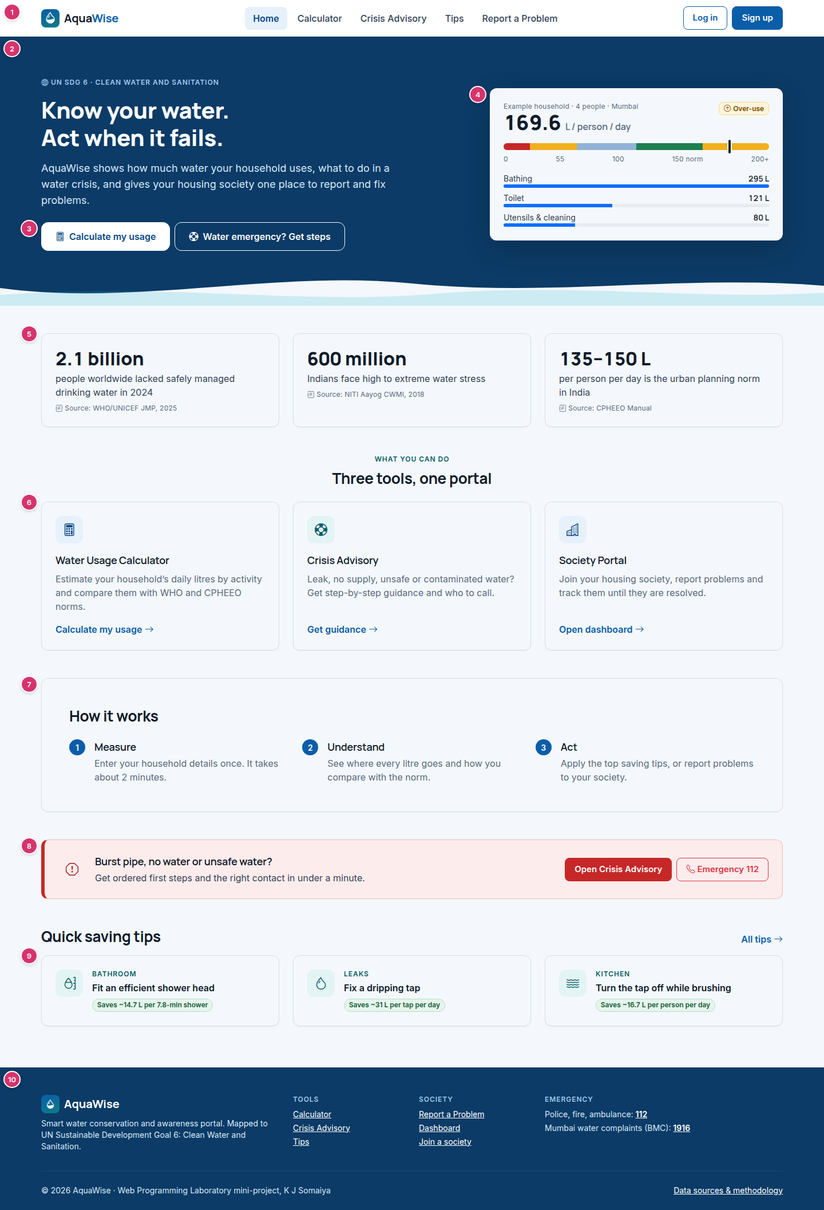
Figure 2. Home — desktop, 1440 px (annotated).

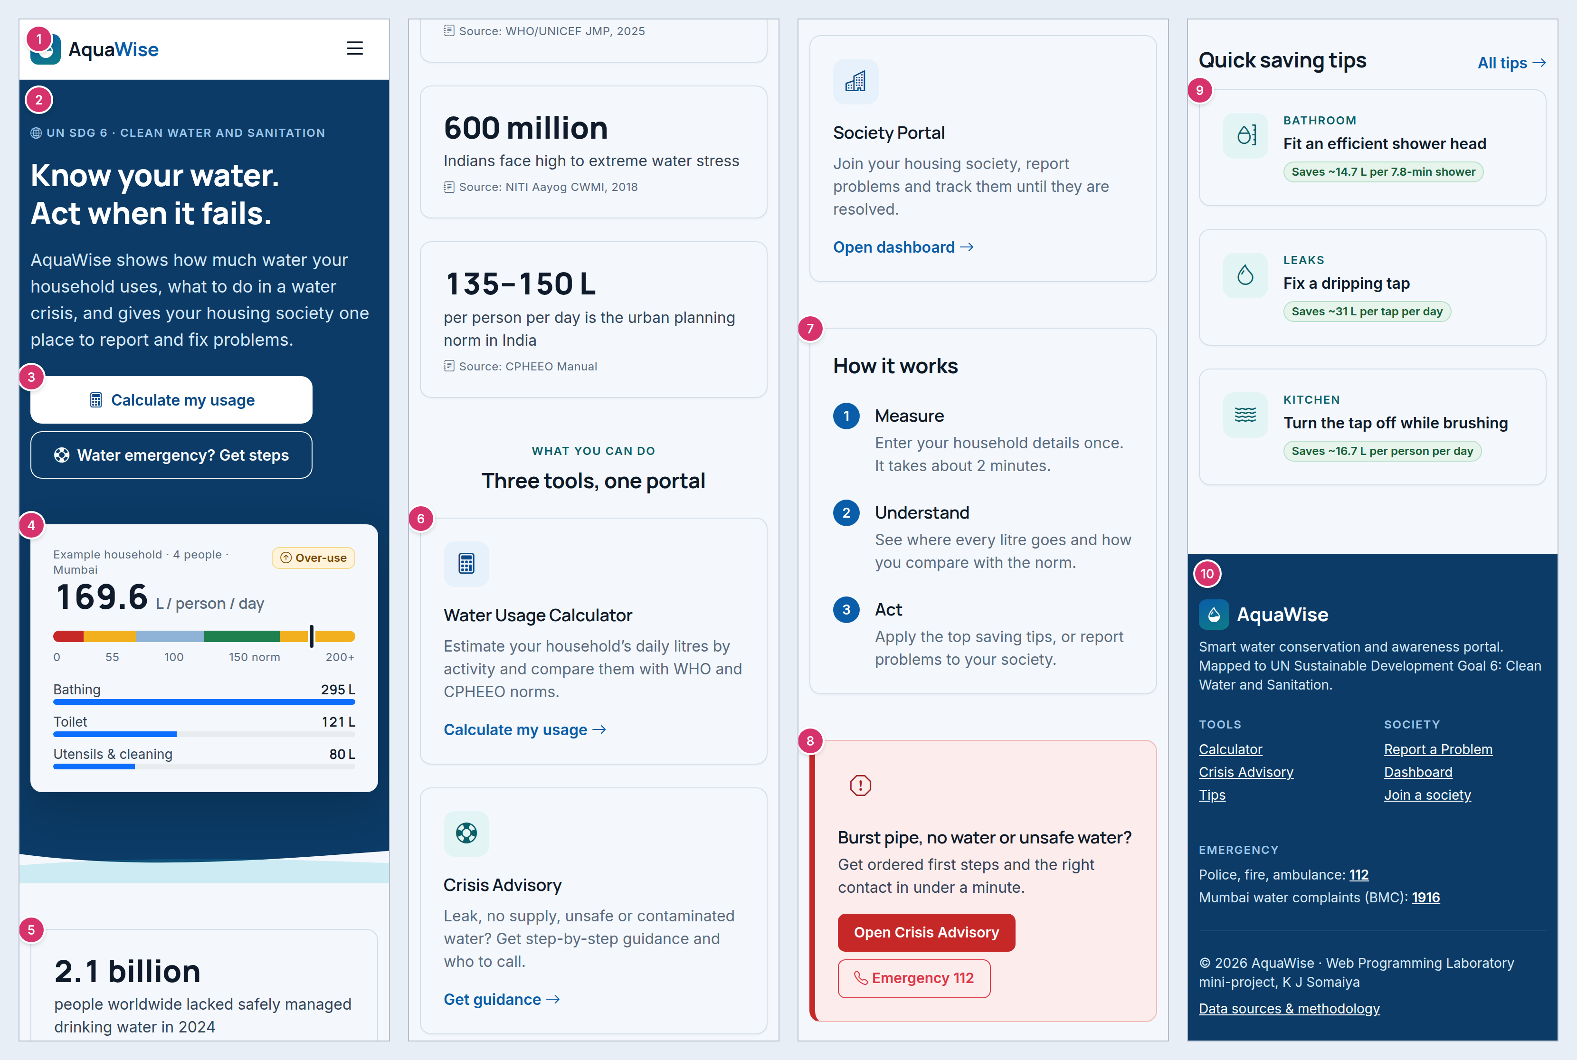
Figure 3. Home — mobile, 390 px (annotated; the long page is split into columns, read left to right).
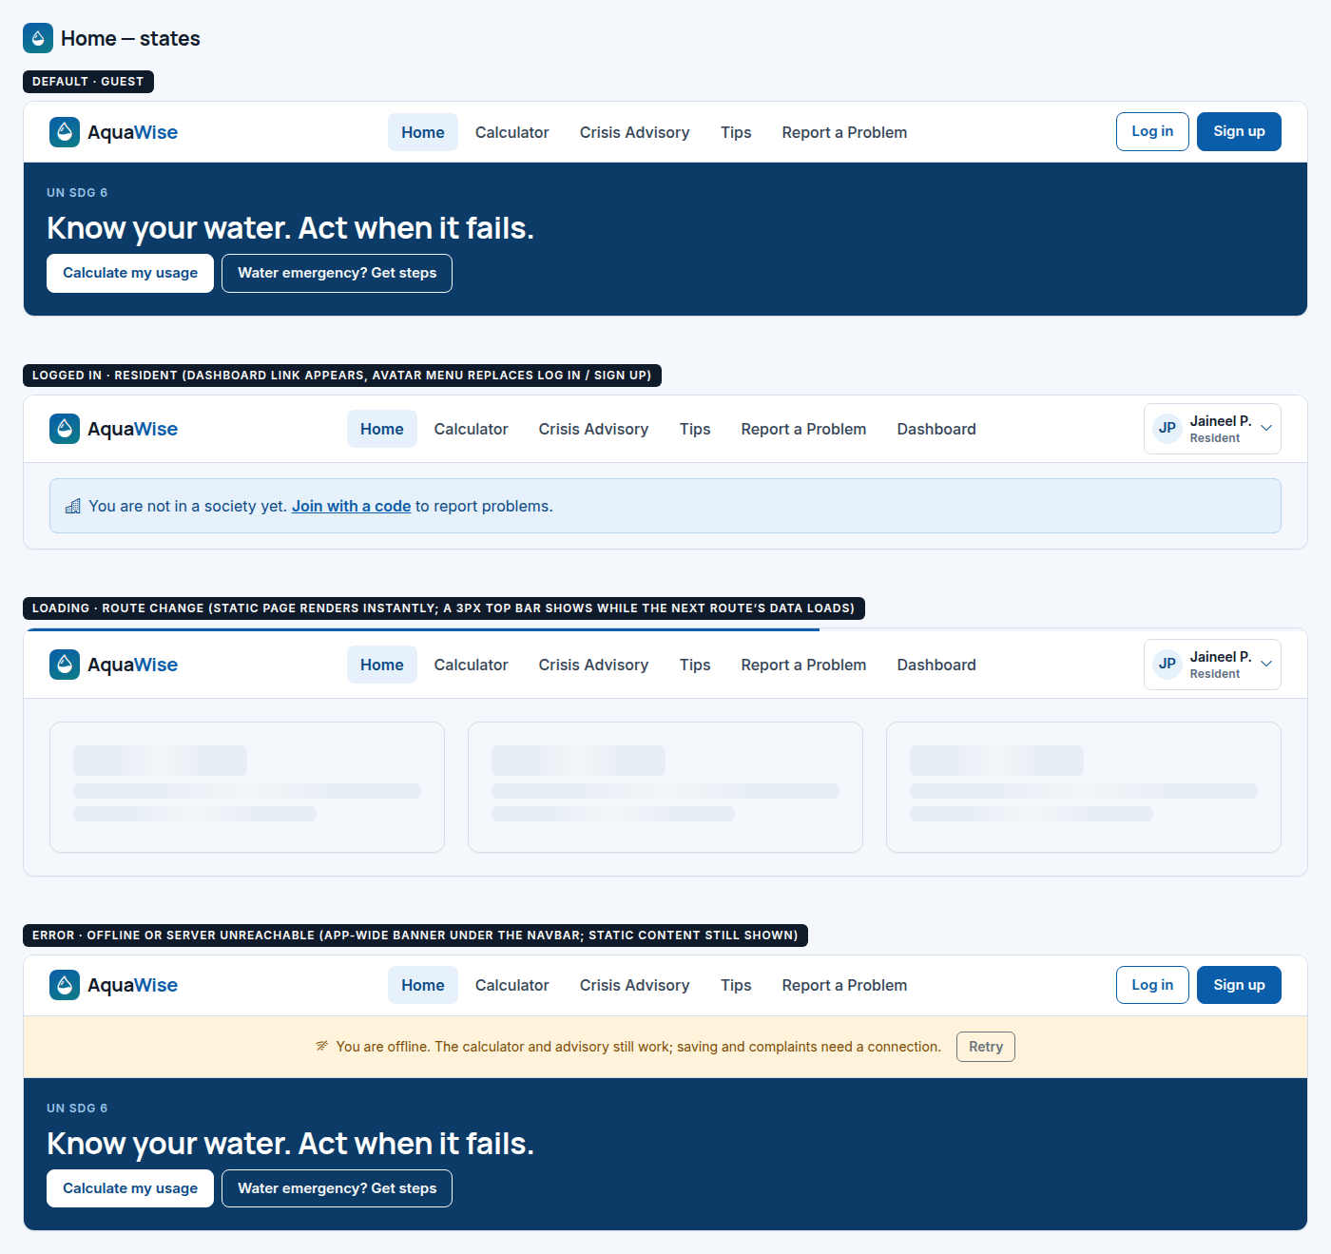
Figure 4. Home — states board.

6.2 Water Usage Calculator
Route | Access | Purpose
/calculator | Everyone (save and history need login) | Collect household details, compute daily litres by activity, classify per-capita use against the norm and suggest the biggest savings (FR-C1 to FR-C12).

Desktop layout (1440). Page header with breadcrumb, title and a right-aligned “Formula v1.0 · Sources & method” group. Body row: form card col-lg-7, results card col-lg-5 (sticky, top 80 px, so it stays visible while editing). History card full width below.
Mobile layout (390). Form first, then results, then history. Form sections stack; paired fields go 2-up (col-6) for Adults/Children, everything else full width. After Calculate the page scrolls smoothly to the result card. History hides the “Total / day” column.

Annotations
# | Element | Component | Behaviour and details
1 | Formula version + sources | Badge, Button | Shows formulaVersion; opens a modal listing every constant and its source (Section 7 of the requirements).
2 | Calculator form | CalculatorForm | One card, five sections split by <hr>. All defaults pre-filled (FR-C2).
3 | Household section | FormSection, NumberField, SelectField | Adults (1–20), Children (0–20), City type (sets the norm: 150 / 135 / 70 L).
4 | Bathing mode | SegmentedControl | Shower / Bucket / Both. Shows the shower fields, bucket fields, or both.
5 | Default with source | FieldHelp | Help text names the default and its source, with an info icon tooltip.
6 | Actions | Button | “Calculate” (primary, large) and “Reset to defaults” (link).
7 | Result card | ResultPanel | Header shows household size and city type. Sticky on desktop.
8 | Band alert | BandAlert | Band name + icon + one sentence with the gap to the norm. Colour from the band table.
9 | Usage gauge | UsageGauge | 0–200+ lpcd scale with zones at 20, 55, 100, N, 200 and a marker at the user’s value. Built from a div with a gradient and an absolutely positioned marker.
10 | Where it goes | ActivityBars | Eight activities sorted by litres, each a Bootstrap .progress bar scaled to the largest, with litres and %. No chart library needed.
11 | Biggest savings | SavingTipList | Top three changes with litres saved per day, and one line on the combined effect.
12 | Save | Button | Logged in: “Save to history” → disabled “Saved” after success. Guest: “Log in to save this result”.
13 | History | HistoryTable | Last 10 runs: date, total, per person, band badge, View (reloads inputs).

States
State | What the user sees
Empty | Result card shows an empty state: “Your result appears here”. History shows “No saved results yet”.
Loading | Result card switches to skeleton blocks; the button shows a spinner and “Calculating…”. Guests compute on the client instantly, so this is only for the server call.
Error | Validation: red field borders + messages, plus a summary alert at the top of the form with links to fields. Save failure: red toast, result stays on screen.
Success | Result appears; after saving, a green toast “Saved to history” and the button changes to “Saved”. A new row is added to History.

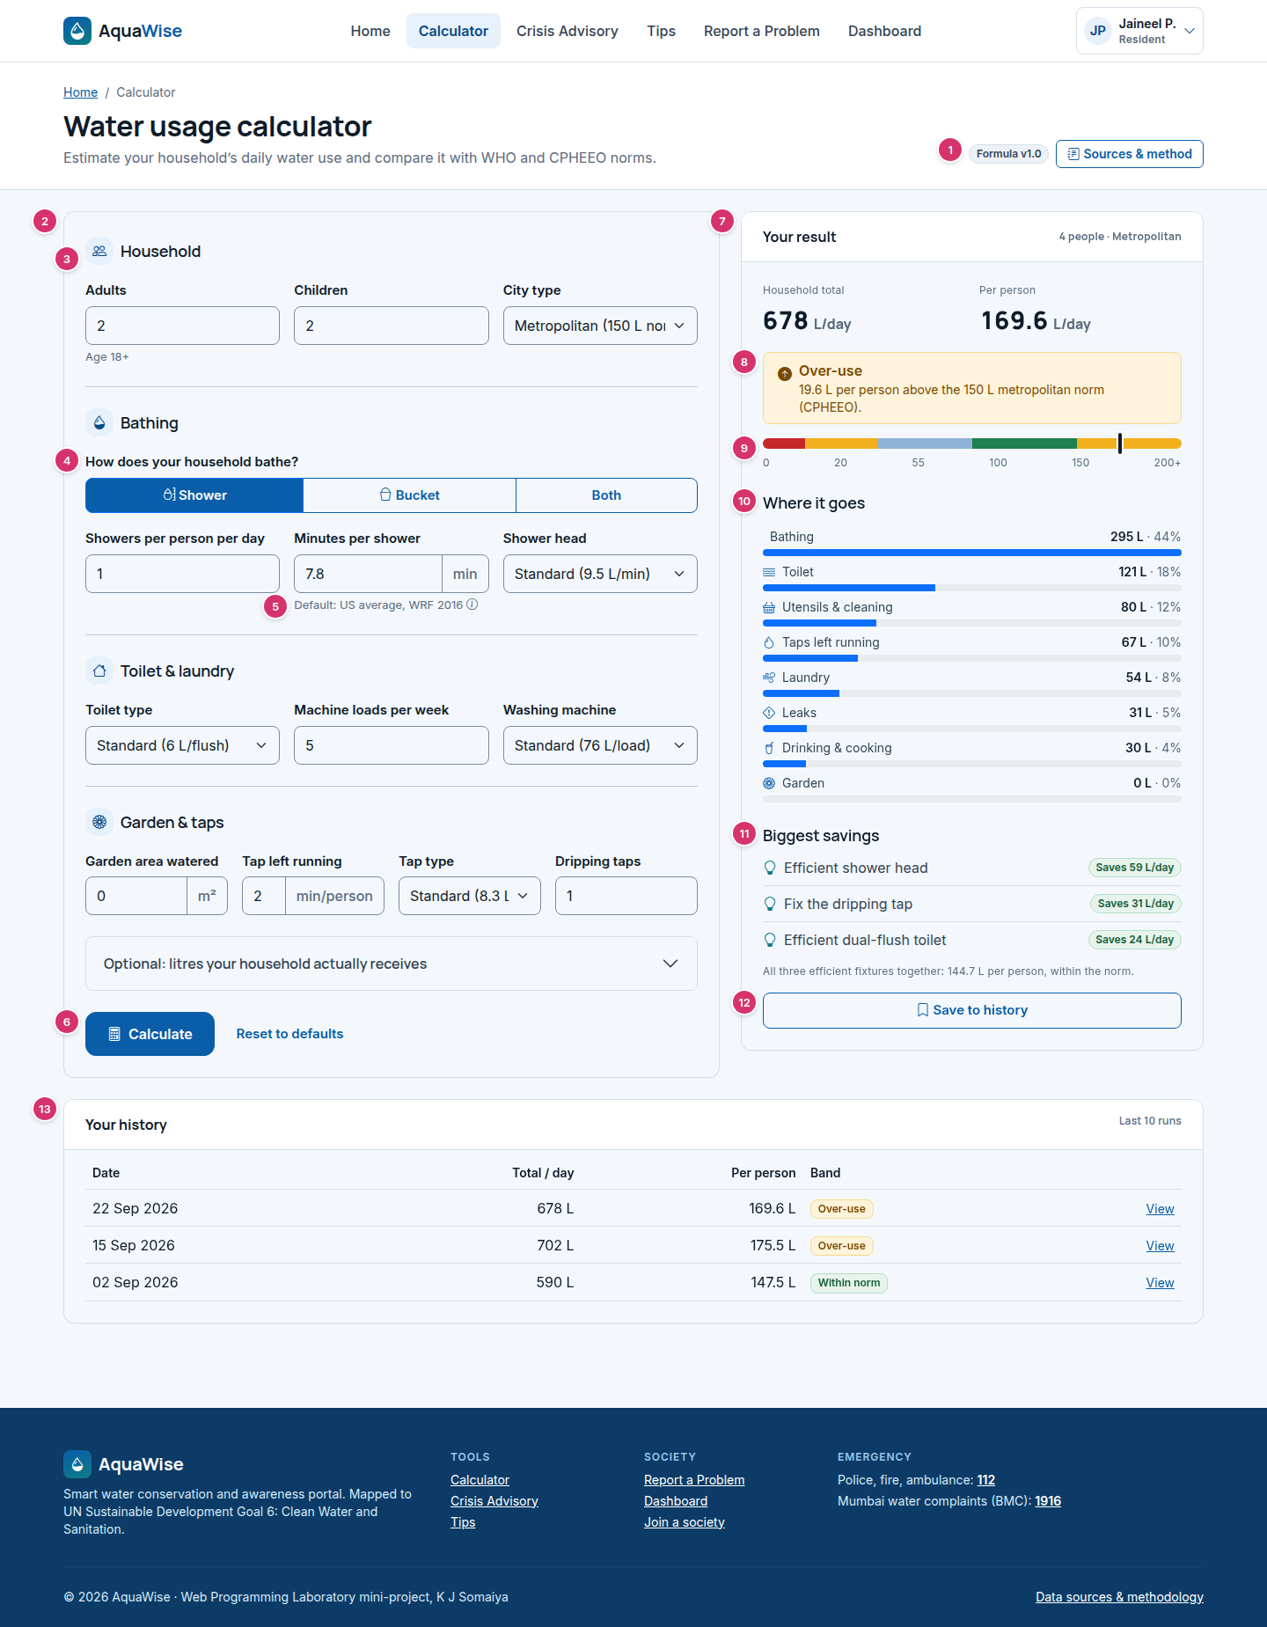
Figure 5. Water Usage Calculator — desktop, 1440 px (annotated).

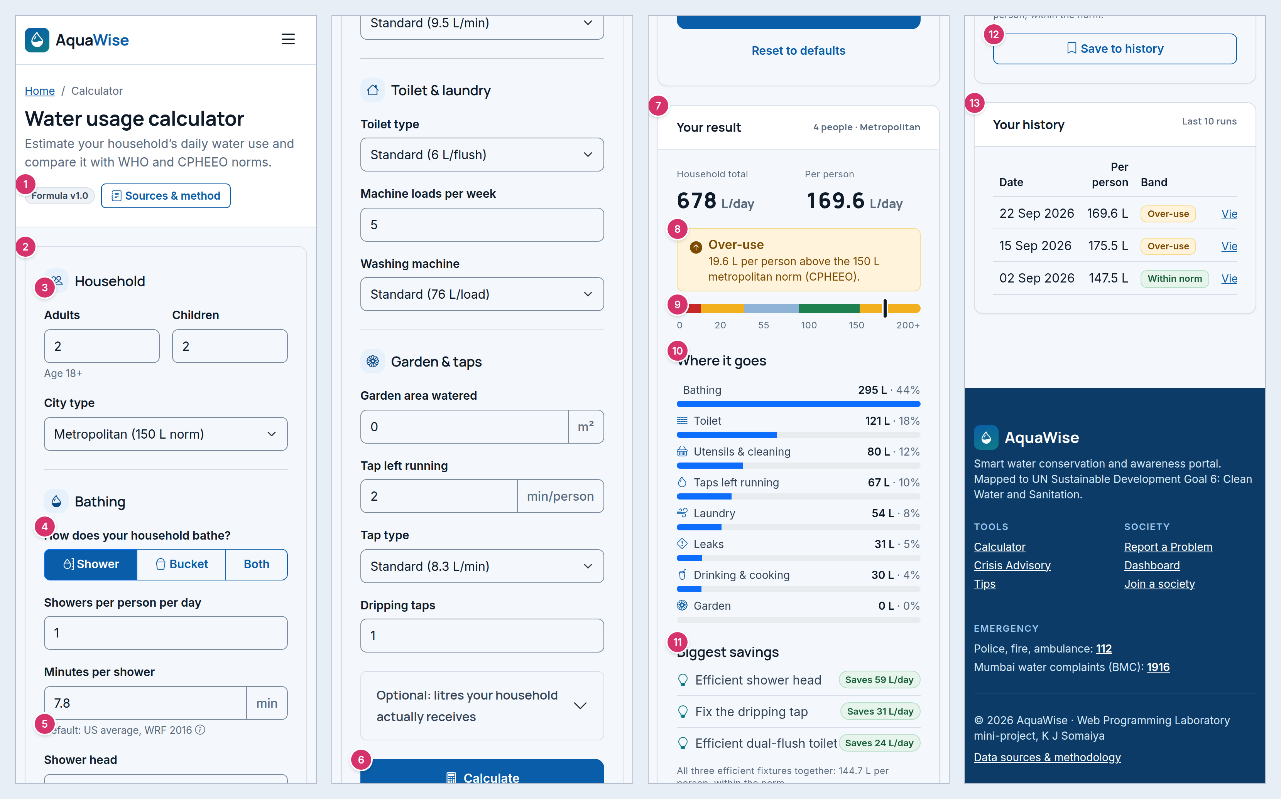
Figure 6. Water Usage Calculator — mobile, 390 px (annotated; the long page is split into columns, read left to right).
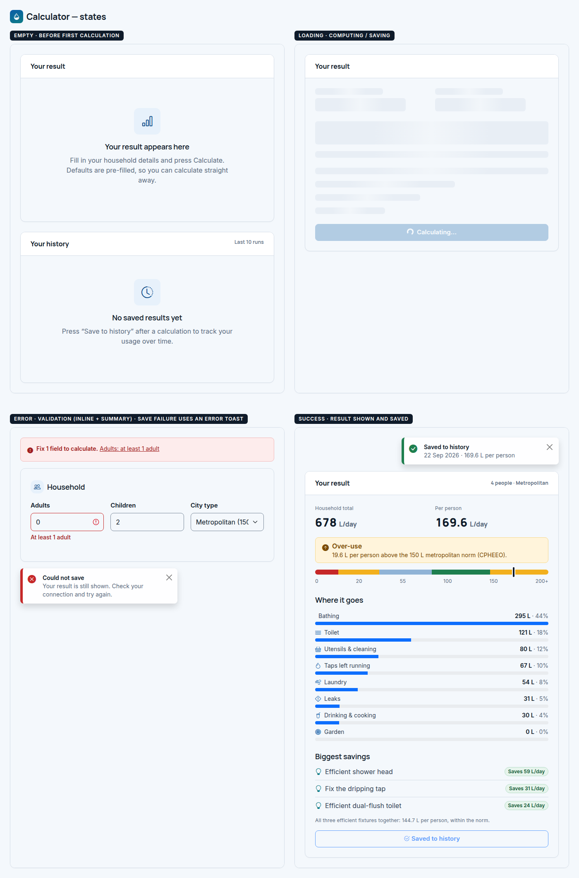
Figure 7. Water Usage Calculator — states board.

6.3 Crisis Advisory
Route | Access | Purpose
/advisory | Everyone (Report needs login + society) | Turn a water problem into ordered first steps and the right contacts in three quick steps (FR-A1 to FR-A9).

Desktop layout (1440). Page header. Thin emergency strip. Step 1: five problem cards in one row (row-cols-xl-5). Below: questions card col-lg-4 and result card col-lg-8. Inside the result: steps col-md-6 and contacts col-md-6.
Mobile layout (390). Problem cards 2-up (row-cols-2), the fifth on its own row. The questions card comes next, then the result. Steps and contacts stack; the action buttons go full width. The red “Call 112” button goes full width in the banner.

Annotations
# | Element | Component | Behaviour and details
1 | Immediate-danger strip | EmergencyStrip (slim) | Always visible above the tool: call 112 first if anyone is in danger.
2 | Step heading | StepHeading | “1 · What is the problem?” Steps are numbered in headings, not a separate stepper, to stay simple.
3 | Problem type cards | ProblemTypeCard ×5 | Radio-card group (role="radiogroup"). Selected: 2 px blue border, tint, check icon.
4 | Questions | QuestionGroup | 1–3 radio questions for the chosen type (from the rule table). “Get guidance” submits.
5 | Result card | AdvisoryResult | Header shows the severity badge and rule ID.
6 | Critical banner | EmergencyBanner | Only for critical rules: red banner with a large “Call 112” tel: button (FR-A5).
7 | Ordered steps | StepList | Numbered circles, one step per row, in stored order (FR-A3).
8 | Contacts | ContactCard ×n | Role, name, when to call, and a tel: button. Society contacts come from the user’s society; 112 is red.
9 | Actions | Button | “Report this to my society” (primary, opens Report pre-filled), Print, Copy steps.
10 | Disclaimer | Caption | General guidance, not professional help; rule-set version.

States
State | What the user sees
Empty | No problem selected: cards unselected, with an empty state under them: “Choose the problem you are facing”. Questions and result are hidden.
Loading | “Get guidance” shows a spinner (“Finding guidance…”); the result area shows skeleton steps.
Error | Rules failed to load: red alert “Advisory is temporarily unavailable” with Call 112 and Try again. The 112 strip is always visible.
Success | Result shown. Critical rules add the red banner. Guests see “Log in to report” instead of “Report this to my society”.

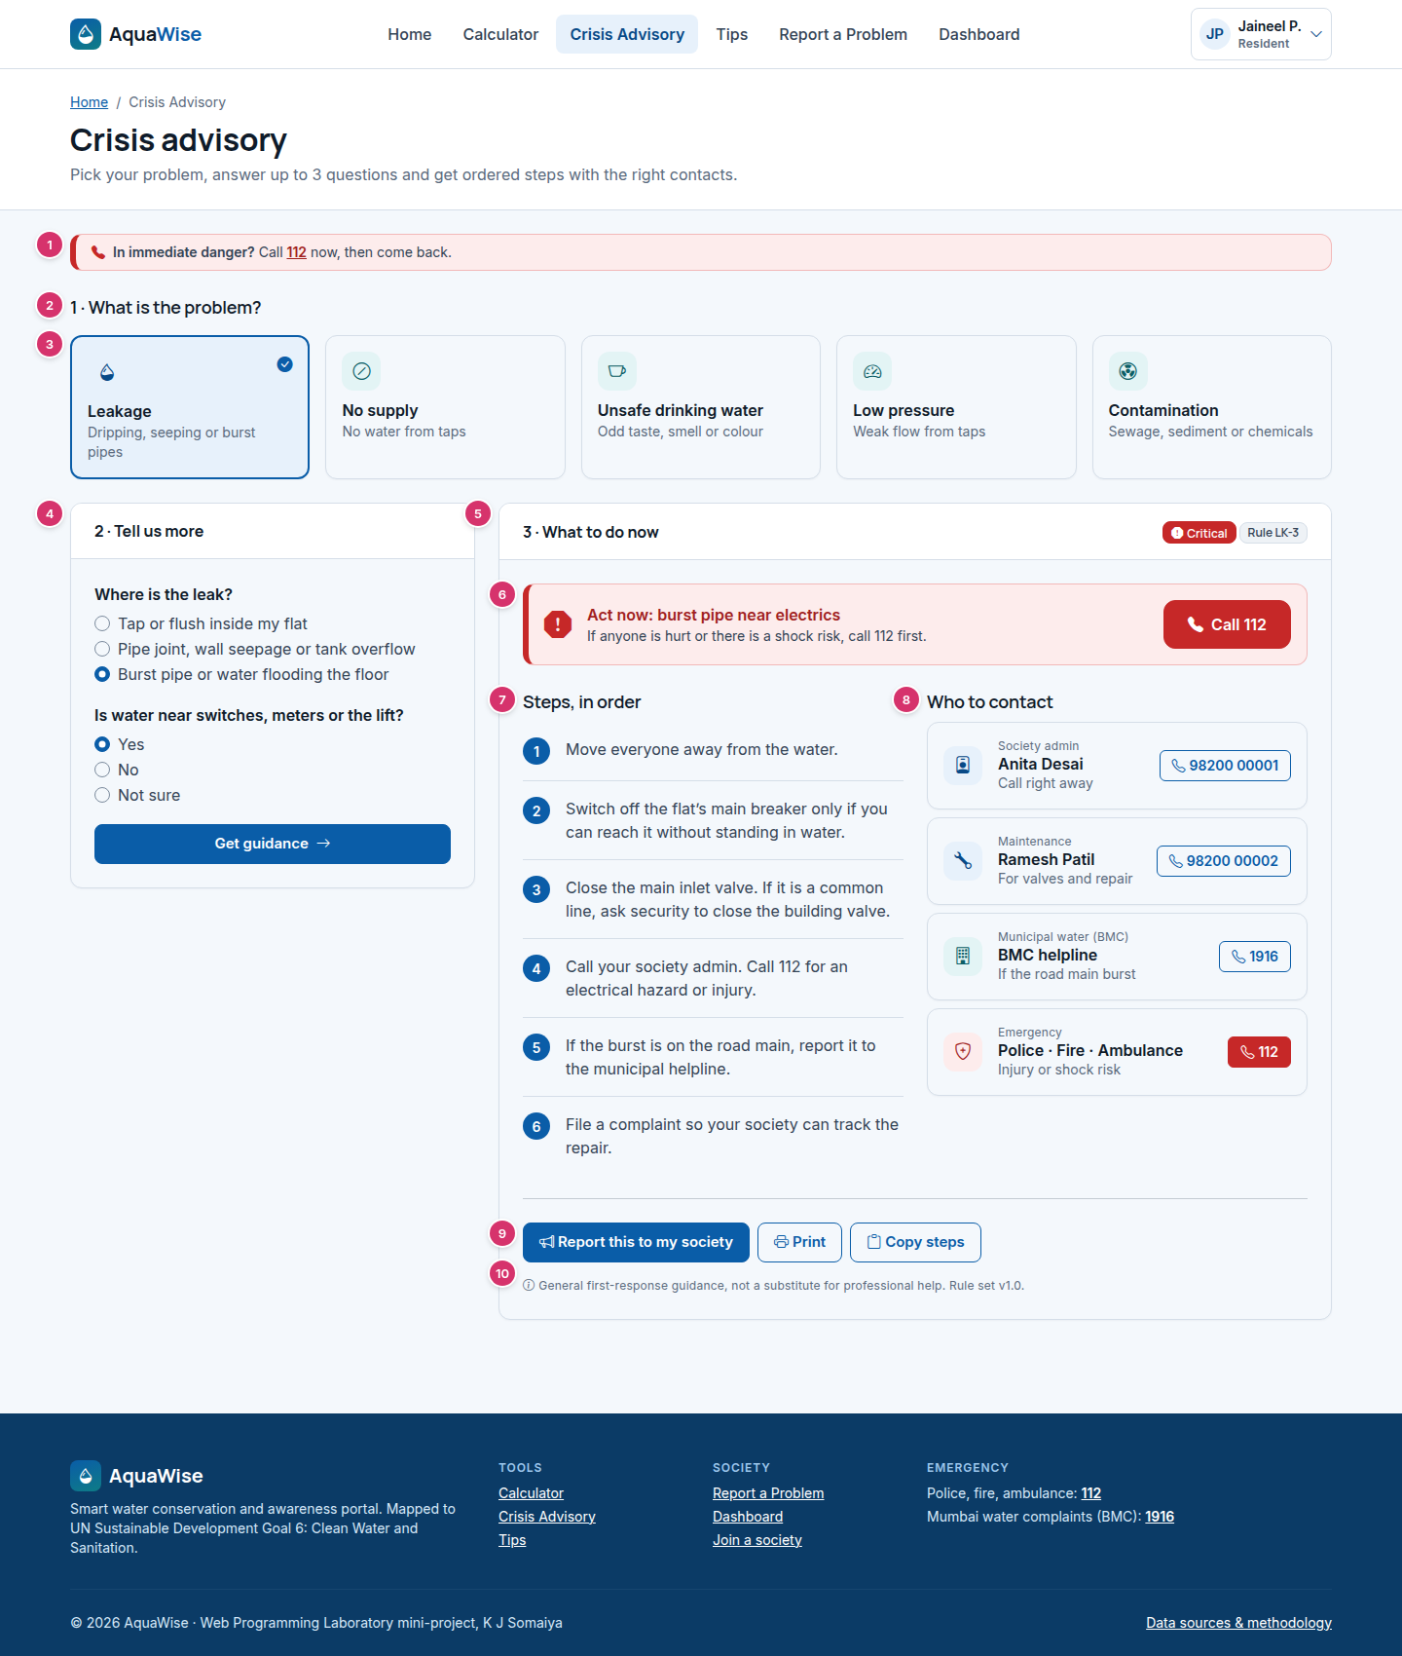
Figure 8. Crisis Advisory — desktop, 1440 px (annotated).

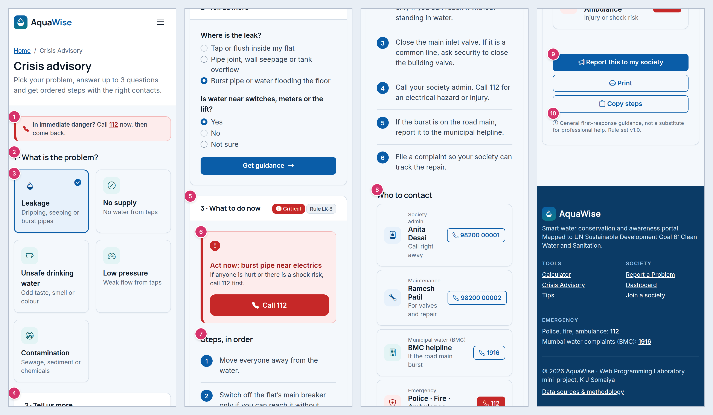
Figure 9. Crisis Advisory — mobile, 390 px (annotated; the long page is split into columns, read left to right).
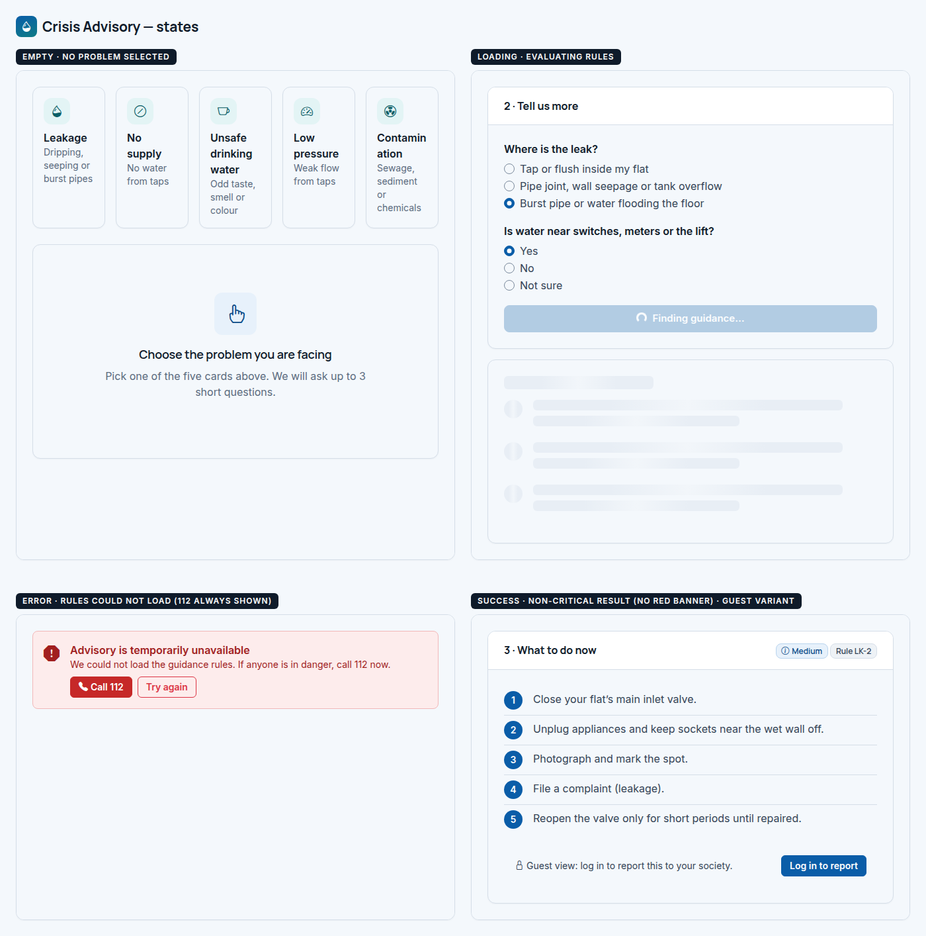
Figure 10. Crisis Advisory — states board.

6.4 Conservation Tips
Route | Access | Purpose
/tips | Everyone | A browsable list of practical changes, each with the litres it saves and its source, linked back to the calculator.

Desktop layout (1440). Page header with tip count. Toolbar row: category chips col-lg-7, search col-lg-3, sort col-lg-2. Featured banner full width. Tip grid row-cols-xl-3 (row-cols-md-2). Calculator CTA card at the bottom.
Mobile layout (390). Chips wrap onto two lines. Search and sort stack full width. The featured banner stacks its icon, text and button. Tip cards are one per row.

Annotations
# | Element | Component | Behaviour and details
1 | Search | SearchInput | Filters by title and text as you type (debounced 250 ms).
2 | Category chips | FilterChips | Single-select pill buttons: All, Bathroom, Kitchen, Laundry, Garden, Leaks, Society.
3 | Sort | SelectField | Most litres saved (default) or A–Z.
4 | Tip card | TipCard | Icon tile, category overline, title, one-sentence explanation, “Saves …” badge, source caption and a “Try in calculator” link.
5 | Featured tip | FeaturedTipBanner | Navy banner for the biggest single saving (old toilet, 83 L per person per day).
6 | Calculator CTA | CtaCard | Sends users to the calculator to rank tips for their own household.

States
State | What the user sees
Empty | No matches: “No tips match “…”” with a “Clear search and filters” button.
Loading | Skeleton tip cards (icon block, two text lines, badge block) in the same grid.
Error | Empty-state card with a cloud icon: “Tips could not load” + Retry.
Success | Filtered grid with a result line: “Showing 2 tips in Leaks, sorted by litres saved”.

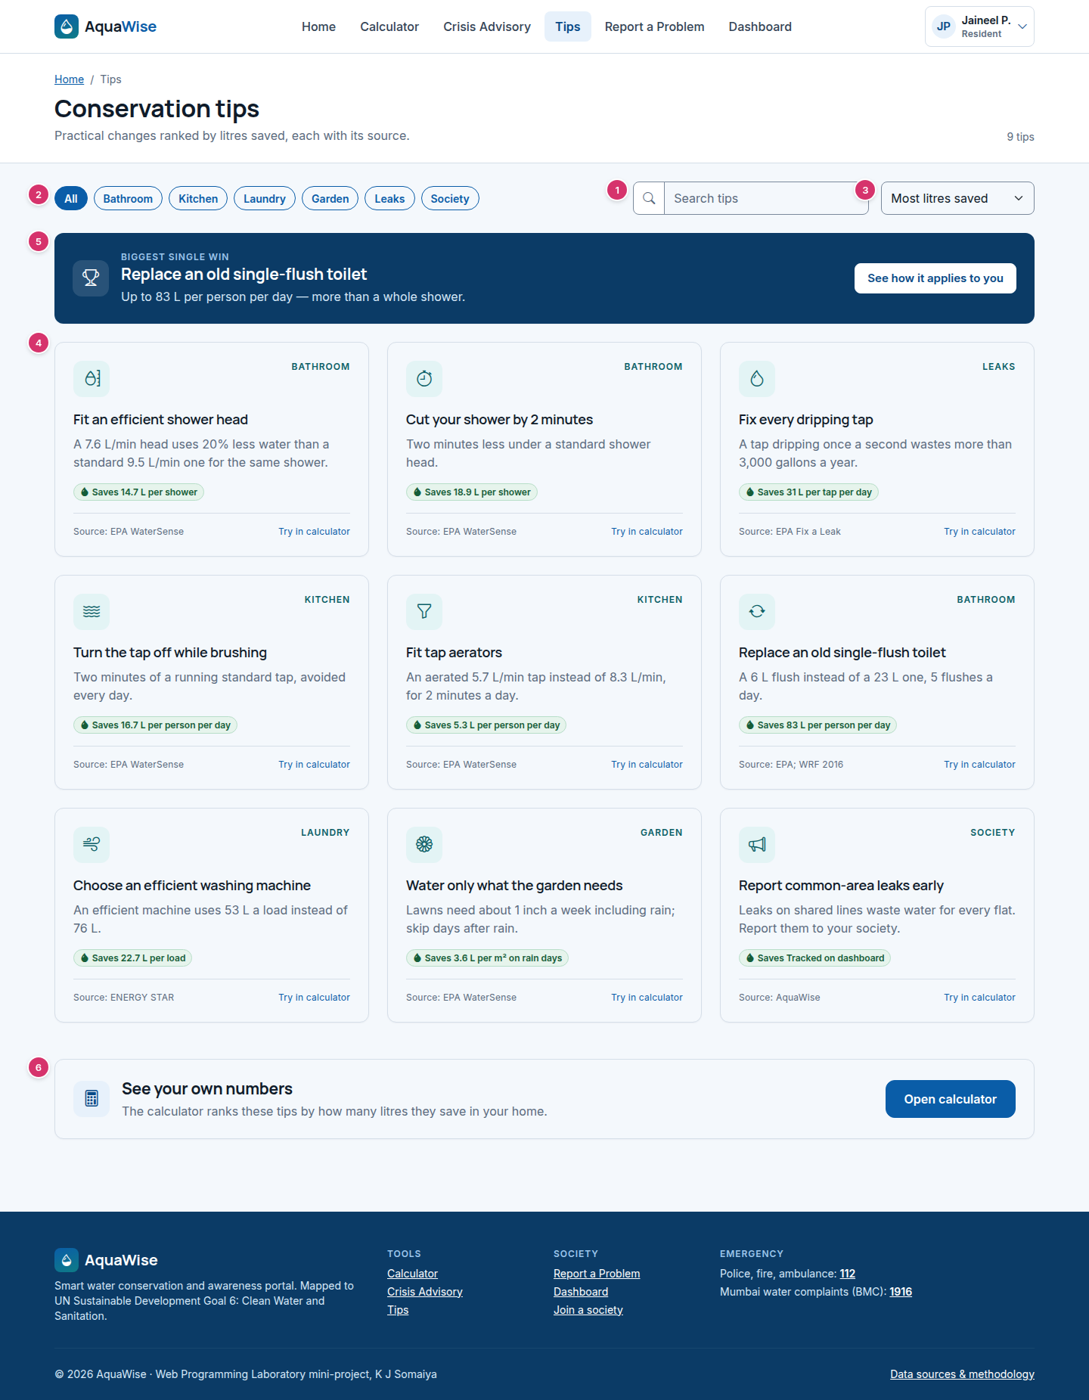
Figure 11. Conservation Tips — desktop, 1440 px (annotated).

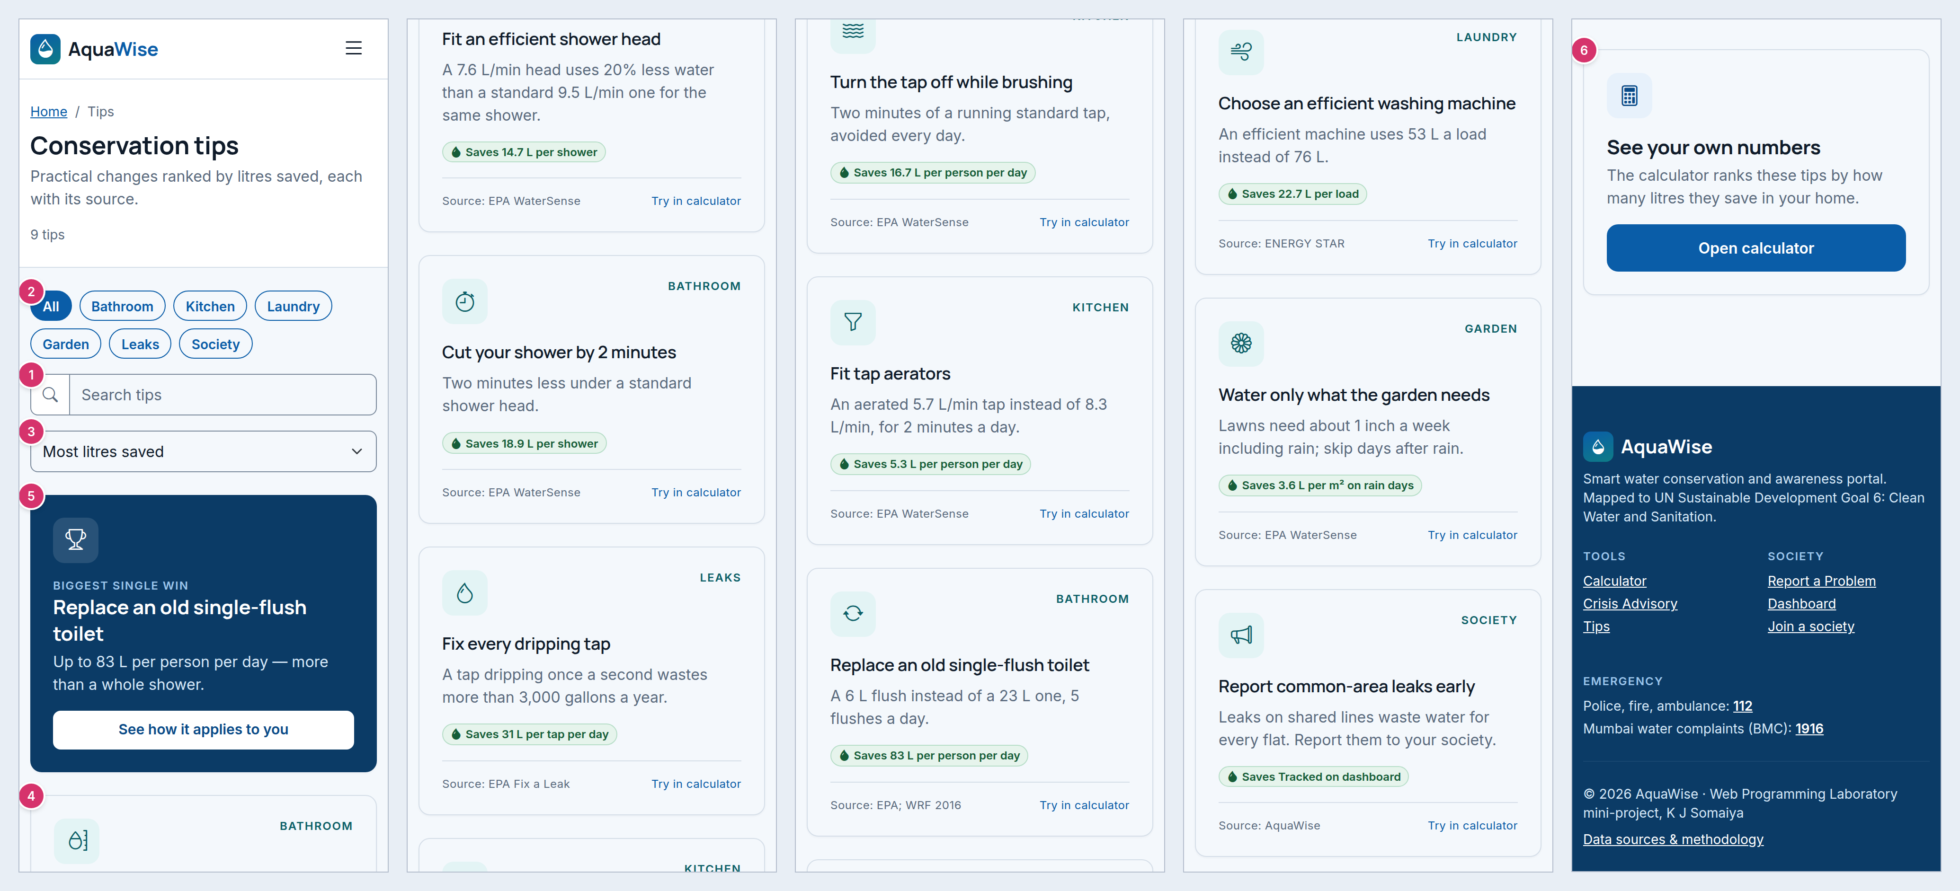
Figure 12. Conservation Tips — mobile, 390 px (annotated; the long page is split into columns, read left to right).
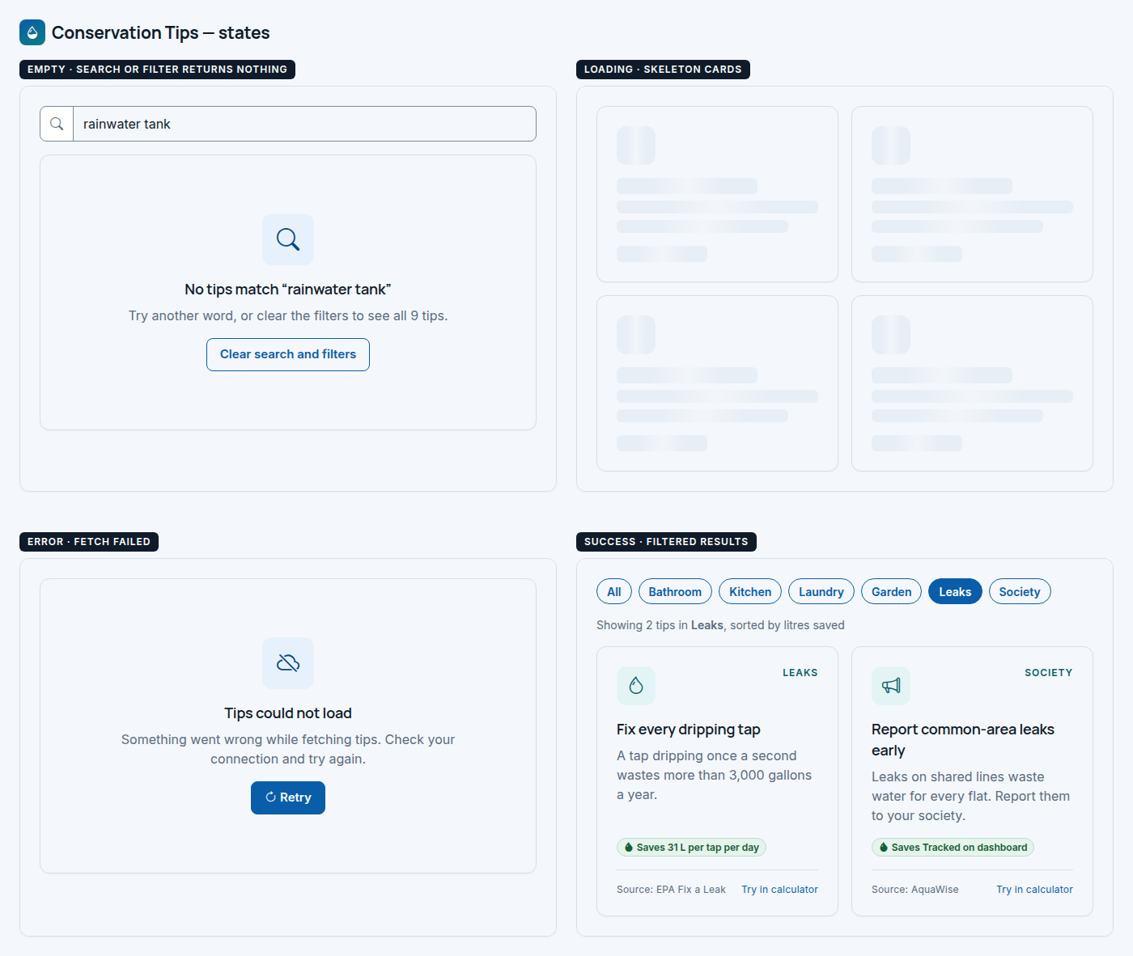
Figure 13. Conservation Tips — states board.

6.5 Report a Problem
Route | Access | Purpose
/report | Logged-in society members | File a complaint that is automatically routed to the right handler (FR-S9 to FR-S12).

Desktop layout (1440). Page header with a society/flat badge. Optional pre-fill alert. Form card col-lg-8; right column col-lg-4 with the routing preview, a “What happens next” timeline and an emergency note.
Mobile layout (390). The pre-fill alert, then the form, then the routing preview, timeline and emergency note. The severity segmented control keeps four equal buttons (Critical shows its icon). Submit goes full width.

Annotations
# | Element | Component | Behaviour and details
1 | Pre-fill notice | InlineAlert | Shown when coming from Advisory: names the rule (LK-2). Dismissible.
2 | Complaint form | ComplaintForm | One card; fields in the order people think: what, how bad, where, then details.
3 | Category | SelectField | Six categories. Changing it updates the routing preview live.
4 | Severity | SegmentedControl | Low / Medium / High / Critical, with help text defining Critical.
5 | Location | SelectField | Own flat, common area, overhead tank, underground tank, road main.
6 | Title | TextField | 5–80 characters with a hint.
7 | Description | TextArea + CharCounter | 10–1000 characters, live counter bottom right.
8 | Actions | Button | “Submit complaint” (primary, large) and Cancel (link).
9 | Routing preview | RoutingPreview | Shows who will receive it, based on society contacts; falls back to the society admin (FR-S12).
10 | What happens next | StatusTimeline | Active → In progress → Resolved, including the 7-day reopen rule.
11 | Emergency note | EmergencyStrip (compact) | A complaint is not an emergency call; 112 for danger.

States
State | What the user sees
Empty | Not in a society: empty state “Join your society to report problems” with a join-code input and a “create a new society” link. Not logged in: redirect to Login, then back.
Loading | Submit shows a spinner (“Submitting…”) and all fields are disabled.
Error | Red alert above the form: “Could not file your complaint. Your text is kept.” Invalid fields are marked.
Success | The form is replaced by a confirmation card: big complaint number (AQW-2026-0019), the assigned contact, and “View on dashboard” / “Report another problem”.

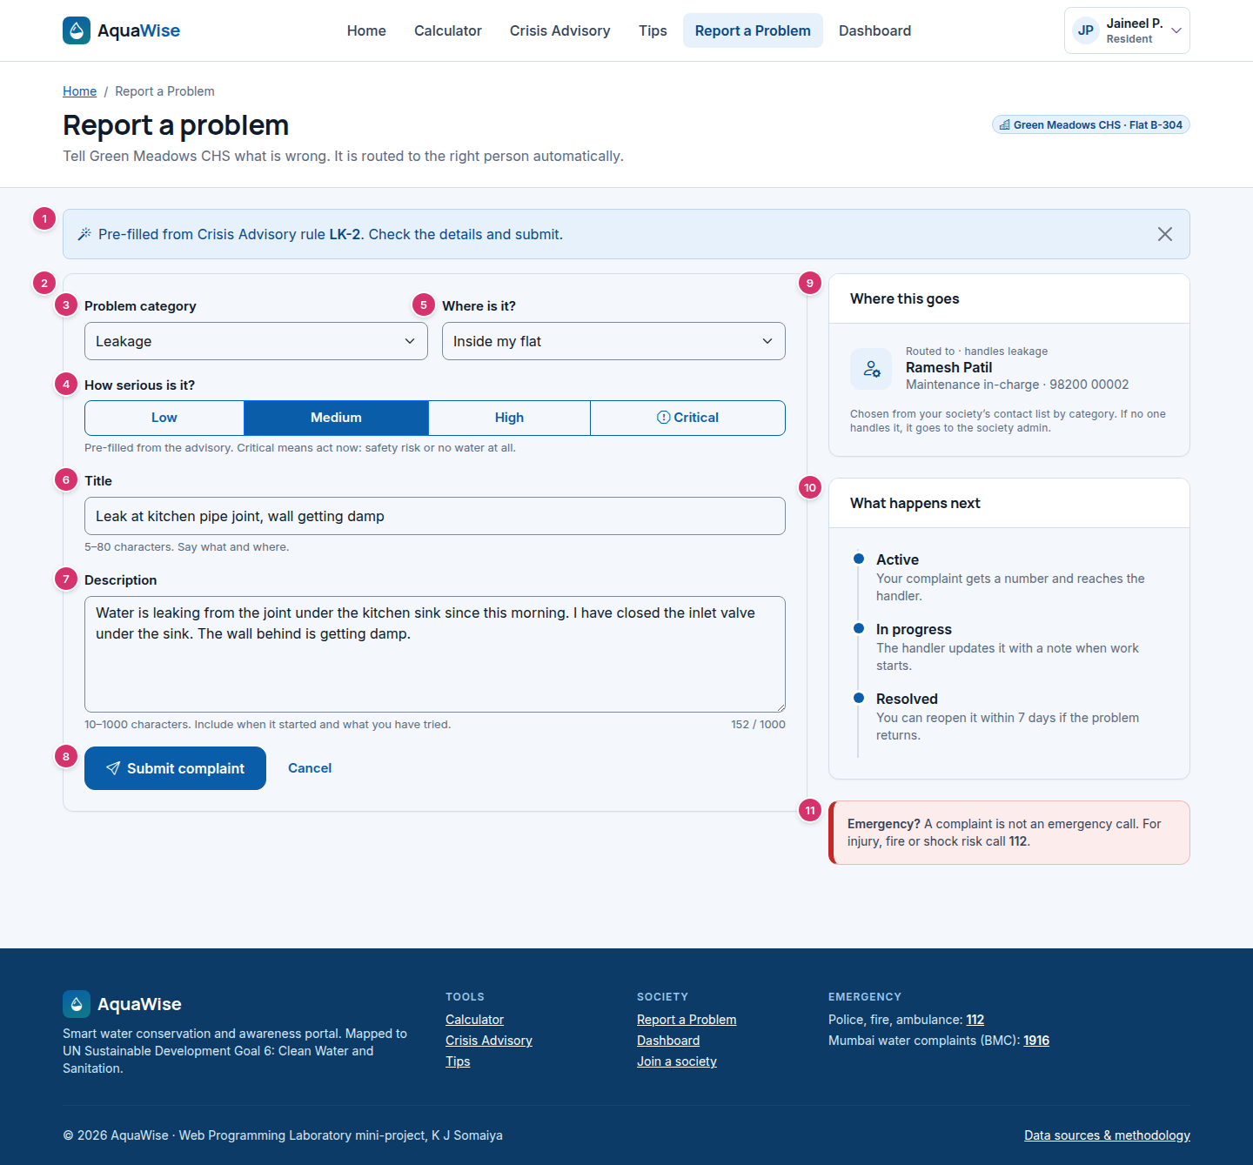
Figure 14. Report a Problem — desktop, 1440 px (annotated).

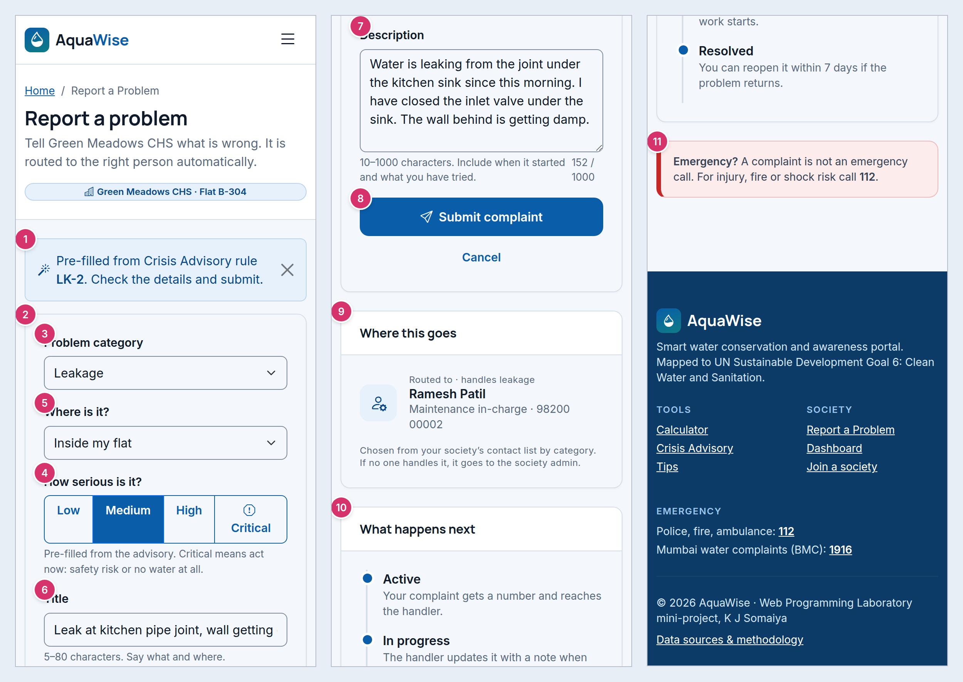
Figure 15. Report a Problem — mobile, 390 px (annotated; the long page is split into columns, read left to right).
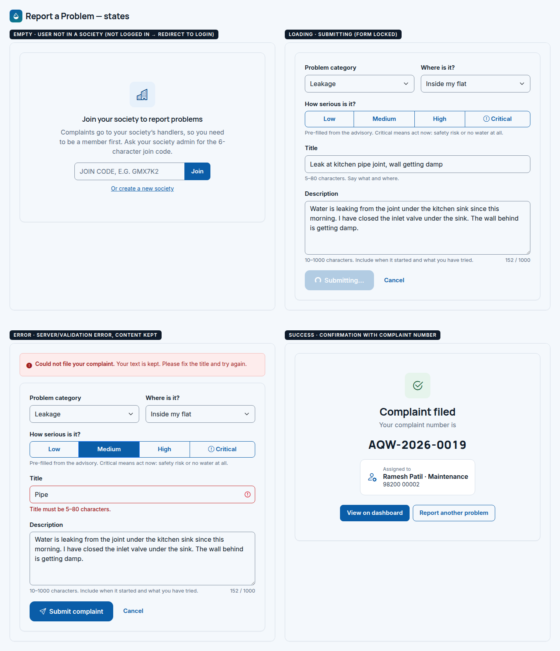
Figure 16. Report a Problem — states board.

6.6 Society Dashboard
Route | Access | Purpose
/dashboard | Logged-in society members (admin controls for the society admin) | See every complaint in the society by status, open one, and — for the admin — move it forward with a note (FR-S13 to FR-S17).

Desktop layout (1440). Page header: society name, area, member count; right: join code with copy/regenerate (admin) and “Report a problem”. Three stat cards (col-4 each). Main row: complaints card col-xl-8 (toolbar, table, pagination) and a right column col-xl-4 with the complaint detail panel and local contacts.
Mobile layout (390). Header items stack; stat cards stay 3-up but compact. The toolbar stacks: status pills scroll horizontally, then category and search. The table becomes a list of complaint cards (d-md-none). Tapping a card opens the detail panel as a bottom .offcanvas (the wireframe shows that panel stacked below the list so its content is visible). Contacts come last.

Annotations
# | Element | Component | Behaviour and details
1 | Join code | JoinCodeChip | Monospace code with Copy (all members) and Regenerate (admin only, with a confirm dialog).
2 | Report CTA | Button | Primary “Report a problem” → Report screen.
3 | Stat cards | StatCard ×3 (filter) | Active / In progress / Resolved counts. Clicking one filters the list and shows it as selected.
4 | Status pills | NavPills | All / Active / In progress / Resolved with counts. Scrolls horizontally on mobile.
5 | Category + search | SelectField, SearchInput | Small (sm) controls to keep the toolbar compact.
6 | Complaint list | ComplaintTable / ComplaintCardList | Desktop table: No., title + category/location, severity, status, assigned, filed. The selected row is highlighted. Mobile: cards.
7 | Detail panel | ComplaintDetail | Number, title, badges, description, assignee. Desktop: side panel. Mobile: offcanvas.
8 | History | StatusTimeline | Every status change with who, when and the note (FR-S14). Newest first.
9 | Update status (admin) | StatusUpdateForm | Only allowed next statuses; note required; primary button. Hidden for residents; the filer instead sees “Reopen” within 7 days.
10 | Local contacts | ContactsPanel | Society contacts with tel: links; “Manage” (admin) opens a modal to edit.
11 | Pagination | Pagination | 20 per page (NFR-P4), with a “Showing 1–20 of N” label.

States
State | What the user sees
Empty | Stats show 0 and the list shows “No complaints yet — your society is all clear” + “Report a problem”. Filtered empty: “No in-progress complaints” + “Show all”.
Loading | Skeleton stat cards and five skeleton table rows.
Error | List failed: empty-state card “Could not load complaints” + Retry. Invalid status change: red toast with the reason.
Success | Green toast “Status updated to Resolved”; the row’s badge and the counts update without reloading.

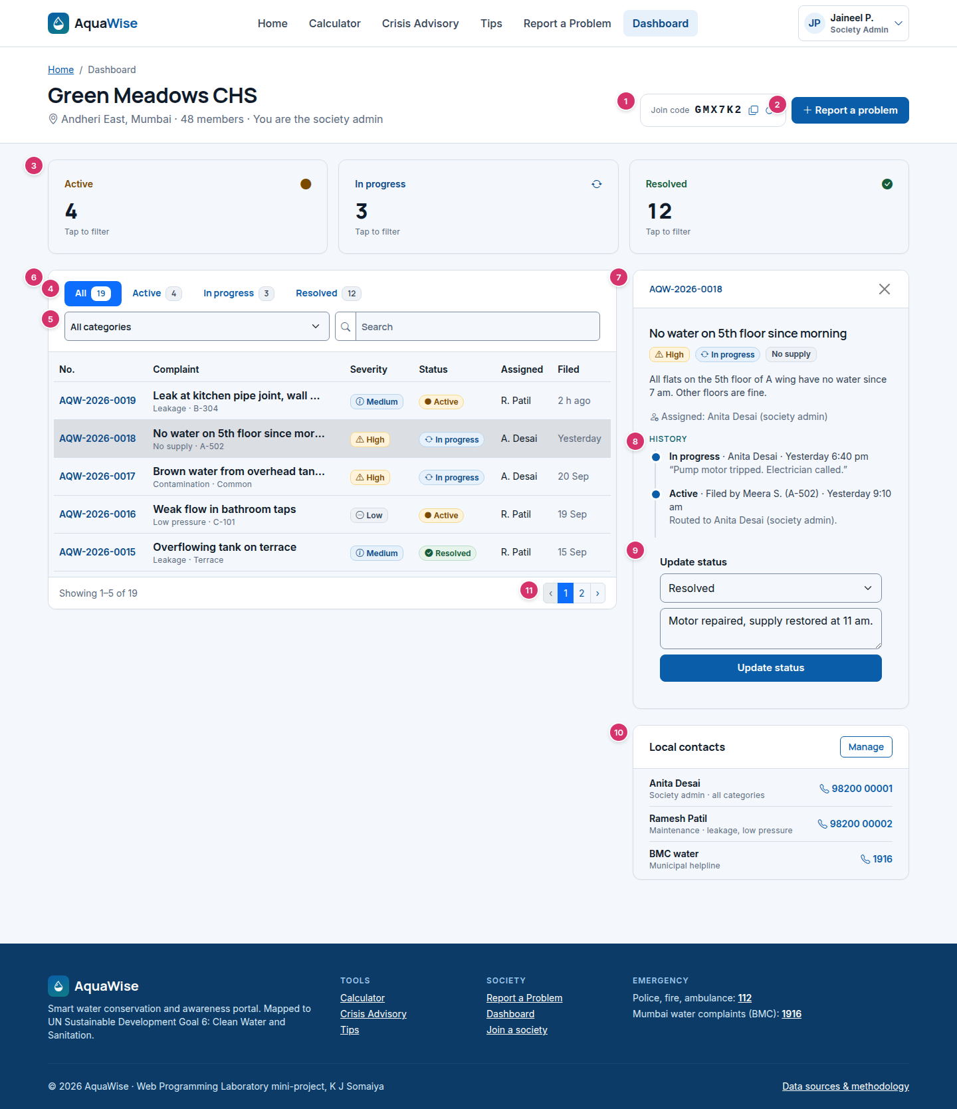
Figure 17. Society Dashboard — desktop, 1440 px (annotated).

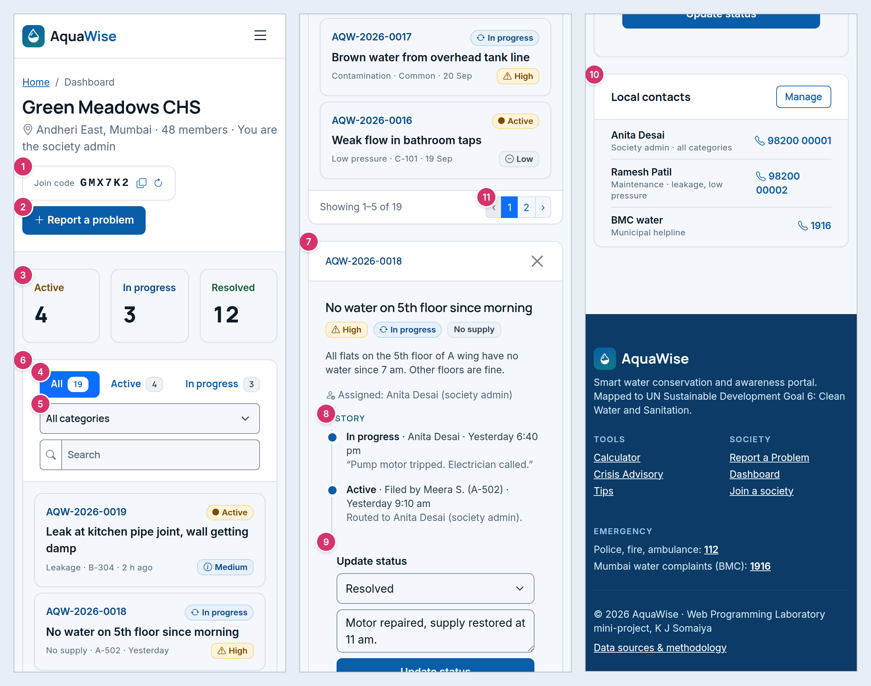
Figure 18. Society Dashboard — mobile, 390 px (annotated; the long page is split into columns, read left to right).
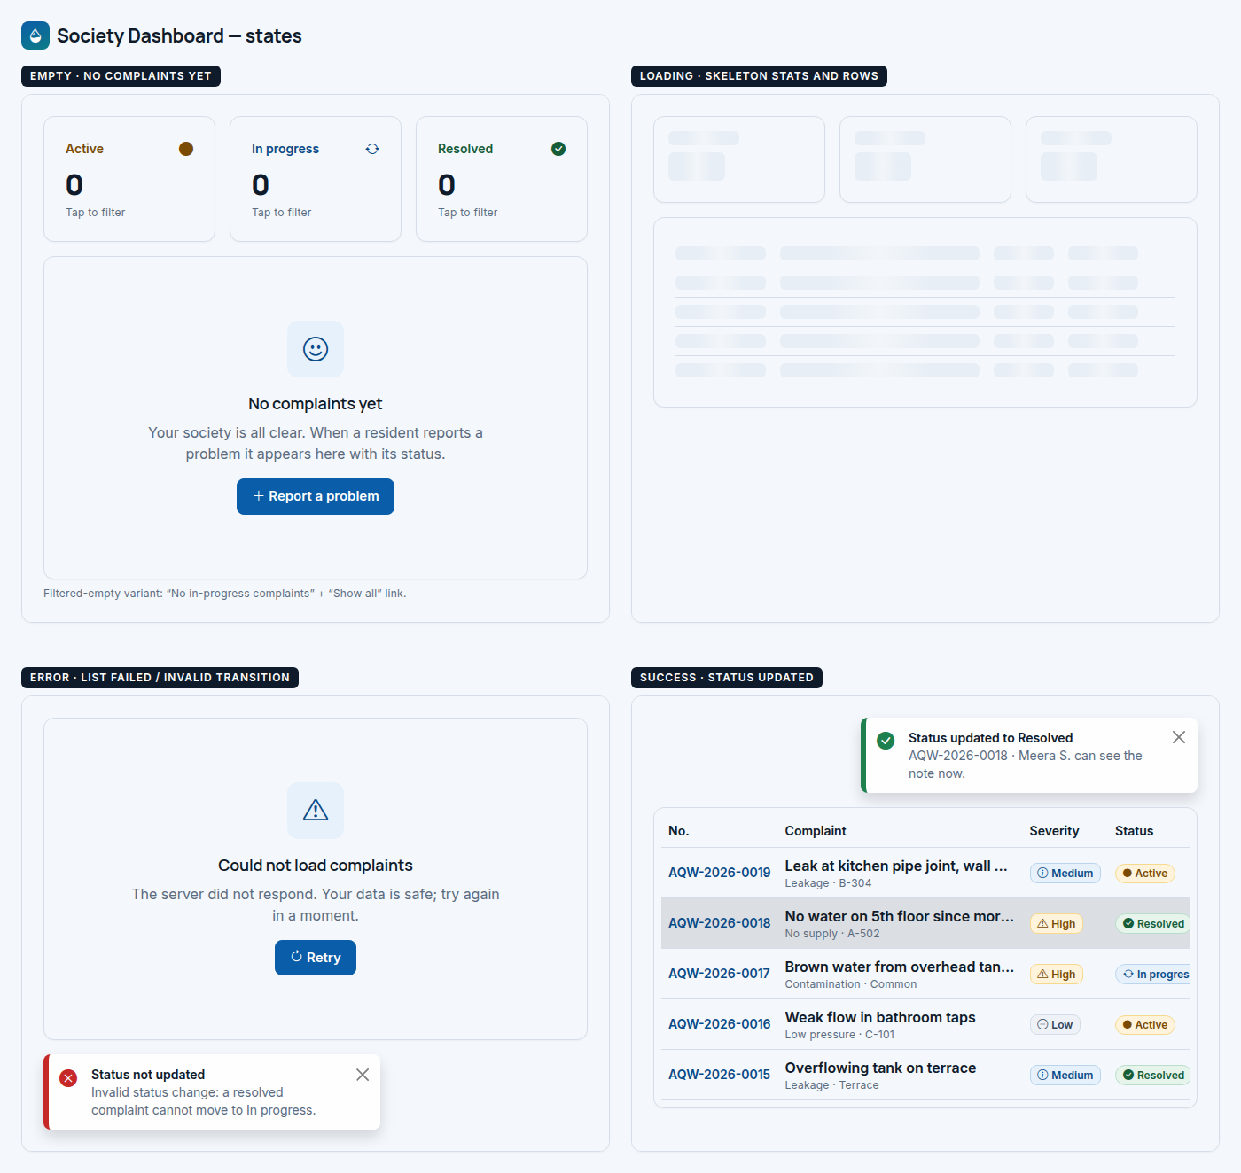
Figure 19. Society Dashboard — states board.

6.7 Login / Signup
Route | Access | Purpose
/login, /signup | Guests | Log in or create an account with minimal friction and clear, safe error messages (FR-S1 to FR-S3, NFR-S4).

Desktop layout (1440). Full-height split: col-lg-6 navy brand panel (logo, headline, three benefits) and col-lg-6 surface panel with the auth card centred (max 440 px). No main navbar; “Back to home” link below the card.
Mobile layout (390). The brand panel shrinks to a navy header strip with the logo only. The auth card takes the full width with 16 px side padding. Buttons are full width.

Annotations
# | Element | Component | Behaviour and details
1 | Brand panel | AuthBrandPanel | Navy panel with three benefits. Hidden text on mobile, logo only.
2 | Auth card | AuthCard | Title and subtitle change with the tab.
3 | Tabs | NavTabs | “Log in” / “Sign up”, each with its own route so links can go straight to sign up.
4 | Password field | PasswordField | Show/hide toggle button inside an input group (aria-pressed).
5 | Submit | Button | Full-width large primary button.
6 | Switch link | TextLink | “New to AquaWise? Create an account” (and the reverse on sign up).

States
State | What the user sees
Empty | Login: empty email and password. Sign up: name, email, +91 mobile, password with a live rules checklist (8–64 characters, a letter, a number).
Loading | Button shows “Logging in…” with a spinner and is disabled.
Error | 401: generic red alert “Invalid email or password” (does not say which). 429: amber alert “Too many attempts. Try again in 15 minutes.” Sign up: field error for an already-registered email with a Log in link.
Success | Login: redirect to Dashboard (or back to the page that asked). Sign up: green toast “Account created” and a “Join your society” step with a code input and Skip.

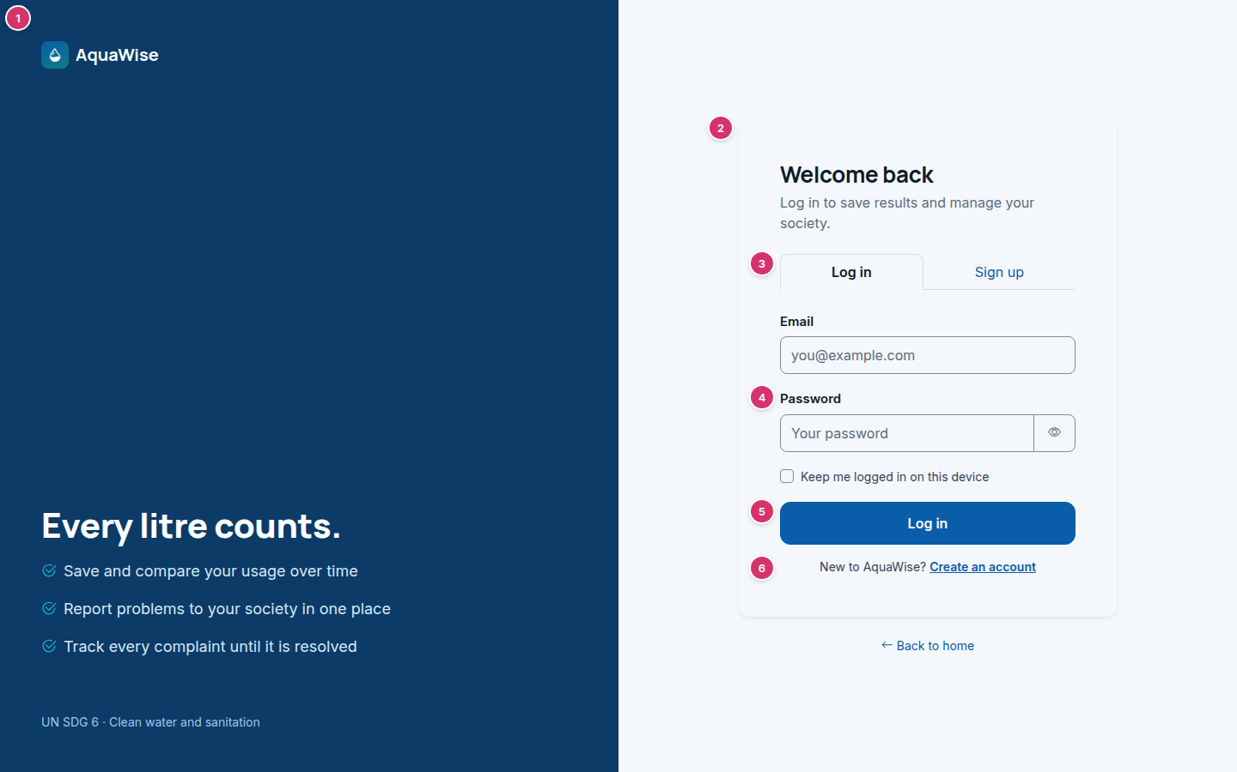
Figure 20. Login / Signup — desktop, 1440 px (annotated).

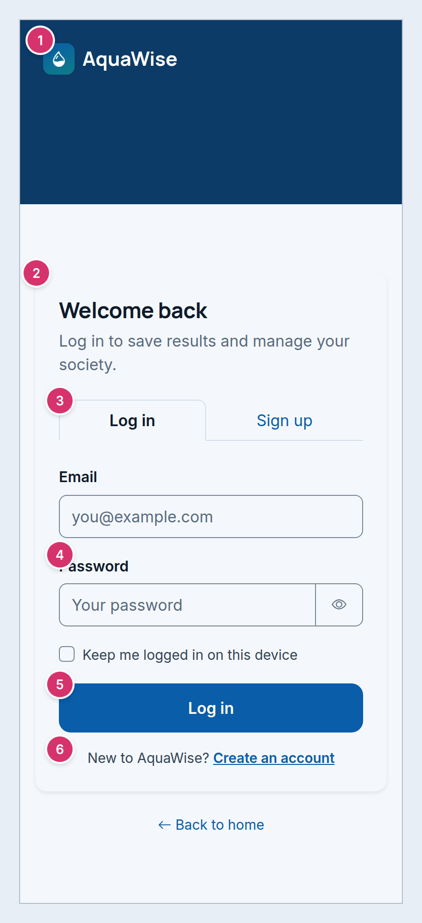
Figure 21. Login / Signup — mobile, 390 px (annotated; the long page is split into columns, read left to right).
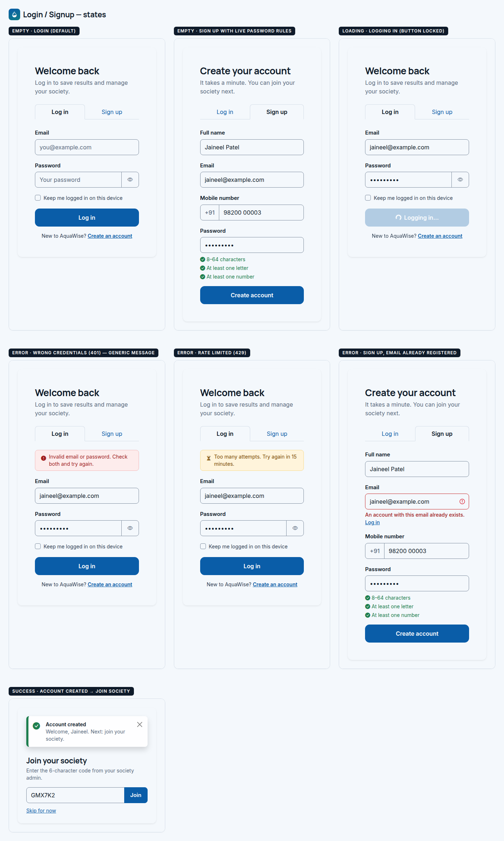
Figure 22. Login / Signup — states board.

7. Component inventory (React)
54 reusable components. Each wraps Bootstrap classes (react-bootstrap is optional; plain className works). Suggested folder: src/components/<group>/<Name>.jsx.
Group | Component | Key props | Used on | Bootstrap base
Layout | AppNavbar | active, user, role | All except auth | navbar, offcanvas, dropdown
Layout | AppFooter | — | All except auth | grid, list-unstyled
Layout | PageHeader | title, subtitle, breadcrumb, actions | Calculator, Advisory, Tips, Report, Dashboard | breadcrumb, flex utilities
Layout | ProtectedRoute | requireSociety, requireRole | Report, Dashboard | — (react-router)
Layout | AuthLayout / AuthBrandPanel | children | Login / Signup | grid, min-vh-100
Feedback | EmptyState | icon, title, text, action | All data screens | text-center, button
Feedback | Skeleton | width, height, variant (text/card/row) | All data screens | custom .aw-skeleton
Feedback | InlineAlert | variant, icon, children, dismissible | Report, Calculator, Auth | alert
Feedback | ToastHost / useToast | variant, title, text | Global | toast, toast-container
Feedback | EmergencyStrip | size (full/slim/compact) | Home, Advisory, Report | custom .aw-emergency
Feedback | OfflineBanner | onRetry | Global | alert
Forms | NumberField | label, value, unit, min, max, step, help, error | Calculator | form-control, input-group
Forms | SelectField | label, options, value, help, size | Calculator, Report, Tips, Dashboard | form-select
Forms | TextField / TextArea | label, value, maxLength, counter, error | Report, Auth | form-control
Forms | SegmentedControl | name, options, value, onChange | Calculator, Report | btn-group, btn-check
Forms | RadioGroup | legend, options, value | Advisory | form-check
Forms | PasswordField | value, showRules | Auth | input-group, button
Forms | SearchInput | value, onChange, debounceMs | Tips, Dashboard | input-group
Forms | FormSection | icon, title, children | Calculator | custom heading
Display | Button (wrapper) | variant, size, icon, loading | All | btn
Display | StatusBadge | status | Dashboard, Report | badge rounded-pill
Display | SeverityBadge | severity | Advisory, Report, Dashboard | badge
Display | BandBadge / BandAlert | band, lpcd, norm | Calculator, Home | badge, alert
Display | StatCard | label, value, icon, selected, onClick | Home, Dashboard | card
Display | FeatureCard | icon, title, text, to | Home | card, stretched-link
Display | IconTile | icon, tone (blue/teal/red) | Many | custom .aw-icon-tile
Display | StepList | steps[], numbered | Home, Advisory | list-group
Display | StatusTimeline | items[] | Report, Dashboard | custom .aw-timeline
Display | ContactCard / ContactsPanel | role, name, phone, when, tone | Advisory, Dashboard, Report | card, list-group
Calculator | CalculatorForm | values, onChange, onSubmit, errors | Calculator | card, grid
Calculator | ResultPanel | result, saved, loggedIn, onSave | Calculator | card, sticky
Calculator | UsageGauge | lpcd, norm | Calculator, Home | custom .aw-gauge
Calculator | ActivityBars | byActivity | Calculator, Home | progress
Calculator | SavingTipList | tips[] | Calculator | list-group
Calculator | HistoryTable | runs[] | Calculator | table
Advisory | ProblemTypeCard | icon, title, text, selected | Advisory | card (radio)
Advisory | QuestionGroup | questions[], answers, onSubmit, loading | Advisory | card, form-check
Advisory | AdvisoryResult | rule, contacts, canReport | Advisory | card
Advisory | EmergencyBanner | title, text | Advisory | custom .aw-emergency
Tips | TipCard | tip | Tips, Home (compact) | card
Tips | FilterChips | options, value | Tips | btn-sm rounded-pill
Tips | FeaturedTipBanner | tip | Tips | card (hero colour)
Society | ComplaintForm | initial, onSubmit, loading, errors | Report | card, grid
Society | RoutingPreview | category, contacts | Report | card
Society | ConfirmationCard | complaintNo, assignee | Report | card
Society | JoinSocietyPrompt | onJoin | Report, Auth success | input-group
Society | JoinCodeChip | code, canRegenerate | Dashboard | border, code
Society | ComplaintTable / ComplaintCardList | items, selectedId, onSelect | Dashboard | table / card
Society | ComplaintDetail | complaint, isAdmin, onUpdate | Dashboard | card / offcanvas
Society | StatusUpdateForm | allowed[], onSubmit | Dashboard | form-select, textarea
Society | ManageContactsModal | contacts, onSave | Dashboard | modal
Society | Pagination | page, total, pageSize | Dashboard | pagination
Auth | AuthCard | tab | Login / Signup | card, nav-tabs
Auth | LoginForm / SignupForm | onSubmit, error, loading | Login / Signup | form

8. Figma build steps
Follow these in order. Frame and component names are the ones to create.

Set up the file
- Create a Figma design file “AquaWise UI”. Add pages: 00 Cover, 01 Foundations, 02 Components, 03 Desktop screens, 04 Mobile screens, 05 States, 06 Prototype.
- On 03 and 04, drag in the clean PNGs (images/screens/*_desktop.png and *_mobile.png) at 100% as reference layers. Name them “ref · …”, set opacity 40% and lock them. Rebuild on top, then hide the references.
- Install fonts locally from Google Fonts: Inter (400/500/600) and Manrope (600/700/800). Install the Bootstrap Icons font or a Bootstrap Icons community plugin.

Foundations (page 01)
- Create colour styles (or Variables → collection “color”) for all 20 tokens using the exact names and hex codes from Section 2, e.g. color/primary = #0A5DA8.
- Create text styles for the 12 roles in Section 3, e.g. “Heading/H1” = Manrope Bold 32/40, −1% letter spacing. Add mobile variants for Display, H1, H2.
- Create number variables for spacing 4, 8, 16, 24, 48 and radius 6, 8, 12.
- Create effect styles: “Card” = drop shadow 0/1/2, #0F1B2A 4%; “Card hover” = 0/6/18, #0A5DA8 12%; “Focus ring” = spread 3, #0A5DA8 35%.
- Create layout grids: “Desktop 1440” = 12 columns, 1320 max width (margin 60), gutter 24. “Mobile 390” = 4 columns, margin 12, gutter 24 (Bootstrap still has 12 columns; 4 is only a drawing aid).
- Place the foundations image (images/foundations.png) beside your styles to check against.

Components (page 02) — build with auto layout and variants
- Button: variants Type (primary, outline, secondary, danger, outline-danger, link, light) × Size (lg 48, md 40, sm 32) × State (default, hover, focus, disabled, loading). Properties: icon (boolean + instance swap), label (text).
- Input: Type (text, number+unit, select, textarea, password) × State (default, focus, invalid, disabled). Include label, help text and error text as optional layers.
- SegmentedControl: 2–4 segments, one selected.
- Badge: Status (active, in progress, resolved), Severity (low, medium, high, critical), Band (6 bands), Saving.
- Card: base, clickable (hover), selected. Plus composed cards: StatCard, FeatureCard, TipCard, ContactCard, ProblemTypeCard.
- Navbar: Desktop (guest, resident, admin) and Mobile (closed, open offcanvas). Footer: desktop and mobile.
- Feedback: InlineAlert (info, warning, danger, success), Toast (success, danger), EmergencyStrip (full, slim), EmptyState, Skeleton (text line, block, card, table row), Spinner-in-button.
- Data: UsageGauge (marker position as a property), ActivityBar row, StatusTimeline item, Complaint table row (default, hover, selected), Complaint card, Pagination.

Desktop screens (page 03) — frame 1440 wide, height hug
- Frames: “D-01 Home”, “D-02 Calculator”, “D-03 Crisis Advisory”, “D-04 Tips”, “D-05 Report a Problem”, “D-06 Society Dashboard”, “D-07 Login”. Add “D-07b Sign up”.
- Apply the Desktop 1440 grid. Build each section as an auto-layout frame inside a 1320 container, using the column splits listed under “Desktop layout” for each screen in Section 6.
- Use only component instances. Any custom element (gauge, timeline) should be a component too.

Mobile screens (page 04) — frame 390 wide
- Frames: “M-01 Home” … “M-07 Login”, plus “M-00 Menu open” (offcanvas navbar) and “M-06b Complaint detail” (offcanvas).
- Apply the Mobile 390 grid. Follow the “Mobile layout” notes in Section 6: stacked cards, full-width buttons, complaint cards instead of the table.

States (page 05)
- For each screen, duplicate the relevant region into four frames named “<Screen> / Empty”, “/ Loading”, “/ Error”, “/ Success”. Use the state boards (images/states/*.png) as references.
- For Login / Signup add “/ Error 401”, “/ Error 429”, “/ Error duplicate email”.

Prototype (page 06)
- Link: Home CTA → Calculator; “Water emergency?” → Advisory; problem card → questions → result; “Report this to my society” → Report (pre-filled) → Success → Dashboard.
- Set desktop flows at 1440 and mobile flows at 390 as separate starting points. Use “Smart animate” only for the offcanvas and the result appearing.
- Before sharing: run a contrast plugin on every frame (targets: 4.5:1 text, 3:1 UI) and check every interactive element is at least 40 × 40 px.

Appendix A. Using aquawise.css
- Install: npm i bootstrap bootstrap-icons. In src/main.jsx import "bootstrap/dist/css/bootstrap.min.css", "bootstrap-icons/font/bootstrap-icons.css", then "./styles/aquawise.css" (order matters).
- Add the Google Fonts <link> from Section 3 to index.html.
- Use standard Bootstrap classes (btn btn-primary, card, form-control, badge). The theme is applied through CSS variables; custom helpers start with .aw- (aw-card-link, aw-emergency, aw-gauge, aw-skeleton, aw-timeline, aw-badge-*, aw-sev-*).
- The wireframe HTML files in source/pages/ use CDN links and the same stylesheet, so any block can be copied into a JSX component (change class to className).

Appendix B. Files delivered
Path | Contents
AquaWise_UI_Design_Spec.docx / .pdf | This document
images/foundations.png | Palette, type, spacing and component sheet
images/screens/NN_screen_desktop.png, _mobile.png | Clean wireframes for Figma (14 images)
images/annotated/NN_screen_desktop_annotated.png, _mobile_annotated.png | Annotated wireframes (14 images)
images/states/NN_screen_states.png | States boards (7 images)
source/aquawise.css | Bootstrap 5.3 theme: tokens and component rules
source/pages/*.html | The Bootstrap wireframe pages (open in a browser; resize to see responsive behaviour)

