Professor
*Section
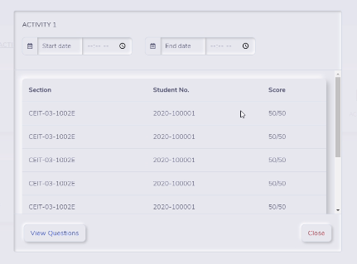
CRUD
*Activity
1. Set start and end date of activity and display section code and student # with score

*Question & Choice
1. Viewing only
*Chapter
1. Set filename, url and note
2. Chapter feedback of student
*Records
1. Display the ff.

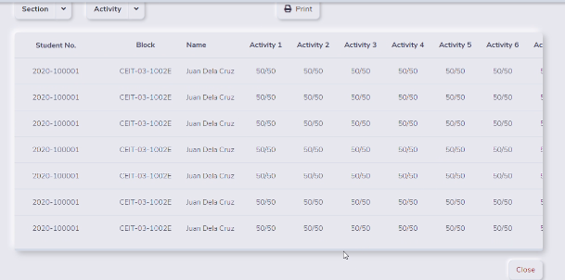
2. Filter by section
3. filter by activity
STUDENT
Activity
1. activity name, score and date taken

