I didn't want to enter such a close market again, but I think 94% is way too high for how close it is. Right now it is above 2x from the current estimates, so what would it take for it to drop to 2x?

**Summary: I think the market should be a little bit north of around 50%. My analysis here:**

Estimating gap in changes day over day for Monday

Using last Monday's numbers (this is very speculative and will be lower but if you assume they will be lower by the same ratio this shouldn't change the result much) I asked what if both Barbie increased by X% and Oppenheimer decreased by X% (concerning the last weekend's two numbers) to see what it would take to make it = 2x: it is about ~1.5%.

Formula for calculating the 1.5% (it will return the decimal already in percent):  
[https://www.wolframalpha.com/input?i=solve+for+x%2C+0+%3D+-2+%2B+%28%28351403+%2B+%281+-+%28x+%2F+100%29%29*%280.5*26105167%29%29+%2F+%28174060+%2B+%281+%2B+%28x+%2F+100%29%29*0.5*12671950%29%29](https://www.wolframalpha.com/input?i=solve+for+x%2C+0+%3D+-2+%2B+((351403+%2B+(1+-+(x+%2F+100))*(0.5*26105167))+%2F+(174060+%2B+(1+%2B+(x+%2F+100))*0.5*12671950)))

I think of this as roughly as needing at least a **3%** relative gap in change, that is, a 3% change in Oppenheimer closing in on Barbie from last monday (this is not a good analog for probability though, for that we have to do something else)

Barbie and oppenheimers change day over day % (from the-numbers.com)

b = [32,9,40,0,11,8,37,19,14]

o = [21,12,45,5,12,6,34,36,20]

Here i­s a chart of the day over day CHANGE % (data from the-numbers.com) for barbie and oppenheimer.

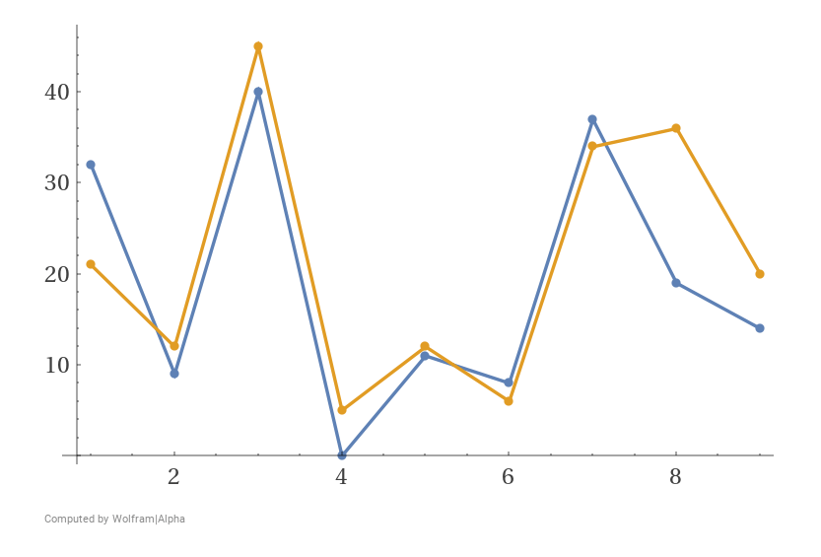  
Link here for chart: [https://www.wolframalpha.com/input?i=plot%7Bb%2Co%7D+for+b+%3D+%5B32%2C9%2C40%2C0%2C11%2C8%2C37%2C19%2C14%5D%2C+o+%3D+%5B21%2C12%2C45%2C5%2C12%2C6%2C34%2C36%2C20%5D](https://www.wolframalpha.com/input?i=plot{b%2Co}+for+b+%3D+%5B32%2C9%2C40%2C0%2C11%2C8%2C37%2C19%2C14%5D%2C+o+%3D+%5B21%2C12%2C45%2C5%2C12%2C6%2C34%2C36%2C20%5D)

It looks very close, but if we take the change in one direction and subtract the gap for it to flip (so oppenheimers % change day over day - barbies % change day over day - 3%) we can create a (flimsy) analog for how likely it might be to flip (positive numbers are events where the gap % changes that could cause a flip, and negative numbers are events where gap% wouldn't cause a flip, while near zeros would make it close again):

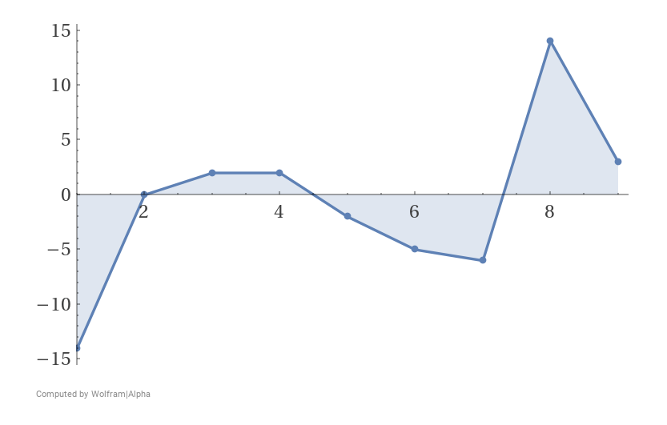Link for the chart:

[https://www.wolframalpha.com/input?i=plot%7Bo-b-3%7D+for+b+%3D+%5B32%2C9%2C40%2C0%2C11%2C8%2C37%2C19%2C14%5D%2C+o+%3D+%5B21%2C12%2C45%2C5%2C12%2C6%2C34%2C36%2C20%5D](https://www.wolframalpha.com/input?i=plot{o-b-3}+for+b+%3D+%5B32%2C9%2C40%2C0%2C11%2C8%2C37%2C19%2C14%5D%2C+o+%3D+%5B21%2C12%2C45%2C5%2C12%2C6%2C34%2C36%2C20%5D)  
  
Looking at this, of the 10 days changes day over day:

4 flipped, 4 stayed the same, and 1 made it very close again.

Using solely this as an analog I come up with that the market really should be around 50%. This, I think is acceptable evidence for my intuition of how close the market really is.