Determination of biodistribution profiles of NPs and BODIPY

Whole brain images were processed using ImageJ software [1]. For each image the RGB channels (Cy7 and BODIPY) were split and the integrated density was calculated in a selected region of interest, followed by background subtraction. The corrected total cell fluorescence (CTCF) of the section was then computed according to:

For a given section, biodistribution for Cy7 and BODIPY on the sagittal plane was plotted as a percentage of the overall brain fluorescence. This quantity is given by the following expression.

Note that is a normalization parameter and represents the cumulative sum of the CTFC of each section, i.e., .

Coverage of the tumor area by NPs was determined using ImageJ and MATLAB [2]. The RGB image channels were split (Cy7 representing the NPs and GFP the tumor), the contrast was enhanced, and extraneous pixels were removed to facilitate the identification of the relevant regions. Subsequently, the images were binarized, i.e., converted to black and white, by means of Otsu’s algorithm. Finally, the arrays of binary pixels representing the NPs and the tumor were multiplied (entrywise product) and the resulting number of nonzero pixels was computed. This quantity indicates the overlap between the NPs and the tumor and was later divided by the total number of nonzero tumor pixels to give a coverage percentage. Equation 1 summarizes the previous computation.

Equation 1: Computation of the coverage percentage of the tumor by the NPs

After applying Equation 1 to the processed images, the computed coverage of the tumor is 56%. The overlap between the tumor and the NPs is shown in Figure 1a. A supplementary plot of the Cy7 signal was then generated representing a low intensity signal with blue and a high intensity signal with red. The background was subtracted and colored in black. This plot is illustrated in Figure 1b.

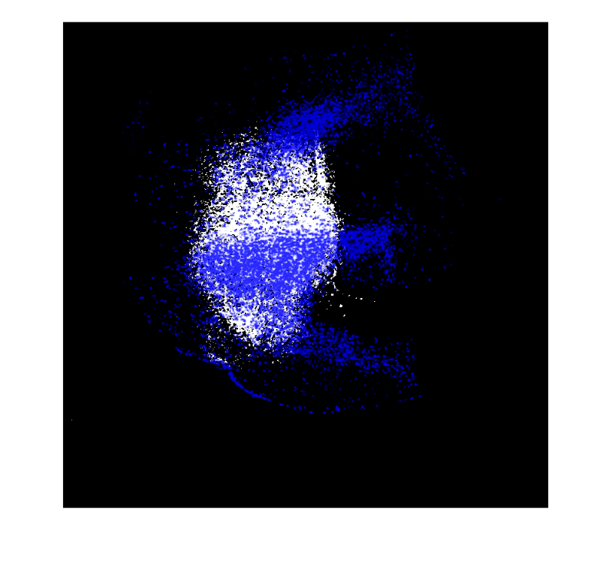(a) 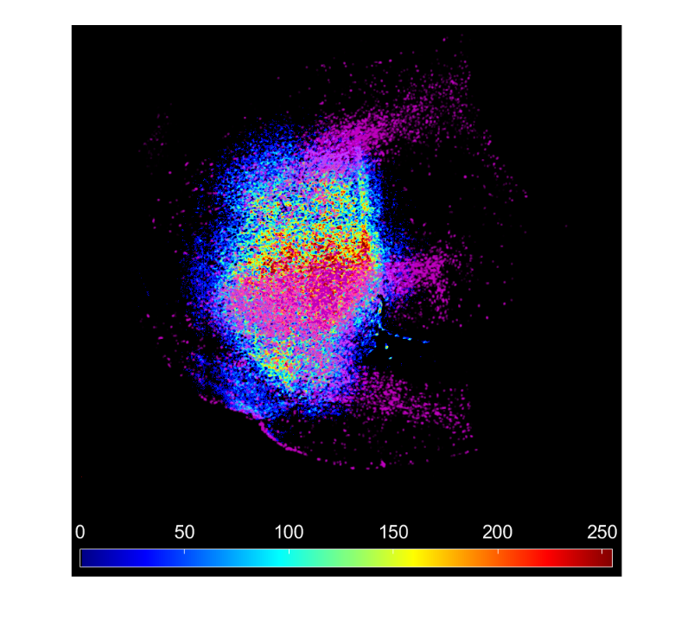(b)

Figure 1: (a) Overlap between the tumor cells denoted in blue and the NPs represented in white. (b) Characterization of the Cy7 signal intensity with overlap of the tumor cells in magenta.

**Feel free to change or take anything that might be necessary?**

1. Schneider, C.A., W.S. Rasband, and K.W. Eliceiri, *NIH Image to ImageJ: 25 years of image analysis.* Nature Methods, 2012. **9**: p. 671.

2. Gonzalez, R.C., R.E. Woods, and S.L. Eddins, *Digital image processing using MATLAB*. Vol. 624. 2004: Pearson-Prentice-Hall Upper Saddle River, New Jersey.