**CSE3020 – Data Visualization (ELA), Winter Semester 2021-2022**

**Lab Assignment IA1 – Slot L43-L44**

**By: Jonathan Rufus Samuel (20BCT0332) Dos: 18.01.2022**

__________________________________________________________________________________

**Lab Assignment – IA1**

**Note on Software used for following Visualizations: (R-Studio and the R language)**

RStudio is an Integrated Development Environment (IDE) for R, a programming language for statistical computing and graphics. R is an integrated suite of software facilities for data manipulation, calculation and graphical display. It includes:

* an effective data handling and storage facility,
* a suite of operators for calculations on arrays, in particular matrices,
* a large, coherent, integrated collection of intermediate tools for data analysis,
* graphical facilities for data analysis and display either on-screen or on hardcopy, and
* a well-developed, simple and effective programming language which includes conditionals, loops, user-defined recursive functions and input and output facilities.

**Q1) Create Data frames which contain details of 10 employees and display summary of the data:**

*Code:*

#Assessment IA1 - Q1 - CSE3020(ELA)

#Jonathan Rufus Samuel (20BCT0332)

#Q1: Create Data frames which contain details of 10 employees and display summary of the data

Employees = data.frame(Name=c("Ana B","Daniel R","Katherine S", "James R","Lauro M","Andrew G","Henry C","Tom S","Polly G","Arthur S"),

Gender=c("M","M","F","M","M","M","M","M","F","M"),

Age=c(23,22,25,26,32,19,26,34,45,31),

Designation=c("Clerk","Manager","Exective","CEO","ASSISTANT","Programmer","Manager","Exective","deputy CEO","Chairman"),

SSN=c("123-34-2346","123-44-779","556-24-433","123-98-987","670-77-576","452-34-2346","123-43-779","356-24-433","123-38-987","679-77-572"))

print("Summary of the data:")

print(summary(Employees))

*Output:*

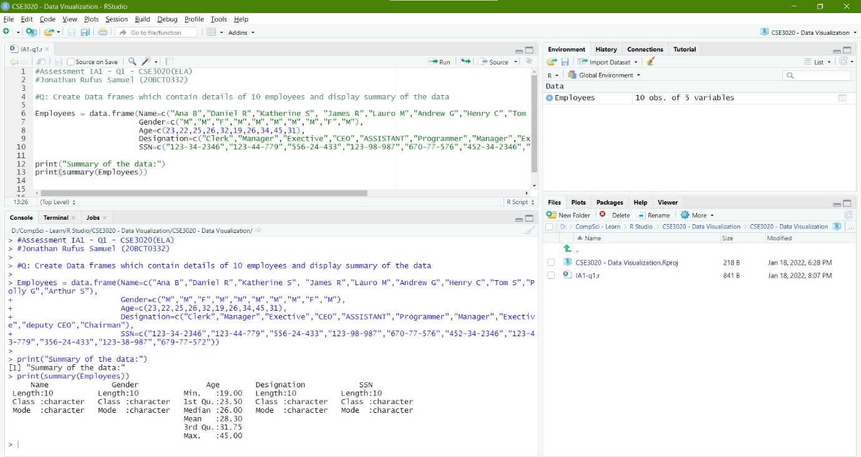

**Q2) Write a R program to get the details of any 5 objects in memory:**

*Code:*

#Assessment IA1 - Q2 - CSE3020(ELA)

#Jonathan Rufus Samuel (20BCT0332)

#Q2: Write a R program to get the details of any 5 objects in memory

name = "Jonathan Rufus Samuel";

n1 = 10;

n2 = 0.5

n3 = -4.56

numbers = c(10, 20, 30, 40, 50, 60)

print(ls())

print("Details of the 5 objects in memory are as follows:")

print(ls.str())

*Output:*

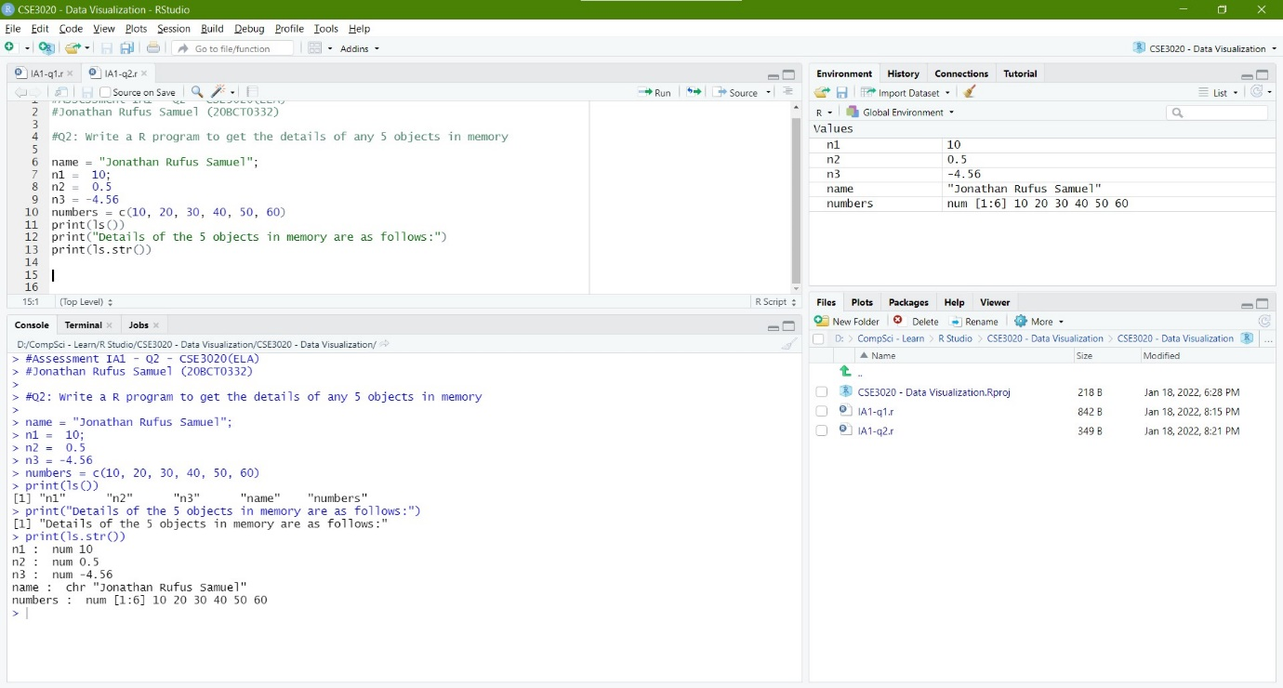

**Q3) Write a R program to print the multiplication table of a number from 1 to 15:**

*Code:*

#Assessment IA1 - Q3 - CSE3020(ELA)

#Jonathan Rufus Samuel (20BCT0332)

#Q3: Write a R program to print the multiplication table of a number from 1 to 15

num = as.integer(readline(prompt = "Enter any number for it's corresponding timestable: "));

for(i in 1:15) {

print(paste(num,'x', i, '=', num*i))

}

*Output:*

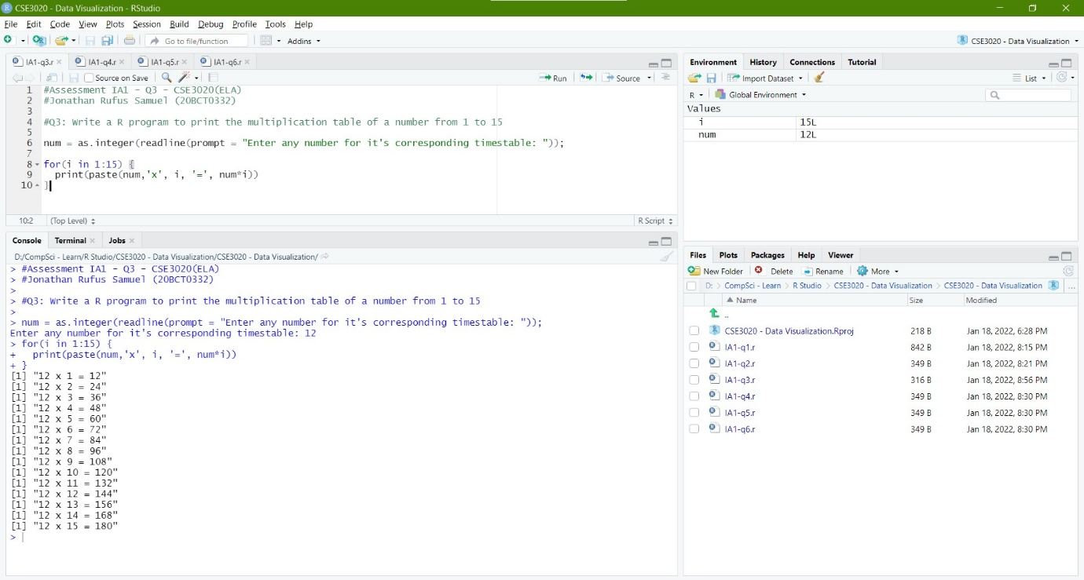

**Q4) Write a R program to print the numbers from 1 to 100 and print "DATA" for multiples of 2, print "VISUALIZATION" for multiples of 4, and print "DATA VISUALIZATION" for multiples of both:**

*Code:*

#Assessment IA1 - Q4 - CSE3020(ELA)

#Jonathan Rufus Samuel (20BCT0332)

#Q4: Write a R program to print the numbers from 1 to 100 and print "DATA" for multiples of 2, print "VISUALIZATION" for multiples of 4, and print "DATA VISUALIZATION" for multiples of both

name = "Jonathan Rufus Samuel";

p1 = "DATA";

p2 = "VISUALIZATION";

p3 = "DATA VISUALIZATION";

for(i in 1:100)

{

if (i%%2==0 && i%%4==0)

{

print(paste( i, '=', p3))

}

else if (i%%2==0)

{

print(paste( i, '=', p1))

}

else if (i%%4==0)

{

print(paste( i, '=', p2))

}

else

{

print(paste( i ))

}

}

*Output:*

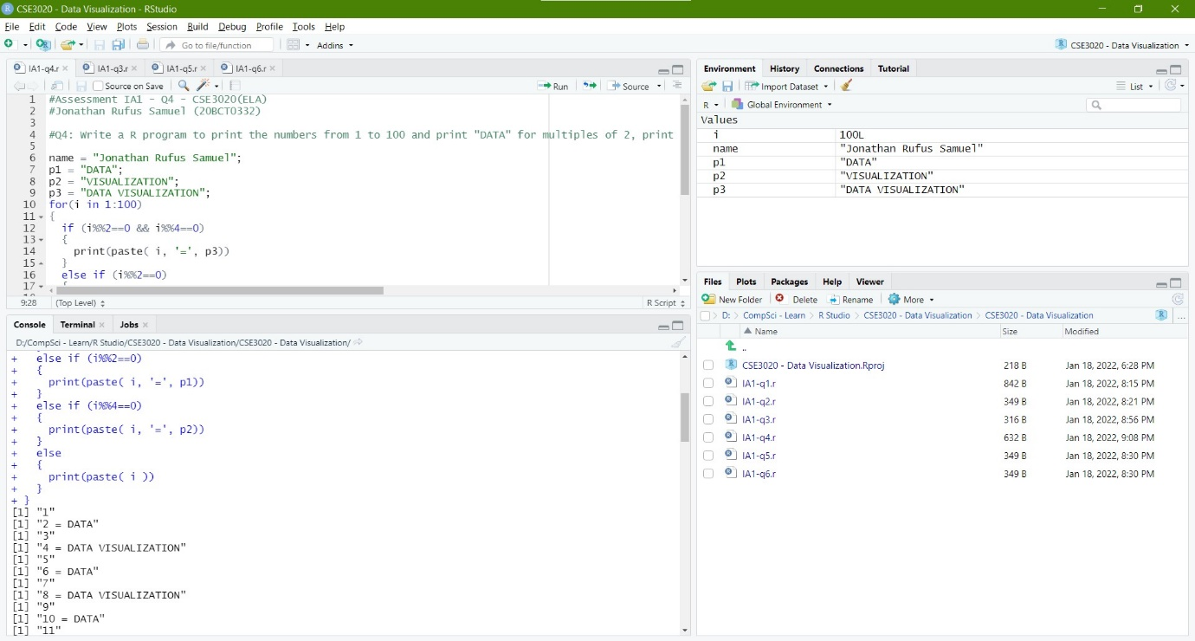

**Q5) Create an empty factor vector, append values in it and find the sum, mean, product of vector elements using R. Also extract every nth element of the vector:**

*Code:*

#Assessment IA1 - Q5 - CSE3020(ELA)

#Jonathan Rufus Samuel (20BCT0332)

#Q5: Create an empty factor vector, append values in it and find the sum, mean, product of vector elements using R. Also extract every nth element of the vector:

sum=0

product=1

#New empty factor vector a

a = c()

print(a)

# appending numbers from 1 to 15

a=1:15

print(a)

n = as.integer(readline(prompt = "Enter a number n: "));

#sum, mean & product of vector elements

for(i in a)

{

sum=sum+i;

product=product*i;

if(i%%n==0)

{

print(i);

}

}

mean = sum/length(a)

#Display values

print(paste("Sum: ",sum))

print(paste("Product: ",product))

print(paste("Mean: ",mean))

*Output:*

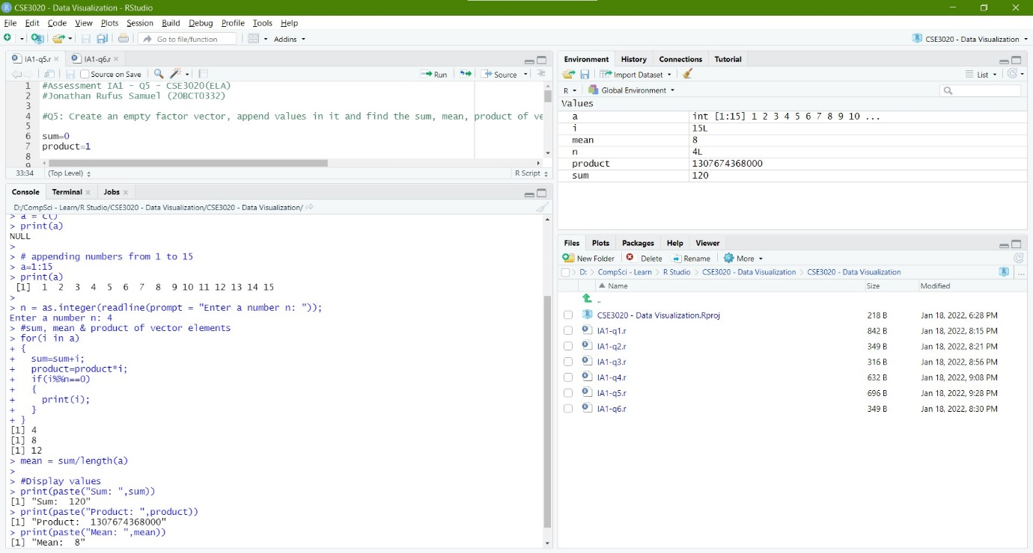

**Q6) Use a nested for loop (a for loop inside a for loop) that produces the following matrix, pre-allocate the matrix with NA values:**

**0 1 2 3 4**

**1 0 1 2 3**

**2 1 0 1 2**

**3 2 1 0 1**

**4 3 2 1 0**

*Code:*

#Assessment IA1 - Q6 - CSE3020(ELA)

#Jonathan Rufus Samuel (20BCT0332)

#Q6: Use a nested for loop (a for loop inside a for loop) that produces the following matrix, pre-allocate the matrix with NA values

vector1 <- c(NA, NA, NA, NA, NA)

vector2 <- c(NA, NA, NA, NA, NA)

# Take these vectors as input to the array.

arr <- array(c(vector1, vector2), dim = c(5, 5))

print(arr)

d =

for(i in 1:5)

{

for(j in 1:5)

{

x=abs(j-i)

arr[i,j] = x

print(arr[i,j])

}

}

print(arr)

*Output:*

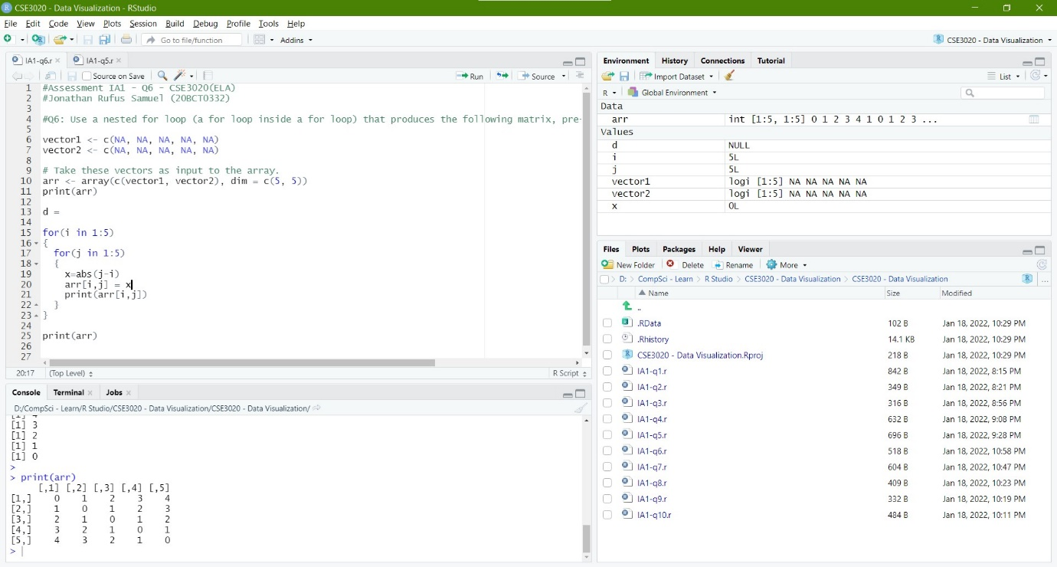

**Q7) Implement a multiplication game. A while loop that gives the user two random numbers from 2 to 12 and asks the user to multiply them. Only exit the loop after five correct answers:**

*Code:*

#Assessment IA1 - Q7 - CSE3020(ELA)

#Jonathan Rufus Samuel (20BCT0332)

#Q7: Implement a multiplication game. A while loop that gives the user two random numbers from 2 to 12 and asks the user to multiply them. Only exit the loop after five correct answers

x=5

while(x > 5)

{

a=floor(runif(1, min=2, max=13))

b=floor(runif(1, min=2, max=13))

print("Answer the Question:")

print(paste(a, 'x', b, '= ?'))

ans = as.integer(readline())

if ((a*b) == ans)

{

print('Correct!')

x=x-1

}

else

{

print('Wrong!')

}

}

*Output:*

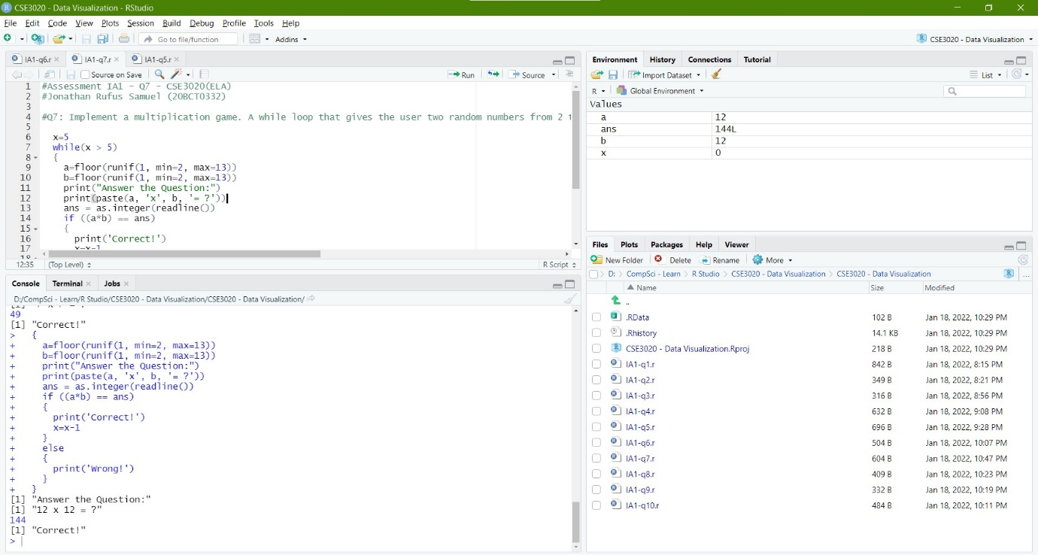

**Q8) Using for loop simulate the flip a coin twenty times, keeping track of the individual outcomes (1 = heads, 0 = tails) in a vector that you pre-allocate:**

*Code:*

#Assessment IA1 - Q8 - CSE3020(ELA)

#Jonathan Rufus Samuel (20BCT0332)

#Q8: Using for loop simulate the flip a coin twenty times, keeping track of the individual outcomes (1 = heads, 0 = tails) in a vector that you pre-allocate

coin <- c('heads', 'tails')

flip <- sample(coin, size=20, replace=TRUE)

ans <- vector(length = 0, mode = "integer")

for (i in flip) {

ans <- c(ans, i)

}

print(ans)

*Output:*

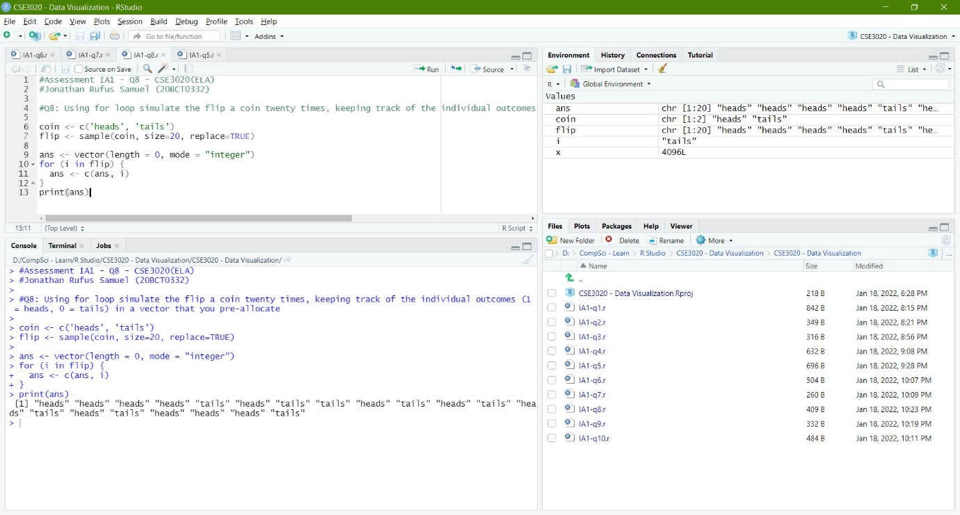

**Q9) Write a R program to know the first positive integer whose square exceeds 4000:**

*Code:*

#Assessment IA1 - Q9 - CSE3020(ELA)

#Jonathan Rufus Samuel (20BCT0332)

#Q9: Write a R program to know the first positive integer whose square exceeds 4000

for(i in 0:100)

{

x = i*i

if(x > 4000)

{

print('First Positive Integer whose square exceeds 4000: ')

print(paste( i, 'Sqaure', x))

break

}

}

*Output:*

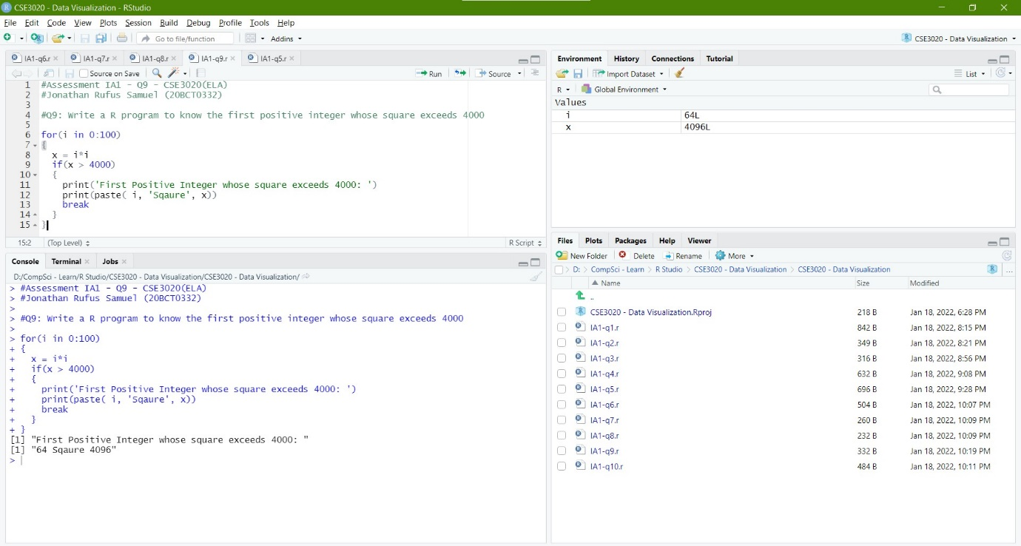

**Q10) Write a R program to create a vector of a specified type and length. Create vector of numeric, complex, logical and character types of length 6:**

*Code:*

#Assessment IA1 - Q10 - CSE3020(ELA)

#Jonathan Rufus Samuel (20BCT0332)

#Q10: Write a R program to create a vector of a specified type and length. Create vector of numeric, complex, logical and character types of length 6

x = vector("numeric", 6)

print("Numeric Vector:")

print(x)

c = vector("complex", 6)

print("Complex Vector:")

print(c)

l = vector("logical", 6)

print("Logical Vector:")

print(l)

chr = vector("character", 6)

print("Character Vector:")

print(chr)

*Output:*



