**CSE3020 – Data Visualization (ELA), Winter Semester 2021-2022**

**Lab Assignment IA10 – Slot L43-L44**

**By: Jonathan Rufus Samuel (20BCT0332) Dos: 20.04.2022**

__________________________________________________________________________________

**Lab Assignment – IA10 – Scientometric/Bibliometric analysis**

**Note on Software used for following Visualizations: (Bibexcel)**

BibExcel. BibExcel is designed to assist in analysis of bibliographic data. This tool-box can generate data files that can be imported to Excel, or any program that takes tabbed data records, for further processing . Bibexcel is a free-ware for academic non-profit use.

It includes:

* Easy to access from different sources.
* No need for any technical or programming knowledge, and Quick response for making a dashboard.
* In terms of connecting and sharing, it has various inbuilt advanced features such as: Collaboration and distribution, highly securable, Multiple data sources connection, Easy importation and exportation of the massive size of data.
* For easy accessibility and analysis, the data file can be downloaded locally on mobile or desktop, multilingual representation of data, real-time exploration of any dataset, etc.

**What is Scientometrics/Bibliometric Analysis?**

The scientometric analysis is used to objectively map the scientific knowledge area while the critical review aims to identify the research themes and the corresponding challenges based on scientometric results. i.e. Bibliometric analysis is a widely used research method for detecting the state of the art for a particular field. The method is capable of utilizing quantitative analysis and statistics to describe patterns of publications within a given period or body of literature.

**Q1) Perform a scientometric analysis of a popular topic of your interest and generate a visualization using the tool BibExcel (Multivariate data visualization):**

**Answer**: Some Key points to note before visualization process:

1. **Dataset Used:**

The dataset used for the given process is the **Alexandru C. Telea-Data Visualization_ Principles and Practice-A K Peters_CRC Press (2014)** file (E-Book) available on VTOP. Scientometric Analysis will therefore be conducted using given text pdf.

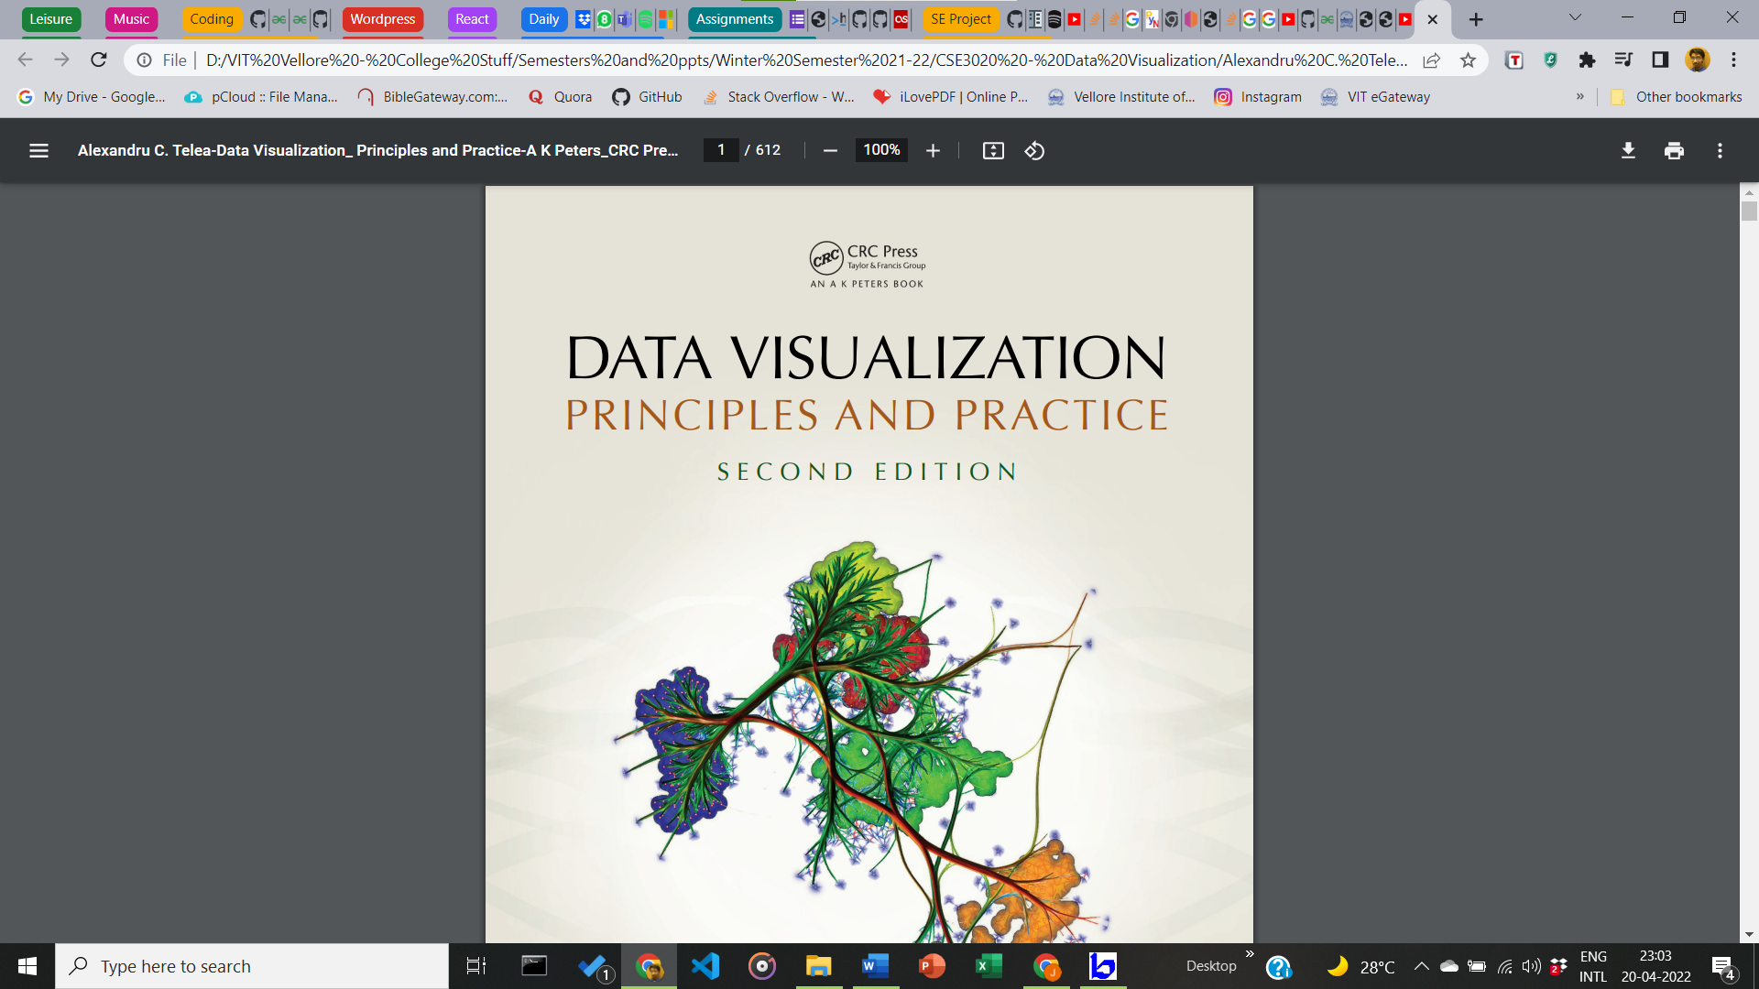

**612 page Text PDF**

1. **Scientometric Analysis:**

Visualization based on Distance (Denoted by size of boxes in tree map), Source (Colour – Spatial Element of Dataset), and Time of Earthquake.

1. **Preparation of File for Analysis:**

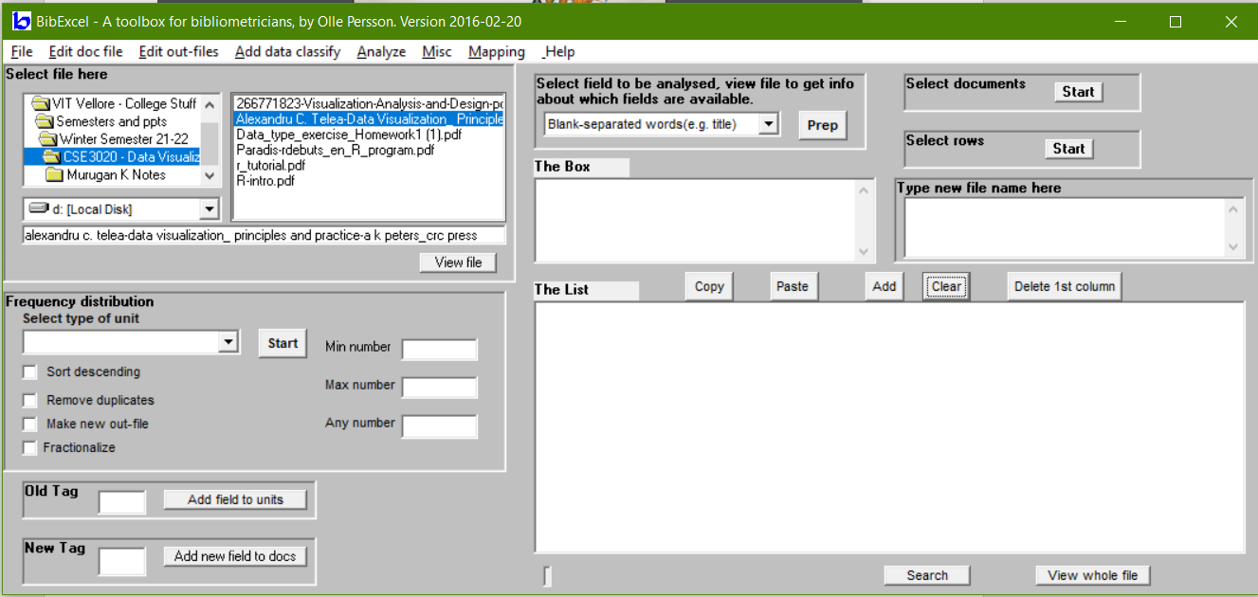

**Selection of File**

First, file has line feed replaced with carriage return. Then under Miscellaneous section, convert from web of science to plain text. Final file is seen as .doc type.

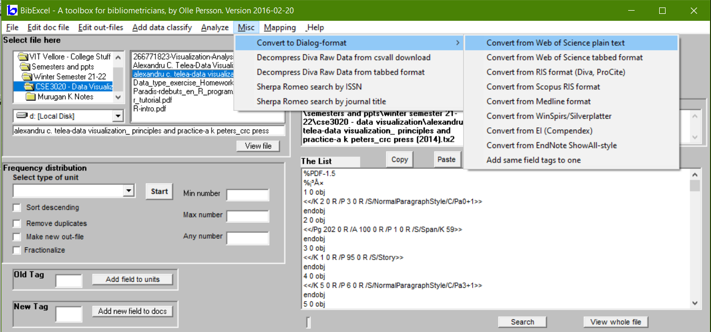

However, no file is compatible for the given processing, therefore visualization is not possible. Will be processed later after consideration.

__________________________________________________________________________________