**CSE3020 – Data Visualization (ELA), Winter Semester 2021-2022**

**Lab Assignment IA2 – Slot L43-L44**

**By: Jonathan Rufus Samuel (20BCT0332) Dos: 1.02.2022**

__________________________________________________________________________________

**Lab Assignment – IA2**

**(Update: Q6 – Improvement of Bell Curve)**

**Note on Software used for following Visualizations: (R-Studio and the R language)**

RStudio is an Integrated Development Environment (IDE) for R, a programming language for statistical computing and graphics. R is an integrated suite of software facilities for data manipulation, calculation and graphical display. It includes:

* an effective data handling and storage facility,
* a suite of operators for calculations on arrays, in particular matrices,
* a large, coherent, integrated collection of intermediate tools for data analysis,
* graphical facilities for data analysis and display either on-screen or on hardcopy, and
* a well-developed, simple and effective programming language which includes conditionals, loops, user-defined recursive functions and input and output facilities.

**Q1) Create a vector of the values of e x cos(x) at x = 3, 3.1, 3.2, . . . , 6:**

*Code:*

#Assessment IA2 - Q1 - CSE3020(ELA)

#Jonathan Rufus Samuel (20BCT0332)

#Q1: Create a vector of the values of e x cos(x) at x = 3, 3.1, 3.2, . . . , 6

x <- seq(3,6,by = 0.1)

expr <- exp(x) * cos(x)

print("Value of the data:")

print(expr)

*Output:*

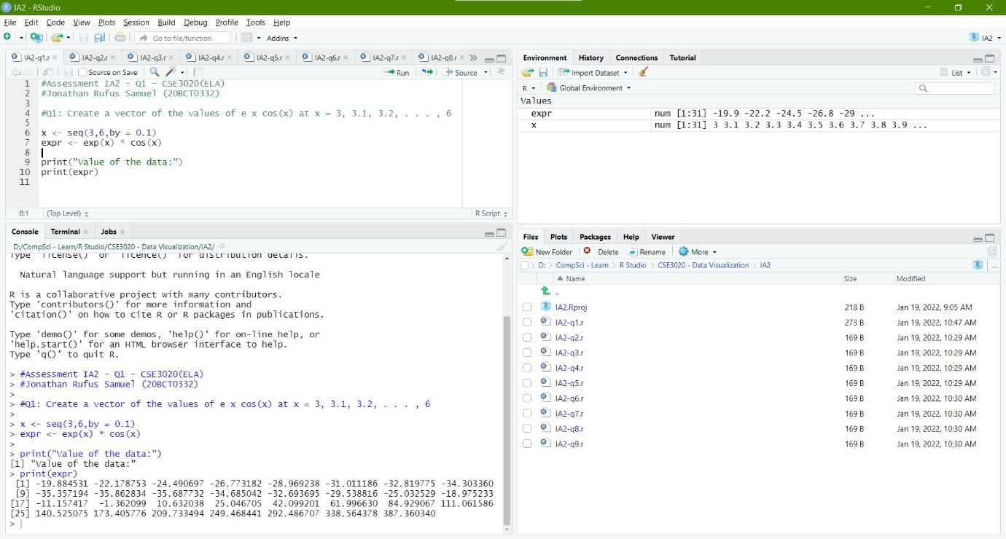

**Q2) Consider five cylinders lengths: 2.1, 3.4, 2.5, 2.7, 2.9 and the diameters are: 0.3, 0.5, 0.6, 0.9, 1.1. Read these data into two vectors. Calculate the correlation between lengths and diameters. Calculate the volumes so that their units are in cubic millimetres. Calculate the mean, standard deviation, and coefficient of variation of these new volumes:**

*Code:*

#Assessment IA2 - Q2 - CSE3020(ELA)

#Jonathan Rufus Samuel (20BCT0332)

#Q2: Consider five cylinders lengths: 2.1, 3.4, 2.5, 2.7, 2.9 and the diameters are: 0.3, 0.5, 0.6, 0.9, 1.1. Read these data into two vectors. Calculate the correlation between lengths and diameters. Calculate the volumes so that their units are in cubic millimetres. Calculate the mean, standard deviation, and coefficient of variation of these new volumes

a = c(2.1, 3.4, 2.5, 2.7, 2.9)

b = c(0.3, 0.5, 0.6, 0.9, 1.1)

co = cor(a,b)

print(co)

vol=c()

for (i in 1:length(a))

vol[i] <- 3.14 * (b[i]/2) * a[i]

print(vol)

*Output:*

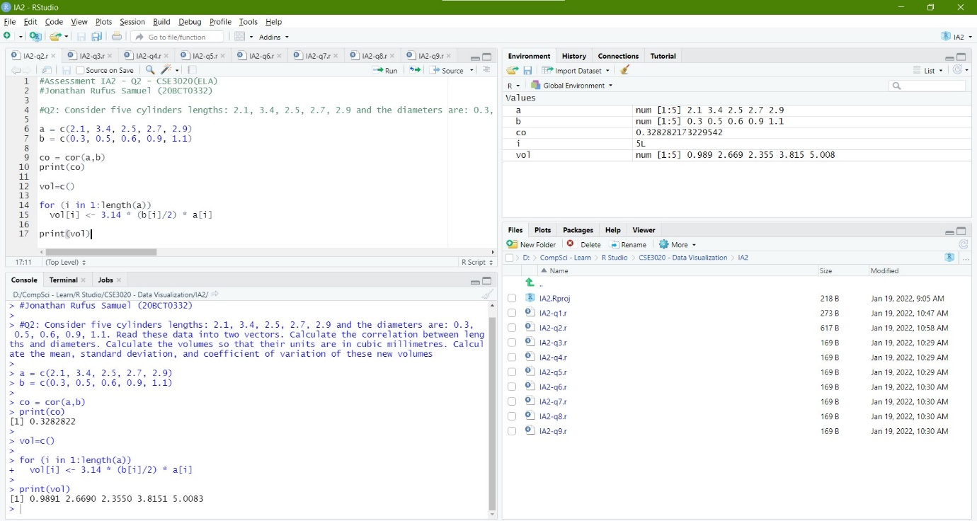

**Q3) Create an empty matrix 5*5 and do the following operations**

**a. Perform elementwise matrix multiplication**

**b. Find the power of a matrix.**

**c. Modify any two elements in the matrix.**

**d. Rotate the matrix to 90 degrees clockwise.**

**e. Access the matrix elements using character index:**

*Code:*

#Assessment IA2 - Q3 - CSE3020(ELA)

#Jonathan Rufus Samuel (20BCT0332)

#Q3: Create an empty matrix 5*5 and do the following operations:

#a. Perform elementwise matrix multiplication

#b. Find the power of a matrix.

#c. Modify any two elements in the matrix.

#d. Rotate the matrix to 90 degrees clockwise.

#e. Access the matrix elements using character index

library(expm)

vector1 <- c(NA, NA, NA, NA, NA)

vector2 <- c(NA, NA, NA, NA, NA)

# Take these vectors as input to the array.

arr <- array(c(vector1, vector2), dim = c(5, 5, 2))

print(arr)

for (k in 1:2)

{

for(i in 1:5)

{

for(j in 1:5)

{

x=floor(runif(1, min=2, max=15))

arr[i,j,k] = x

}

}

}

print(arr)

print("Answer A:")

print(arr[,,1]*arr[,,2])

print("Answer B:")

print(arr[,,1]%*%arr[,,1])

print("Answer C:")

arr[2,4,1] = 0

arr[5,3,1] = 0

print(arr[,,1])

print("Answer D:")

rotate = t(apply(arr[,,1], 2, rev))

print(rotate)

print("Answer E:")

print(arr[1,3,1])

*Output:*

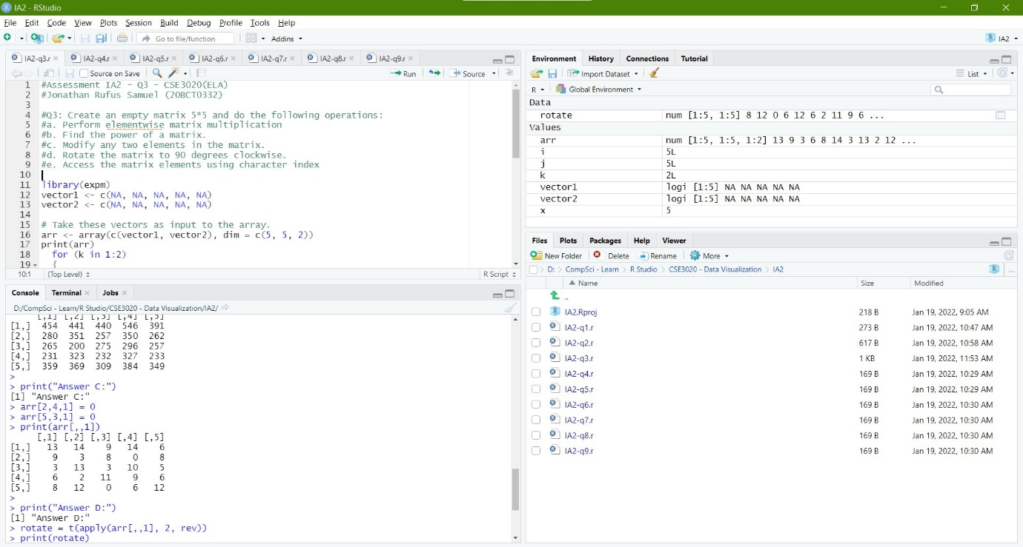

**Q4) Write a R program to create a list of random numbers in normal distribution and count occurrences of each value:**

*Code:*

#Assessment IA2 - Q4 - CSE3020(ELA)

#Jonathan Rufus Samuel (20BCT0332)

#Q4: Write a R program to create a list of random numbers in normal distribution and count occurrences of each value

n = floor(rnorm(100, 1, 100))

print('List of random numbers in normal distribution:')

print(n)

t = table(n)

print("Count occurrences of each value:")

print(t)

*Output:*

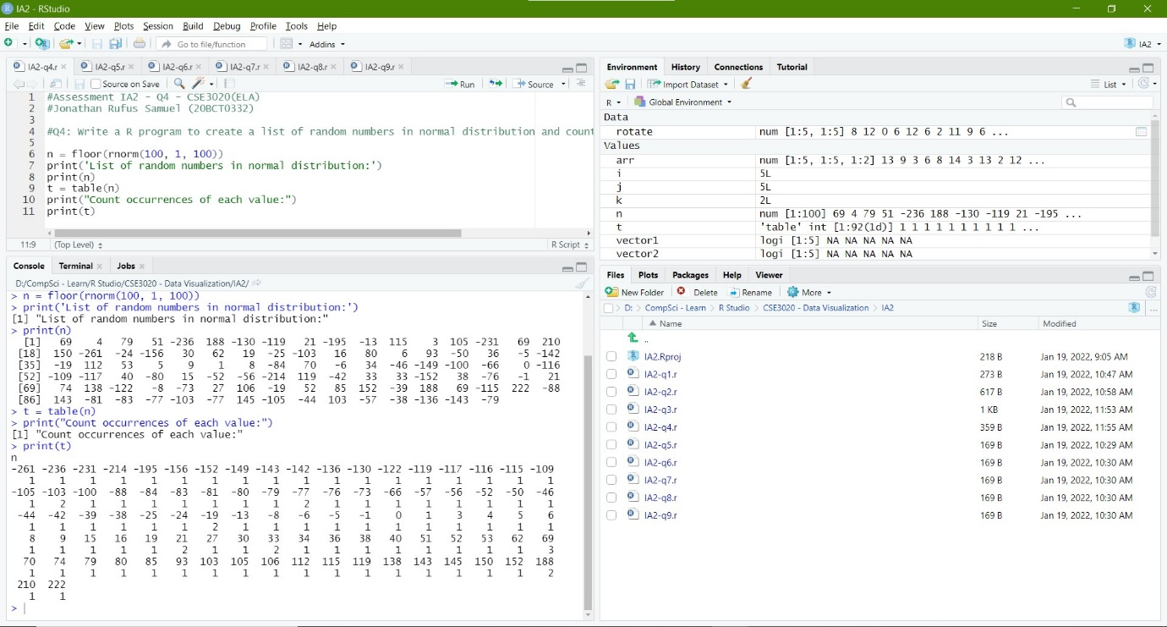

**Q5) Write a R program to create three vectors numeric data, character data and logical data. Display the content of the vectors and their type:**

*Code:*

#Assessment IA2 - Q5 - CSE3020(ELA)

#Jonathan Rufus Samuel (20BCT0332)

#Q5: Write a R program to create three vectors numeric data, character data and logical data. Display the content of the vectors and their type

a = c( 5, 3, 4, 0, -1, -3)

b = c("Happy", "Sad", "Blue")

c = c(TRUE, TRUE, TRUE, FALSE, TRUE, FALSE)

print(a)

print(typeof(a))

print(b)

print(typeof(b))

print(c)

print(typeof(c))

*Output:*

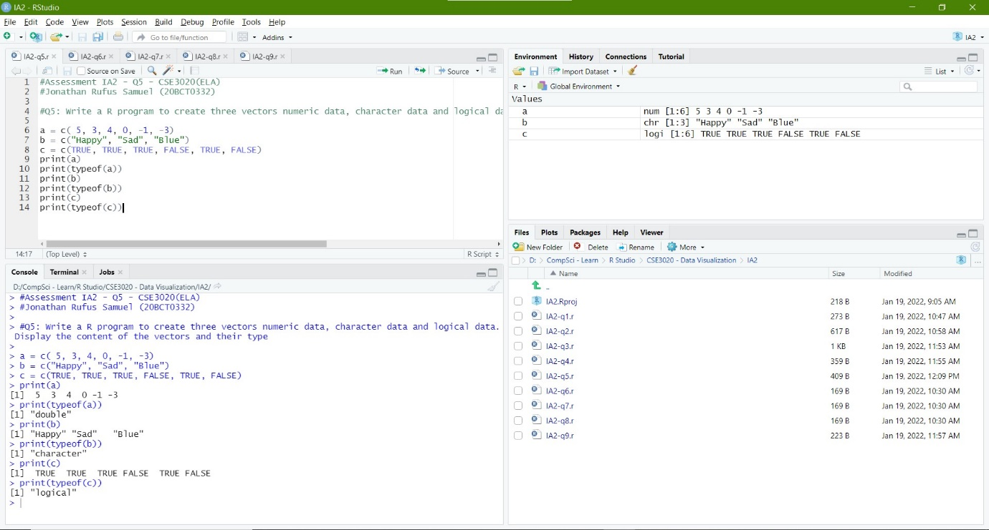

**Q6) Write a R program to create bell curve of a random normal distribution:**

*Code:*

#Assessment IA2 - Q6 - CSE3020(ELA)

#Jonathan Rufus Samuel (20BCT0332)

#Q6: Write a R program to create bell curve of a random normal distribution

n = floor(rnorm(10000000, 500, 100))

t = table(n)

plot(t)

*Output:*

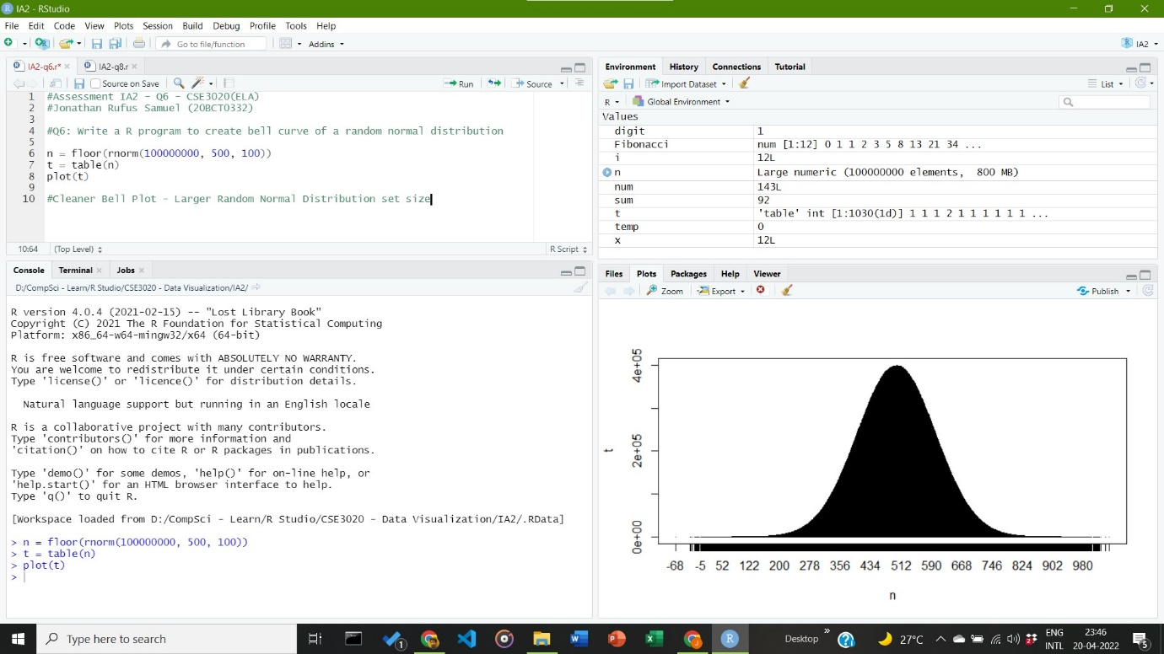

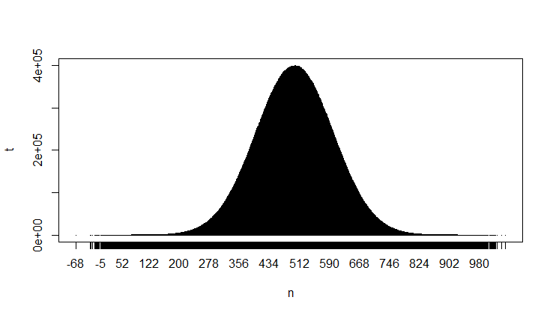

**Q7) Write a R program to create a list containing strings, numbers, vectors and a logical values:**

*Code:*

#Assessment IA2 - Q7 - CSE3020(ELA)

#Jonathan Rufus Samuel (20BCT0332)

#Q7: Write a R program to create a list containing strings, numbers, vectors and a logical values

list_data = list("Grey", "C++", TRUE, c(5, 7, 9, 11), 125.17, -75.83)

print("Data of the list:")

print(list_data)

*Output:*

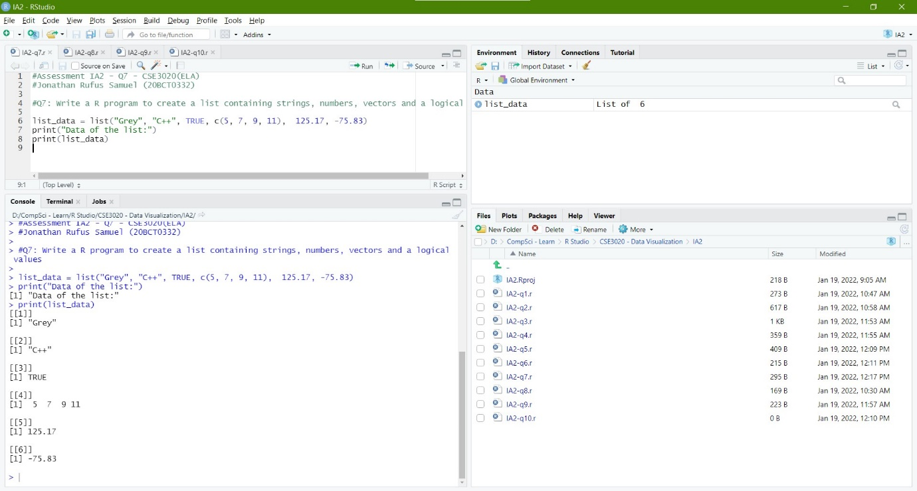

**Q8) Write a R program to compute the Armstrong number and Fibonacci series:**

*Code:*

#Assessment IA2 - Q8 - CSE3020(ELA)

#Jonathan Rufus Samuel (20BCT0332)

#Q8: Write a R program to compute the Armstrong number and Fibonacci series

#Armstrong Number Check

num = as.integer(readline(prompt="Enter a number: "))

sum = 0

temp = num

while(temp > 0) {

digit = temp %% 10

sum = sum + (digit ^ 3)

temp = floor(temp / 10)

}

if(num == sum) {

print(paste(num, "is an Armstrong number"))

} else {

print(paste(num, "is not an Armstrong number"))

}

#Fibonacci Series

x = as.integer(readline(prompt="Enter number of terms: "))

Fibonacci <- numeric(x)

Fibonacci[1] <- 0

Fibonacci[2] <- Fibonacci[3] <- 1

for (i in 4:x) Fibonacci[i] <- Fibonacci[i - 2] + Fibonacci[i - 1]

print("Fibonacci numbers:")

print(Fibonacci)

*Output:*

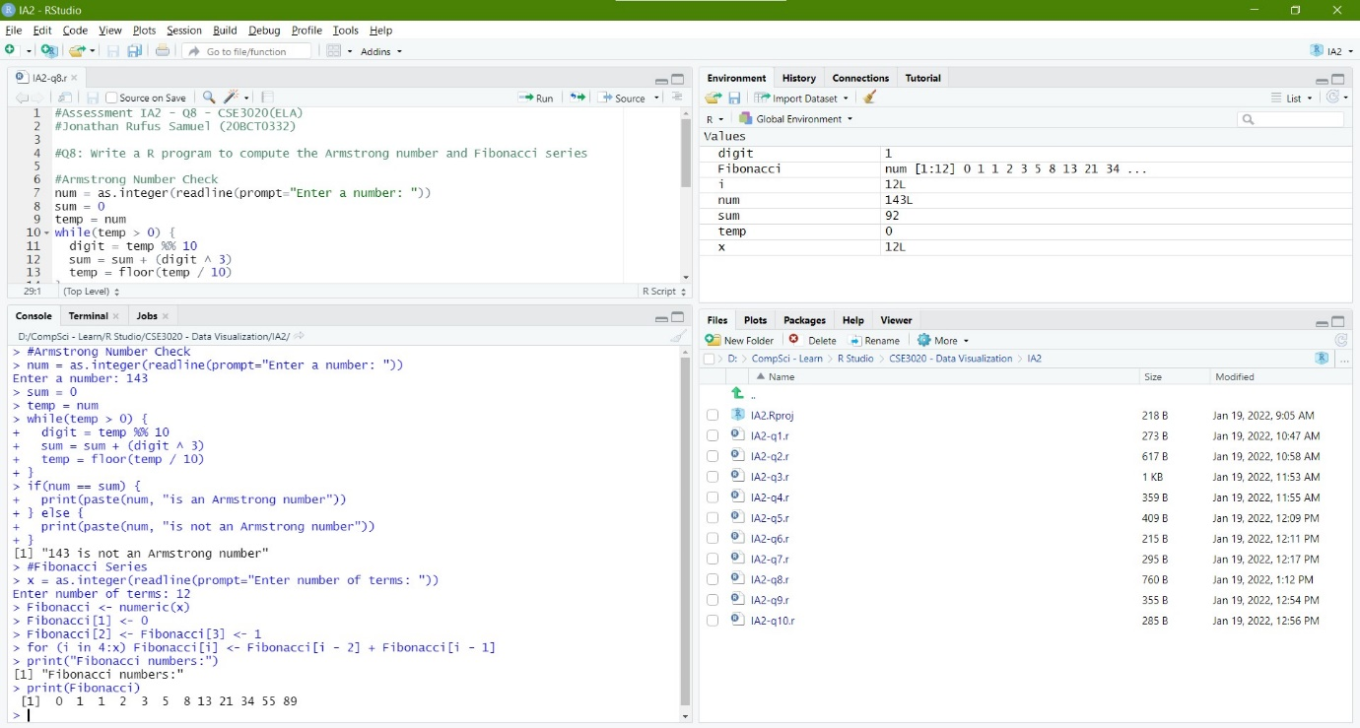

**Q9) Write a R program to create a two-dimensional 5x3 array of sequence of even integers greater than 50:**

*Code:*

#Assessment IA2 - Q9 - CSE3020(ELA)

#Jonathan Rufus Samuel (20BCT0332)

#Q9: Write a R program to create a two-dimensional 5x3 array of sequence of even integers greater than 50

a <- array(seq(from = 50, length.out = 15, by = 2), c(5, 3))

print("Content of the array:")

print("5×3 array of sequence of even integers greater than 50:")

print(a)

*Output:*

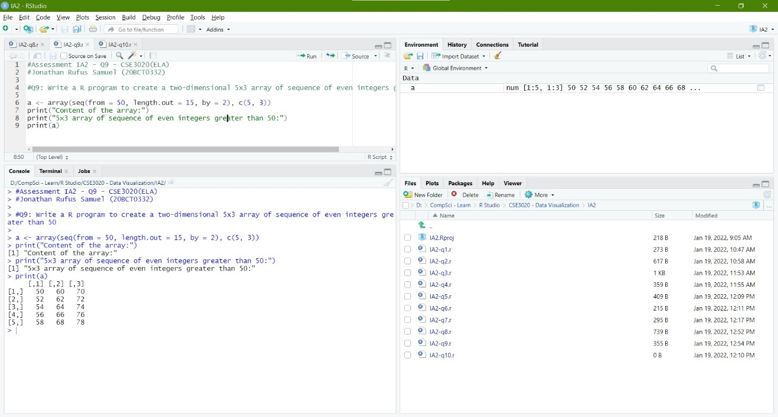

**Q10) Write a R program to add two vectors of integers type and length 3:**

*Code:*

#Assessment IA2 - Q10 - CSE3020(ELA)

#Jonathan Rufus Samuel (20BCT0332)

#Q10: Write a R program to add two vectors of integers type and length 3

x = c(1, 2, 3)

y = c(0, 1, 4)

print("Original Vectors:")

print(x)

print(y)

print("On adding two Vectors:")

z = x + y

print(z)

*Output:*



