**CSE3020 – Data Visualization (ELA), Winter Semester 2021-2022**

**Lab Assignment IA3 – Slot L43-L44**

**By: Jonathan Rufus Samuel (20BCT0332) Dos: 8.02.2022**

__________________________________________________________________________________

**Lab Assignment – IA3 Scalar Visualizations – 1**

**Note on Software used for following Visualizations: (Tableau)**

Tableau is a visual analytics platform transforming the way we use data to solve problems—empowering people and organizations to make the most of their data.

It includes:

* Easy to access from different sources.
* No need for any technical or programming knowledge, and Quick response for making a dashboard.
* In terms of connecting and sharing, it has various inbuilt advanced features such as: Collaboration and distribution, highly securable, Multiple data sources connection, Easy importation and exportation of the massive size of data.
* For easy accessibility and analysis, the data file can be downloaded locally on mobile or desktop, multilingual representation of data, real-time exploration of any dataset, etc.

**Q) Create a dataset of 20 rows and 10 columns of data associated with any of your interested domain. The dataset shall include data of types: Qualitative and Quantitative (ordinal, nominal, interval and ratio – continuous / discrete).**

**For the created dataset, perform the following visualization of:**

**a. Precise Comparison of Two or more categorical data**

**b. Two or more Continuous Data over a period of time**

**c. Numerical data across one or more categorical data**

**d. Relative Proportion of one or more categorical data**

**Answer**: Some Key points to note before visualization process.

1. **Dataset Used:**

The dataset used is that of the Placement Data at a given College. As mentioned on the parent website Kaggle; *“This data set consists of Placement data of students in a XYZ campus. It includes secondary and higher secondary school percentage and specialization. It also includes degree specialization, type and Work experience and salary offers to the placed students”.* Contains 20 Rows and 10 Columns as required by the question.

**Link(s):** [**https://www.kaggle.com/benroshan/factors-affecting-campus-placement**](https://www.kaggle.com/benroshan/factors-affecting-campus-placement)

[**https://mksaad.wordpress.com/2020/06/30/datasets-for-visualization/**](https://mksaad.wordpress.com/2020/06/30/datasets-for-visualization/)

**Categories Present in Dataset:**

* **Qualitative: (Categorical Data)**
* Degree T
* Gender
* Highschool Board (hsc b)
* Status
* Work Experience (Work ex)
* **Quantitative:**
* Degree Percentage (Degree P)
* Employability Test (Etest P%)
* Secondary Education Percentage (ssc p%)
* Higher Secondary Education Percentage (hsc p%)
* Salary

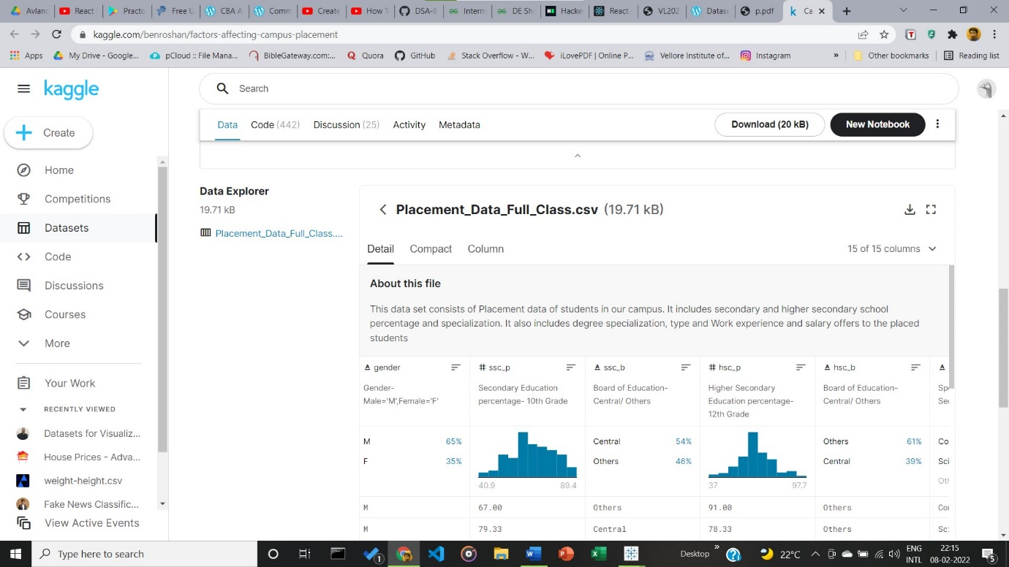

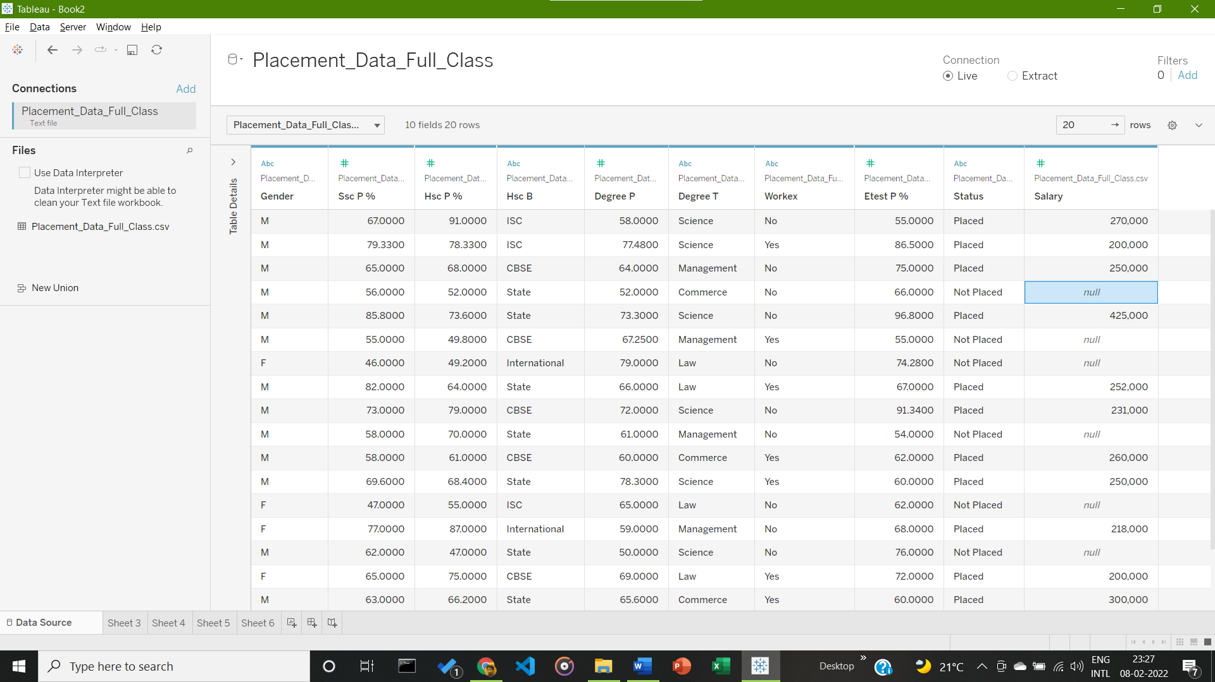

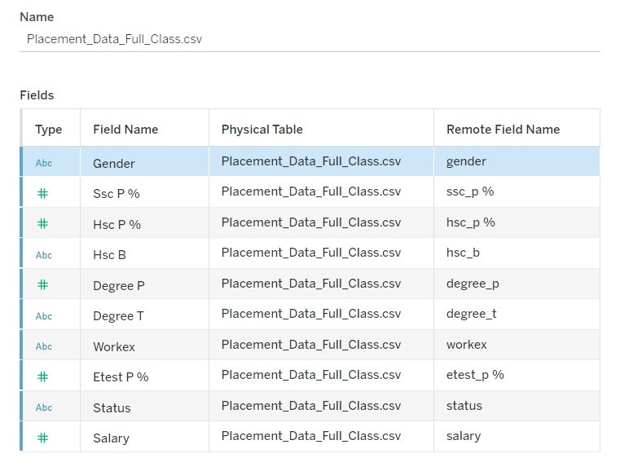

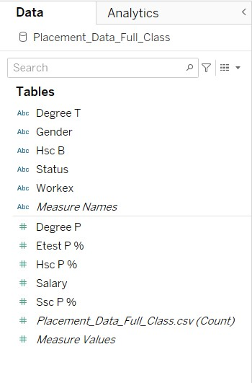

1. **Visualization:**
2. **Precise Comparison of Two or more categorical data**

Generalization based on the three following Categorical Data: Status, Gender and Higher Secondary Scores, with data on x axis being Employability Test scores, to give a relation A student’s gender, board marks and test scores with overall chance of getting placed.

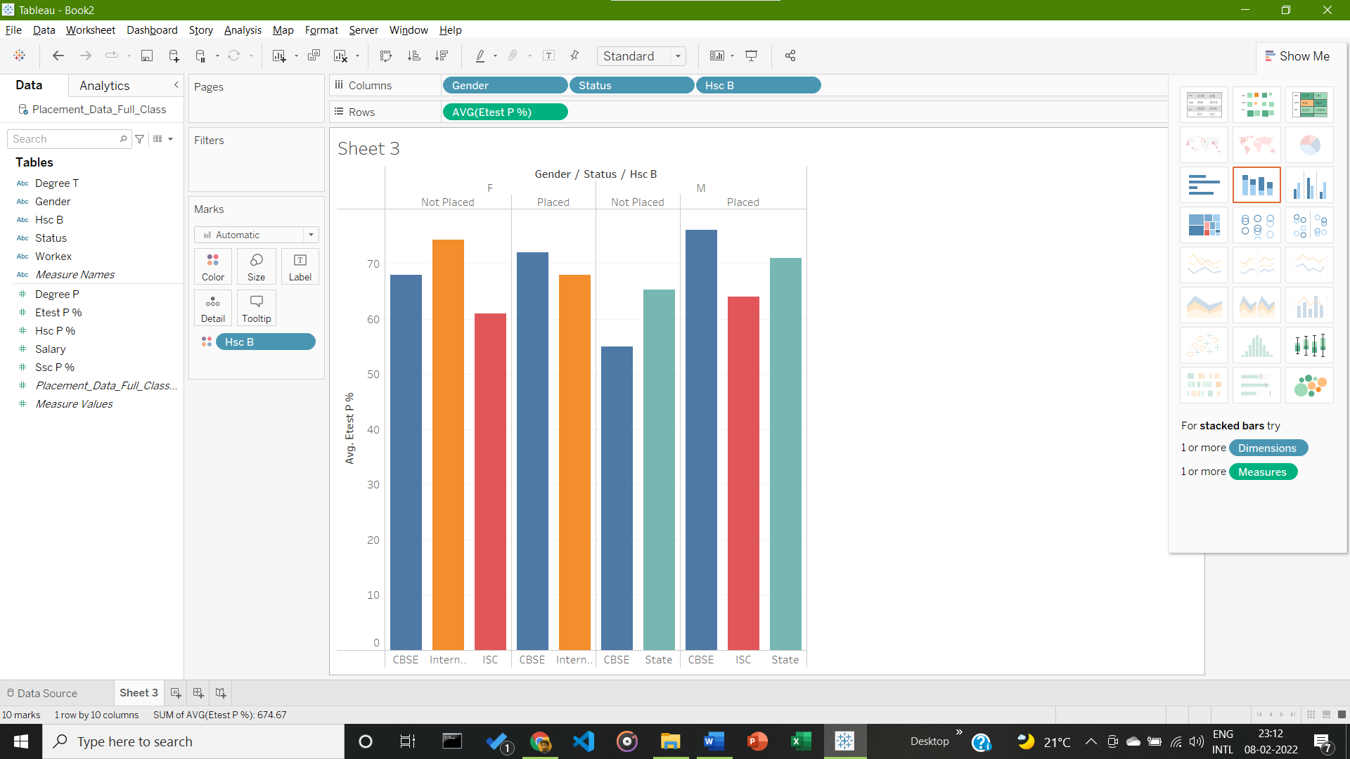

Conclusion from Given Visualization: Highest Summation of Employability in given Dataset goes to Male who have are from CBSE at 76.11%

1. **Two or more Continuous Data over a period of time**

Generalization based on the two following Continuous Data: Salary and Board (Bo time related fields available)

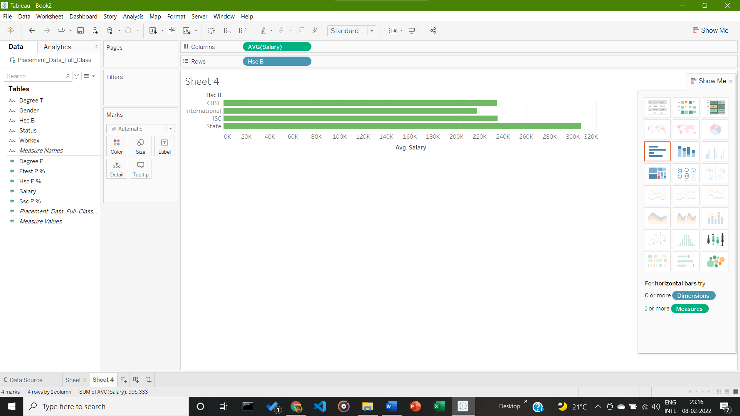

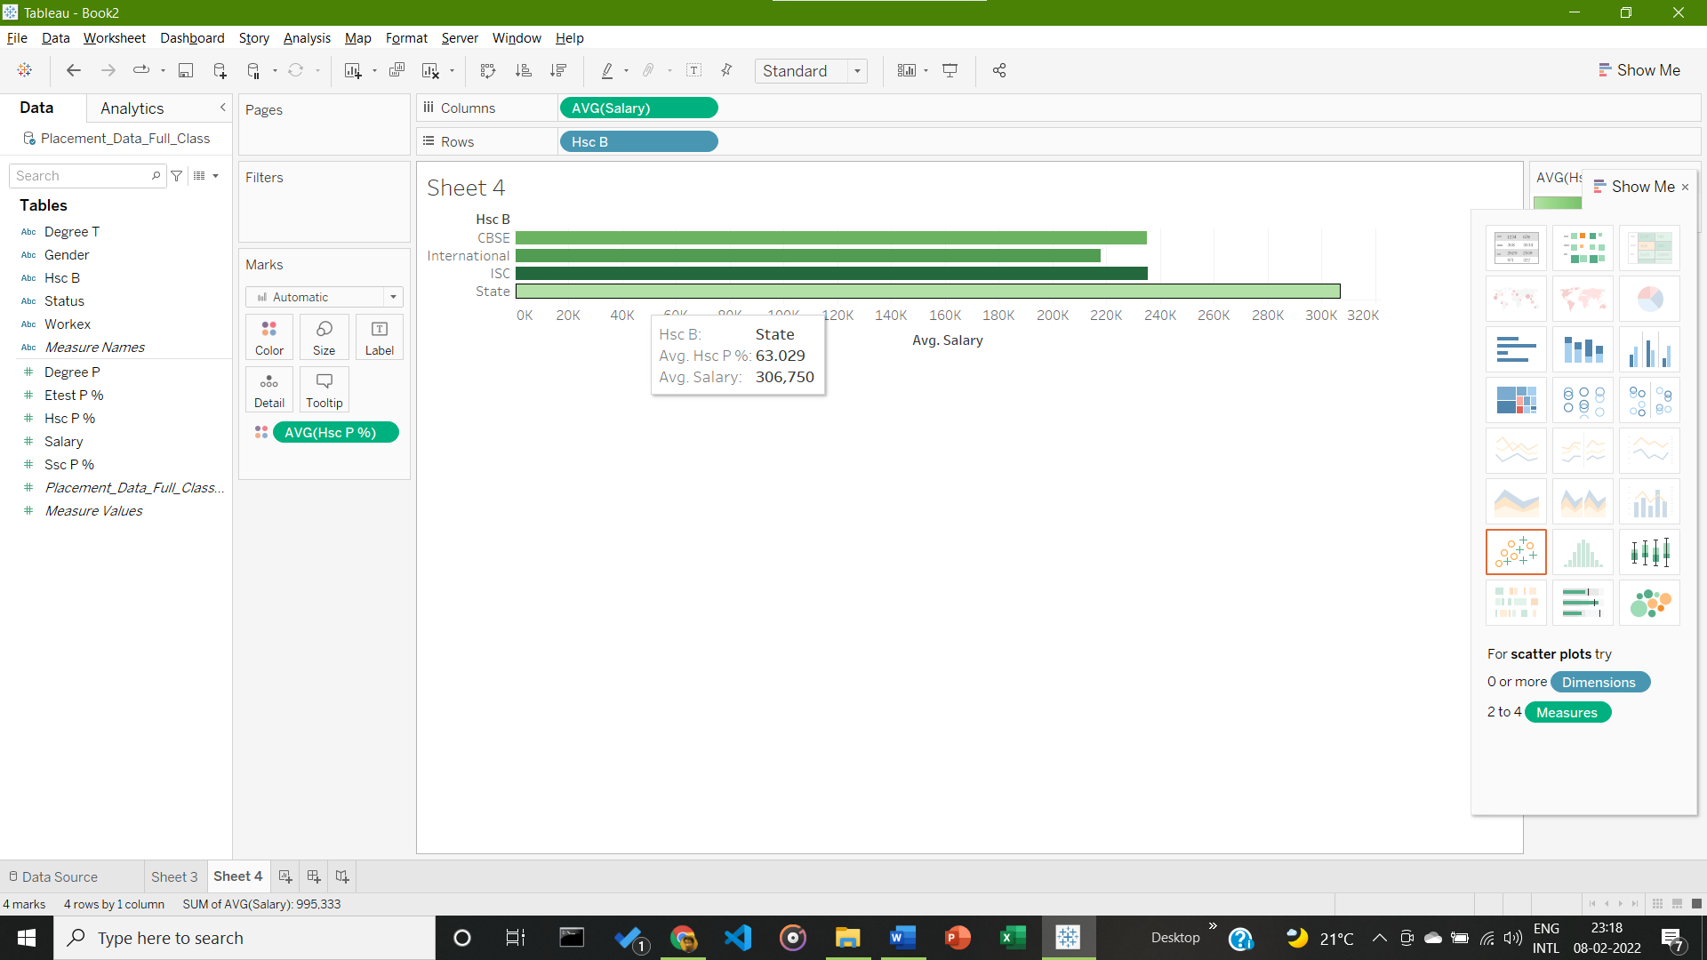

Conclusion from Given Visualization: Highest Average Salary in given Dataset goes to Students from State with an average salary of 306,750.

1. **Numerical data across one or more categorical data**

Generalization based on the three following Categorical and Numerical Data: Board, Average High School Board Marks and Field/Degree chosen.

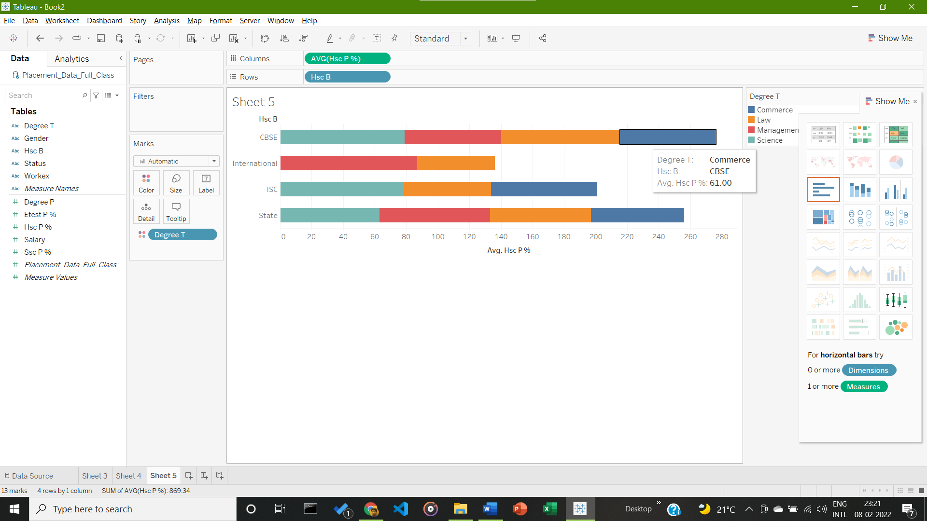

Conclusion from Given Visualization: Highest Average Scores in High School Boards in given Dataset goes to CBSE Students within the Commerce field.

1. **Relative Proportion of one or more categorical data**

Generalization based on the 6 following Categorical Data: Degree, Gender, Hec B, Measure Names, Degree Scores, and Employability Test scores.

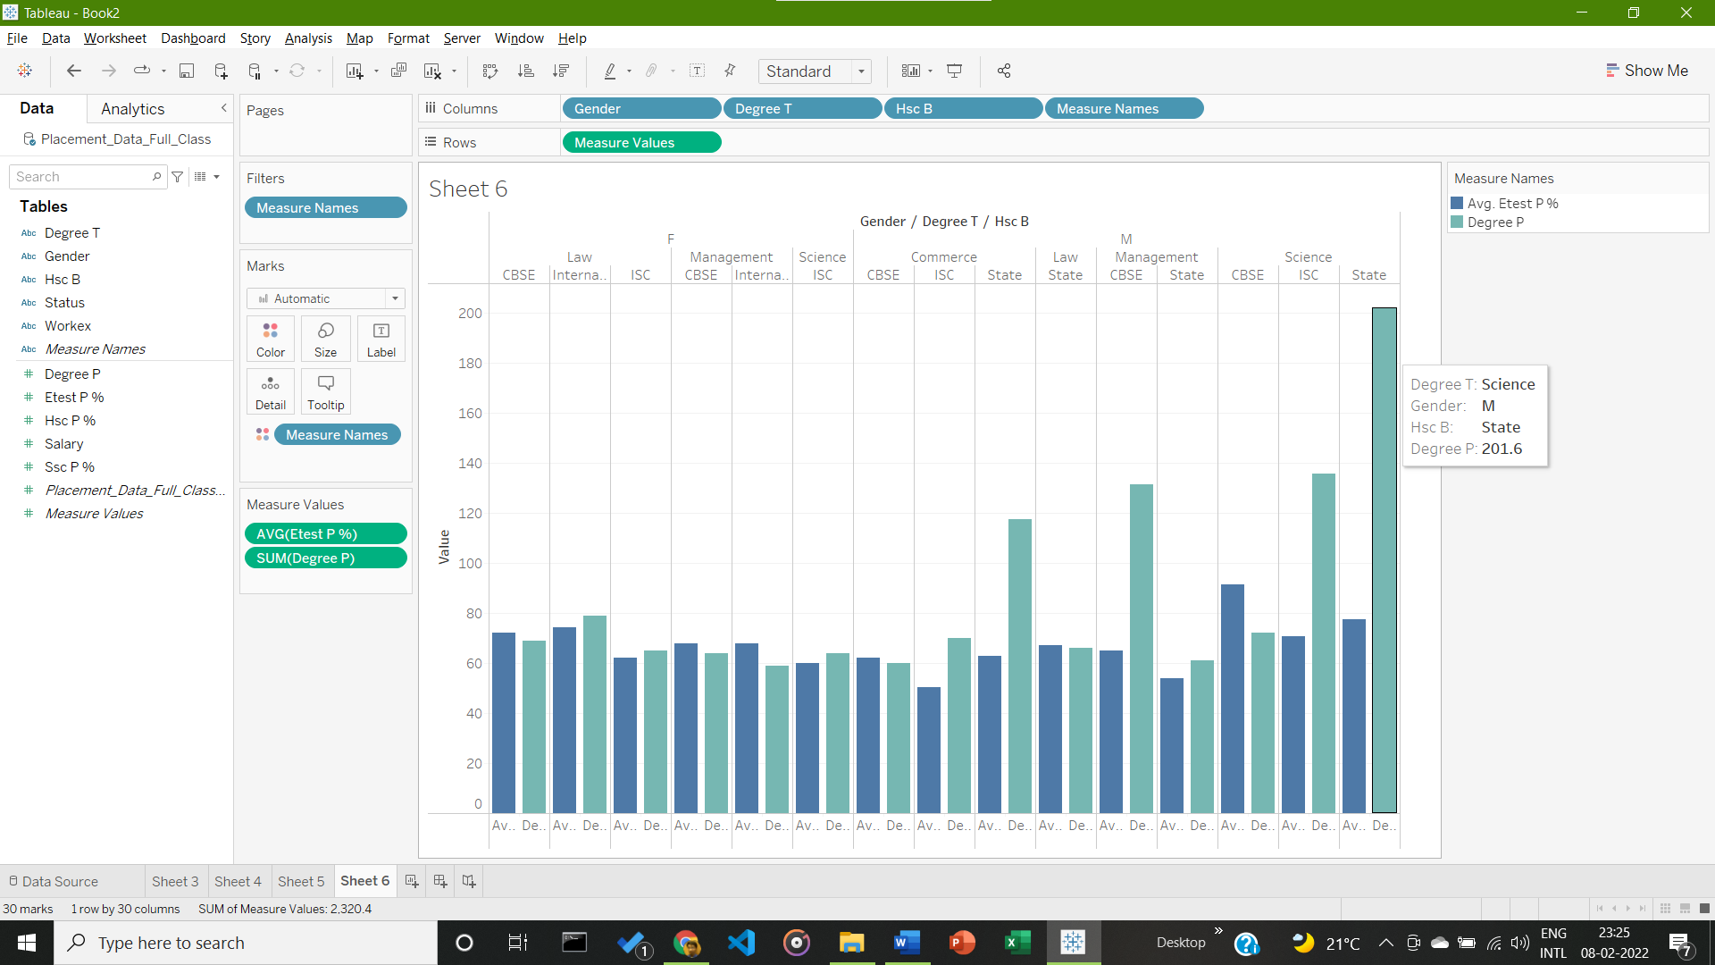

Conclusion from Given Visualization: Highest Cumulative Summation of Degree Test Scores in given Dataset goes to Male who have taken Science as their course and in the CBSE board.

__________________________________________________________________________________