**CSE3020 – Data Visualization (ELA), Winter Semester 2021-2022**

**Lab Assignment IA4 – Slot L43-L44**

**By: Jonathan Rufus Samuel (20BCT0332) Dos: 22.02.2022**

__________________________________________________________________________________

**Lab Assignment – IA4 Scalar Visualizations – 2**

**Note on Software used for following Visualizations: (Tableau)**

Tableau is a visual analytics platform transforming the way we use data to solve problems—empowering people and organizations to make the most of their data.

It includes:

* Easy to access from different sources.
* No need for any technical or programming knowledge, and Quick response for making a dashboard.
* In terms of connecting and sharing, it has various inbuilt advanced features such as: Collaboration and distribution, highly securable, Multiple data sources connection, Easy importation and exportation of the massive size of data.
* For easy accessibility and analysis, the data file can be downloaded locally on mobile or desktop, multilingual representation of data, real-time exploration of any dataset, etc.

**Q) Create a dataset of five or more ordinal values of two categorical data associated with any of your interested domain. Visualize the data using:**

**a. Luminance colour map**

**b. Zebra Colour map**

**c. Rainbow colour map**

**d. Contours**

**(Note: In case if you find that the dataset created does not have sufficient fields or data, you can add the type of field / data as per the necessity)**

**Answer**: Some Key points to note before visualization process:

1. **Dataset Used:**

The dataset used is that of the Superstore Sales Data at a given Superstore Chain. Contains 8390 Rows and 21 Columns as required by the question.

**Link(s):** <https://drive.google.com/drive/folders/1eEL3dpCk_mfSsvEhME04-qJkWjrpi8Ib>

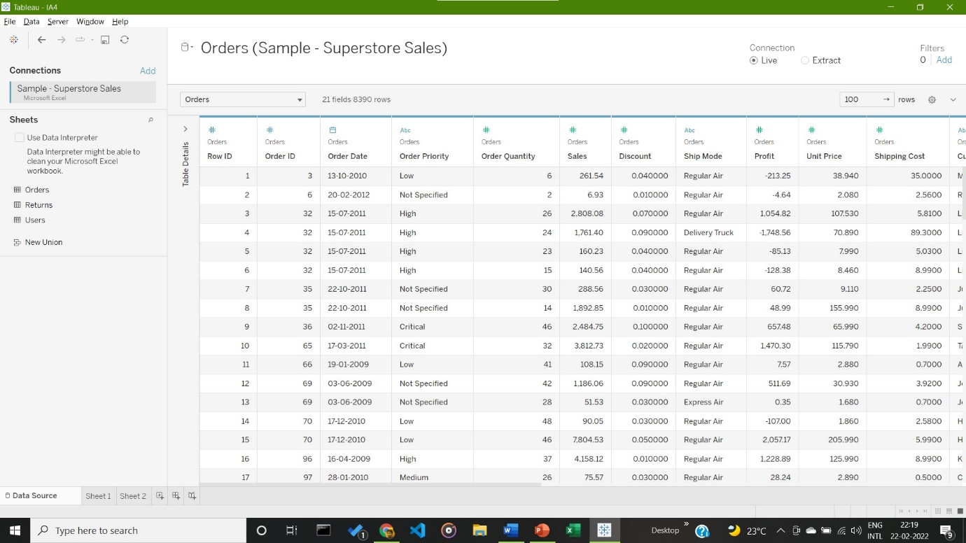

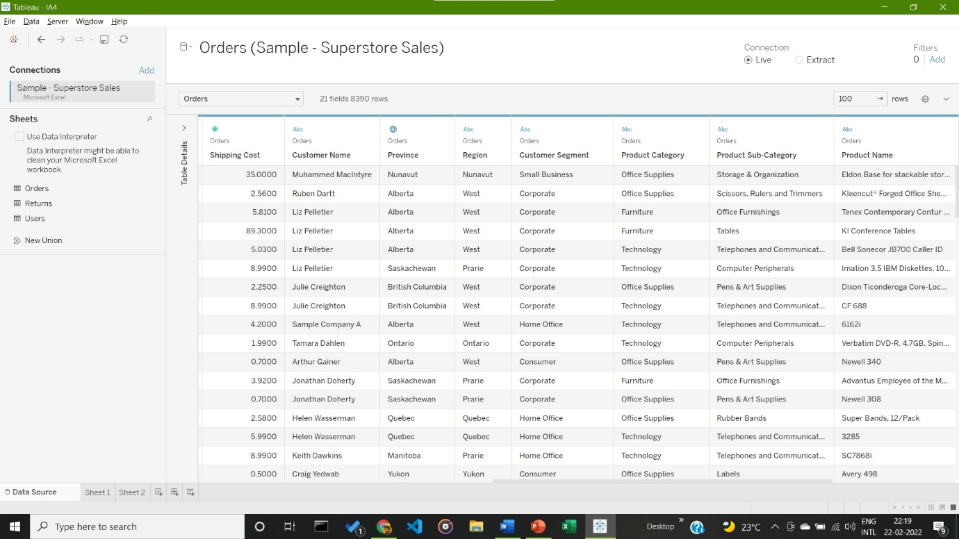

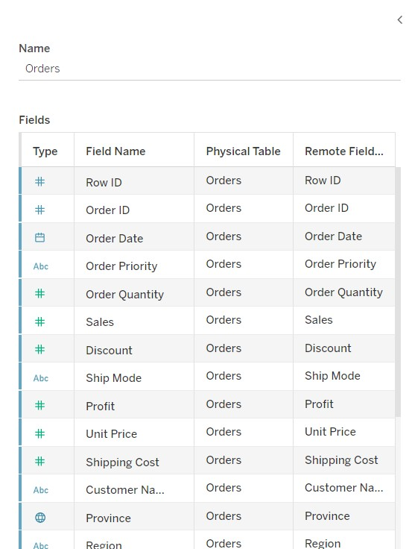

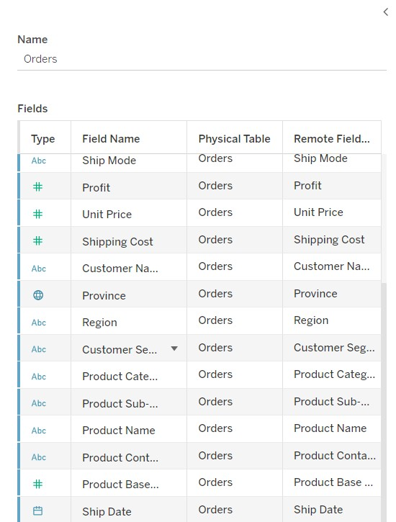

1. **Visualization:**
2. **Visualization using Luminance Colour Mapping**

Generalization based on the three following Categorical Data: Product Sub-Category, Order Priority and SUM(Profits), with data on x axis being Order Priority (Ordinal Data) From Critical to Non-Specified.

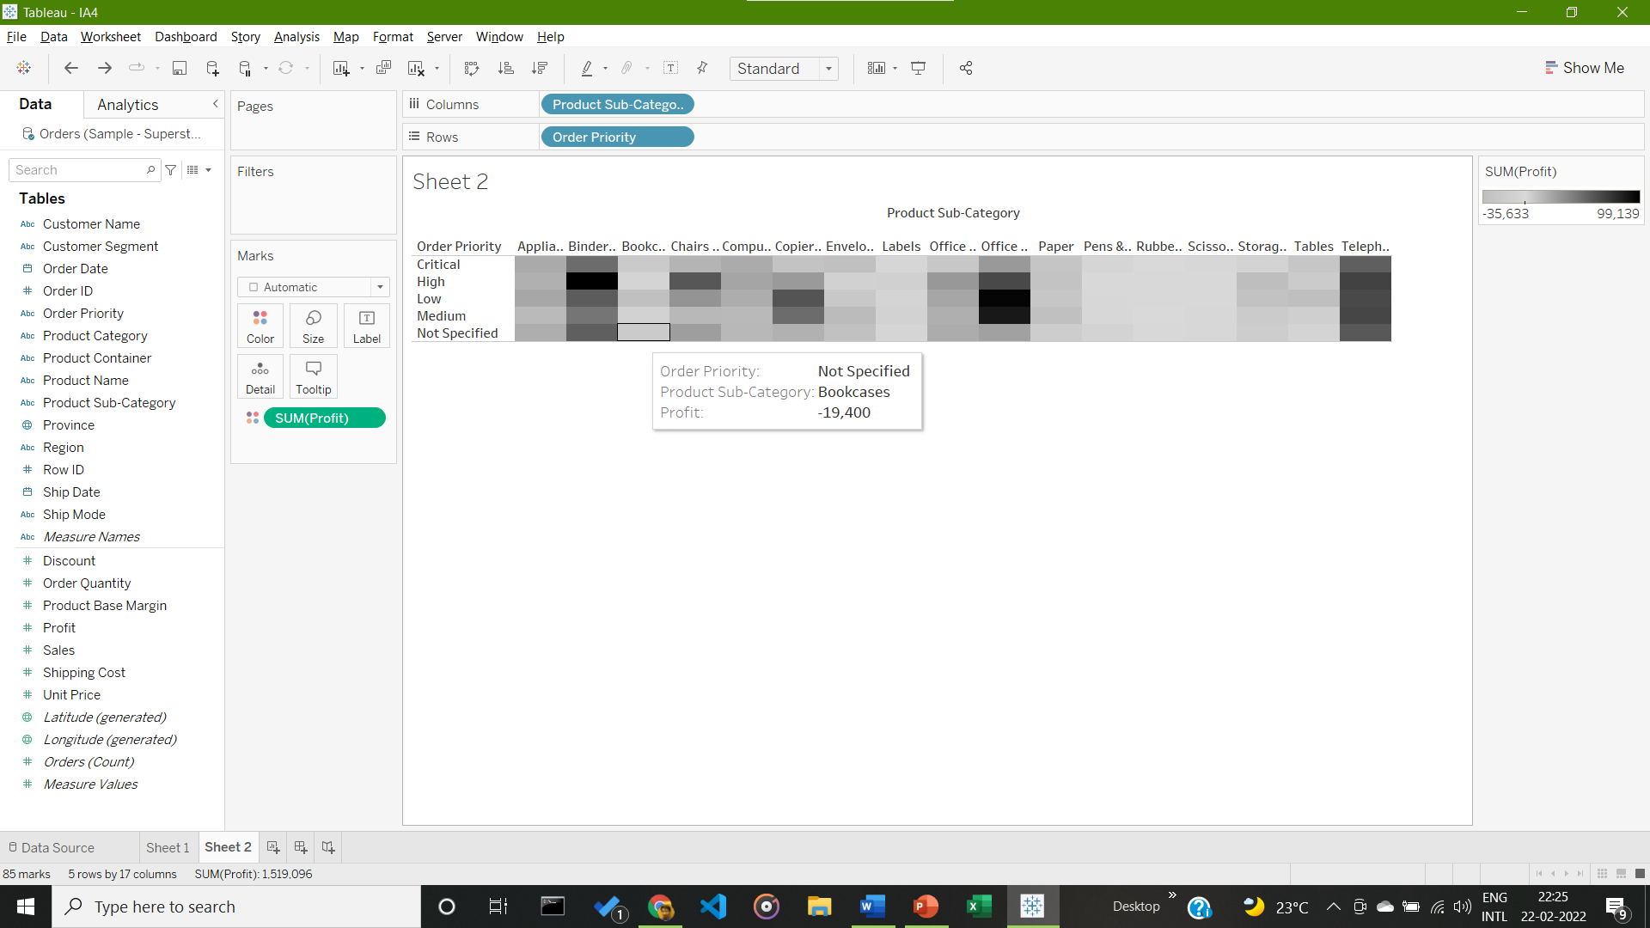

It is given in a Luminance Mapping Format, with SUM(Profit) Ranging from values -35633 (Grey) to 99139 (Black). Highest Profit Margin is seen in High Priority of Binders & Binder Accessories.

1. **Visualization using Zebra Colour Mapping**

Generalization based on the two following Continuous Data: Product Sub-Categories, Region and Order Count (Ordinal Values) With Count < 155 given in grey and count > 155 in black, in accordance with Zebra type Colour Mapping.

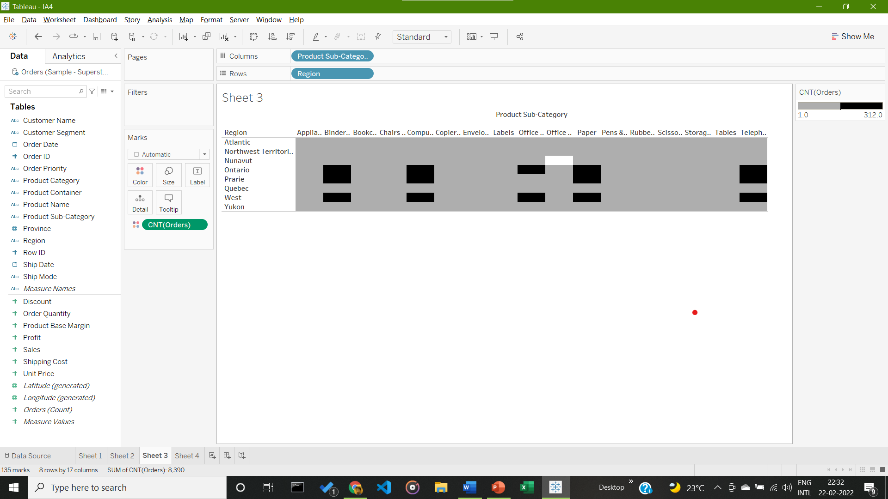

Conclusion from Given Visualization: Highest Count of Orders for Paper from the West, at 312 Orders.

1. **Visualization using Rainbow Colour Mapping**

Generalization based on the three following Categorical and Numerical Data: Product Sub-Categories, Order Priority & SUM(Sales). Given in accordance to Rainbow Colour Mapping, with SUM(Sales) ranging from 2000 (blue) to 494000 (red). Follows Rainbow Colour Mapping with 5 stepped Colours (Blue, Green, Yellow, Orange, Red).

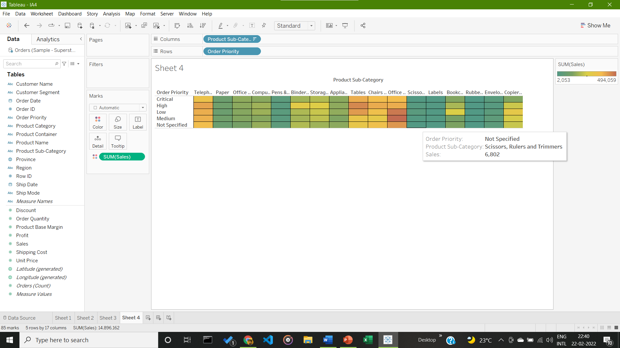

Conclusion from Given Visualization: Highest Number of Cumulative Sales – Machines with Medium Priority at 494,059 pieces.

1. **Contouring of Given Data fields**

Generalization based on the 3 following Categorical Data: Order Priority (Ordinal), Order Quantity and Sales (Ordinal, with different colours for different ranges. Done in Excel as Tableau does not support Contour Plots Natively.

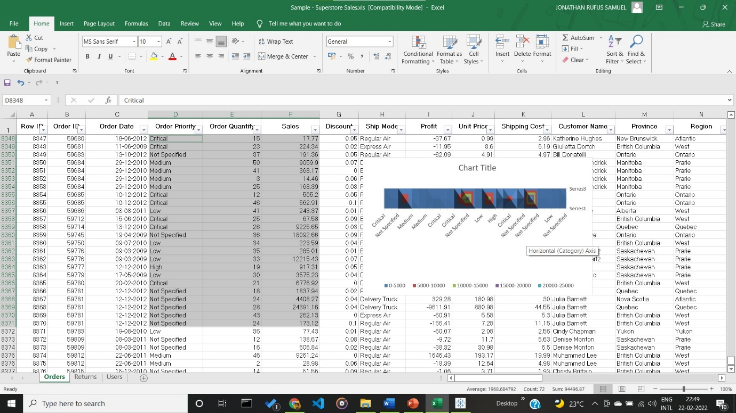

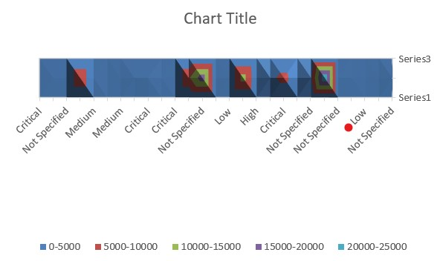

Conclusion from Given Visualization: Series 2 received highest sales at 25000.

__________________________________________________________________________________