**CSE3020 – Data Visualization (ELA), Winter Semester 2021-2022**

**Lab Assignment IA5 – Slot L43-L44**

**By: Jonathan Rufus Samuel (20BCT0332) Dos: 06.03.2022**

__________________________________________________________________________________

**Lab Assignment – IA5 Vector Visualizations**

**Note on Software used for following Visualizations: (Python)**

Python is a High-Level Programming Language, commonly used for data analysis, AI and Machine Learning related fields.

It includes:

* Python is a**high-level programming language** that has English-like syntax. This makes it easier to read and understand the code.
* Python is really easy to**pick up**and **learn**, that is why a lot of people recommend Python to beginners. You need less lines of code to perform the same task as compared to other major languages like **C/C++** and **Java**.

**Q) Create a vector dataset and using an appropriate tool, create its visualization**

**Answer**: Some Key points to note before visualization process:

1. **Dataset Used:**

The dataset is self-made, depicts the elevation of various points on a surface. Describes the nature of the surface, as well as the cities present within the topography. Total of 49 Rows for 5 Columns. Description given below (within Image).

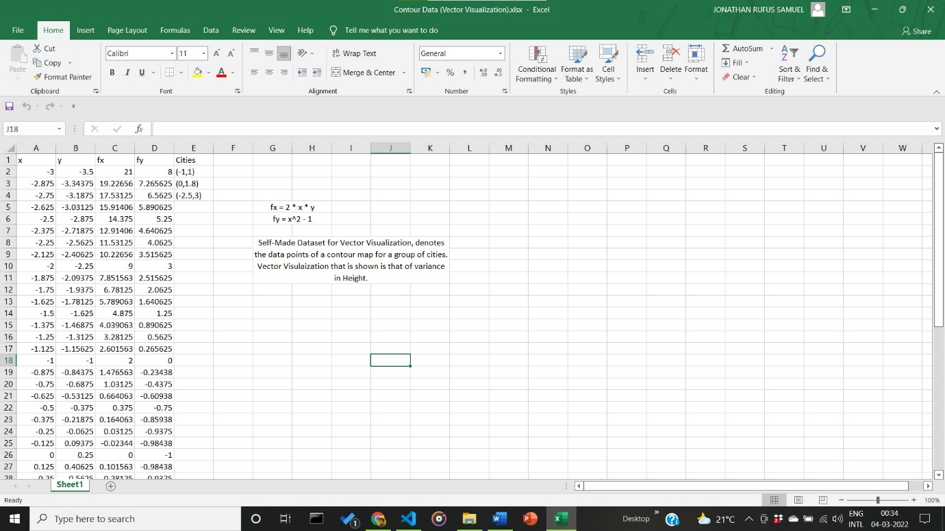

1. **Visualization:**
2. **Visualization using Colour Mapping for Given Vector Visualization**

Generalization based on the 2 following Numerical Data: x-coordinate and y-coordinate. Surface Equation given by Z(x,y) = 2*x*y, x^2-1. Final Vector Map of Elevation to be displayed.

**Code:**

from turtle import color

import matplotlib.pyplot as plt

from matplotlib import cm

import numpy as np

from mpl_toolkits.mplot3d import axes3d

import pandas as pd

data = pd.read_csv('D:/CompSci - Learn/Python/Data Visualization/IA5/final.csv')

print(data.head(5))

x = data['x'].values

y = data['y'].values

X,Y = np.meshgrid(x,y)

Z = X**2*Y - Y

fx = 2*X*Y

fy = X**2 - 1

fig = plt.figure(*figsize*=(20, 8))

ax1 = fig.add_subplot(121, *projection*='3d')

ax1.title.set_text('Z = f(x, y) = $x^2 y - y$')

ax1.plot_surface(X, Y, Z)

color = (((fx-y)/2)*2 + ((fy-x)/2)*2)

ax2 = fig.add_subplot(122)

ax2.grid()

ax2.plot([-1, 1], 'bo', *label* = 'City Group 1', *color*='red')

ax2.plot([0, 1.8], 'bo', *label* = 'City Group 2', *color*='blue')

ax2.plot([-2.5,3], 'bo', *label* = 'City Group 3', *color*='green')

ax2.quiver(X, Y, fx, fy, color, *alpha* = 1)

ax2.title.set_text('Gradient of Terrain f(x, y) = (2xy, x^2 - 1)')

ax2.legend()

plt.show()

**Output:**

Windows PowerShell

Copyright (C) Microsoft Corporation. All rights reserved.

Try the new cross-platform PowerShell https://aka.ms/pscore6

PS D:\CompSci - Learn\Python\Data Visualization> python -u "d:\CompSci - Learn\Python\Data Visualization\IA5\q1.py"

x y fx fy Cities

0 -3.000 -3.50000 21.000000 8.000000 [-1,1]

1 -2.875 -3.34375 19.226562 7.265625 [0,1.8]

2 -2.750 -3.18750 17.531250 6.562500 [-2.5,3]

3 -2.625 -3.03125 15.914062 5.890625 NaN

4 -2.500 -2.87500 14.375000 5.250000 NaN

d:\CompSci - Learn\Python\Data Visualization\IA5\q1.py:21: UserWarning: Z contains NaN values. This may result in rendering artifacts.

ax1.plot_surface(X, Y, Z)

d:\CompSci - Learn\Python\Data Visualization\IA5\q1.py:27: UserWarning: color is redundantly defined by the 'color' keyword argument and the fmt string "bo" (-> color='b'). The keyword argument will take precedence.

ax2.plot([-1, 1], 'bo', label = 'City Group 1', color='red')

d:\CompSci - Learn\Python\Data Visualization\IA5\q1.py:28: UserWarning: color is redundantly defined by the 'color' keyword argument and the fmt string "bo" (-> color='b'). The keyword argument will take precedence.

ax2.plot([0, 1.8], 'bo', label = 'City Group 2', color='blue')

d:\CompSci - Learn\Python\Data Visualization\IA5\q1.py:29: UserWarning: color is redundantly defined by the 'color' keyword argument and the fmt string "bo" (-> color='b'). The keyword argument will take precedence.

ax2.plot([-2.5,3], 'bo', label = 'City Group 3', color='green')

PS D:\CompSci - Learn\Python\Data Visualization>

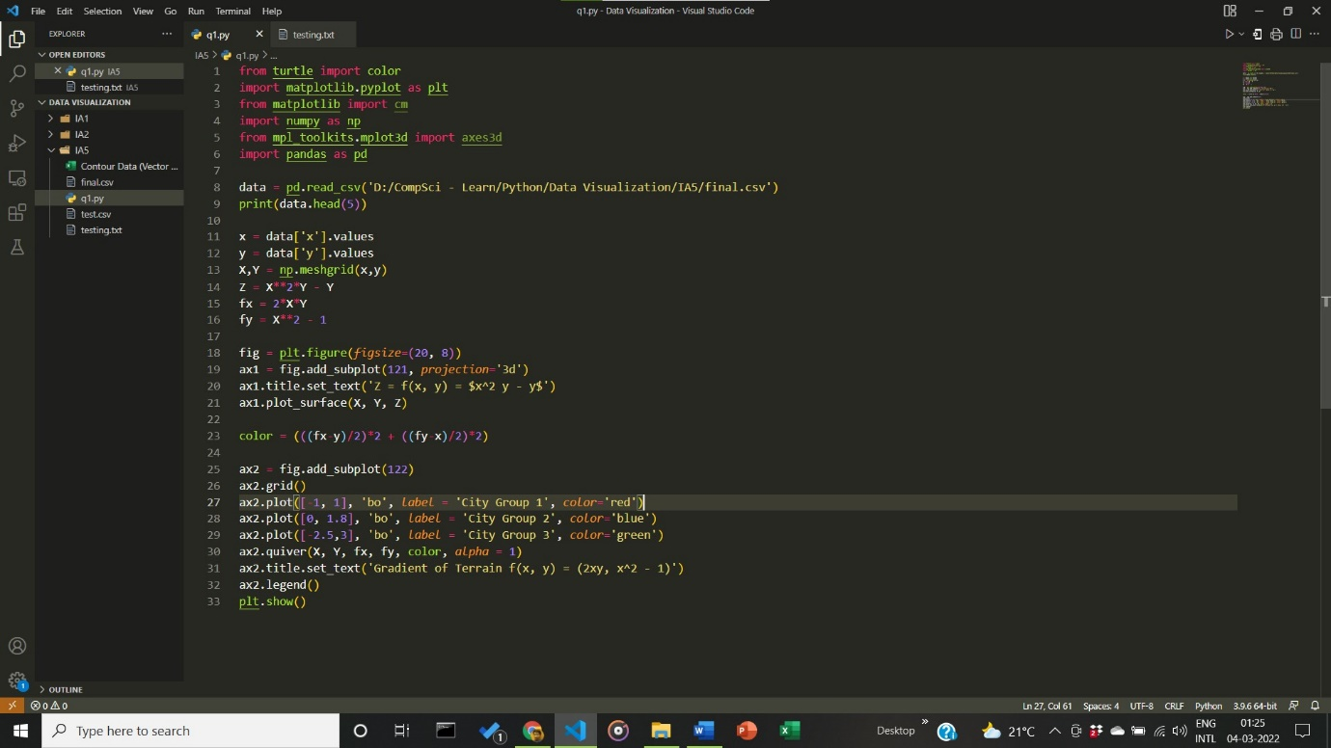

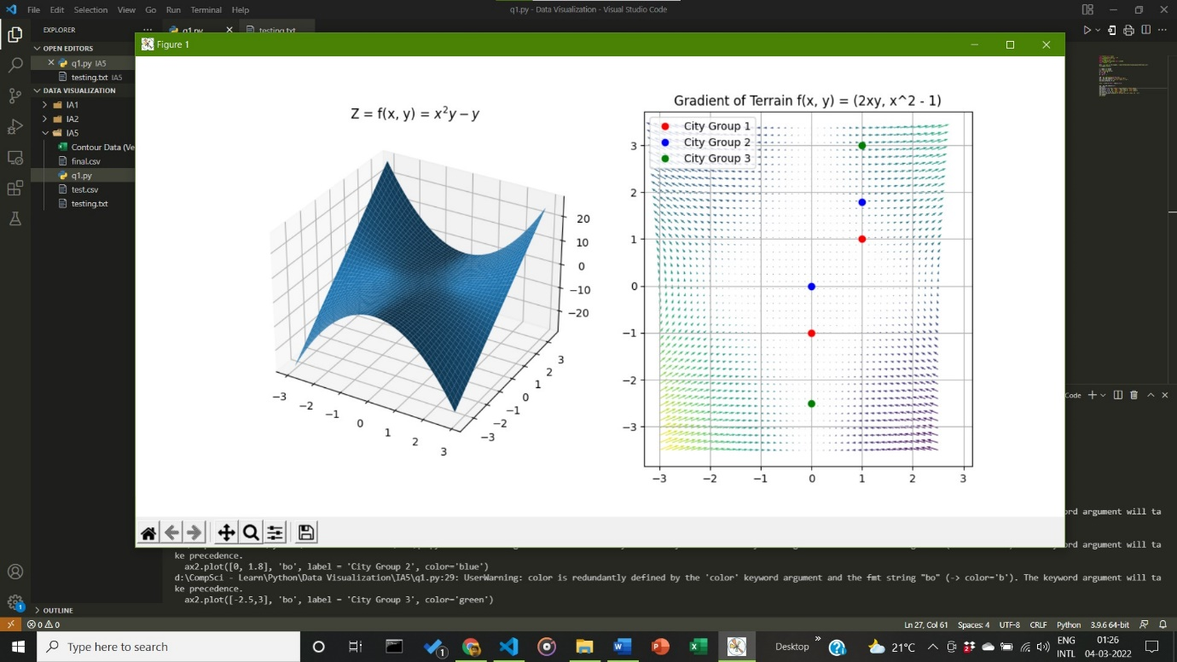

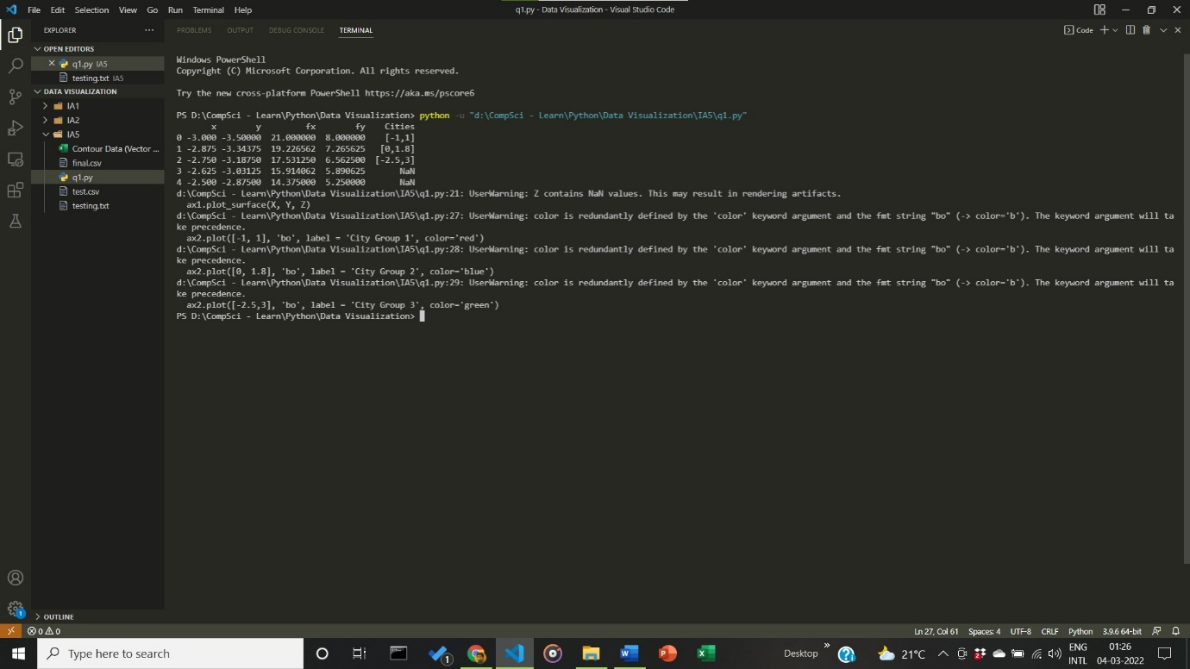

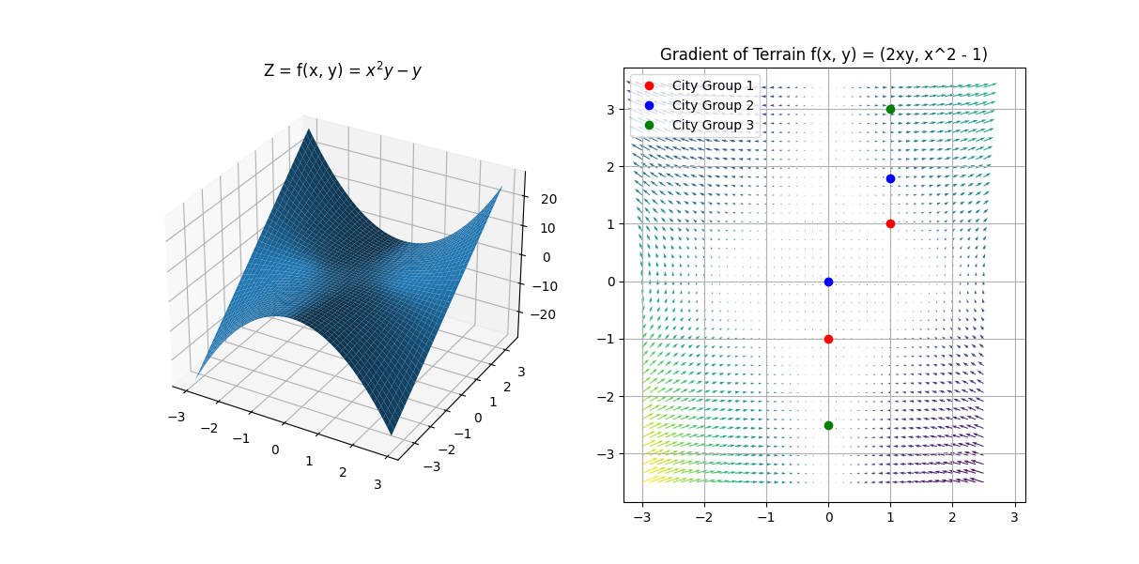

**Inference:**

Almost all the cities have little to negligible amounts of elevation within them.

__________________________________________________________________________________