**CSE3020 – Data Visualization (ELA), Winter Semester 2021-2022**

**Lab Assignment IA6 – Slot L43-L44**

**By: Jonathan Rufus Samuel (20BCT0332) Dos: 15.03.2022**

__________________________________________________________________________________

**Lab Assignment – IA6 Hierarchical Data Visualizations**

**Note on Software used for following Visualizations: (Tableau)**

Tableau is a visual analytics platform transforming the way we use data to solve problems—empowering people and organizations to make the most of their data.

It includes:

* Easy to access from different sources.
* No need for any technical or programming knowledge, and Quick response for making a dashboard.
* In terms of connecting and sharing, it has various inbuilt advanced features such as: Collaboration and distribution, highly securable, Multiple data sources connection, Easy importation and exportation of the massive size of data.
* For easy accessibility and analysis, the data file can be downloaded locally on mobile or desktop, multilingual representation of data, real-time exploration of any dataset, etc.

**Q) Create a Hierarchical data set to contain 3 levels of information of your choice in an**

**domain. Visualize the hierarchy using:**

**a. Tree maps**

**b. Heat maps**

**c. Cluster Map/ chart (Exempted for now – on 15.03.2022)**

**Answer**: Some Key points to note before visualization process:

1. **Dataset Used:**

The dataset is self-designed dataset, loosely based on the <https://data.worldbank.org/indicator/NY.GDP.PCAP.PP.CD> dataset. It depicts the name of countries, the standard for GDP per capita and the GPD per capita for the years 2008 & 2018.

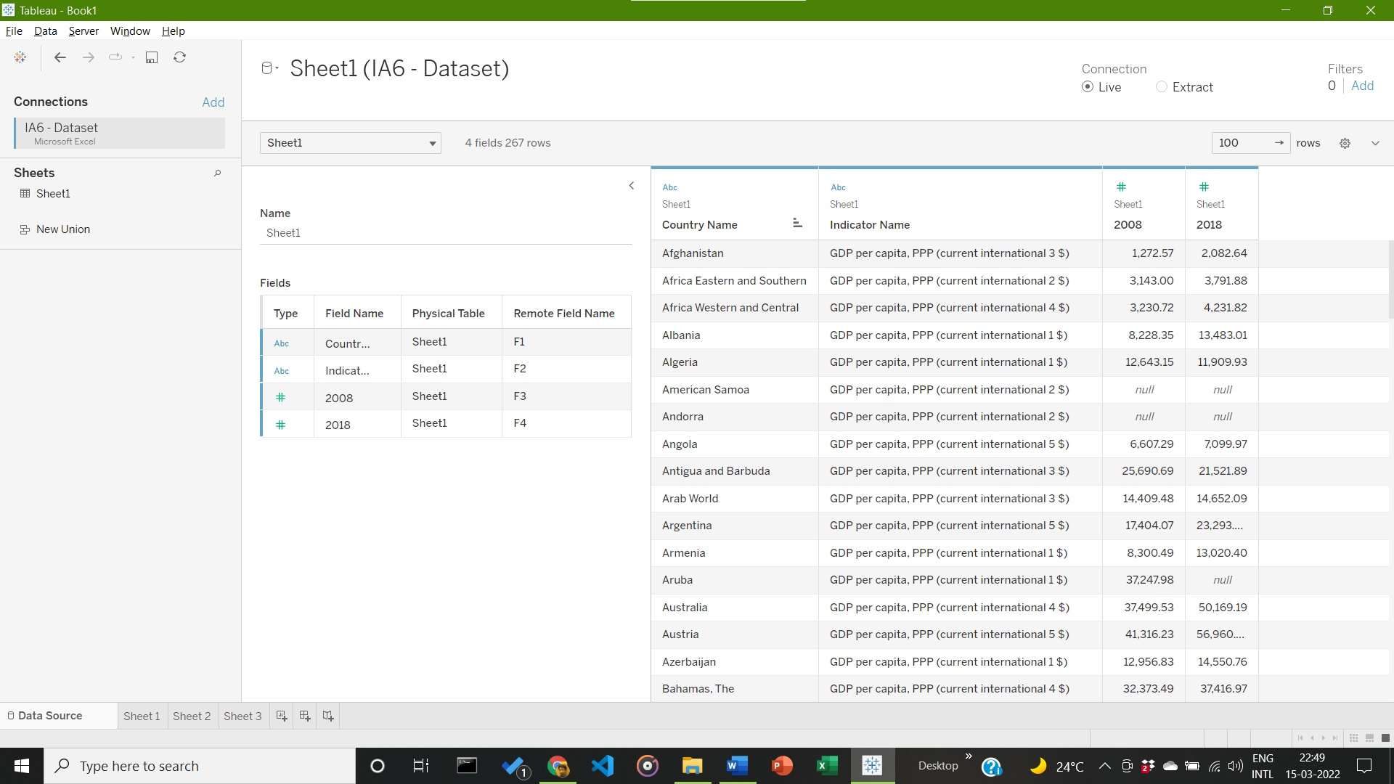

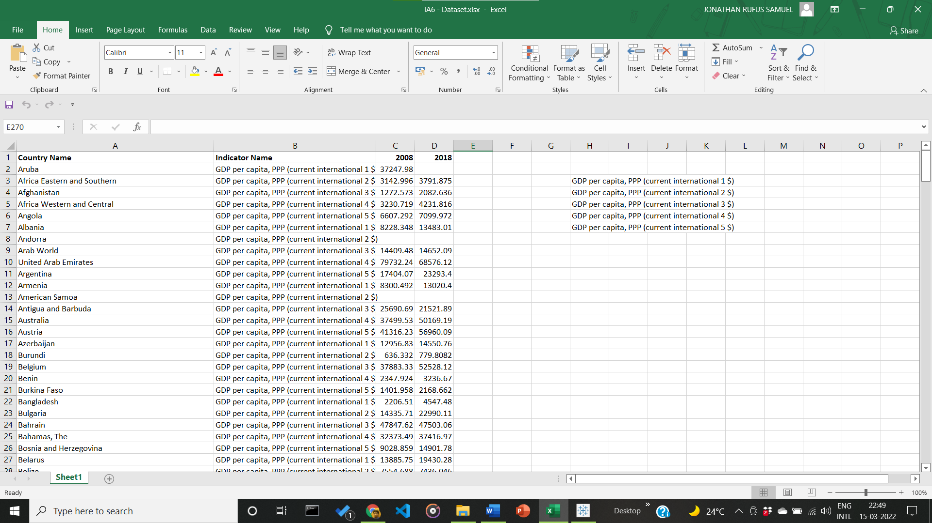

1. **Visualization:**
2. **Visualization using Tree Mapping for Given Hierarchical Dataset Visualization**

Visualization based on country names and the given GDP per capita of the years 2008 (as seen in figure 1) and a combination of GDP per capita for years 2008 and 2018 to visualize tree map data in difference of a span of a decade.

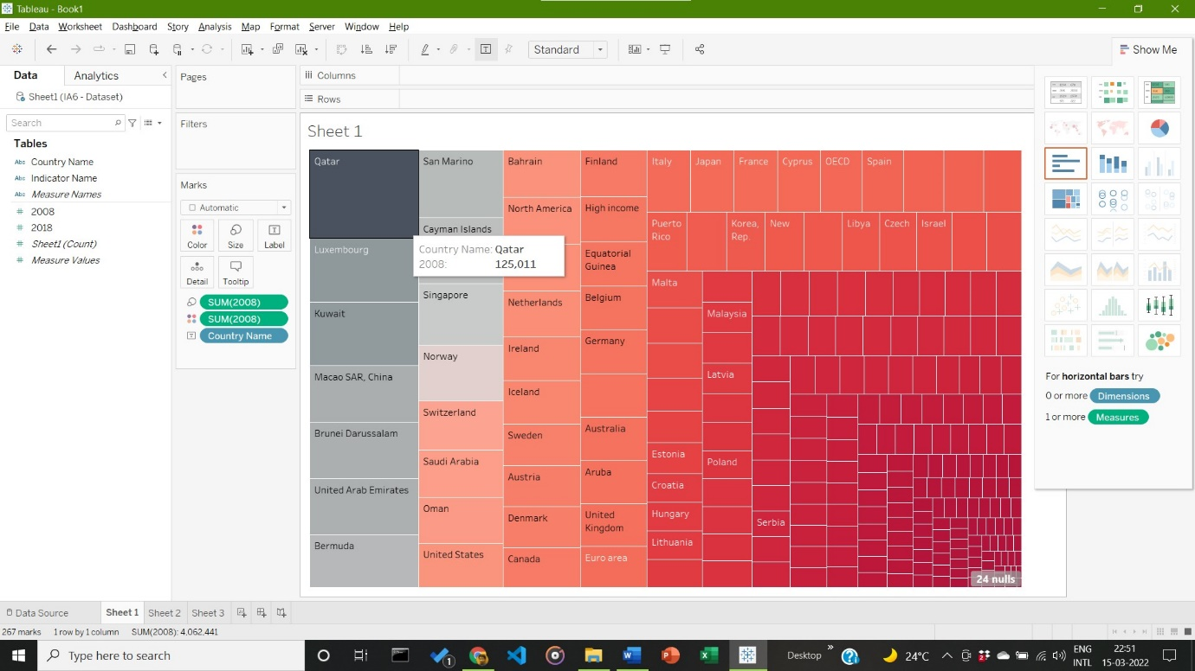

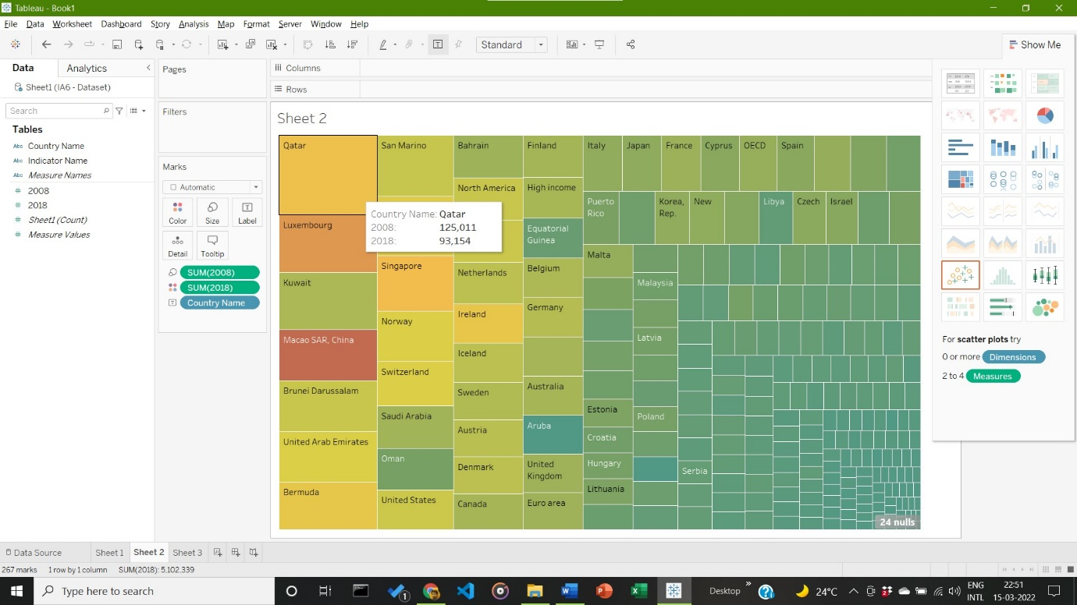

**Inference:**

Qatar maintains the highest GDP per capita, in both years 2008 and 2018. It also maintains the highest difference over a decade. There is also a noticeable fluctuation in the GPD per capita of MACAO SR China, over the decade.

1. **Visualization using Heat Mapping for Given Hierarchical Dataset Visualization**

Visualization based on country names and the given GDP per capita of the years 2008 (as seen in figure 1) and a combination of GDP per capita for years 2008 and 2018 to visualize Heat map data in the year 2008.

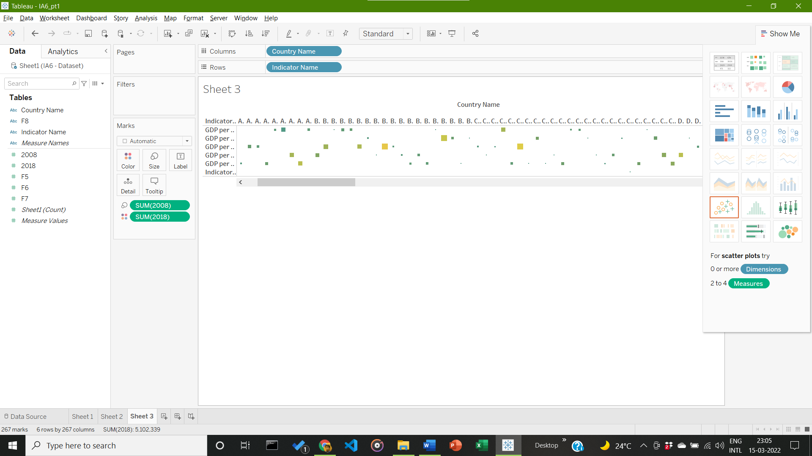

**Inference:**

Heat Map is displayed, but due to levels present in Hierarchical dataset, gaps are present in the Heat Map. Can be worked on in Review 2 of IA6

1. **Visualization using Cluster Mapping for Given Hierarchical Dataset Visualization**

Visualization based on country names and the given GDP per capita of the years 2008 (as seen in figure 1) and a combination of GDP per capita for years 2008 and 2018 to visualize Heat map data in the year 2008.



**Inference:**

Heat Map is displayed, but due to levels present in Hierarchical dataset, gaps are present in the Heat Map. Can be worked on in Review 2 of IA6

__________________________________________________________________________________