**CSE3020 – Data Visualization (ELA), Winter Semester 2021-2022**

**Lab Assignment IA6 – Slot L43-L44**

**By: Jonathan Rufus Samuel (20BCT0332) Dos: 15.03.2022 Re-DOS: 20.04.2022**

__________________________________________________________________________________

**Lab Assignment – IA6 Hierarchical Data Visualizations**

(V2.0 - Completion of Cluster Maps)

**Note on Software used for following Visualizations: (Tableau)**

Tableau is a visual analytics platform transforming the way we use data to solve problems—empowering people and organizations to make the most of their data.

It includes:

* Easy to access from different sources.
* No need for any technical or programming knowledge, and Quick response for making a dashboard.
* In terms of connecting and sharing, it has various inbuilt advanced features such as: Collaboration and distribution, highly securable, Multiple data sources connection, Easy importation and exportation of the massive size of data.
* For easy accessibility and analysis, the data file can be downloaded locally on mobile or desktop, multilingual representation of data, real-time exploration of any dataset, etc.

**Q) Create a Hierarchical data set to contain 3 levels of information of your choice in an**

**domain. Visualize the hierarchy using:**

**a. Tree maps**

**b. Heat maps**

**c. Cluster Map/ chart**

**Answer**: Some Key points to note before visualization process:

1. **Dataset Used:**

The dataset is self-designed dataset, loosely based on the <https://data.worldbank.org/indicator/NY.GDP.PCAP.PP.CD> dataset. It depicts the name of countries, the standard for GDP per capita and the GPD per capita for the years 2008 & 2018.

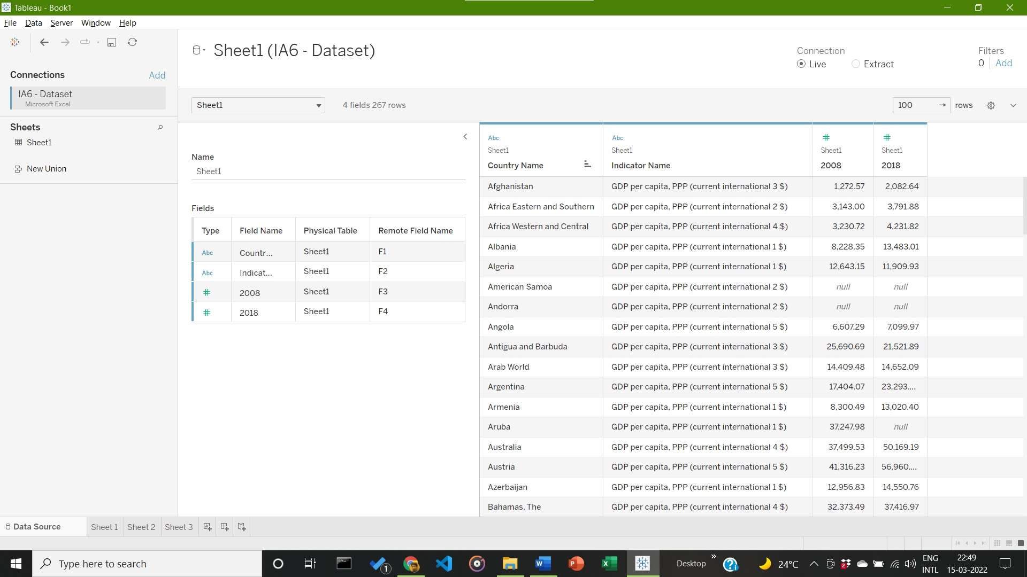

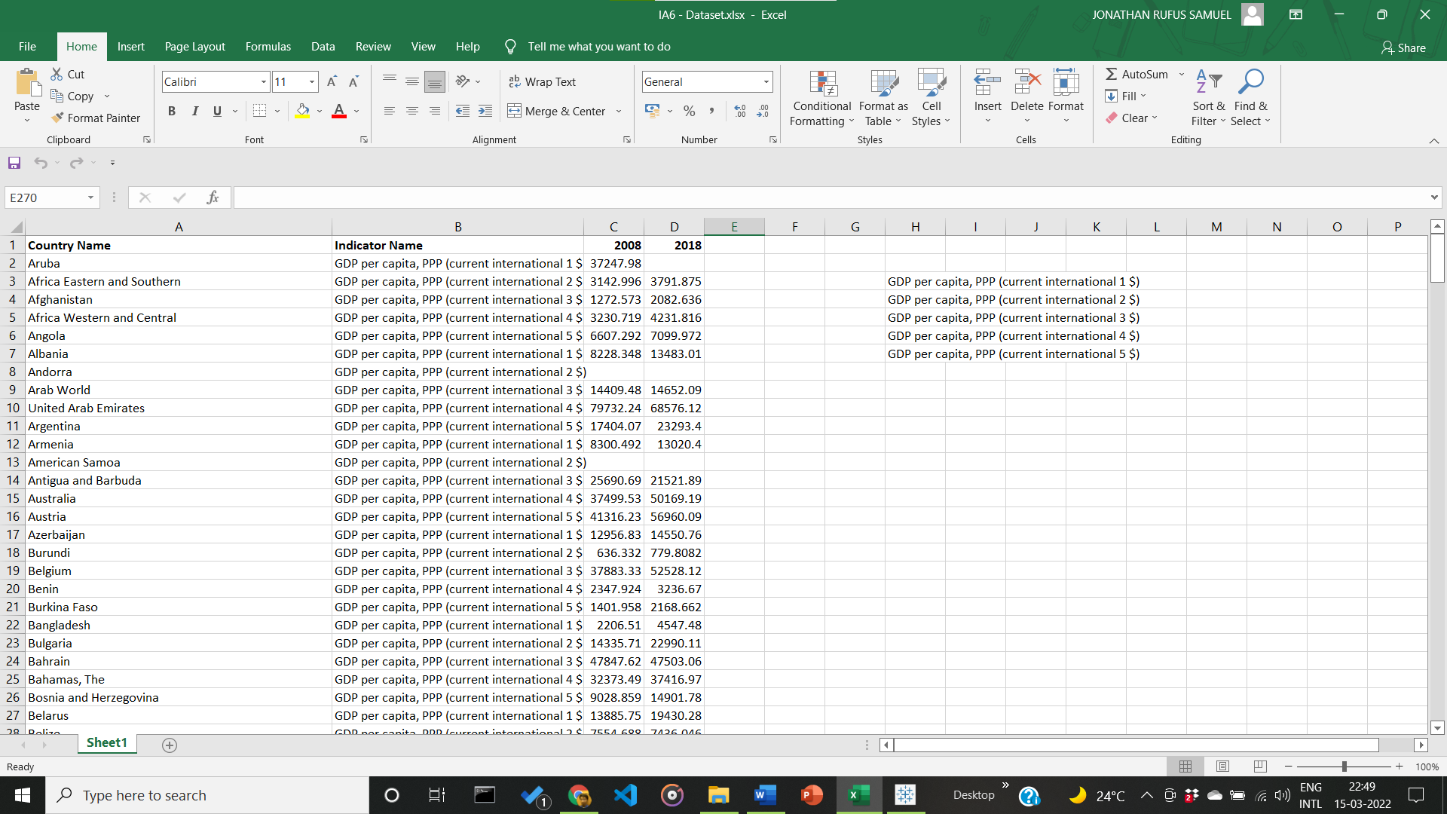

1. **Visualization:**
2. **Visualization using Tree Mapping for Given Hierarchical Dataset Visualization**

Visualization based on country names and the given GDP per capita of the years 2008 (as seen in figure 1) and a combination of GDP per capita for years 2008 and 2018 to visualize tree map data in difference of a span of a decade.

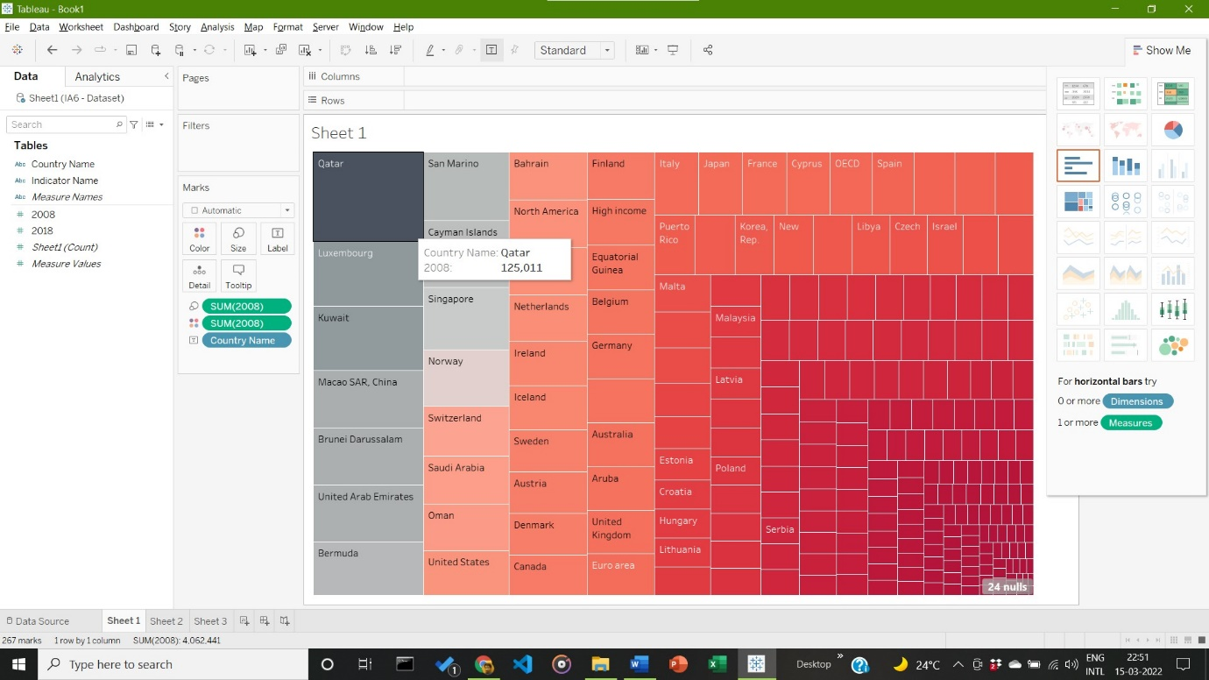

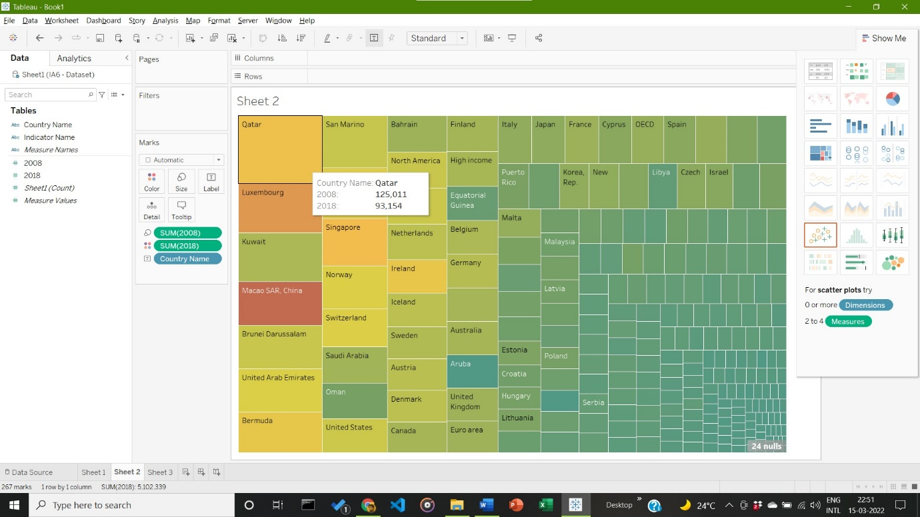

**Inference:**

Qatar maintains the highest GDP per capita, in both years 2008 and 2018. It also maintains the highest difference over a decade. There is also a noticeable fluctuation in the GPD per capita of MACAO SR China, over the decade.

1. **Visualization using Heat Mapping for Given Hierarchical Dataset Visualization**

Visualization based on country names and the given GDP per capita of the years 2008 (as seen in figure 1) and a combination of GDP per capita for years 2008 and 2018 to visualize Heat map data in the year 2008.

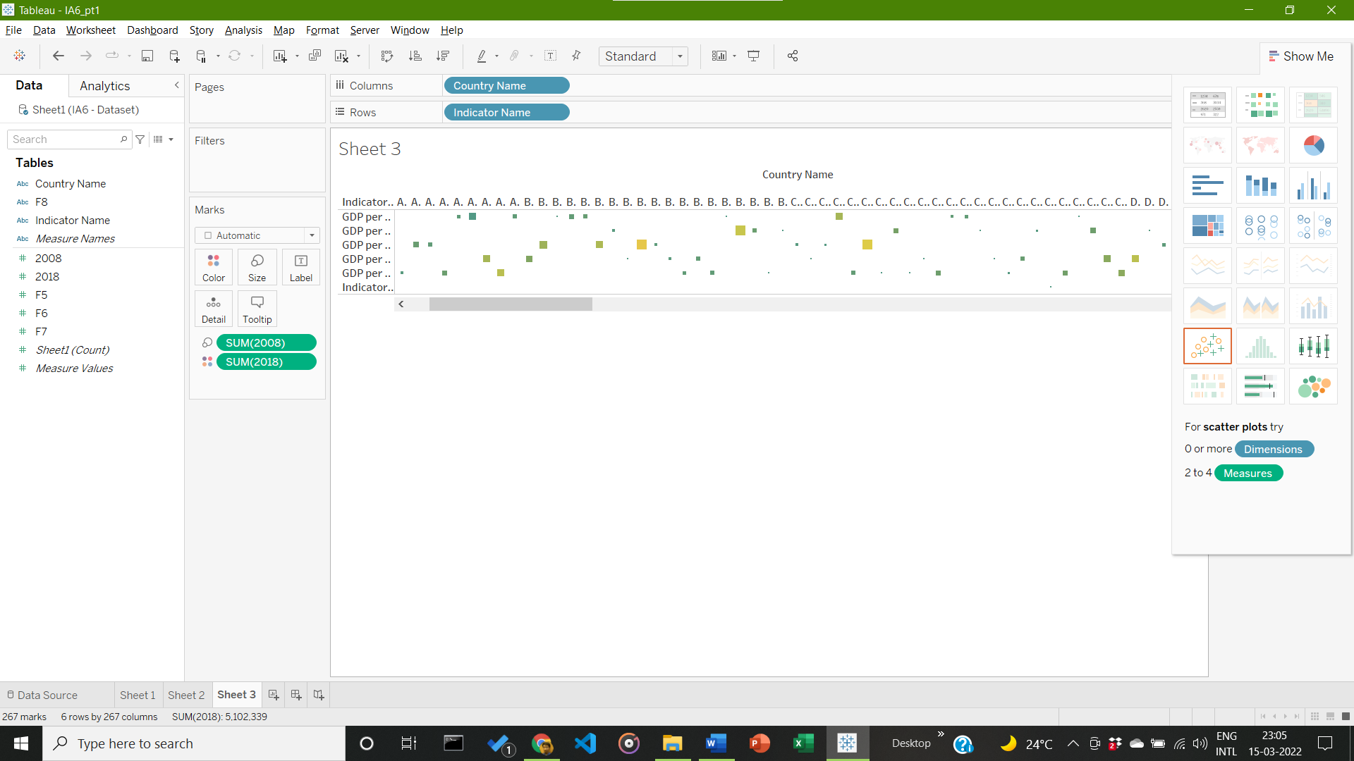

**Inference:**

Heat Map is displayed, but due to levels present in Hierarchical dataset, gaps are present in the Heat Map. Can be worked on in Review 2 of IA6

1. **Dataset Used (For Cluster Maps:**

The dataset is the in-built World Indicators Dataset, freely available in Tableau. It shows the various birth rates and population for the year 2012.

1. **Visualization using Cluster Mapping for Given Hierarchical Dataset Visualization**

Cluster Maps of the World Map for Population is shown. Birth rate is depicted by colour variations (as shown in the side bar). Size of Clusters determines the average population, and tooltip gives info on other parameters, like county name, region, etc.

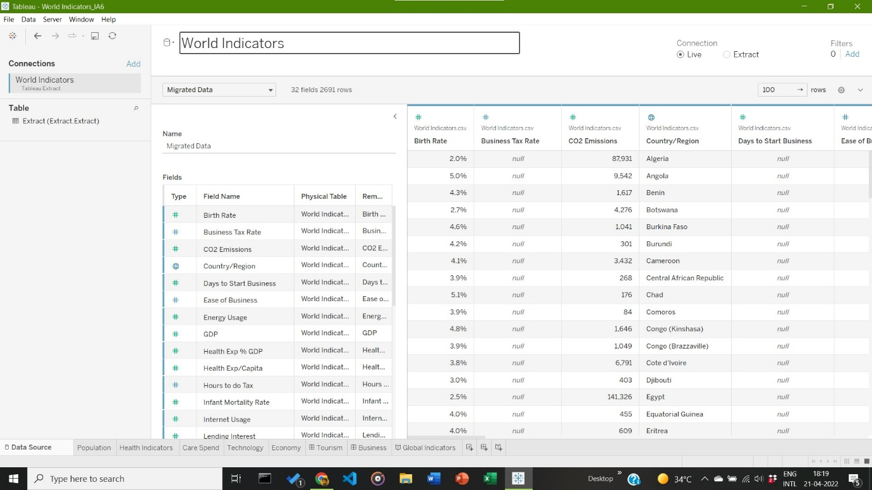

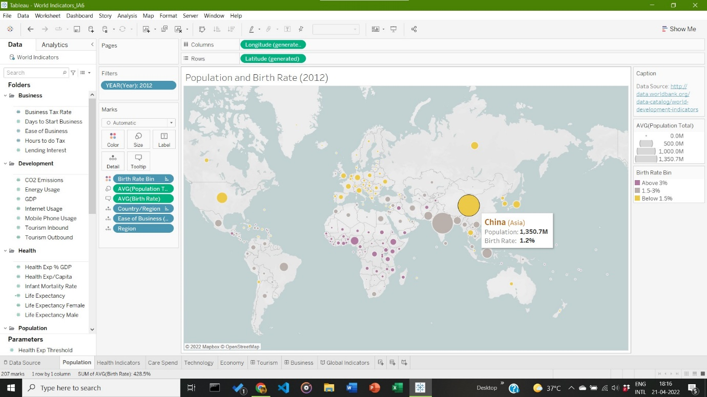

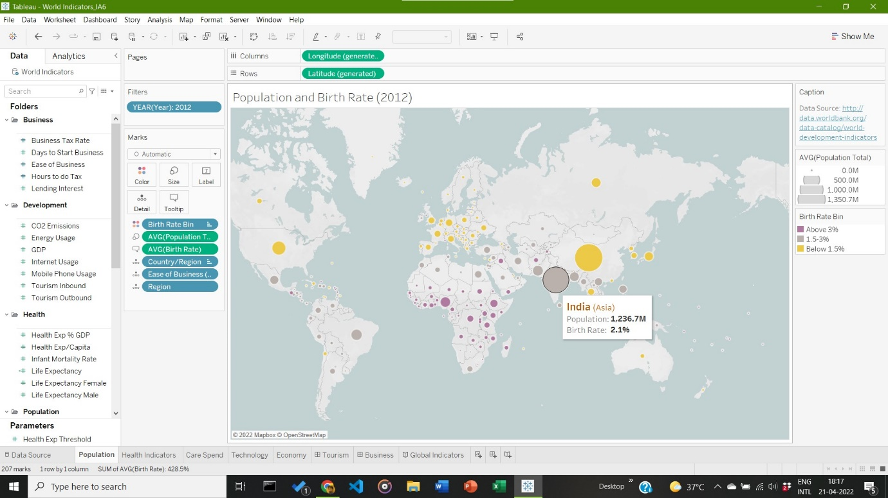

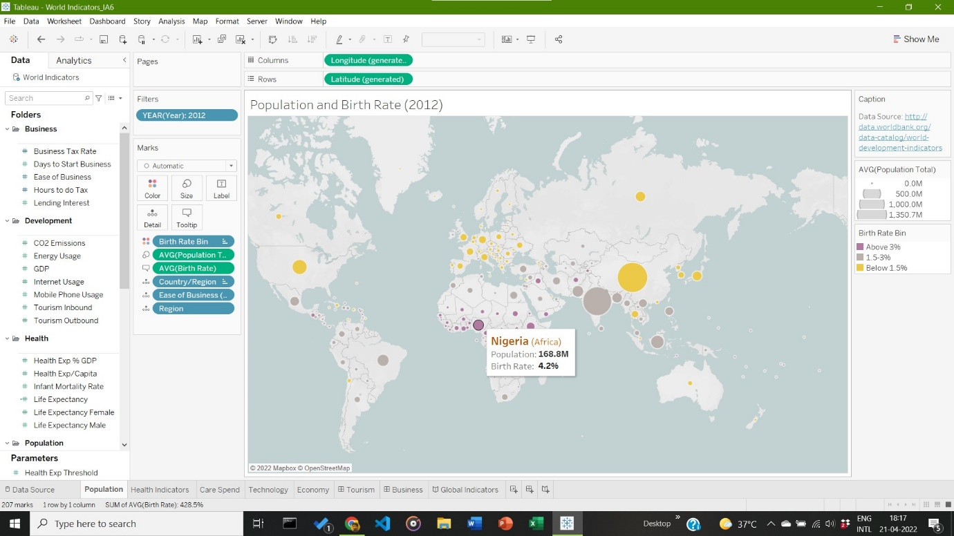

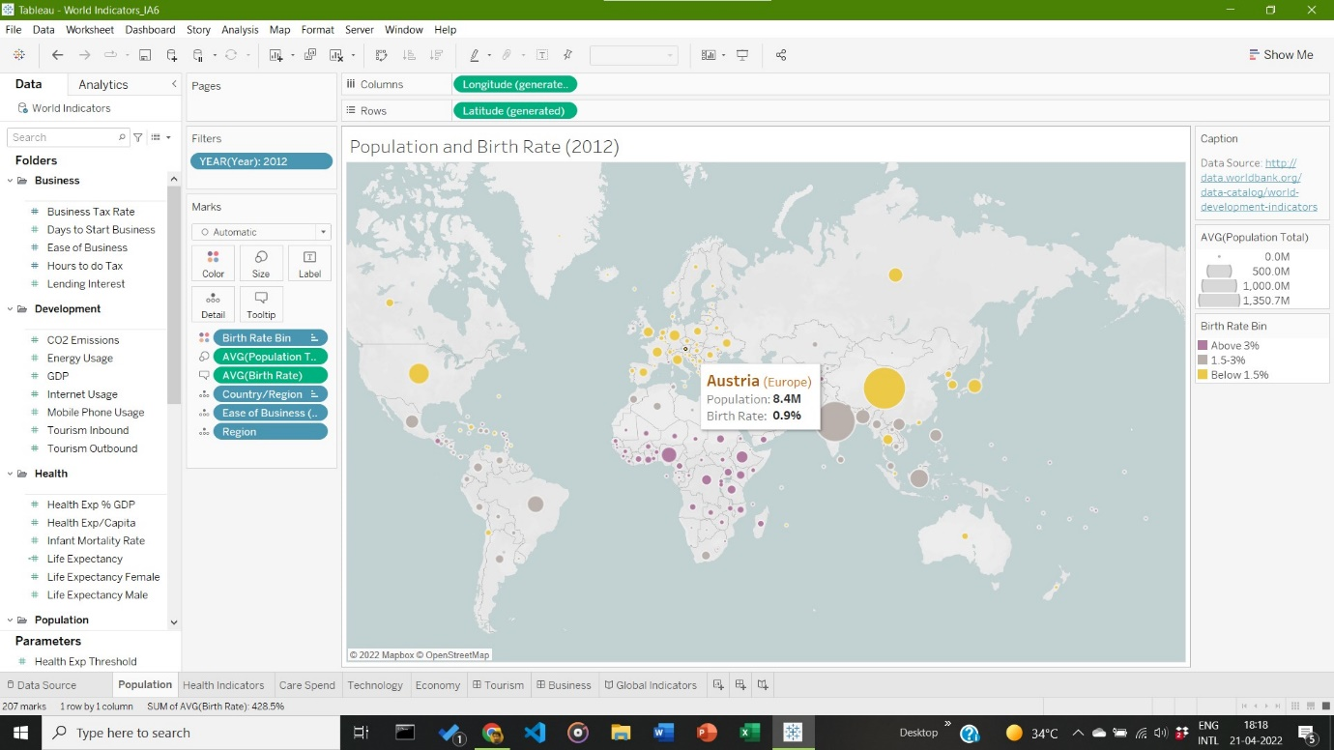

**Inference:**

Countries with highest population is China and India, with 1.3 and 1.2 billion citizens respectively. They both boast growing birth rates of 1.2% and 2.1% respectively, with India set to overtake China by the year 2027. Nigeria has the highest birth rate of 4.2%, making it one of the most rapidly growing countries in terms of population in the world. Many countries have a decreasing birth rate of 0.9%, one of them being Austria, as shown above.

__________________________________________________________________________________