**CSE3020 – Data Visualization (ELA), Winter Semester 2021-2022**

**Lab Assignment IA8 – Slot L43-L44**

**By: Jonathan Rufus Samuel (20BCT0332) Dos: 10.04.2022 Re-DOS: 20.04.2022**

__________________________________________________________________________________

**Lab Assignment – IA8 – Spatial and Temporal Datasets**

(Update: Improvement/Correction of Both visualizations)

**Note on Software used for following Visualizations: (Tableau)**

Tableau is a visual analytics platform transforming the way we use data to solve problems—empowering people and organizations to make the most of their data.

It includes:

* Easy to access from different sources.
* No need for any technical or programming knowledge, and Quick response for making a dashboard.
* In terms of connecting and sharing, it has various inbuilt advanced features such as: Collaboration and distribution, highly securable, Multiple data sources connection, Easy importation and exportation of the massive size of data.

For easy accessibility and analysis, the data file can be downloaded locally on mobile or desktop, multilingual representation of data, real-time exploration of any dataset, etc.

**Q1) Choose a standard Spatial dataset and generate the visualization of selected spatial data:**

**Answer**: Some Key points to note before visualization process:

1. **Dataset Used:**

The dataset used is the inbuilt dataset **Regional (Obesity)** available in Tableau. The dataset depicts the obesity rates in all the states of the United States of America via Mapping based Visualizations.

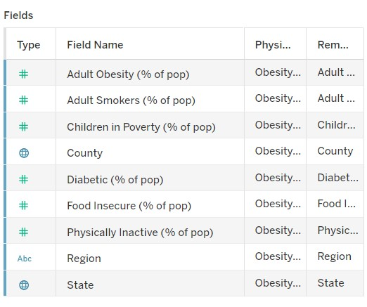

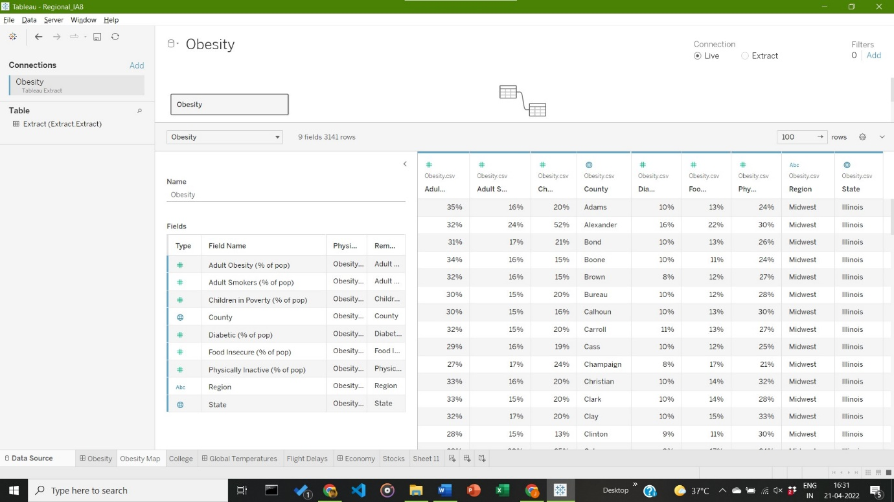

1. **Visualization:**

Visualization based on Obesity Rates, and the comparison with the average obesity rate of the given Dataset for the states of USA. Differentiation of tool tip seen with variation in colour. Also specifies percentage of people who do not eat fruits, who exercise less and who smoke.

1. **Visualization using Maps for Given Spatial Data**

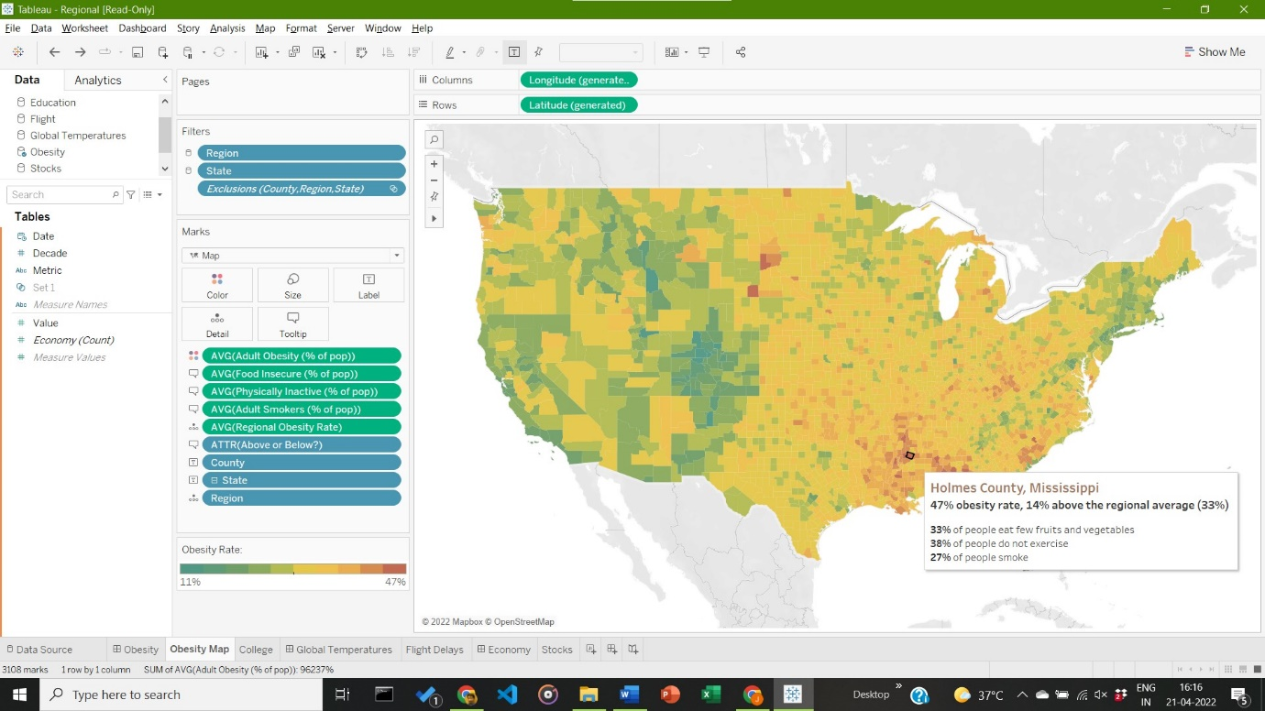

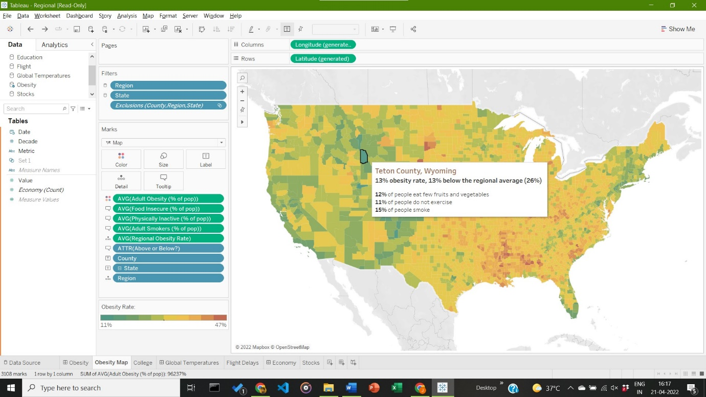

**Inference:**

The state county with the lowest obesity rate is Teston County in Wyoming, with a rate of 13%. The state county with the highest obesity rate is Holmes County, Mississippi, with a rate of 47%.

**Q2) Choose a standard temporal dataset and generate appropriate visualization for it:**

**Answer**: Some Key points to note before visualization process:

1. **Dataset Used:**

The dataset used is the inbuilt dataset **Regional (Stocks)** available in Tableau. The dataset depicts the Stock annual returns from the years 2010-2014 in all the states of the United States of America via Mapping based Visualizations.

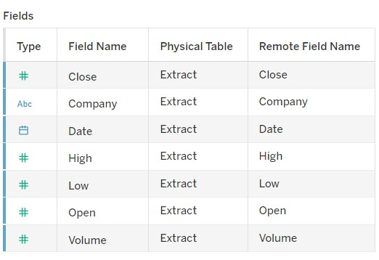

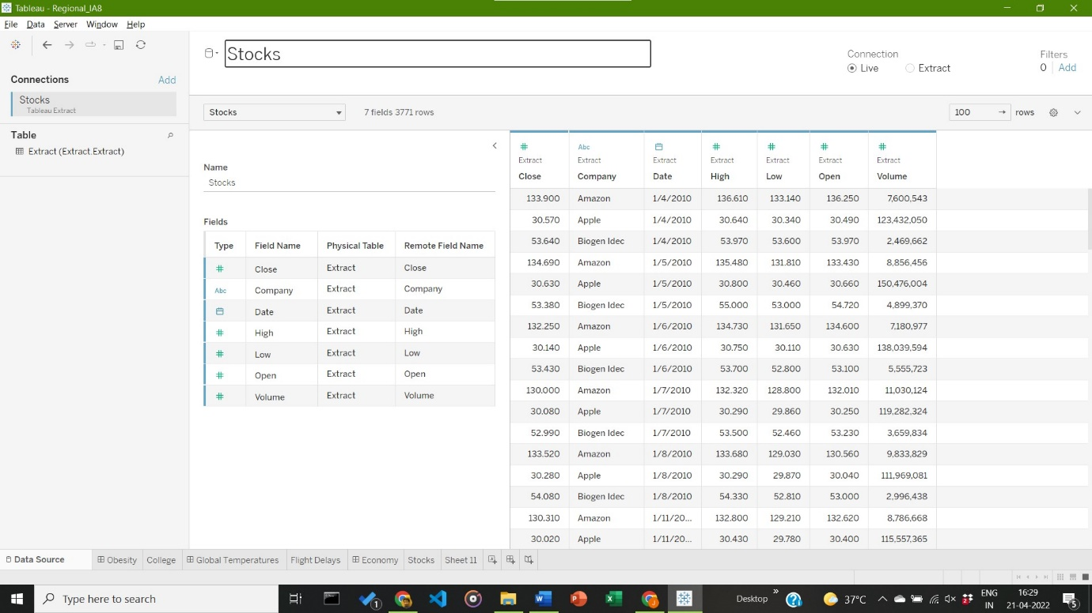

1. **Visualization:**

Visualization based on Time (given in Weeks of Dates present in dataset), Average closing value, with different companies denoted with different colours (here; Apple: red, Amazon: Yellow, Biogon Idec: Green)

1. **Visualization using Tree Maps for Given Temporal Dataset:**

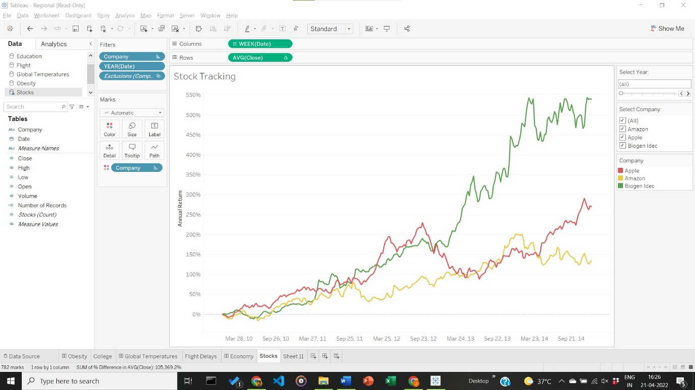

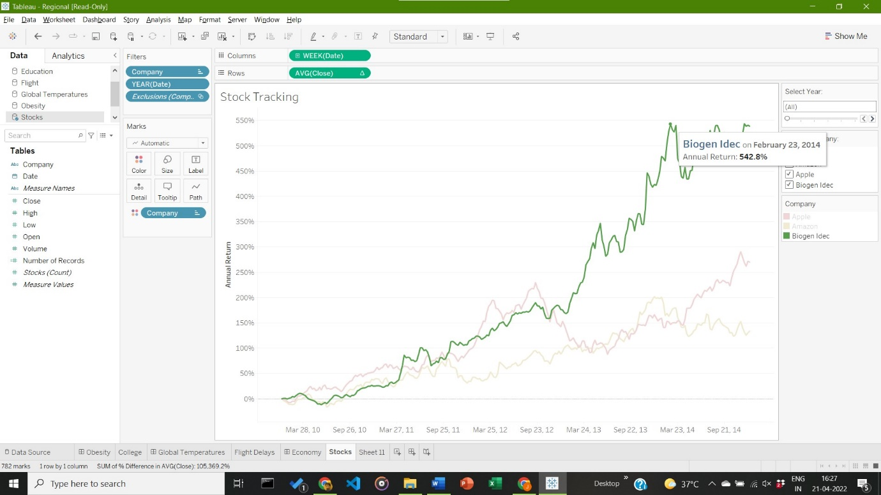

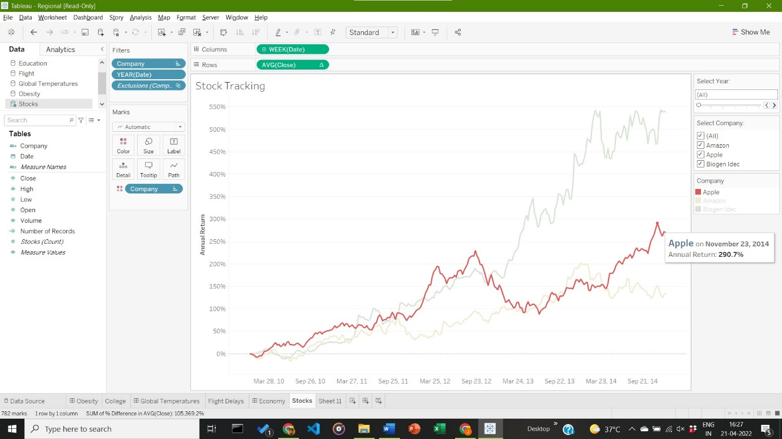

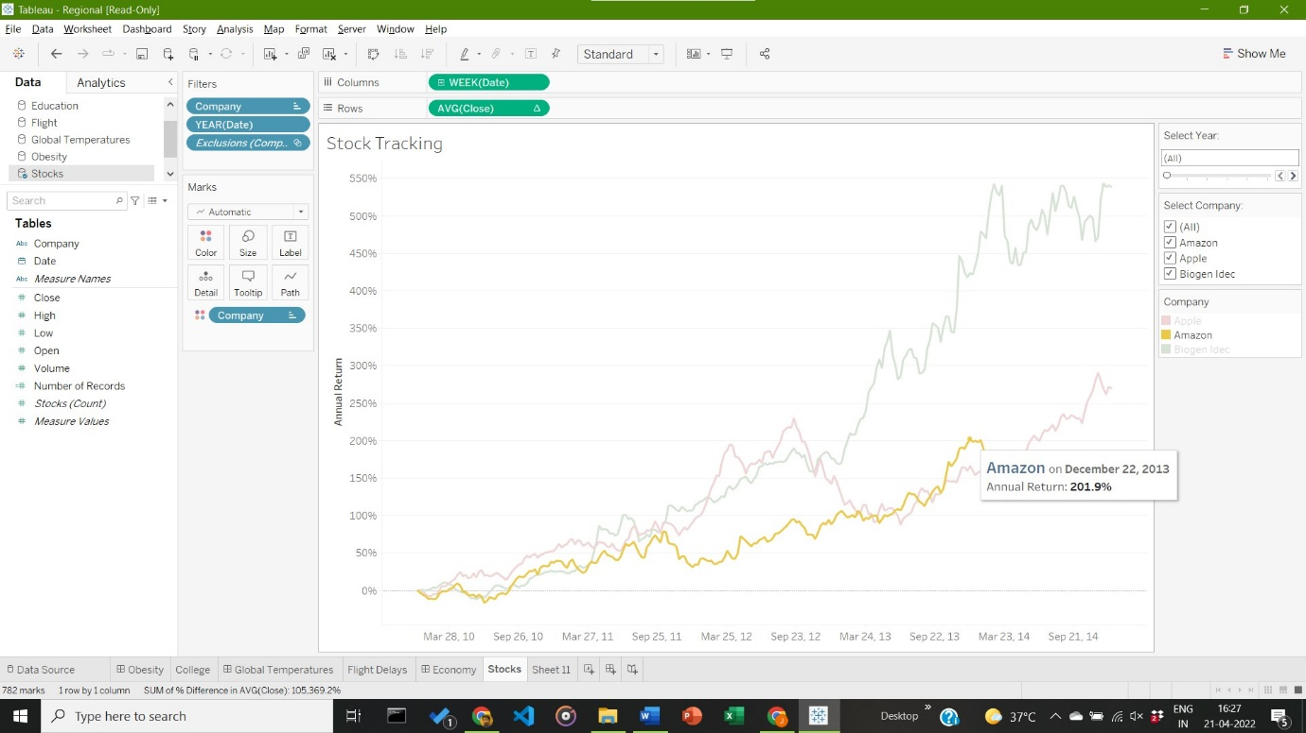

**Inference:**

Between the years 2010 – 2014, Biogen idec had the highest Annual Returns, with a peak annual return of 542.8% on the 23rd of February, 2014. Amazon had the lowest Annual Returns of the three companies, with a peak annual return of 201.9% on the 22nd of December, 2014.

__________________________________________________________________________________