System Overview:

This door operator uses an ESP32 to control 2 overhead door operator motors. The 2 Liftmaster 41D749 DC replacement motors are each driven by a BTS7960B H-bridge module (BT-2). The entire system is powered using (8) 18650 batteries I recovered from damage power tool battery packs that get trickle charged by a 16VDC supply. I monitor the battery voltage and motor currents using an INA219 module on each motor. The current is monitored while the door is moving and stops the motor if the current is more than expected. An optical beam is used to detect obstructions and stop the door. The position of the door is tracked using the optical shaft encoder built into the Liftmaster motors I used. The ESP32 has build in hardware counters, which eliminate the need to use interrupts in the code. I also use a hall effect sensor as a limit switch in the fully closed position as a reference for the position encoder. It just sets the counter to zero when the door is closed. This eliminates any counter errors from accumulating over time and gives a zero reference when initially installing.

Battery holder and BMS:

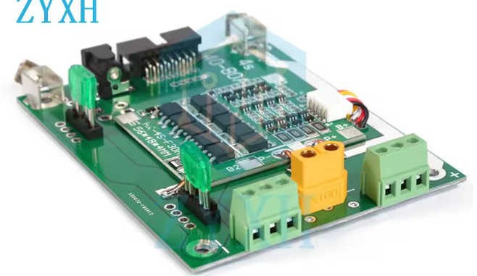
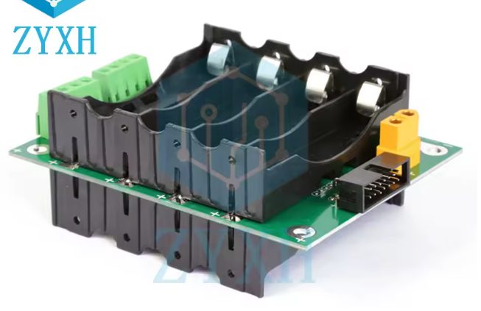

BTS7960B H-Bridge Module:

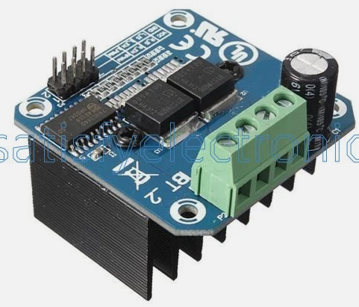
INA219 Modules:
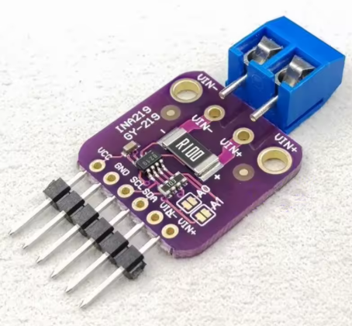

PCB:

