Name: **John Rey J. SIlverio**

Date Submitted: **August 24, 2023**

Figure 2.1

Given the network topology in figure 2.1

1. Configure R1 and R2  user EXEC password as cisco and  privileged EXEC password as class.

PrintScreen your configuration.

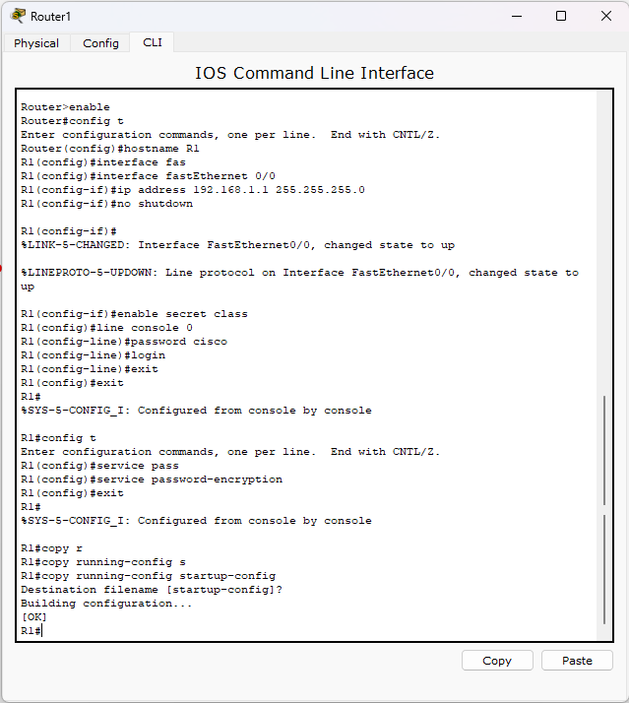 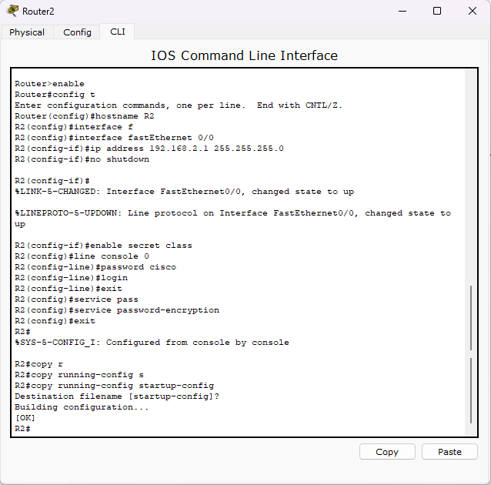

1. Configure R1 and R2 Telnet password as telnet

PrintScreen your configuration

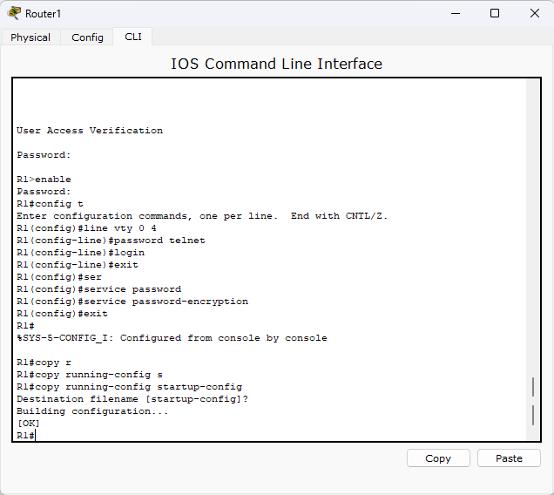 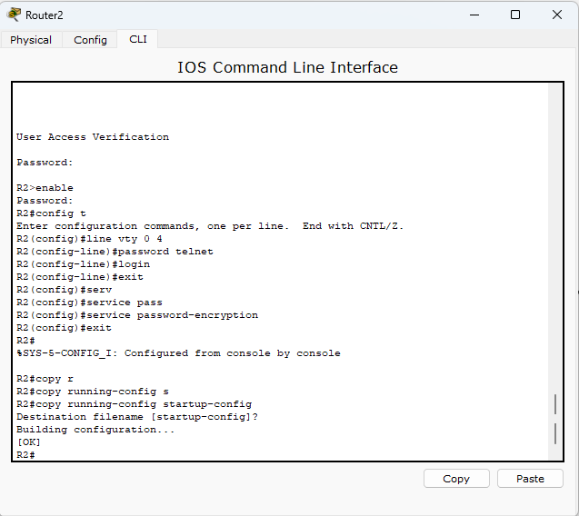

1. Configure router R1 and R2 using the addressing scheme that connects R1 and R2.

PrintScreen your configuration

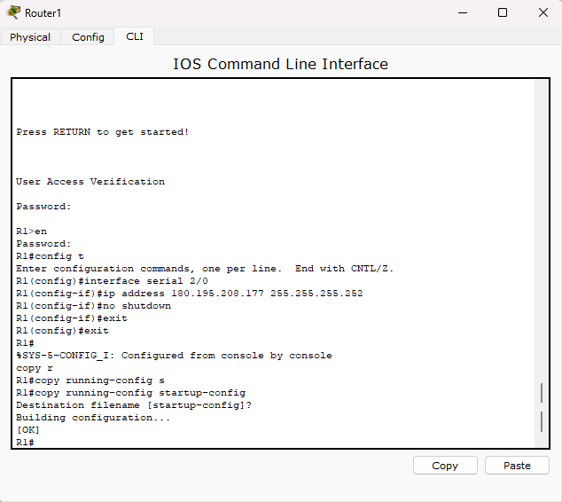 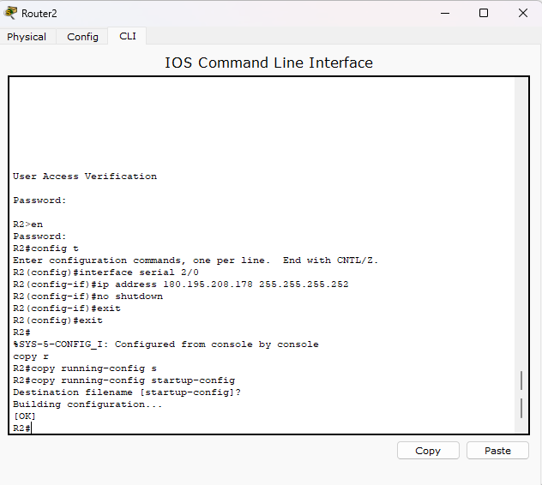

1. Configure router R1 using the addressing scheme that connect to LAN 1.

PrintScreen your configuration

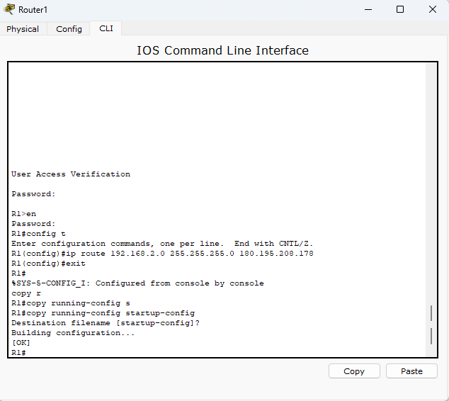

1. Configure router R2 using the addressing scheme that connect to LAN 2.

PrintScreen your configuration

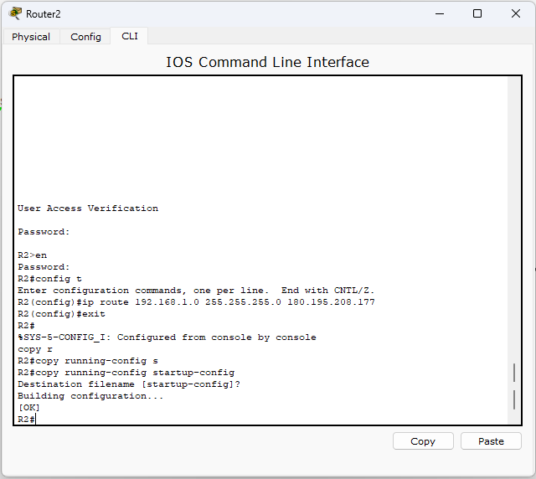

1. Assign ip address, subnet mask and gateway on PC0, PC1, PC2 and PC3 using the addressing scheme on the network where it is assigned.

|  |  |  |
| --- | --- | --- |
| Device | IP Address | Subnet Mask |
| PC0 | 192.168.1.2 | 192.168.1.1 |
| PC1 | 192.168.1.3 | 192.168.1.1 |
| PC2 | 192.168.2.2 | 192.168.2.1 |
| PC3 | 192.168.2.3 | 192.168.2.1 |