Final Project: Breathing Rate Detection System
Jonathan Sumner, Diego Lopez, and Rachel DuBois, Department of Engineering Technology, Rochester Institute of Technology

Abstract—This paper presents a standalone breathing rate monitoring system for early detection of acute respiratory infections (pneumonia) in children aged 11 months to 5 years. An LM61 temperature sensor captures nasal/oral temperature fluctuations, which are digitized by an 8-bit Arduino (10-bit ADC, two kB RAM). A software-only DSP pipeline, comprising an FIR equalizer, a low-pass FIR noise filter, and a three-channel IIR Chebyshev filter bank, extracts breathing rate bands. Energy detection via standard deviation over 100-sample windows drives decision logic that triggers distinct audible alarms within two minutes for high rate (> 40 BPM), low rate (< 12 BPM), or sensor fault conditions while remaining silent during normal breathing (12–39 BPM). Results from a swept-tone validation confirm precise band discrimination and correct alarm selection under minimal hardware constraints.

I. INTRODUCTION
P
neumonia remains a leading cause of mortality in children under five, particularly in low-resource settings where advanced clinical monitors are unavailable. Respiratory rate is a critical, objective indicator: rates above 40 breaths per minute (BPM) often signal pulmonary distress, while readings below 12 BPM may indicate sensor disconnection. Conventional methods rely on manual observation or expensive medical instruments, which can be impractical or inaccessible. This work demonstrates an automated, low-cost solution using only an LM61 temperature sensor and an Arduino, with all signal conditioning and decision logic performed in software.
By capturing temperature swings caused by inhalation and exhalation, digitizing at 100 ms intervals, and processing through a DSP chain of FIR and IIR filters, the system reliably classifies normal breathing (12–39 BPM), high rate (> 40 BPM), and fault/disconnection (< 12 BPM). Distinct tones for each abnormal condition are sounded within two minutes, addressing clinical needs and hardware constraints (no analog gain or filtering, two kB RAM). Our thesis is that, despite low signal amplitude and high quantization noise (SNR < 10 dB), careful DSP design and energy-based detection enable robust pediatric respiratory monitoring on minimal hardware.

II. METHODOLOGY

System Overview
Fig. 1 illustrates the signal chain: the signal path begins at the LM61 temperature sensor, proceeds through the Arduino’s Analog-to-Digital Converter (ADC) with oversampling and dither noise injected, then it passes through an FIR Equalizer and an FIR Low-Pass Filter, the output is then sent through a filter bank containing three IIR Chebyshev filters, of which the output of the filter bank is passed through an energy detector, and finally the alarm generator.
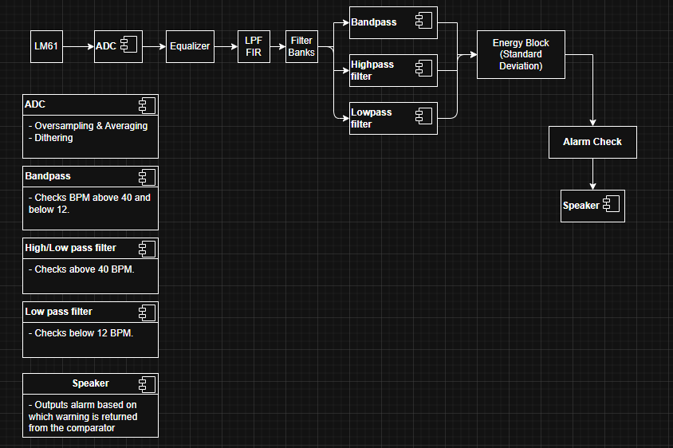
Fig. 1: System Design Overview

Filter Bank Development and Implementation
During Week 1, the development and implementation of the filter bank was the primary focus. The three filters were designed using the provided MATLAB IIR_Designer tool: a Low-Pass, Band-Pass, and High-Pass filter. All filters were configured as Chebyshev filters with a passband ripple of 0.5 dB and five poles. The Low-Pass filter was configured to have a corner frequency of 12 BPM, the Band-Pass filter was configured to have a lower corner frequency of 12 BPM and an upper corner frequency of 40 BPM, and the High-Pass filter was configured to have a corner frequency of 40 BPM. Each filter was implemented into the codebase using the variables of the second-order system the IIR_Designer tool generated, as shown in Fig 2.
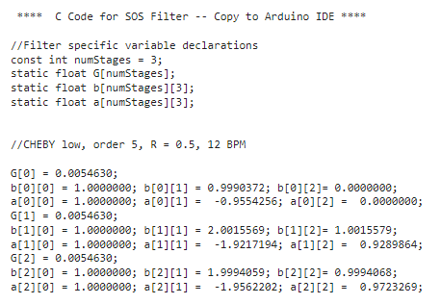
Fig. 2: Output of IIR_Designer for Low-Pass Filter
Once all filters were implemented into the codebase, an energy detection block was implemented for each filter. The energy detection block measures the standard deviation of the signal at the output of the filter. It is utilized to determine which filter has the most energy passing through to determine the patient’s breathing rate. In the codebase, each standard deviation is held in a stats structure for each filter containing mean, variance, and standard deviation, as shown in Fig 3.
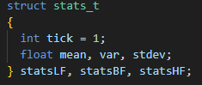
Fig. 3: Struct Declaration in Codebase
The structure is then passed to a getStats function, which incrementally computes the inputted data's mean, variance, and standard deviation. The function is called within the main loop of the codebase and has a reset variable for restarting the running values to make convergence quicker for each filter. The getStats function is shown in Fig 4, and the call for each instance of getStats in main is shown in Fig 5.
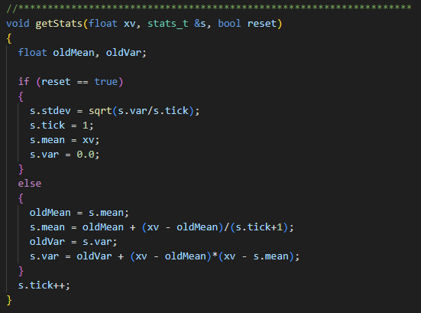
Fig. 4: getStats Function
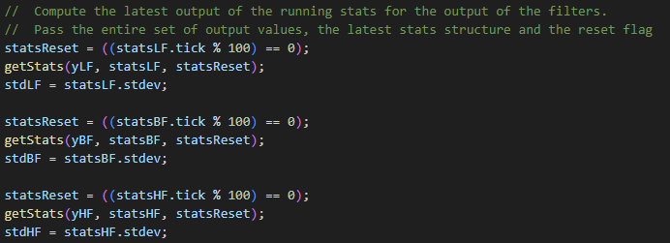
Fig. 5: Each Call of getStats for Each Filter

Equalizer and Noise Filter Development and Implementation
In Week 2, the development and implementation of an Equalizer and Noise Filter began. These filters were implemented to preprocess the ADC data before passing it to the filter bank. During Lab 8 for the class section, a version of an equalizer was developed to compensate for the LM61 temperature sensor's time response and perform convolution in the time domain. The Equalizer was implemented into the codebase, and a call was implemented following a conversion of the data being read into a fixed-point value. The code for the Equalizer is shown in Fig 6.
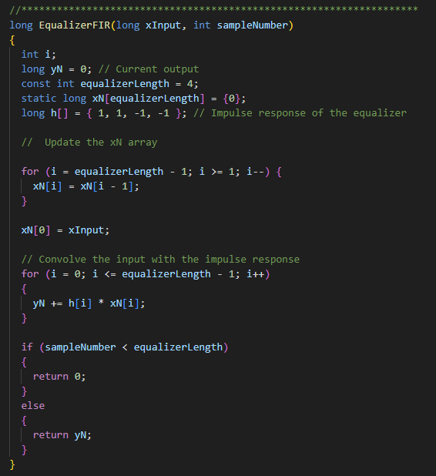
Fig. 6: EqualizerFIR Function
To minimize the range of readable breaths per minute, the Noise Filter was determined to negate breathing exceeding 70 BPM and function as a Windowed-Sinc Filter. Using the FIR_Designer from Lab 7, a Low-Pass Filter was generated with an impulse response length of 61 and a corner frequency of 70 BPM. The output of the FIR_Designer was then implemented into the codebase and placed following the EqualizerFIR function call. The output of the FIR_Designer is shown in Fig 7, the NoiseFilter function is shown in Fig 8, the function calls for the EqualizerFIR, and the NoiseFilter is shown in Fig 9.
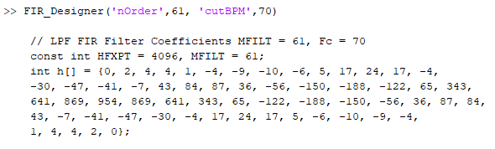
Fig. 7: FIR_Designer Output
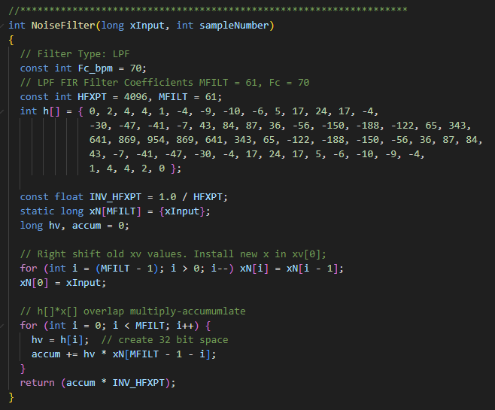
Fig. 8: NoiseFilter Function
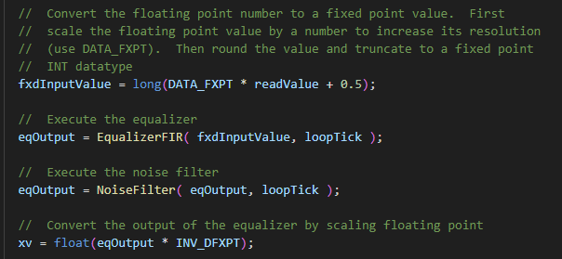
Fig. 9: Function Calls for EqualizerFIR and NoiseFilter

Alarm System and Tone2 Library
Week 3 was the final week of integration and the development of the alarm system. The alarm system was divided into two separate functions, AlarmCheck and setAlarm. The AlarmCheck function checks for the three standard deviations of the filter bank to indicate which filter was receiving the most energy passing through based on the filtered data. Based on a flowchart, it was determined that the system would need to have a disconnect check along with three checks for each standard deviation greater than the other two standard deviations, as shown in Fig 10.
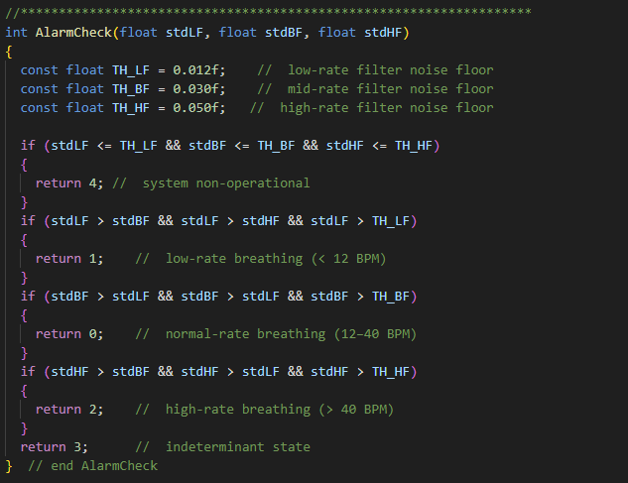
Fig. 10: AlarmCheck Function
The setAlarm function was implemented as a switch case based on the alarm code determined by the AlarmCheck function. The four cases each had a different tone and frequency that was played depending on which code was passed to the function and included a default state for the speaker being turned off. The setAlarm function also uses the Tone2 library, a modified version of the Tone library, and it enabled the use of the Timer1 interrupt as the codebase used the Timer2 interrupt for the synchronization of samples. The function setAlarm is illustrated in Fig 11.
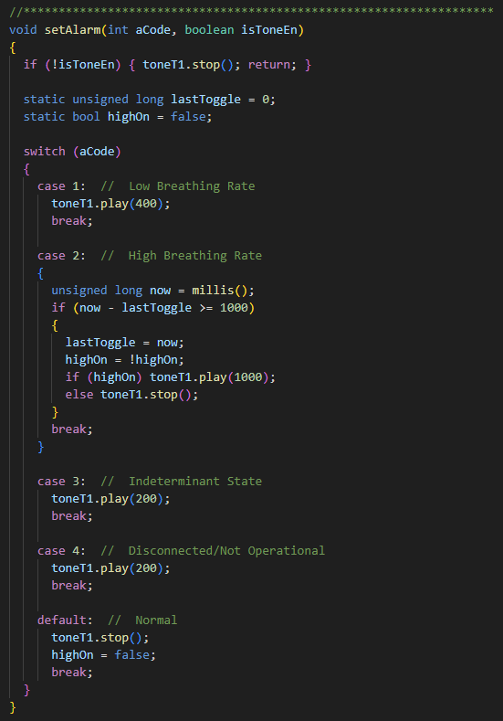
Fig. 11: setAlarm Function

Testing and Calibration
During each week of development, testing and calibration were performed on the system's individual components.
During Week 1, each filter was tested for impulse, frequency, and time-domain responses. Following the validation of all filters, the filters were then implemented in parallel in the codebase, shown in Fig 12, to validate the ranges for each filter and determine accuracy using a test vector. Once all filters were validated for accuracy in parallel, the energy detection block was implemented, as shown in Fig 5.
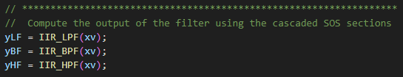
Fig. 12: IIR Filters in Parallel
During Week 2, the Equalizer was tested separately from the Noise Filter to determine that data being read from MATLAB was being equalized over the sample period. Following successful testing of the Equalizer, the Noise Filter was tested separately utilizing a similar method to the Equalizer to ensure that breaths per minute did not exceed 70 BPM. Once validated, both the Equalizer and Noise Filter were implemented in series to determine equalized, mitigated data resulting from passing the ADC data, as shown in Fig 9.
Week 3 concluded with the testing of the speaker. Testing was accomplished by connecting the speaker with a 100Ω resistor to PIN 12 and ground on the Arduino board. Once the codebase was uploaded to the Arduino with the readFromMATLAB function uncommented, three different breathing data files were called in the CaptureArduinoData function call in MATLAB. As a result, the speaker activated and played audible sounds for low, normal, and high breathing. To validate each breathing rate being tested in one sequence, the SweptTone.mat file was called in the CaptureArduinoData function call in MATLAB to determine the changing of breathing rates over time.
To determine the baseline threshold used to determine if the LM61 sensor was connected, the analogReadDitherAverage function was uncommented, and the readFromMATLAB function was commented out. This enabled the LM61 temperature sensor to be read, and the threshold was determined by conducting no breathing on the sensor. This resulted in a minimum threshold for each standard deviation of the filter bank.

III. Results

Filter Bank Test Results
During the Week 1 testing period, the filters were tested using a test vector that simulated breathing data. As shown in Fig 13, the Low-Pass Filter generated by the IIR_Designer had a time-domain response that successfully showed the filter recognizing the lower frequencies.
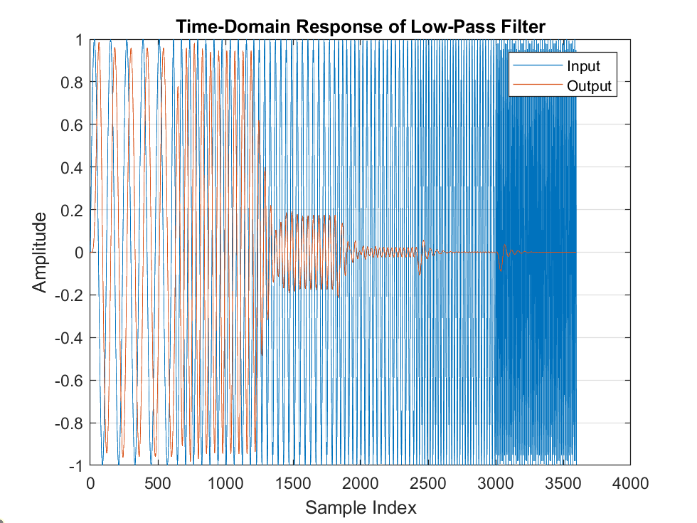
Fig. 13: FFT of Low Pass Filter
Similarly, the High-Pass Filter (Fig 14) and the Band-Pass Filter (Fig 15) generated by the IIR_Designer captured the higher and mid-range frequencies within the time-domain response, respectively.
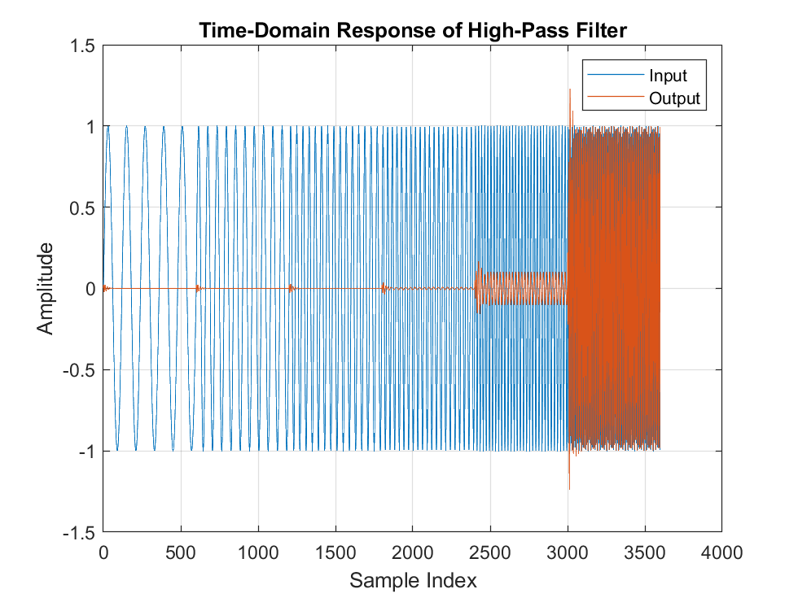
Fig. 14: FFT of High Pass Filter
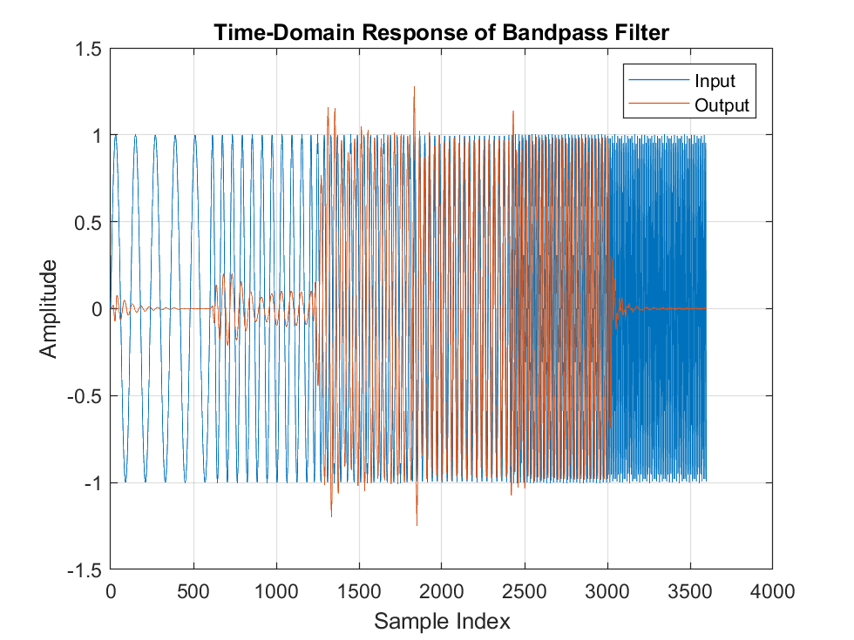
Fig. 15: FFT of Band Pass Filter
Following the successful verification of each filter, the codebase was updated with all three filters enabled, and the test vector was used to test all the filters in parallel. As shown in Fig 16, each filter has a different frequency range while implemented in parallel. At this point, the energy block was also implemented to return the standard deviation of each filter in parallel; the results are shown in Fig 17.
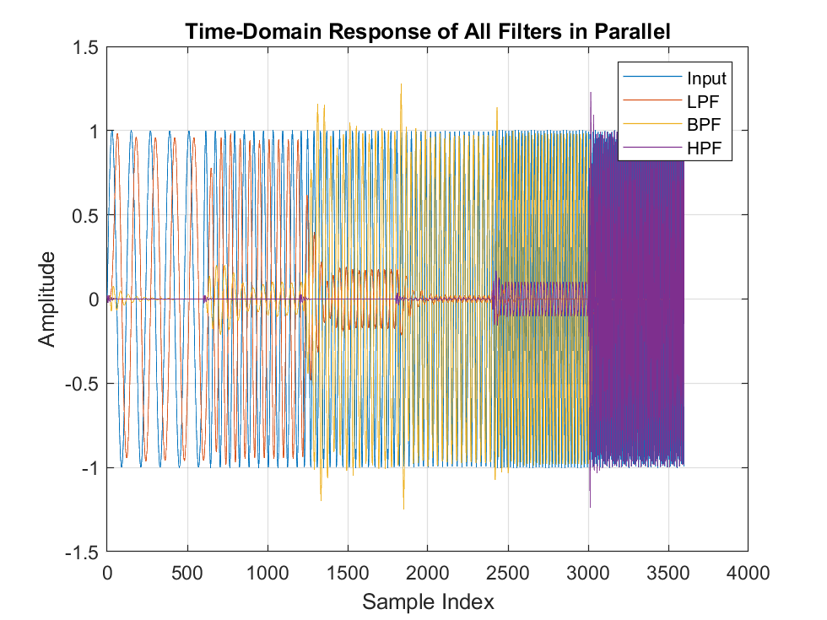
Fig. 16: FFT of All Filters in Parallel
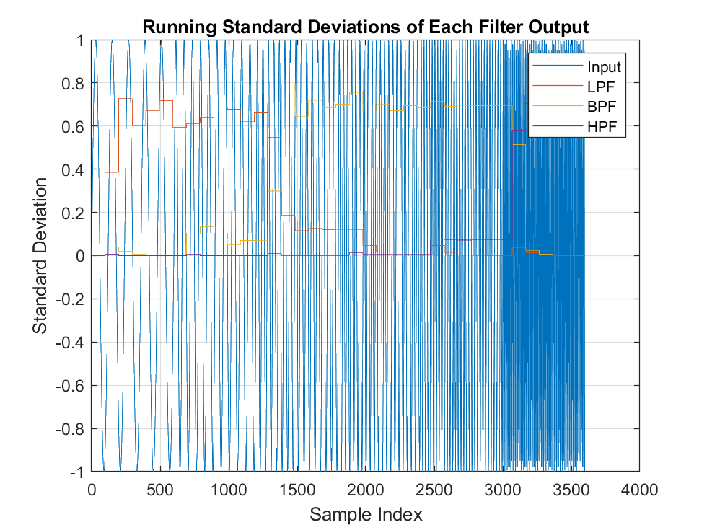
Fig. 17: Standard Deviation of All Filters in Parallel

Swept Tone Test Results
During this week of testing, all components, excluding the LM61 temperature sensor, were fully integrated into the codebase and debugged for any issues or conflicts. The system at the time was tested using the SweptTone.mat data file as it provided the most diverse testing range for the filter bank and other key components.
Fig 18 shows the output of the Equalizer and the Noise Filter. This figure also illustrates the Noise Filter, as after approximately 2250 samples, the range of values starts to narrow, indicating that the Noise Filter with a corner frequency of 70 BPM is activated.
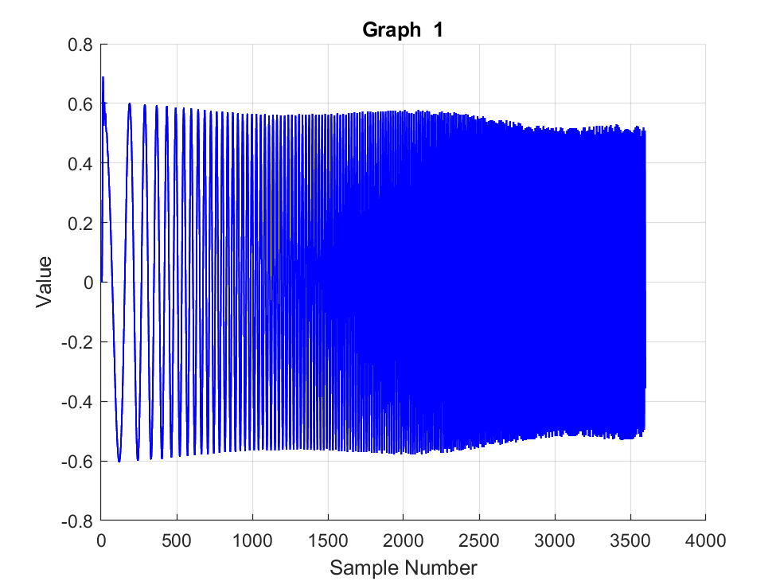
Fig. 18: Equalized and Filtered Input Data
The filter bank's results are shown in Figs 19, 20, and 21, with the equalized and filtered data at different breaths per minute.
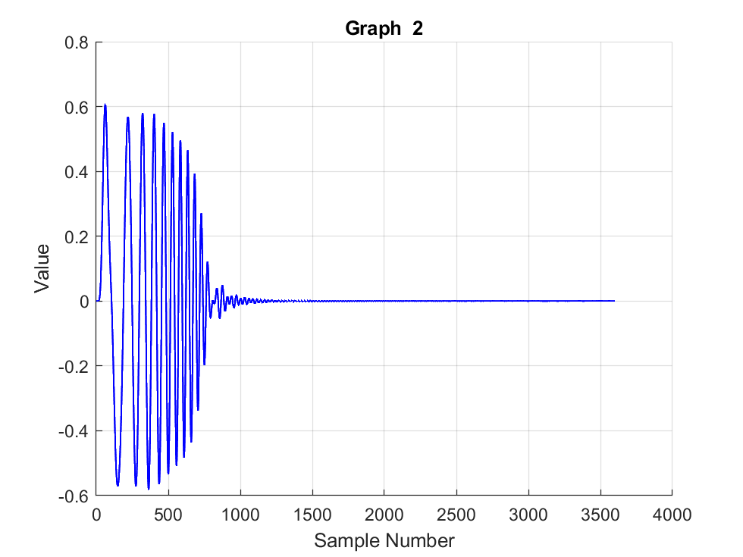
Fig. 19: Output of Low Pass Filter
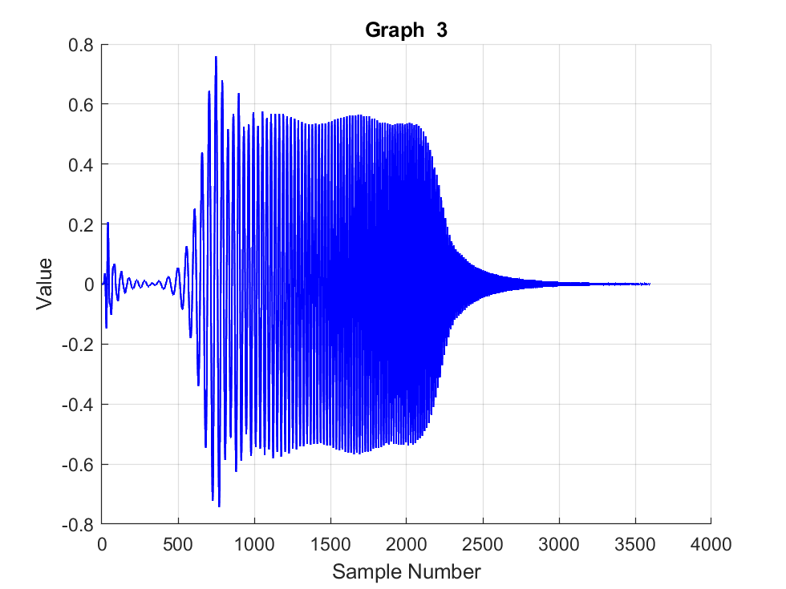
Fig. 20: Output of Band Pass Filter
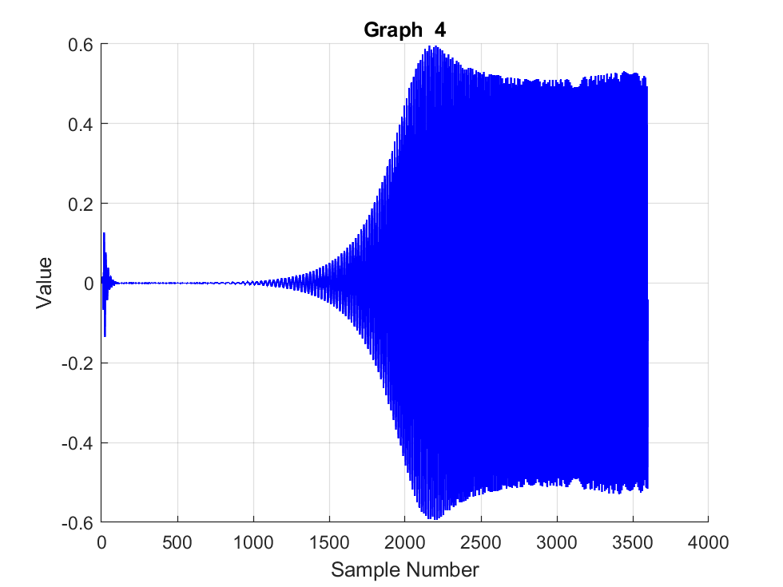
Fig. 21: Output of High Pass Filter
Figs 22, 23, and 24 show the results of the energy block and the standard deviation for each filter. Note: The standard deviation values match the frequencies captured by the respective filter.
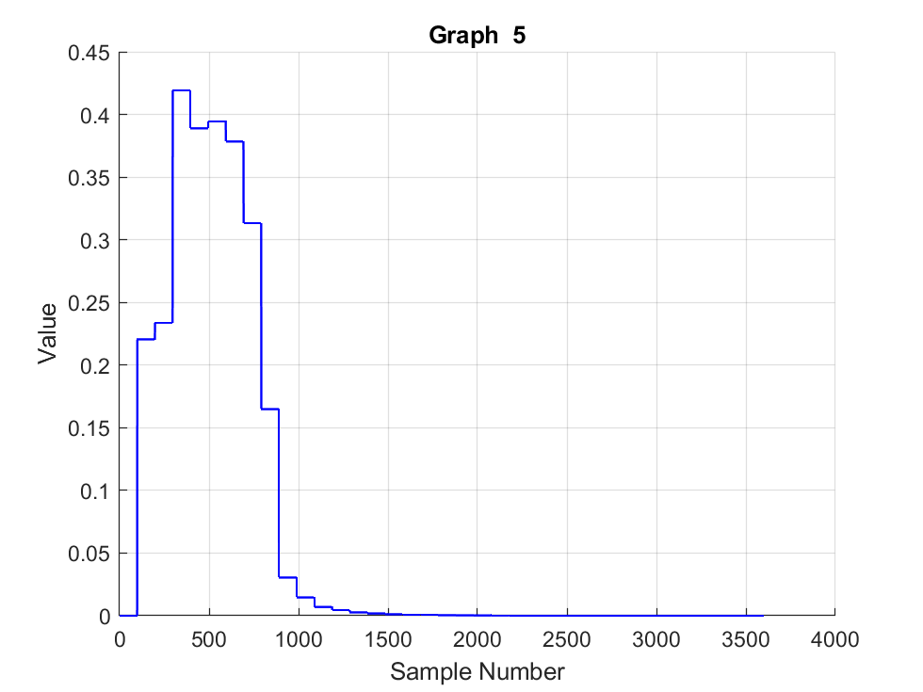
Fig. 22: Standard Deviation of the Low Pass Filter
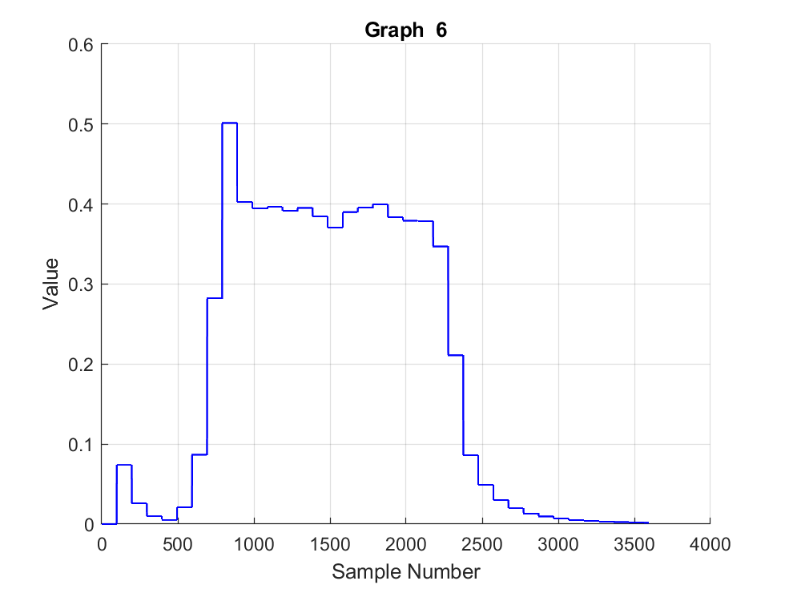
Fig. 23: Standard Deviation of the Band Pass Filter
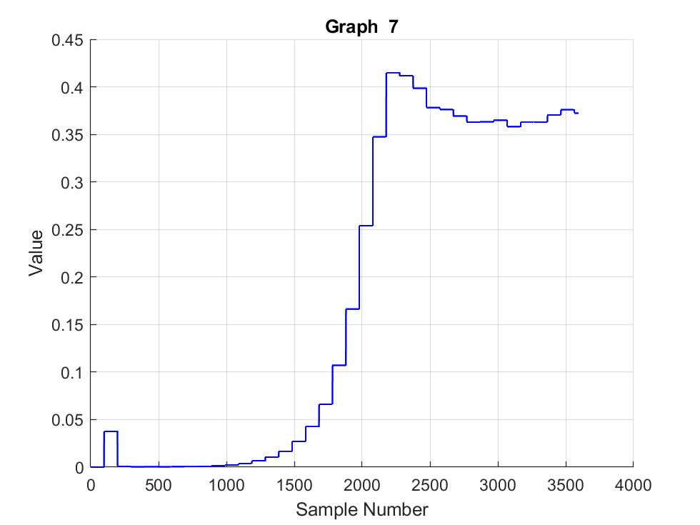
Fig. 24: Standard Deviation of the High Pass Filter
Lastly, Fig 25 shows the alarm code based on the standard deviations checked within the AlarmCheck and setAlarm functions. Note that the system starts with an alarm code of 4; this is due to the system not having collected 100 samples yet.
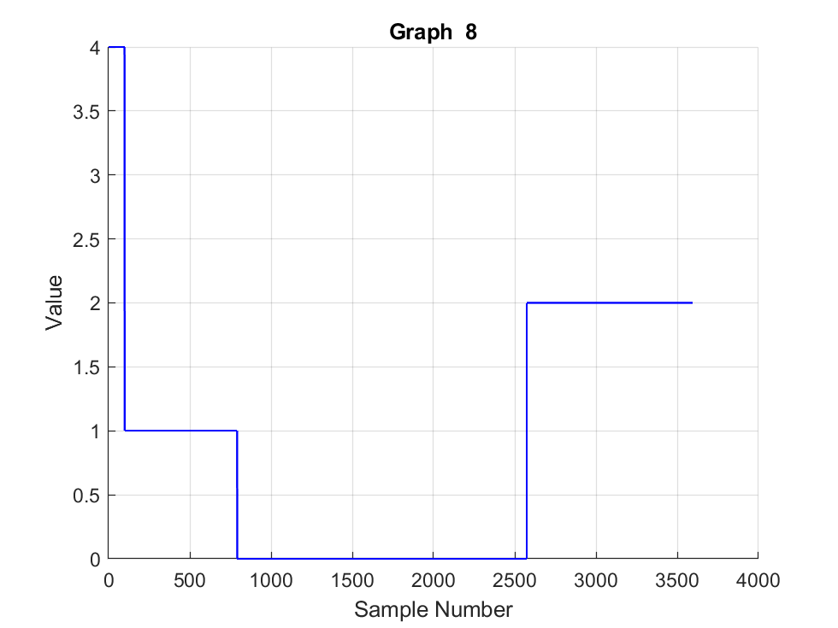
Fig. 25: Alarm Code

Complete System without Connection to PC
To validate the standalone functionality of our system, we adopted a structured testing approach, ensuring each component operated correctly before full integration. Initially, we verified individual subsystems—including the filter bank, alarm logic, and sensor interface—using pre-recorded test signals. This step confirmed that the FIR and IIR filters correctly classified breathing rates and that the alarm system triggered appropriately for abnormal conditions (BPM less than 12 or greater than 40) and sensor disconnections.
Once the DSP chain was validated, we disconnected the system from the PC and enabled real-time data acquisition via the LM61 sensor. The ADC sampled and processed the sensor's analog output through the equalizer and noise filters to ensure signal uniformity. We tested the system under controlled conditions, simulating normal (12–40 BPM), low (<12 BPM), and high (>40 BPM) breathing rates by modulating breath frequency near the sensor. Additionally, we induced error conditions by disconnecting the sensor to verify the system’s fault detection capability.
Finally, we deployed the system in continuous operation mode, confirming that it maintained stability without PC oversight. The alarm tones (normal, high/low BPM, and sensor disconnect) were audibly distinct, and the filter bank’s real-time responses aligned with expected thresholds. This end-to-end validation confirmed that the system met all design requirements as a self-contained, portable monitoring device.

IV. CONCLUSION
This project successfully demonstrates the feasibility of a low-cost, real-time breathing rate detection system using digital signal processing (DSP) techniques. By leveraging an LM61 temperature sensor and an Arduino-based processing unit, we developed a robust system capable of identifying abnormal respiratory rates in children aged 11 months to 5 years, a critical metric for early detection of acute respiratory infections like pneumonia.
Integrating FIR and IIR filters, including a custom filter bank with energy detection, enabled accurate classification of breathing rates into clinically relevant ranges (below 12 BPM, normal 12–40 BPM, or above 40 BPM). The system's alarm functionality, validated through swept tone testing and sensor disconnect scenarios, ensures timely alerts for caregivers.
Future work could explore wireless connectivity for remote monitoring or additional sensors to enhance reliability. Nevertheless, this project highlights the potential of DSP-driven solutions to improve pediatric healthcare accessibility, particularly in resource-limited settings where cost and simplicity are paramount.

