GitHub, Travis CI

Command in Git

Git chechout -b Harvard

It creates a new branch

Git status

What is going on in the directory and what you should do

Git add app/views/shared/_header.html.erb

Then git commit -m ‘add a link to harvard’

Then if a go to

Git checkout master

It goes back to the main branch

I don’t want yet to upgrade my app in the master, so I want to send the modified app to a another computer. It is used:

Git push johnbritton Harvard

It does push the app branch Harvard to the repository of John Britton

Then in Github I can check the app that was sent and I can add a note about it

Then Travis can make checks to see whether the changes I made wont break something important o disrupt something. Then to see whether the app passed all the tests

In the mean time I can write that everything went fine in the test therefore we can ship it

In github I can gwrite something to say that the app in the branch can be deployed

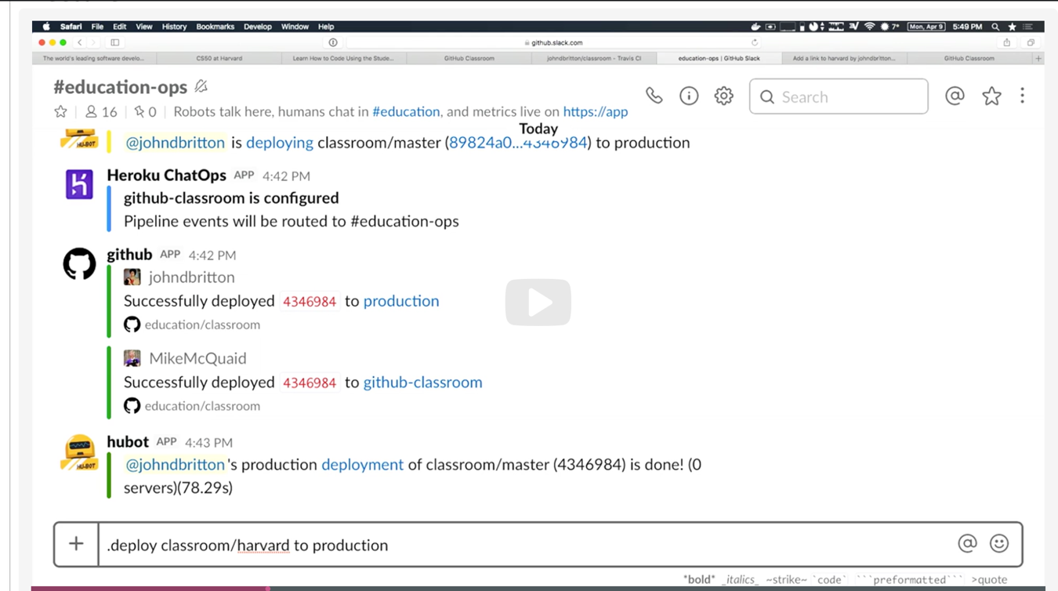

Then I can see in Travis if errors exist

When developing an application, the changes in one branch should be deployed to the main branch as soon as possible as making many changes in one branch without testing the result may make it very difficult to test and to spot errors

So one strategy is to create a logical breaks in the code, where you can choose two different paths in the code to see what happen with the new code

I

In this example it is written as simple as:

<% If current_user.feature_enabled?(:Harvard) %>

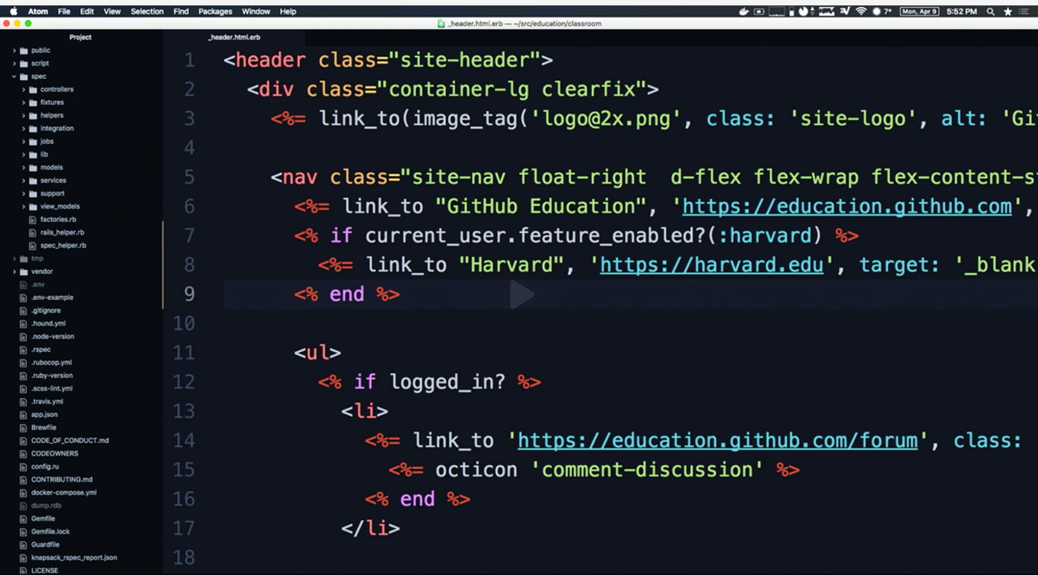

In this example it is written as simple as:

<% If current_user.feature_enabled?(:Harvard) %>

<% end %>

Then I go back to my browswer

Features and then dolphins because not all the code is written by us but we can access other libraries is a common pattern in app production

There is a little rocket to click on to add features

Then I go add a feature

Per percentage of actors (users)

Percebtage of time

Actors

This is useful to allow some features of the page to some groups of people, for instance, just friends, just customers, just something

Time

There is a chat and deployment to see what is happening in the advances of the branches of the software

In the chat everybody sees that I deployed the app of the main branch

Command .deploy xxx

Travis CI

Education.travis-ci.com

1.3 m8llion repositories in Travis

Testing in industry

Code is tested, write the code

Types of test

Automated vs manual

Functional vs non-functional test

Automated test

A machine follows a script to veryf an “assertion·. These are part of a codebase, and run in CI.

Functional test.. the test specific functionality (or several) of the system “does this elmente meet the requirements that is is supposed to meet?”

Unit test, integration test, end-to-end testys

Piramid test

E2E

Integration testing

Component testing

Unit testing

If the test passes… we know the method is still doing what it is supposed to be doing!

What to test for:

Positives-things work as they should be working

Cibtrapositives-things fail as they should be failing

Goal: maintain logic + integrity of the application

Software Engineering is done in teams

The if passes test the following step is Build and building!

Build is a verb for compile/convert this source code into something runnable

Build is also a noun, the end result of a build process

Why CI Systems?

“Works on my maching”

We are looking for

Reproductibility. Clean environment, everybody has the same environment

It is a big deal how to install CI.

Tidy Deploys. Test in an environment that maches your production environment!.. and does not have all your helper script and dependencies

Faster development.

Improved confidence in code + PRs. Projects with CI release twice as often, PR acceptance is 1.6 hours sooner (cope.eecs.oregonstate.edu/CISurvey)

Automate all the things!

Cide coverage, linting, language runtimes

Dependecy management, config management

Deployment, container-building (deployment environments)

Documentation generation, demo generation

CICD

CD needs CI- “is this code deployable now?”/”deploy all changes to the code?”

…tests are really important to this

Builds & testing

Thurns this code into something runnable, then run these tests and see what we get

Historical builds become a kind of semi-living audit-log for tests

Code quality & Reliability

CICD in the wild

Software Engineering teams use CI systems to build and test code as it is changed

CI also functions as a kind of automation hub-notifications, artifacts uploading deployment

CD-CointinuosDElivery/Deployment:

“Could this be deployed at any step?” Vs “is this deployed at every step?”