Middlesex County

Academy For

Science, Mathematics and Engineering Technologies

100 Technology Drive

Edison, New Jersey 08837

Phone (732) 452-2600

Fax (732) 906-8421

http://www.mcvts.net

America’s Best High School

GOLD Medal Award

|  |  |
| --- | --- |
| Dr. Linda Russo | Sonja Paprota |
| Principal | Assistant Principal |
|  |  |

Enzo Paterno 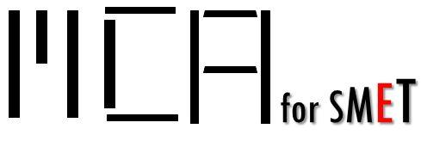

Engineering Instructor

October 23, 2017

Dear Sir or Madam:

My name is Dr. Linda Russo, principal at the Middlesex County Academy for SMET and Mr. Enzo Paterno is our instructor for the Electronics/Computer Engineering Technology (ECET) program. This letter is to certify that Abhishek Hariharan and Jonathan Wong, students of the Middlesex County Academy for Science, Mathematics, and Engineering Technologies, have been granted permission to communicate with the Middlesex County Improvement Authority’s Division of Recycling for their senior project.

At the senior level, students design a product from conception to realization with emphasis that addresses a particular problem. The senior project is a year-long engineering-based team project in which students work on an invention of their choice. These students are working on an independent recycling sorter, which will be able to detect the type of recyclable material inputted (e.g. cartons, bottles, cans) and sort the item accordingly upon its entry into a specific bin using image recognition software and conveyor belts.

They are seeking to collaborate with a real end user customer to acquire feedback for their project idea. We truly appreciate your cooperation in providing your time and expertise to this project and I feel confident it will result in a win-win situation.

Sincerely,

Dr. Linda Russo

Enzo Paterno