# Exercise 2: Ekman transport in the tropical Atlantic

rho0 = 1025.0 # reference density [kg m^-3]
R_earth = 6.371e6 # Earth radius [m]

# Coriolis parameter f = 2 * Omega * sin(phi)
coriolis = 2 * earth_rotation_rate * np.sin(np.deg2rad(windstress["lat"]))
windstress["coriolis_parameter"] = coriolis.assign_attrs(
dict(long_name="Coriolis parameter", units="s^-1")
)

# Annual mean wind stress
windstress_annual = windstress.mean(dim="month", skipna=True)

# Meridional Ekman transport per unit width M_Ey = -tau_x /(rho0 * f)
windstress_annual["meridional_ekman_transport"] = -(
windstress_annual.zonal_windstress
/ (rho0 * windstress_annual.coriolis_parameter)
)
windstress_annual.meridional_ekman_transport.attrs.update(
dict(long_name="Meridional Ekman transport per unit width",
units="m^2 s^-1")
)

# Restrict to Atlantic sector
atlantic = windstress_annual.sel(lon=slice(-60, 30))

# Grid rows closest to 10°N and 10°S
ekman_10N = atlantic.meridional_ekman_transport.sel(lat=10, method="nearest")
ekman_10S = atlantic.meridional_ekman_transport.sel(lat=-10, method="nearest")

lat_10N = float(ekman_10N.lat)
lat_10S = float(ekman_10S.lat)

print(f"Using latitude {lat_10N:.2f}° for '10°N'")
print(f"Using latitude {lat_10S:.2f}° for '10°S'")

# Convert to transport in Sv per degree longitude
dlambda_rad = np.deg2rad(1.0)

dx_10N = R_earth * np.cos(np.deg2rad(lat_10N)) * dlambda_rad # [m per 1° lon]
dx_10S = R_earth * np.cos(np.deg2rad(lat_10S)) * dlambda_rad # [m per 1° lon]

T_10N_Sv = ekman_10N * dx_10N / 1e6 # [Sv per degree longitude]
T_10S_Sv = ekman_10S * dx_10S / 1e6 # [Sv per degree longitude]

print(f"Mean Ekman transport at 10N: {float(T_10N_Sv.mean()):.3f} Sv/deg")
print(f"Mean Ekman transport at 10S: {float(T_10S_Sv.mean()):.3f} Sv/deg")

# Plot meridional Ekman transport vs longitude
plt.figure(figsize=(8, 4))
plt.plot(T_10N_Sv["lon"], T_10N_Sv, label="10°N", linewidth=2)
plt.plot(T_10S_Sv["lon"], T_10S_Sv, label="10°S", linewidth=2)
plt.axhline(0, color="k", linewidth=0.8)
plt.xlabel("Longitude [°E]")
plt.ylabel("Meridional Ekman transport [Sv per degree longitude]")
plt.title("Annual-mean meridional Ekman transport in the tropical Atlantic")
plt.legend()
plt.grid(True)
plt.tight_layout()
plt.show()

OUTPUT:
Using latitude 10.50° for '10°N'
Using latitude -9.50° for '10°S'
Mean Ekman transport at 10N: 0.227 Sv/deg
Mean Ekman transport at 10S: -0.208 Sv/deg
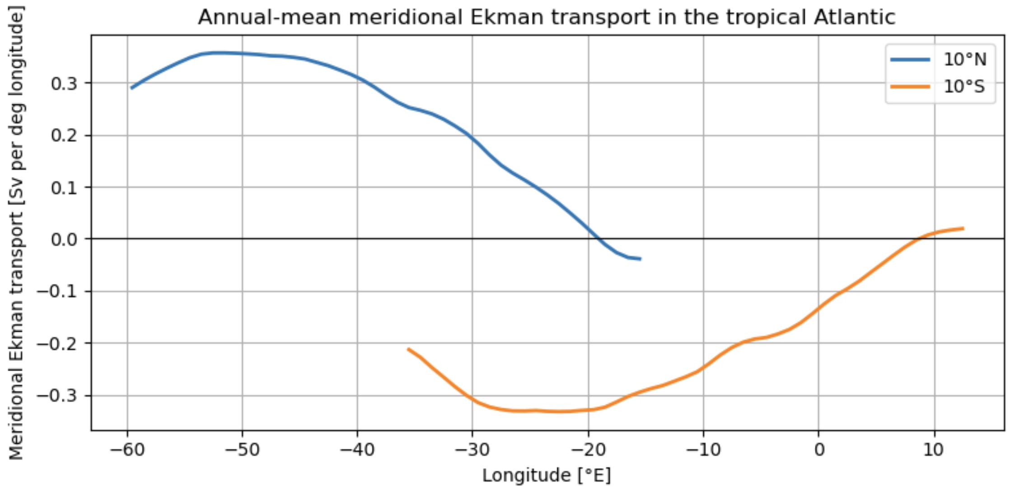

Discussion:
In the tropics the trade winds blow from east to west on both sides of the equator, which corresponds to a negative zonal wind stress τx<0. So, at 10°N: Ekman transport is northward and at 10°S the Ekman transport is southward. Water on both sides of the equator is pushed away from the equator, which is equatorial divergence. This divergence forces upwelling of colder subsurface water, which supports the development of the equatorial cold tongue and forms the surface branch of the shallow subtropical–tropical overturning circulation. Upwelled waters flow poleward in the surface Ekman layer, deeper waters return equatorward as part of the interior circulation.

