CS60 Project 1 Fall 2018

Due Midnight, Sunday Sept 9

Total 25 Pts

*Figures from below are also available as data files if you prefer to use MS Access.*

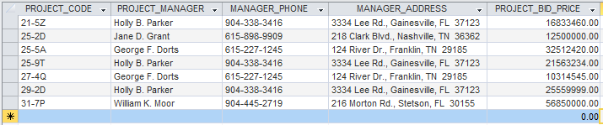

1. How many records (rows of raw data) does the above table store, and how many fields (columns or attributes) are in each record? (2 Pts). 7 individual rows (entity occurrences) and 5 columns (attributes)

2. What problem would you encounter if you wanted to list the records in order of the manager’s last name, or if you sometimes wanted to omit the first name or middle name in a display or printout? This design fault is referred to as a **composite attribute**. Show the table structure of an altered table that will correct this problem? (2 Pts)

The first, middle and last names contained within a single field are *composite attributes* making an operation of sorting based on any one of them difficult. The correction to this problem is to alter the table structure as follows:

Column Fields –

PROJECT_CODE

PROJECT_MANAGER_LAST_NAME

PROJECT_MANAGER_FIRST_NAME

PROJECT_MANAGER_PHONE

PROJECT_MANAGER_ADDRESS

PROJECT_BID_PRICE

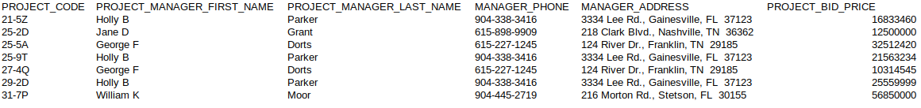The newly revised table would look something like:

3. What problem would you encounter if you wanted to list the records in order of the street address, city, state, or zip, or area code? Building upon the improvements that you’ve already made, show the table structure of an altered table that also corrects this problem? Show all columns and rows in this revised table, including the new ones from Step 2.

(3 Pts)

*Once again the problem of composite attributes would make address a non-sortable category or attribute.*

*The correction for address and phone is to once again alter the table structure to extend and allow new fields*:

MANAGER_STREET_ADDRESS, MANAGER_ADDRESS_CITY, MANAGER_ADDRESS_STATE, MANAGER_ADDRESS_ZIP, MANAGER_AREA_CODE.

E.g.



4. What data redundancies do you detect; i.e., what unnecessary repetitions are occurring? How could these redundancies lead to update anomalies, delete anomalies, or insert anomalies? (2 Pts)

**Given the redundancy of certain information,such as name, address, and phone number. *Any of the three update/delete/insert anomalies could occur, especially update/delete.*** The insert anomaly is also present because all data is stored in a single table.

5. Using two relational tables, PROJECT and MANAGER, eliminate the redundancies you identified in Problem 4. Create a ManagerID column in both tables so you can link the two tables with the ManagerID being the primary key in MANAGER and a foreign key in PROJECT. Identify the primary key in each table. With words, show how the two tables join together by a foreign key that references a primary key. The columns must correct all faults (composite attributes and redundancies) that you saw above. (5 Pts)

PK FK

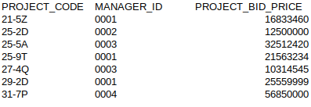

PK

***Redundancy is reduced based on maintaining two tables with all relevant information manually entered only once. The project table has a Manager_ID key which is foreign meaning that this table must also follow the rules of data integrity for both entity integrity and referential integrity.***

6. Create the **relational schema** to show the two tables and their columns, primary keys, foreign key, a line that shows how the two tables join, and the symbols 1 and ∞ (for *many*).The columns must correct the faults you saw above.(5 Pts)

***This is my schema for the keys:***

PROJECT.MANAGER_ID references MANAGER.MANAGER_ID

*Foreign Key* *Primary Key*

Here is the diagram required for number 6.

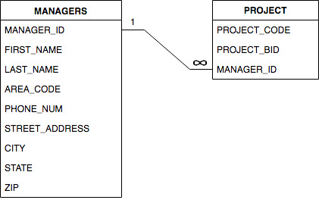

A new table for questions 7 and 8:

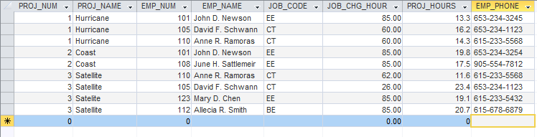

7. Based on the table above, identify pairs of columns (***actually should be pairs of rows not columns)*** that for the same value in one column, the 2nd column also has the same value. Such columns are **dependent** upon each other, or one column **determines** the other. You could write this functional relationship as

Column2 = function(Column1)

Unlike mathematical functions such as y = x2 and functions that are plotted or graphed as y = f(x), this function is a tabular function with data stored in a table. (3 Pts)

***Project Number and Project Name, Employee Number and Employee Name, as well as Job Code with either employee number or employee name are all functional dependence.***

8. These dependencies lead to what redundancies in the table (what data is being stored redundantly)? Do you see any relationship between the pairs of columns that you identified in Question 7 and the occurrence of redundancies?

(3 Pts)

***Redundant entries like the names of projects or employees can cause update or insertion anomalies; functional dependence in data table (with redundancy) can also lead to deletion anomalies.***

9. Create an ERD for each of the following descriptions. (Note the work *many* merely means *more than one* in the database modeling environment.)

a. Each of the ABC Corp’s divisions is composed of many departments. Each department has many employees assigned to it, but each employee works for only one department. Each department is managed by one employee and each of the managers can manage only one department at a time. (4 Points)

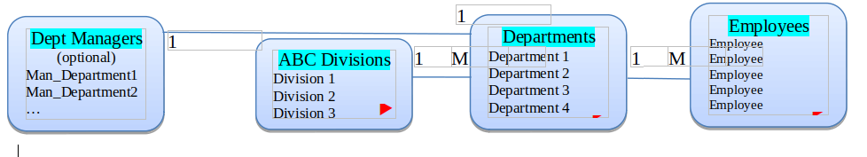

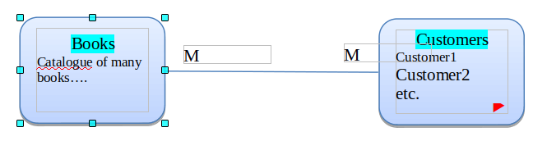b.

During some period of time, a customer can download many ebooks from BooksOnline. Each of the books can be downloaded by many customers during this period of time. (2 Pts)

***Books to customers have a many-to-many relationship.***

c. An airliner can be assigned to fly many flights, but each flight is flown by only one airliner. (2 Pts)

***Airliner to Flight has a one-to-many relationship between the airline and its outbound/inbound travel.***

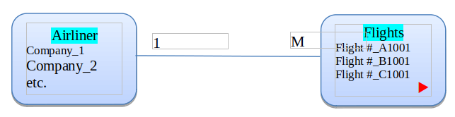

d. QuickTime Corp operates many factories. Each factory is located in a region and each region can be home to many

QuickTime factories. Each factory has many employees but each employee is employed by only one factory.

(4 Pts)

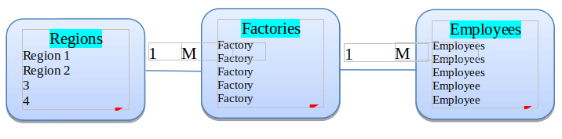

***Regions of the corporation have a one-to-many relationship with Factories, and those factories also have a one-to-many relationship with employees. The regions are therefore also one-to-many with employees (implied relationship).***

e. An employee may have earned many degrees and each degree may have been earned by many employees. (3 Pts)

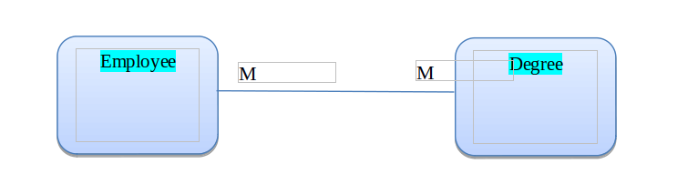

***A many-to-many relationship exists.***

10. Use this Figure as a guide to answer parts (a) to (c).

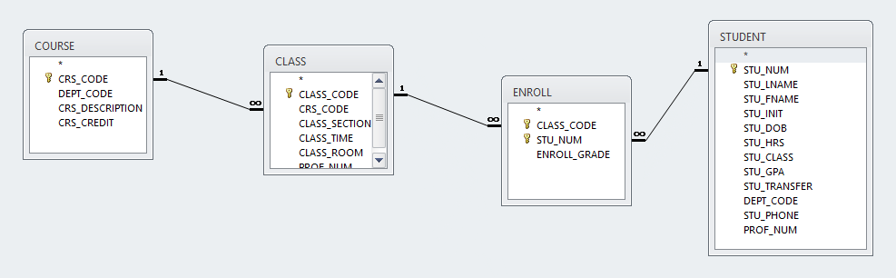

a. identify each relation type and write all business rules. (3 Pts)

***Answer:***

1. A class must be for just 1 course, but each course can have Many classes. (CRS_CODE key)
2. Student enroll in multiple classes, but each enrollment entry is for just one student (STU_NUM)
3. A class generates many enrollments, but each enrollment is for one class. (CLASS_CODE key )

NOTE: Each course or class can be made of many students, and each student can be taking several classes or courses (M:N is hence not listed in the rules, but nonetheless applies).

b. create the basic Crow’s Foot ERD for Tiny College. (3 Pts)

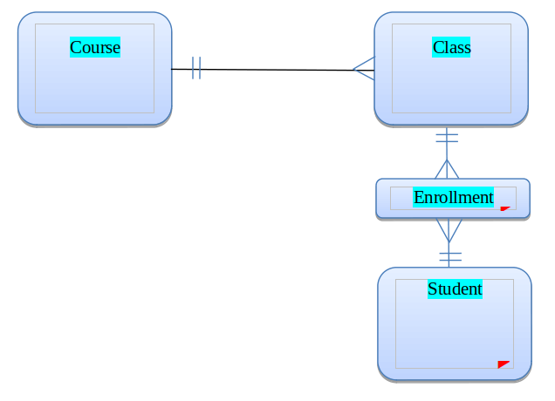

c. create the UML class diagram that reflects the entities and relationships you identified in the relational diagram.

(4 Pts)

1…*

1…1

1…1

Class

+has a

+has a

+is a

+is a

+has a

Course

1…*

Enroll

Student

+is a

0…*

1…1