**Problem Set 3**

**Submission**:- Create a zipped folder with all your assignment files - rename the folder to have the form:-**YourStudentId#_CS60_Lastname_Firstname_PS3.zip** After completing the project, load the zipped folder using the Problem Set 3 Upload option. If you need to make changes to an already uploaded assignment, change your filename to*:-YourStudentId#_CS60_V***X***_Lastname_Firstname_PS3.zip***,***where X indicates the version number.*

**Due Date***:-* Oct 7 at 11:59pm

**Problem 1**: Some Tiny College staff employees are information technology (IT) personnel. Some IT personnel provide technology support for academic programs. Some IT personnel provide technology infrastructure support. Some IT personnel provide technology support for academic programs and technology infrastructure support. IT personnel are not professors. IT personnel are required to take periodic training to retain their technical expertise. Tiny College tracks all IT personnel training by date, type, and results (completed vs. not completed). Given that information, create the complete ERD containing all primary keys, foreign keys, and main attributes.

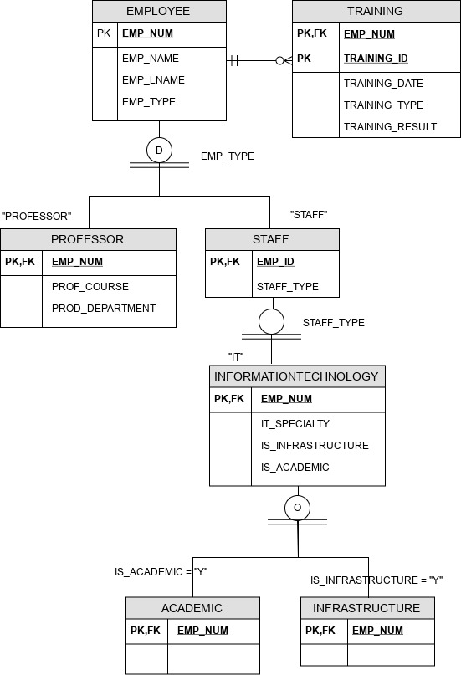

**Problem 2**:-

The FlyRight Aircraft Maintenance (FRAM) division of the FlyRight Company (FRC) performs all maintenance for FRC’s aircraft. Produce a data model segment that reflects the following business rules: All mechanics are FRC employees. Not all employees are mechanics. Some mechanics are specialized in engine (EN) maintenance. Some mechanics are specialized in airframe (AF) maintenance. Some mechanics are specialized in avionics (AV) maintenance. (Avionics are the electronic components of an aircraft that are used in communication and navigation.) All mechanics take periodic refresher courses to stay current in their areas of expertise. FRC tracks all courses taken by each mechanic—date, course type, certification (Y/N), and performance. FRC keeps a history of the employment of all mechanics. The history includes the date hired, date promoted, date terminated, and so on. (Note: The “and so on” component is, of course, not a real-world requirement. Instead, it has been used here to limit the number of attributes you will show in your design.) Given those requirements, create the Crow’s Foot ERD segment.

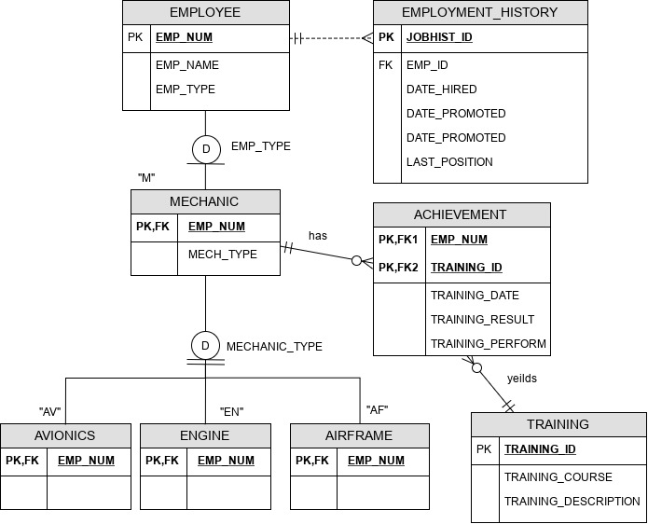

**Problem 3**:-

“Martial Arts R Us” (MARU) needs a database. MARU is a martial arts school with hundreds of students. It is necessary to keep track of all the different classes that are being offered, who is assigned to teach each class, and which students attend each class. Also, it is important to track the progress of each student as they advance. Create a complete Crow’s Foot ERD for these requirements:-

* Students are given a student number when they join the school. This is stored along with their name, date of birth, and the date they joined the school.
* All instructors are also students, but clearly, not all students are instructors. In addition to the normal student information, for all instructors, the date that they start working as an instructor must be recorded, along with their instructor status (compensated or volunteer).
* An instructor may be assigned to teach any number of classes, but each class has one and only one assigned instructor. Some instructors, especially volunteer instructors, may not be assigned to any class.
* A class is offered for a specific level at a specific time, day of the week, and location. For example, one class taught on Mondays at 5:00 p.m. in Room #1 is an intermediate-level class. Another class taught on Mondays at 6:00 p.m. in Room #1 is a beginner-level class. A third class taught on Tuesdays at 5:00 p.m. in Room #2 is an advanced-level class.
* Students may attend any class of the appropriate level during each week, so there is no expectation that any particular student will attend any particular class session. Therefore, the actual attendance of students at each individual class meeting must be tracked.
* A student will attend many different class meetings, and each class meeting is normally attended by many students. Some class meetings may have no students show up for that meeting. New students may not have attended any class meetings yet. (OPTIONAL ATTENDANCE)
* At any given meeting of a class, instructors other than the assigned instructor may show up to help. Therefore, a given class meeting may have several instructors (a head instructor and many assistant instructors), but it will always have at least the one instructor who is assigned to that class. For each class meeting, the date that the class was taught and the instructors’ roles (head instructor or assistant instructor) need to be recorded. For example, Mr. Jones is assigned to teach the Monday, 5:00 p.m., intermediate class in Room #1. During one particular meeting of that class, Mr. Jones was present as the head instructor and Ms. Chen came to help as an assistant instructor.
* Each student holds a rank in the martial arts. The rank name, belt color, and rank requirements are stored. Each rank will have numerous rank requirements. Each requirement is considered a requirement just for the rank at which the requirement is introduced. Every requirement is associated with a particular rank. All ranks except white belt have at least one requirement.
* A given rank may be held by many students. While it is customary to think of a student as having a single rank, it is necessary to track each student’s progress through the ranks. Therefore, every rank that a student attains is kept in the system. New students joining the school are automatically given a white belt rank. The date that a student is awarded each rank should be kept in the system. All ranks have at least one student who has achieved that rank at some time.

Values for ROLE would include Head Instructor, Assistant Instructor or Student. (Multivalued attribute)

