**The things I like:**

1. Dogs and animals
2. Movies
   * Comedy
   * Horror
   * Fantasy/Action
   * Documentary
3. Television shows including: The Sopranos, Homeland, The Office, The Simpsons

**Table of SMC courses, course number, department and brief course desription**

| **Picture of a camel** | My courses  as of 3/2/2019 | | |
| --- | --- | --- | --- |
| Course # | Department | Description |
| Internet, HTML, and Web Design | CIS50 | Computer Information Systems | A hands on web design course in HTML web authoring. |
| Intro to Computer Science | CS3 | Computer Science | Beginning course for computer programming and computer science. |
| Data Strucures with Java | CS20B | Computer Science | Introduction to study of computer algorithms and data structures. |
| Linux Administration | CS41 | Computer Science | Foundations of the environment of Linux operating system. |
| Java Programming | CS55 | Computer Science | General purpose study of programming using Java. |
| Database Concepts and Applications | CS60 | Computer Science | Introduction to databases with emphases on relational database model. |
| Network Fundamentals and Architecture | CS70 | Computer Science | Introduction to broad concepts about networking. |
| Python Programming | CS87A | Computer Science | Introduction to Python programming language. |

I want to visit the city of Madrid, Spain (click image to learn more)

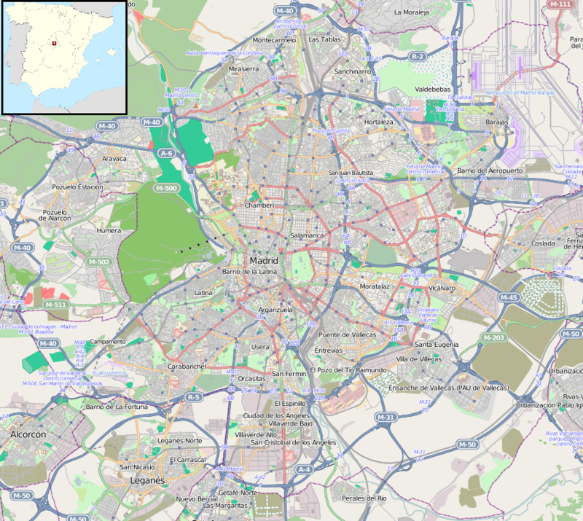 **Now I want to learn about you (First & last name required.)**

First name:

Last name:

What is your favorite color?

(NOTE: Click to use dial or enter the hexadecimal code such as #ADD8E6)

Please answer the following questions:

How many years have you been in the Los Angeles area?

What is your favority month of the year?