Instructor: Viren Sharma

Session: ON CAMPUS from Aug 27– Dec 18

Class Times Mondays 6:45pm-9:50pm Room:- BUS 250
Final Exam: Dec 18 2018 during class time
Office Hours Mondays from 05:45PM-06:30PM Room BUS250
Lecture Time: Mondays from 06:45PM-09:50PM Room BUS250
E-mail: sharma_viren_d@smc.edu

Course Description:
This course introduces modern database concepts, emphasizing the relational database model. Topics include design methodologies, normalization of tables, referential integrity, SQL, security, and event driven programming. Principles are applied by performing exercises using a relational Database Management System. Advisory prerequisites: CS3 and one programming course.

Student Learning Outcomes:
- Students explain differences between file-based, hierarchical, network, relational, and object-oriented databases and the many design principles that reduce redundancy and increase performance. As assessed by: design and coding projects and exams

- Students describe the use of a database management system language to apply the concepts by creating tables, populating them with data, retrieving data, creating indexes, and creating programs that manipulate data. As assessed by design and coding projects and exams.

Text/Materials:
Text:  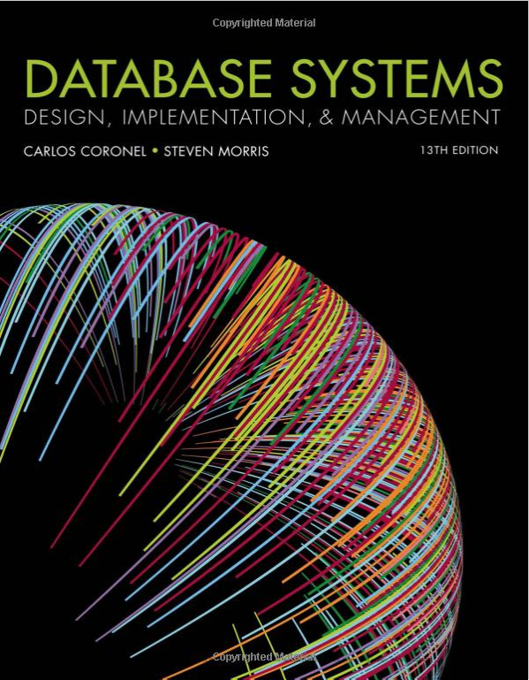 |  | Coronel & Morris, Database Systems: Design, Implementation & Management, Cengage Learning, 2018.  ISBN: 9781337627900  Any Edition Will Do! Don’t Knock Yourself Out Trying To Get The 13th Edition…  A Course Packet Has Been Made Available In The Bookstore
Free eBook:
Text:
In an effort to assist with the price of textbooks, I am making use of an open educational resource in this class. This free eBook will be made available to every enrolled student via Canvas. You may use either textbook.

Course Format:
This course is being offered face to face mode. We will meet here on Monday’s on a weekly basis. The entire course will be covered in 16 weeks. This kind of course requires a diligent and motivated student. A course website has been created with content, slides and sample code. Be forewarned that this class is fairly challenging. As a result, I would like to stress that you work through each chapter content provided. In addition to reading the online content, homework will be assigned.
All quizzes and the final exam will be held in class during the scheduled week/time. There will be multiple versions of each exam so cheating really will not do you much of any good.
Overall, this kind of course requires a very diligent, self-motivated learner who can commit to the course schedule and format. Homework assignments will be posted on a bi-weekly basis. Follow the course schedule closely and be sure to submit all assignments in Canvas by the due date/time. Students can turn in assignments whenever they choose; however, I will only be grading what is currently due.

Coursework:
Homework is to be submitted by the due date assigned. LATE HOMEWORK WILL NOT RECEIVE FULL CREDIT.

Electronic Submission:
It is your responsibility to make certain that all files that are submitted electronically can be easily accessed from your submission folder. Following the naming conventions described in class is the best way you can ensure that you receive the highest grades for your assignments. Files that cannot be opened will receive a lower grade. It is very good idea to make a backup copy of your assignments!
You must follow the electronic submission guidelines to turn in all projects. This course will be making extensive use of the course Canvas Page. You must upload all assignments there by following the electronic submission guidelines discussed in class. Please monitor that site regularly for important notices and announcements posted online, as mid-course corrections maybe necessary. Do not email any assignments to me. Only those uploaded via Canvas will be marked.

Course Canvas Page:
All students enrolled in this class have been provided access to the course Canvas Page. You will find electronic copies of all the information presented and available for downloading. While the class has yet to get going, I highly recommend you familiarize yourself with the site and the way I am posting content for your use.

Evaluation and Grading:
Problem:
Sets: During the semester, you will be required to work on 6 Problem Sets. These Problem Sets need to be turned in by the date scheduled. All of these problem sets will be considered in your grade. YOU WILL BE DROPPED FROM THE CLASS IF YOU FAIL TO TURN IN THREE PROBLEM SETS.

Mid Semester Tests: There will be two tests. Refer to the course schedule for the chapters covered. Format for the test will be posted in Canvas prior to the test.

Final Exam: A comprehensive final exam will be given at the end of the semester. It will cover most topics covered during the course. Format for the final exam will be posted prior to the exam.

Important:- If an emergency arises which prevents you from attempting any of the assessments by the dates/times specified, email me as soon as possible

Assessment:
Category | Point Value | Total | Percent |  | Grading Scale
Problem Sets (6) | 25 | 150 | 30% |  | 500-450 A
Tests (2)  Test 1 Monday Oct 8th  Test 2 Monday Nov 26th | 100 | 200 | 40% |  | 449-400 B
Final Exam (1) | 150 | 150 | 30% |  | 399-350 C
 |  |  |  |  | 349-300 D
 |  |  |  |  | 0-299 F

Late Policy
All assignments are due on the scheduled dates. Late work is highly discouraged because you need to keep up with the class to succeed. Unless prior arrangements have been made with the instructor, no late assignments will be accepted.

Participation
Participation in online discussion is encouraged and necessary for maximum credit. Be sure to login into Canvas, access the lecture materials and submit your assignments. Use the Discussion Boards to raise any doubts you may have. I would highly encourage students to participate in discussion forums.

Honor Code and Code Of Student Conduct
As a testament to their commitment and readiness to join the Santa Monica College academic community, all students are expected to uphold the Honor Code. At the time of admission, students will certify the following statement:

In the pursuit of the high ideals and rigorous standards of academic life, I commit myself to respect and uphold the Santa Monica College Honor Code, Code of Academic Conduct, and Student Conduct Code. I will conduct myself honorably as a responsible member of the SMC community in all endeavors I pursue.
Honest and ethical students are protected in this class. The SMC Honor Code and Code of Academic Integrity, printed in the General Catalog, remind students of their responsibility to behave honestly and ethically. It is your responsibility to familiarize yourself with these codes. Please be extremely careful that you do not engage in any behavior that could even be construed as cheating. Outside of class, students are allowed to study together. However, copying another student's homework is not acceptable. If I determine that students have relied too heavily on each other in preparing homework or any other project, the students may be assigned no credit. Future occurrences could result in academic disciplinary action.

Cheating
All work you submit must be your own individual work. If you copy another person’s work or let another person copy your work, you are cheating. Cases where submitted work looks alike will result in an “F” on the project and will be subject to the student discipline process. The College’s Code of Academic Conduct applies to each and every course as well as each and every member of the academic community, faculty and students alike. IN ORDER TO JOIN THIS SECTION, ALL STUDENTS ARE REQUIRED TO STATE THAT THEY ARE AWARE OF AND WILL FOLLOW THE ACADEMIC HONESTY POLICY. I enforce a ZERO-TOLERANCE policy on cheating in this course. There is no excuse whatsoever for not doing your own work.

Discrimination
Santa Monica College and this academic department welcome students from all over the world with various backgrounds and life experiences. SMC is committed to fostering a safe and productive learning environment. SMC has zero tolerance for discrimination, and/or sexual harassment, which includes sexual misconduct such as, domestic and dating violence, sexual assault, sexual exploitation, and stalking. Any sexual violence or physical abuse, as defined by California law, whether committed by an employee, student, or member of the public, occurring on college-owned or controlled property, at college-sponsored or supervised functions, or related to or arising from college attendance or activity is a violation of District policies and regulations, and is subject to all applicable punishment, including criminal and/or civil prosecution and employee or student discipline procedures.

SMC Students assume an obligation to conduct themselves in a manner compatible with the college’s function as an educational institution, which respects the rights of others to learn, and to acknowledge the academic freedom to teach and communicate in an environment that fosters learning and creativity. With that in mind, it is important to keep a respectful tone and attitude when communicating and interacting with your colleagues. You are the only you. No one else will have your sensibilities of what is funny or interesting. Part of being respectful is also realizing that someone else may be offended by something you think is “every day normal.”

Students who have experienced some form of sexual misconduct or discrimination are encouraged to talk to someone about their experience, so they can get the support they need. To learn more about support available for students, please see http://www.smc.edu/StudentServices/SVPE/Pages/What-is-Title-IX.aspx.

Use of the Discussion Board and Email
The Discussion board in the online course site is intended to facilitate questions and answers. You may post questions as long as you use proper language that is respectful and does not attack any other person in the class. If you abuse the discussion board you will be referred to the school’s Disciplinarian. This may also result in further actions taken by the Disciplinarian’s office including but not limited to suspension from class.

Students with Special Needs
In compliance with the Americans with Disabilities Act (ADA), all qualified students enrolled in this course are entitled to “reasonable accommodations”. Any student who needs special attention should speak privately with the instructor to describe their needs. This should be done within the first two weeks of the start of class.

Incomplete Policy
Students will not be given an incomplete grade in the course without sound reason and documented evidence. In any case, for a student to receive an incomplete grade, he or she must be passing and have completed a significant portion of the course. Make sure you are aware of the college drop policy. In case of absence, it is your responsibility to find out what material was covered and what assignments were given.
IT IS YOUR RESPONSIBILITY TO DROP/WITHDRAW FROM CLASS BY THE PUBLISHED DEADLINES OR YOU WILL RECEIVE AN ‘F’ GRADE.

Tentative Class Schedule
Below is a tentative schedule and is subject to change. It is important to access the course website frequently since changes may be made to the schedule published below.

Week | Week Of | Topics
1 | Aug 27 | Course Introduction  Complete Chapters 1 & 2
2 | Sep 3 | No class – Labor Day Holiday  Submit Problem Set 1 by Midnight Sep 9
3 | Sep 10 | Complete Chapter 3
4 | Sep 17 | Complete Chapter 4  Submit Problem Set 2 by Midnight Sep 23
5 | Sep 24 | Complete Chapter 5
6 | Oct 1 | Complete Chapter 6  Submit Problem Set 3 by Midnight Oct 7  Discuss format for Test 1
7 | Oct 8 | Test 1  Coverage:- Chapters 1 to 5
8 | Oct 15 | Complete Chapter 7
 | Oct 22 | Mid Semester Break – No Class
9 | Oct 29 | Complete Chapter 8  Submit Problem Set 5 by Midnight Nov 4
10 | Nov 5 | Complete Chapter 9
11 | Nov 12 | No Class – Veteran’s Day Holiday
12 | Nov 19 | Complete Chapter 10  Discuss format for Test 2  Submit Problem Set 6 by Midnight Nov 25
13 | Nov 26 | Test 2  Coverage Chapters 6 to 10
14 | Dec 3 | Complete Chapter 11  Submit Problem Set 6 by Midnight Dec 2
15 | Dec 10 | Complete Chapter 12  Discuss Final Exam Format
16 | Dec 17 | Final Exam  All Chapters

