CSCI 1480
University of Central Arkansas
Lab 5 In B-class Assignment

Topic: Copy Constructor - 5 Points
Reading: Ch. 14

*Note: Include the following set of comments at the top of your source code for all assignments.
//Your Name
//Assignment # (Example: Lab5InB)
//Brief description of the purpose of the program (Example: //Calculates the area of a square.)

Overview
Write a C++ program that will process text information entered by the user –. The data will be prompted by the user in main:

Example Input:

Enter Word: individual

A set of images corresponding to the alphabet is also provided in alpha.zip. Examples of the images are shown below:
 ……  
a.bmp b.bmp y.bmp z.bmp - Each letter is 32.x32
The central objective of this lab is to:
1.Enter a word from the user
2. Display the corresponding images that represent the individual letters of the word for 3 seconds
3. Reverse the letters and display on top of the original word.

The following class, named Word is also used when implementing this lab.

class Word
{
private:
string word;
int* x; //x-coords
int* y; //y-coords

public:
Word();
~Word();
void setWord(string word);
void setCoords(int x_val, int y_val);
string getWord();
void draw();
};

Guidelines for main follows:

1. Declare Word object

2.Prompt the user for the word to be displayed..

3. Prompt the user for the starting x/y coords

3. Invoke setWord method that sets the private data field word.

4. Invoke the setCoords method using the starting x/y coordinate. All other coordinates will be set within the x/y arrays by this initial coordinate

4. Invoke the draw method that displays the alphabetic images corresponding to the letters of the entered word. The letters will be displayed based on the coordinates stored in the x/y arrays.

5. Invoke the reverseWord independent function to reverse the original word. The Word object is passed by value invoking the Copy Constructor.

5. Repeat as many times as desired.

Example input/output:

Enter word: individual
Enter starting x/y coordinate: 100 250

For this example, the resulting graphics display is shown as:
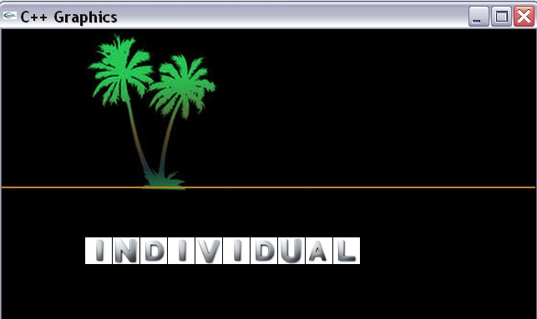

(100,250)
For this example, the entered word is individual. This is displayed for 3 seconds before the word is reversed as shown below:

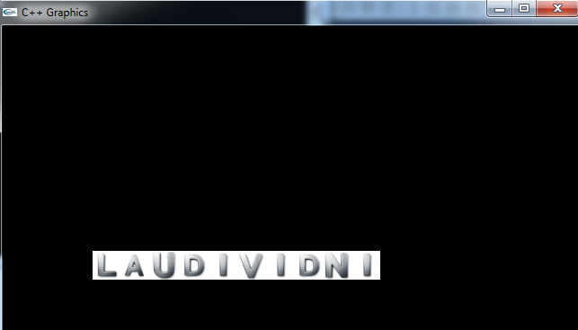

Data Field Description

string word;
A word entered by the user. Set the word by

void setWord(string word);

int* x;
Array containing all x-coordinates corresponding to each displayed letter of word

int* y;
Array containing all y-coordinates corresponding to each displayed letter of word

Methods Description

Word();
Default Constructor. Sets x/y datafields to NULL. Sets word to empty string (“”)

void setWord(string word);
Setter for word data field.

string getWord();
Getter for the word data field.

void draw();
Displays the images associated with each letter of the randomly selected word.

void setCoords(int x_val, int y_val);
Dynamically allocates the x/y arrays based on the length of word. Sets the values for each element based on the input parameters x_val and y_val.

~Word() //Destructor

The independent function that reverses the word is given by

void reverseWord(Word& word);

Note how the word object is passed by reference (we’ll see the reason why this was done next week)

Template for lab5inB.cpp

#include <iostream>
#include <string>
#include "graph1.h"

class Word
{
private:
string word;
int* x; //x-coords
int* y; //y-coords

public:
Word();
~Word();
void setWord(string word);
void setCoords(int x_val, int y_val);
string getWord();
void draw();
};

Word::Word()
{
//Initialize pointers to NULL, word to “”
}
Word::~Word()
{
//Cleanup pointers
}

void Word::setCoords(int x_val, int y_val)
{
//Dynamically allocate x/y arrays
//Set the values in the x/y arrays based on x_val/y_val
}
void Word::setWord(string word)
{

}
string Word::getWord()
{
}

void Word::draw()
{

}

Template for main

//
//
//Reverses input word

void reverseWord(Word& copy, int x_val, int y_val);

int main()
{
int x = 0;
int y = 0;
string input;
int size = 0;
Word word;
char repeat;

do
{
displayGraphics();

//Prompt the user for the word to be displayed..
cout << "Enter word: ";
cin >> input;
cout << endl;

// Invoke setWord method that sets the private data field word.

//Prompt for the inital x/y coord
cout << "Enter initial x/y coord: ";
cin >> x >> y;

//Set the x/y coords

/ Invoke the draw method that displays the alphabetic images corresponding

//5. Add the delay
Sleep(3000);

//6. Invoke the reverseWord independent function to reverse the original
reverseWord(word,x,y);

//5. Repeat as many times as desired.
cout << "Repeat? <y/n>: ";
cin >> repeat;

} while (repeat == 'y' || repeat == 'Y');

return 0;
}

void reverseWord(Word& copy, int x_val, int y_val)
{
//Reverse the copy
//Display the reversed word

}

What you Submit

Submit lab5inB.cpp via Blackboard.

