CSCI 1480
University of Central Arkansas
Lab 1 In-class Assignment

Topic: Review of Arrays and Graphics
Reading: Ch. 7 and Supplement

*Note: Include the following set of comments at the top of your source code for all assignments.
//Your Name
//Assignment # (Example: Lab1In)
//Brief description of the purpose of the program (Example: //Calculates the area of a square.)

Assignment
(Save this file as lab1in.cpp)
Write a C++ program that draws a polyline. A polyline is defined as:

A series of connected line segments that are treated as a single object

A polyline has the following properties:

1. The number of points are one greater the number of line segments
2. Each point is also an endpoint of a segment.

This program will prompt the user for the following data:

1. Prompt the user for the number of points the polyline contains.
2. Prompts the user for the x/y coordinates for the each point

Example for the data input prompts are shown below:
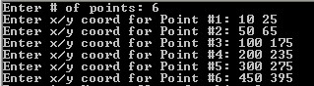

Your program will store the x/y coordinates in parallel arrays and then draw a red circle (radius of 5) centered on each point. Your program will then draw a yellow line between each point. An example of each point is shown below:
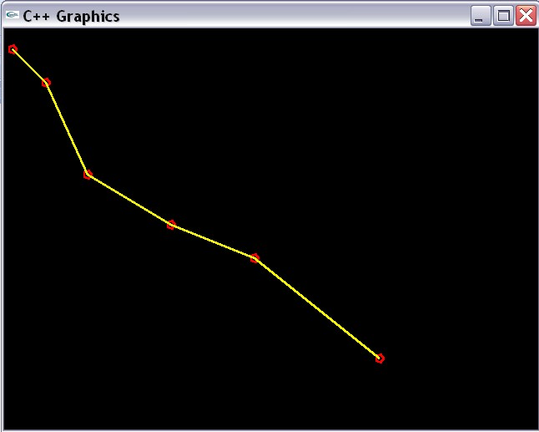
Note that each point has a red circle centered with radius of 5.

Your program should use the following functions:

int getNoPoints();
Prompts the user for the number of points to use for the polyline.

Returns the number of points the polyline uses.

void getPoints(int x[], int y[],int no_points);

Prompts for the x/y coordinates of each point.

int no_points - number of points to user for the polyline (previously entered in getNoPoints)

int x[] - Parallel array used for storing x-coordinates for all points

int y[] - Parallel array used for storing y-coordinates for all points

void drawPolyLine(int x[], int y[], int no_points );
Draws a yellow (255,255,0) line between each consecutive point. Also draws a red circle centered on each point.

Use the following template when implementing this program:

#include <iostream>
#include "graph1.h"

using namespace std;

//Add Function Prototypes Here
int getNoPoints();
void getPoints(int x[], int y[], int no_points);
void drawPolyLine(int x[], int y[], int no_points);

int main()
{
//Variable Declaration/Initialization
int no_points = 0;
const int MAX_POINTS = 10;
int x[MAX_POINTS];
int y[MAX_POINTS];

//Display Graphics Window

//Prompt for the number of points

//Prompt for the data for the points

//Draw the polyline

return 0;
}

//Function Stubs Follows
int getNoPoints()
{
//Declare local variables

//Prompt for the number of points

//Return the number of points
}

void getPoints(int x[], int y[], int no_points)
{
//Declare local variables

//Using a for-loop, prompt for the coordinates of each point and store in arrays x and y

}

void drawPolyLine(int x[], int y[], int no_points)
{
//Declare local variables

//Use 1 for-loop for drawing the red circle on each point

//Use a second for-loop for drawing the lines - remember there is always one less line than there are points!

}

Note that the drawPolyLine function utilizes 2 for-loops: one for drawing the red circles on each point and one for drawing the lines.

Once you have implemented the function this way, see if you can combine the 2 loops into only one loop, thus making your code more efficient and concise.

Have the program repeat as many times as desired.

What you submit:

lab1in.cpp

Submit via Blackboard..

