CSCI 1480
University of Central Arkansas
Lab 8 In-class Assignment

Topic: Classes- Operator Overloading - 5 Points
Reading: Ch. 14

*Note: Include the following set of comments at the top of your source code for all assignments.
//Your Name
//Assignment # (Example: Lab8inP1)
//Brief description of the purpose of the program (Example: //Calculates the area of a square.)

Overview
Write a C++ program that overloads several basic operators (+,-,*,/, etc.) for a Color Class. The declaration for the Color class is shown below:
#ifndef COLOR_H
#define COLOR_H

class Color
{
private:
int r;
int g;
int b;

public:
Color();
Color(int r, int g, int b);
void setColor(int r, int g, int b);
int getRed();
int getGreen();
int getBlue();
Color operator+(Color right);
Color operator-(Color right);
Color operator/(int right);
Color operator*(int right);
bool operator==(Color right);
bool operator!=(Color right);
void operator=(Color right);
Color operator!();
void draw(int x, int y, int w, int h);
};

#endif

The purpose of this class is to manage the r,g,b components for a color object. An example main is provided (see page ) that utilizes the above class in the following menu:
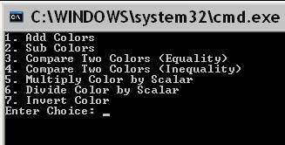
The main declares 3 color objects as shown below:

Color c1;
Color c2;
Color result1;

The menu will utilize these color objects when implementing the above menu. Selecting menu item # 1 results in the user prompted for 2 colors:
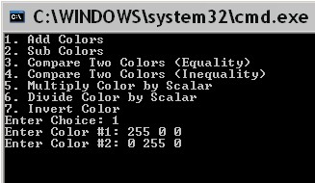
Selecting menu item #1 results in the addition of the two colors (representing the operands to be added):
(255,0,0)
(0,255,0)

The rule for adding two colors follows:
Add the corresponding r components, g components, and b components together. Values greater than 255 are set to 255.

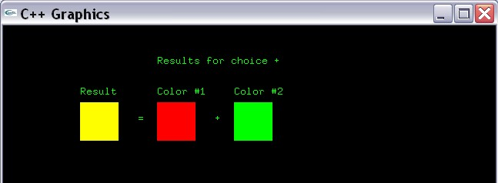
The example main will then display the results for adding 2 colors as shown below:
(200,50)
(100,90)
(100,100)
(175,125)
(200,100)
(300,100)
(275,125)
Each square is 50x50. The program then allows to be repeated:
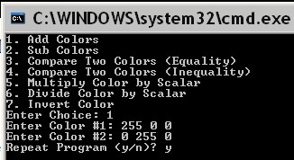
Entering y repeats the program by clearing the graphics window and redisplays the menu:
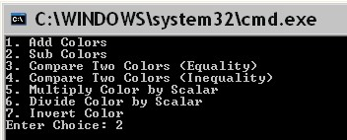
Entering 2 subtracts two colors. The user is again prompted for 2 colors (representing the operands to be subtracted).
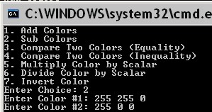
The rule for subtracting 2 colors - color 2 is subtracted from color 1 - is:

Subtract the corresponding r components, g components, and b components of color #2 from color #1. Values less than 0 are set to 0.

The example main then displays the results of subtracting color #2 from color #1:
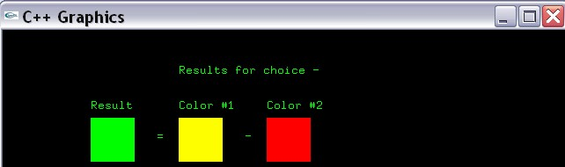
After running the program again, the user selects menu item #3 and enters the 2 colors:
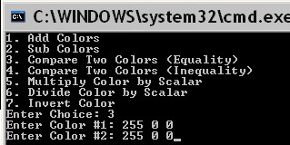

Equality of 2 colors is defined as:

Compare each corresponding r,g,b component between the 2 colors.
Return true if all 3 components match. Return false otherwise.

The main displays the results for the above example as shown below:
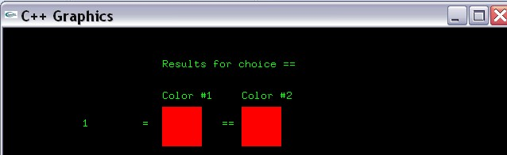

Running the program again and selecting menu item #4 results in the following:
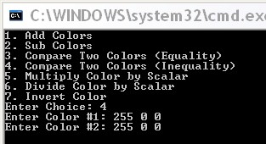
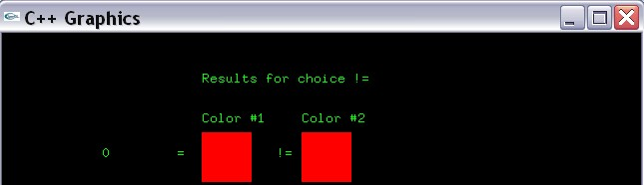
The Inequality rule is opposite for Equality. The results displayed in the graphics window is shown below:
Running the program again and selecting item #5 is shown below:
\ 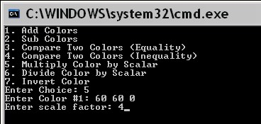

Multiplying a Color by a scalar is defined as:

Multiply each r,g,b component by the scalar amount. Results greater than 255 are set to 255.

The result for the above example is shown as:
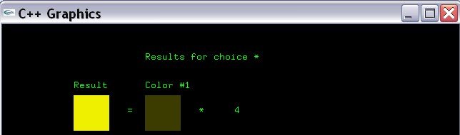

Re-running the program and selecting menu item #6 results in the following:

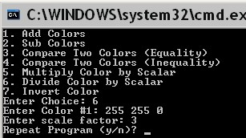

Dividing a color by a scalar is defined as:

Divide each r,g,b component by the scalar amount.

The results for the above example are shown below as:
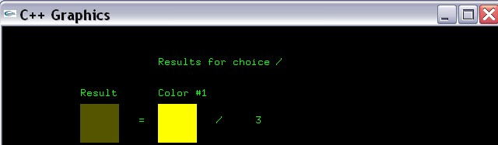

Re-running the program and selecting item #7 results in the following menu:
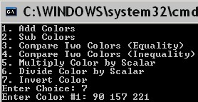
Note only one color is added. Inverting a color is defined as subtracting each corresponding r,g,b component from 255. In other words,

result.r = 255 - r;
result.g = 255 -g;
result.b = 255 -b;

The displayed results for this operation is:
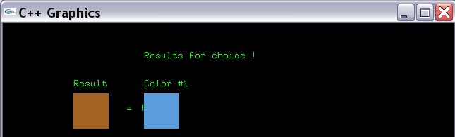

Datafield Description

Utilize the following datafields in the Color class:

int r;
int g;
int b;

Each datafield corresponds the r,g,b component of the color.

Method Description

The Color class utilizes the following methods:

Color();
Default Constructor sets r,g,b color components all to 0.

Color(int r, int g, int b);
Parameterized Constructor. Set r,g,b private datafields to values in the formal parameters.

void setColor(int r, int g, int b);
Setter for r,g,b private datafields.

int getRed();
int getGreen();
int getBlue();
Getters for private datafields.

Color operator+(Color right);
Adds two Color objects based on the following rule:

Add the corresponding r components, g components, and b components together. Values greater than 255 are set to 255. Returns the result of adding the two colors.

Color operator-(Color right);
Subtracts two Color objects based on the following rule:

Subtracts the corresponding r components, g components, and b components. Values less than 0 are set to 0. Returns the result of subtracting the two colors.

Color operator/(int right);
Divides a Color by an integer. Each r,g,b component of the Color object is divided by the integer. Returns the results of this division.

Color operator*(int right);
Multiplies a Color by an integer. Each r,g,b component of the Color object is multiplied by the integer. Returns the results of this multiplication.

bool operator==(Color right);
Tests the equality of 2 colors. Return true if the r,g,b components of both colors exactly match. Otherwise, return false.

bool operator!=(Color right);
Tests the inequality of 2 colors. Return true if any of the r,g,b components of either color does not match. Otherwise, return false.

void operator=(Color right);
Assignment operator. Assigns the r,g,b component of the Color object on the right side of th eassignment operator to the r,g,b component on the left side of the assignment operator.

Color operator!();
Computes the inverse of a Color object. The inverse of a Color object is defined as:

Subtract the corresponding r,g,b value from 255. Return a Color object containing these values.

This inverse can be computed as:

result.r = 255 - r;
result.g = 255 -g;
result.b = 255 -b;

Where result is returned from this method.

void draw(int x, int y, int w, int h);
Draws a rectangle positioned at coordinate (x,y) with width set to w and height set to h. The rectangle is then colored to r,g,b color maintained by this Color object.

Example Template for Color.cpp is given below:

#include <iostream>
#include "graph1.h"
#include "Color.h"

Color::Color()
{

}
Color::Color(int r, int g, int b)
{

}
void Color::setColor(int r, int g, int b)
{

}
int Color::getRed()
{

}
int Color::getGreen()
{

}
int Color::getBlue()
{

}
Color Color::operator+(Color right)
{

}
Color Color::operator-(Color right)
{

}
Color Color::operator/(int right)
{

}
Color Color::operator*(int right)
{

}
bool Color::operator==(Color right)
{

}
bool Color::operator!=(Color right)
{

}
void Color::operator=(Color right)
{

}
Color Color::operator!()
{

}
void Color::draw(int x, int y, int w, int h)
{

}

Example main follows (please fill in the blanks appropriately):
#include <iostream>
#include "graph1.h"
#include "Color.h"

using namespace std;

int main()
{
//Variable Declaration/Initialization
int choice = 0;
int r = 0;
int g = 0;
int b = 0;
int scale_factor = 0;
Color c1;
Color c2;
Color result1;
bool result3;
char repeat = 'y';
string operators[] = {"+","-","==","!=","*","/","!"};

//Display graphics window
displayGraphics();

//Repeat as many times as desired
do
{

//Display menu
cout << "1. Add Colors" << endl;
cout << "2. Sub Colors" << endl;
cout << "3. Compare Two Colors (Equality)" << endl;
cout << "4. Compare Two Colors (Inequality) " << endl;
cout << "5. Multiply Color by Scalar" << endl;
cout << "6. Divide Color by Scalar" << endl;
cout << "7. Invert Color" << endl;
cout << "Enter Choice: ";
cin >> choice;

//Always Prompt for one colors
//Prompt for color #1
cout << "Enter Color #1: ";
cin >> r >> g >> b;
c1.___ (r,g,b);

//Prompt for color #2 (if choice is 1,2,3,4
if ( (choice == 1) || (choice == 2) || (choice == 3) ||(choice == 4) )
{
cout << "Enter Color #2: ";
cin >> r >> g >> b;
c2._____(r,g,b);

}
//Prompt for scalar if choice is 5,6
else if ( (choice == 5) || (choice == 6) )
{
cout << "Enter scale factor: ";
cin >> scale_factor;
}

//Process choice
switch(choice)
{
case 1:
//Add results
result1 = c1 _ c2;
break;

case 2:
//subtract results
result1 = c1 _ c2;
break;

case 3:
//Compare 2 results (equality)
result3 = (c1 __c2);
break;

case 4:
//Compare 2 results (inequality)
result3 = (c1 __ c2);
break;

case 5:
//Multiply by scalar
result1 = c1__scale_factor;
break;

case 6:
//Divide by scalar
result1 = c1__scale_factor;
break;

case 7:
//Invert Color
result1 = !c1;
break;

default:
//Display error message
cout << "Incorrect choice" << endl;

}

//Display title for results
gout << setPos(___,___) << "Results for choice " << operators[choice-1] << endg;

//Display Results in Graphics Window
if ( (choice == 1) || (choice == 2) || (choice == 3) || (choice == 4) )
{

//Draw Color 1
c1.draw(___,__,50,50);
gout << setPos(__,__) << "Color #1" << endg;

//Draw the operator
gout << setPos(275,125) << operators[choice-1] << endg;

//Draw Color 2
c2.draw(300,100,50,50);
gout << setPos(300,90) << "Color #2" << endg;

//Draw the assignment operator
gout << setPos(175,125) << "=" << endg;

if ( (choice == 1) || (choice == 2) )
{
//Draw Color Result (1/2)
result1.draw(100,100,50,50);
gout << setPos(100,90) << "Result" << endg;
}
else if ( (choice == 3) || (choice == 4) )
{
//Display equality
gout << setPos(100,125) << result3 << endg;
}
}
else if ( (choice == 5) || (choice == 6) )
{
//Draw Color 1
c1.draw(200,100,50,50);
gout << setPos(200,90) << "Color #1" << endg;

//display the operator
gout << setPos(275,125) << operators[choice-1] << endg;

//display the scale factor
gout << setPos(325,125) << scale_factor << endg;

//Draw the assignment operator
gout << setPos(175,125) << "=" << endg;

//Draw Color Result
result1.draw(100,100,50,50);
gout << setPos(100,90) << "Result" << endg;

}
else if (choice == 7)
{
//Draw Color 1
c1.draw(200,100,50,50);
gout << setPos(200,90) << "Color #1" << endg;

//display the operator
gout << setPos(195,125) << operators[choice-1] << endg;

//Draw the assignment operator
gout << setPos(175,125) << "=" << endg;

//Draw Color Result
result1.draw(100,100,50,50);
gout << setPos(100,90) << "Result" << endg;
}

//Repeat?
cout << "Repeat Program (y/n)? ";
cin >> repeat;

system("cls");
clearGraphics();

}while( (repeat == 'y') || (repeat == 'Y') );

return 0;
}

What you Submit

Submit Color.h, Color.cpp, and main.cpp via Blackboard.

