CSCI 1480
University of Central Arkansas
Lab 4 In-class Assignment

Lab Test Next Week

Topic: String Processing - 5 Points
Reading: Ch. 10

*Note: Include the following set of comments at the top of your source code for all assignments.
//Your Name
//Assignment # (Example: Lab4inP1)
//Brief description of the purpose of the program (Example: //Calculates the area of a square.)

Overview
(Save this file as lab4in.cpp)
Write a C++ program that implements a form that inputs/validates name, address, and phone information. First, prompt the user for the name, address, and phone information as shown below:
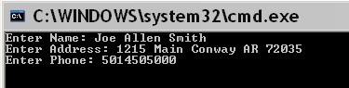

Each field (e.g., name, address, and phone) must be validated based on the following rules:

- Name can contain alphas and spaces only
- Address can contain alphanumeric and spaces only
- Phone can contain numeric only and have exactly 10 characters

Your program will display an error message and re-prompt the user if the input data fails its validation rule.

The fields are then displayed in a form once the validation rules are satisfied. An example of this form is given below (with suggested coordinates):

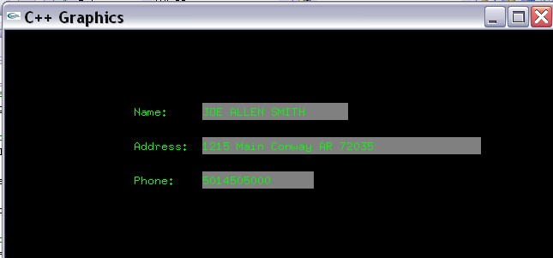
(150,100)

(150,140)

(150,180)
(230,125) (230,85)

(230,165)

The color of each rectangle is suggested as (128,128,128).

The text inside the gray rectangles (i.e., textfields) have the following suggested coordinates:

Name: (230,100)
Address: (230,140)
Phone: (230,180)

The suggested height for all rectangles is 20. The suggested width of the Name rectangle is 170. The suggested width of the Address rectangle is 325. The suggested width of the Phone rectangle is 125. For this lab, the text can overflow beyond the width of the bounding gray rectangle.

Note: The name can be entered in any case, but displayed in the textfield as uppercase.

Required Functions

The following functions are required when implementing this program. You are free to add any extra functions that you like.

string getString(string prompt);
Prompts the user for a string based on the input parameter prompt. The user-entered string is returned as a string data type.
Input: string prompt - string informing user what type of string data they should enter. Examples for this prompt are:

Enter Name:
Enter Address:
Enter Phone:

Return Value: string containing the data entered by the user.

bool validateName(string name);
Validates the name based on rules given previously for names.

Input: string name - string containing a name

Return Value: true if name is valid, false otherwise

bool validateAddress(string address);
Validates the name based on rules given previously for addresses.

Input: string address - string containing an address

Return Value: true if address is valid, false otherwise

bool validatePhone(string phone);
Validates the name based on rules given previously for phones.

Input: string phone - string containing a phone number

Return Value: true if name is valid, false otherwise

string convertToUpper(string input);
Converts the input string – input - to all uppercase.

Input: string input - string. Can be stored in any case.

Return Value: An uppercase version of the input parameter input .

void displayFields(string name, string address, string phone);
This function displays the name, address and phone data as shown in Fig. 1.

Input: string name - string containing a name
Input: string address - string containing an address
Input: string phone - string containing a phone number

Have program repeat as many times as desired.

Use following template to get started:

//Paige Ingram
//Lab 4 in
//Creates a form for inputting/validating information

#include <iostream>
#include <string>
#include <cctype>
#include "graph1.h"

using namespace std;

//Prototypes are below
string getString(string prompt);
bool validateName(string name);
bool validateAddress(string address);
bool validatePhone(string phone);
string convertToUpper(string string);
void displayFields(string name, string address, string phone);

int main()
{
//Variable Declaration/Initialization
string name = "";
string address = "";
string phone = "";
string upperName = "";
bool res = false;

//Display graphics window
displayGraphics();

//Process name info
do
{
//Prompt for the name -
name = getString("Enter Name: ");

//validate the name
res = validateName(name);

} while (!res);

//Process the address info
do
{
//Get the address
address = getString("Enter Address: ");

//validate the address
res = validateAddress(address);

} while (!res);

//Process phone info
do
{
//Get the phone
phone = getString("Enter Phone: ");

//validate the phone
res = validatePhone(phone);

} while (!res);

//Convert the name to all uppercase

//Display the fields

return 0;
}

//Prompts for input based on input parameter prompt
string getString(string prompt)
{

//Prompt user for name using getline (prompt contains the message displayed to user))

}

//Validates characters of name
bool validateName(string name)
{
//Validate the name – return true if valid, false if not
}

//Validates characters of address
bool validateAddress(string address)
{
//Validate the address – return true if valid, false if not
}

//Validates characters of phone number
bool validatePhone(string phone)
{
//Validate the phone – return true if valid, false if not
}

//Converts text to uppercase
string convertToUpper(string input)
{
//Convert input to all uppercase
//Return converted input
}

//Displays the information in graphics window
void displayFields(string name, string address, string phone)
{
//Draw the form (rectangles)
//Display the fields
}

Have program repeat as many times as desired.

What you Submit

Submit lab4in.cpp via Blackboard.

