CSCI 1480
University of Central Arkansas
Lab 10 In-class Assignment

Topic: Files - 5 Points
Reading: Ch. 12

*Note: Include the following set of comments at the top of your source code for all assignments.
//Your Name
//Assignment # (Example: Lab9inP1)
//Brief description of the purpose of the program (Example: //Calculates the area of a square.)

Overview
Write a C++ program that will process text information stored in a file and provide the initial starting place for a word game to be fully implemented in lab9out – The WordGame. The data is stored in a file named words1.txt and consists of 1149 unique words placed on each line as shown below:

ability
account
accumulated
accumulating
accuracy
……..
windows
within
wollborn
workshop
workshops
yellow

A set of images corresponding to the alphabet is also provided in alpha.zip. Examples of the images are shown below:
 ……  
a.bmp b.bmp y.bmp z.bmp - Each letter is 32.x32
The central objective of this lab is to:
1. Randomly select a word from the file shown above
2. Display the corresponding images that represent the individual letters of the word

The following class, named Game is also used when implementing this lab.

#ifndef GAME_H
#define GAME_H

class Game
{
private:
string fileName;
string word;

public:
Game();
string getFileName();
void setFileName(string fn);
void setWord(int rand_no);
string getWord();
void draw();
};

#endif

An example of main.cpp is provided and performs the following steps:

1. Declare Game object

2.Prompt the user for the file name containing the words to be processed.

3. Generate random number between 0 and 1148 inclusively.

4. Invoke setWord method that selects a random word from the file and sets the private data field word.

5. Invoke the draw method that displays the alphabetic images corresponding to the letters of the randomly selected word.

The example prompt from main is shown below:
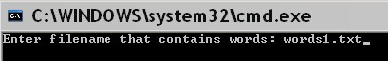

The resulting graphics display is shown as:
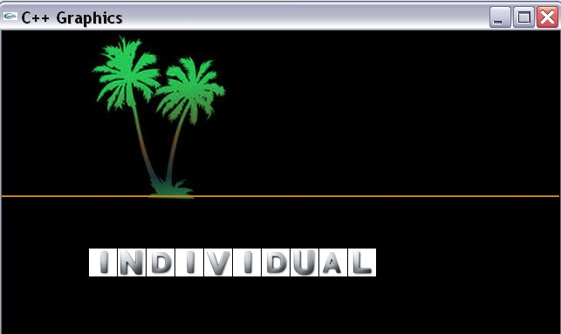

(100,250)
For this example, the randomly selected word is individual.

Data Field Description

string fileName;
The name of the file containing the words used by the game. For our lab, it will be words1.txt.

string word;
The randomly selected word from the file containing the word. Set by the

void setWord(int rand_no);

method.

Methods Description

Game();
Default Constructor. Sets datafields to “”.

string getFileName();
Getter for fileName field.

void setFileName(string fn);
Setter for fileName field.

void setWord(int rand_no);
Setter for word data field. This method performs the following steps.

1. Opens a file associated with the fileName data field for reading (input)
2. Tests the file stream to assure it is opened correctly
3. Reads one word at a time from the file
4. Accumulates a counter for the number of words in the file
5. Stops reading once the counter is equal to input parameter rand_no
6. Assigns the word data field to randomly selected word

string getWord();
Getter for the word data field.

void draw();
Displays the images associated with each letter of the randomly selected word.

Template for Game follows:

#include <iostream>
#include <cstring>
#include <fstream>
#include "graph1.h"
#include "Game.h"

using namespace std;

Game::Game()
{

}

string Game::getFileName()
{

}
void Game::setFileName(string fn)
{

}
void Game::setWord(int rand_no)
{

}
string Game::getWord()
{

}
void Game::draw()
{

}

Example main follows:

#include <iostream>
#include <ctime>
#include "Game.h"
#include "graph1.h"

using namespace std;

int main()
{
//Variable Declaration/Initialization
int rand_no = 0;
string fn;
char repeat = 'y';
Game game;

//Display graphics
displayGraphics();

//Initialize random # generator
srand(time(0));

//Run program as many times as desired
do
{

//Generate random #
rand_no = rand() % 1149;

//Prompt for fn
cout << "Enter filename that contains words: ";
cin >> fn;

//Set the filename
game.setFileName(fn);

//Set the word
game.setWord(rand_no);

//Draw the scene
game.draw();

//Get the word
string temp = game.getWord();

//Display the actual word
cout << "Random word is: " << temp << endl;

cout << "Repeat? (y/n): ";
cin >> repeat;

//Clear screen
system("cls");
clearGraphics();

} while ((repeat == 'y') || (repeat == 'Y'));

return 0;
}

What you Submit

Zip up VS project and name lab9in.zip. Submit lab9in.zip via Blackboard.

