Lab 9In

Consider the following class hierarchy:
Quadrilateral

Rectangle

A Quadrilateral is composed of 4 points (We’ll use GenPoint provided in GenPoint.h and GenPoint.cpp):
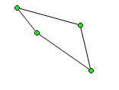
a

b
d

c

A color is also applied to each line (We’ll use Color - same as in lab7in -provided in Color.h and Color.cpp)

The declaration for Quadrilateral is given below:

#ifndef QUADRILATERAL_H
#define QUADRILATERAL_H

#include "GenPoint.h"
#include "Color.h"

class Quadrilateral
{
protected:

GenPoint a;
GenPoint b;
GenPoint c;
GenPoint d;
Color color;

public:
Quadrilateral(); //Sets all points/colors to 0
void setPoints(GenPoint a, GenPoint b, GenPoint c, GenPoint d);
void setColor(Color color);
double getPerimeter();
void print();
void draw();
};

#endif

The main.cpp prompts the user for:
1. All 4 points
2. The r,g,b color

Example of the prompts are shown below:
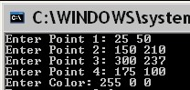
Min for x/y coordinates is 0. Max for x coordinate is 639. Max for y coordinate is 399. Clip values to min/max when input is out of range. The Quadrilateral and its information is then displayed in the graphics window:
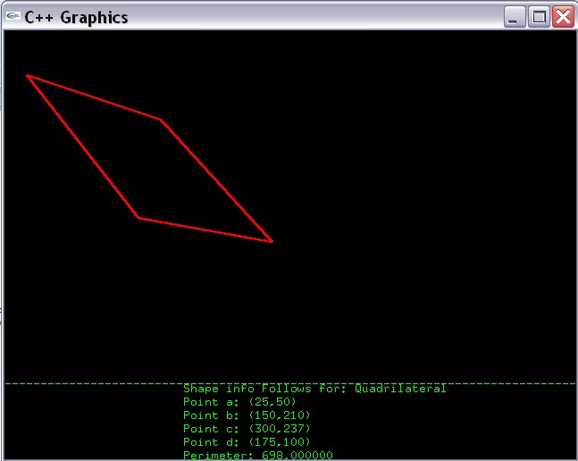
draw method draws 4 lines
print method displays info
starting at
(0,400)
(200,405)
(200,420)

Use 15px separation for each line other than 1st one.

A Rectangle is-a Quadrilateral. The GenRectangle class will be used to represent the Rectangle class. The class declaration for GenRectangle is given below:

#ifndef GENRECTANGLE_H
#define GENRECTANGLE_H

#include "Quadrilateral.h"

class GenRectangle: public Quadrilateral
{

public:
GenRectangle();
void setPoints(GenPoint ul, GenPoint lr);
double getArea();
void print();
};

#endif

Note the additional method - getArea(). GenRectangle also has its own implementation of the print method. The main.cpp prompts for the 2 points - upper left (ul) and lower right (lr) - and sets the GenRectangle using the setPoints method. Example of these prompts is shown below:
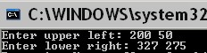
The rectangle is drawn in the graphics window as shown below:
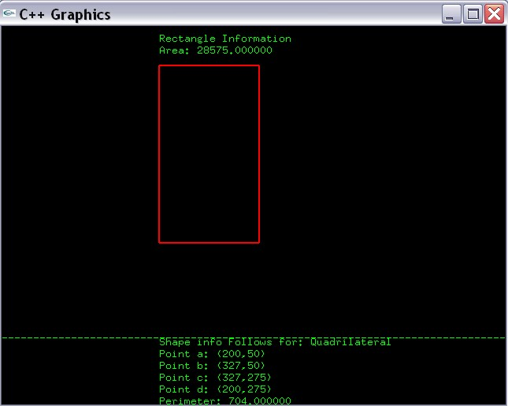
print method of GenRectangle
print method of Quadrilateral

Note that the print method of GenRectangle should invoke the print method of Quadrilateral and the setPoints method for GenRectangle should invoke the setPoints. The same color used for coloring the Quadrilateral is also used for coloring the GenRectangle.

Example main follows:

#include <iostream>
#include "graph1.h"
#include "Quadrilateral.h"
#include "GenRectangle.h"

using namespace std;

int main()
{
//Variable Declaration/Initialization
int x = 0;
int y = 0;
int r = 0;
int g = 0;
int b = 0;
char repeat = 'y';
GenPoint p1;
GenPoint p2;
GenPoint p3;
GenPoint p4;
Color c;
Quadrilateral quad;
GenRectangle rect;

//Display Graphics
displayGraphics();

//Run programs as many times as desired
do
{

//Prompt for point #1
cout << "Process Quadrilateral" << endl;
cout << "Enter Point 1: ";
cin >> x >> y;
p1.setPoint(x,y);

//Prompt for point #2
cout << "Enter Point 2: ";
cin >> x >> y;
p2.setPoint(x,y);

//Prompt for point #3
cout << "Enter Point 3: ";
cin >> x >> y;
p3.setPoint(x,y);

//Prompt for point #4
cout << "Enter Point 4: ";
cin >> x >> y;
p4.setPoint(x,y);

//Prompt for the color
cout << "Enter Color: ";
cin >> r >> g >> b;

//Set all objects (including quad);
c.setColor(r,g,b);
quad.setColor(c);
quad.setPoints(p1,p2,p3,p4);
quad.draw();
quad.print();

cout << "Press y to Continue: ";
cin >> repeat;

//Clear graphics/console
system("cls");
clearGraphics();
//--------------------------------------------------------------------------------

//Prompt for rectangle points
cout << "Process Rectangle " << endl;
cout << "Enter upper left: ";
cin >> x >> y;
GenPoint ul(x,y);

cout << "Enter lower right: ";
cin >> x >> y;
GenPoint lr(x,y);

//Set the color
rect.setColor(c);

//Set the points for rectangle
rect.setPoints(ul,lr);

//Draw the rectangle
rect.draw();

//Display info
rect.print();

cout << "Repeat: (y/n): ";
cin >> repeat;

}while ( (repeat == 'y') || (repeat == 'Y') );

return 0;
}

Submit all .h, .cpp and main.cpp via Blackboard.

