APIGateway Controllers
- Get() [GET Request]
  - Purpose: Entry point for clients (like the front-end or another service) to retrieve a list of games and their metadata.
  - Sends To Microservices:
    - For each game (Snake, Tetris, Pong), it:
      - Determines the internal URL based on environment:
        - If in Development, uses: PublicUrls:{Game} from config
        - If in Production/Containers, uses: Microservices:{Game} from config
      - Calls the microservice at: internalUrl + /{Game} via FetchGameInfo()
  - Receives From Microservices:
    - Expects a List<GameInfo> JSON from each game's endpoint.
    - Populates the Content property of each GameInfo object with the corresponding public JS path (e.g., /js/snake.js)
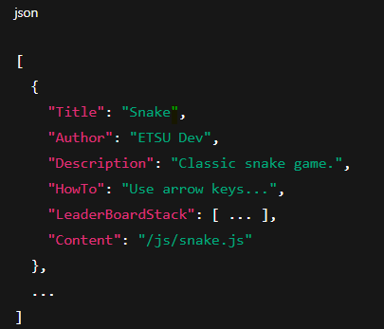
  - Returns to Client: Combined list of GameInfo objects for all successfully contacted games.
    - If any error occurs, returns a fallback response via GenerateFailureResponse()

- FetchGameInfo(string internalUrl, string endpoint, string publicJsUrl) [Private, Called Internally]
  - Purpose: Fetches game metadata from an individual game microservice.
  - Sends HTTP Request:
    - Uses HttpClient to GET data from internalUrl + endpoint, e.g.:
    - http://snake-service/Snake
    - http://pong-service/Pong
  - Processes Microservice Response:
    - Parses JSON response into List<GameInfo>
    - Sets game.Content to the public JS URL (used for loading the game in-browser)
  - Updates Internal Store:
    - Thread-safely adds the results to the shared _gameInfos list

- GenerateFailureResponse() [Private, Fallback]
  - Purpose: If any microservice call fails or throws an exception, returns a dummy list with a placeholder GameInfo.
  - No external communication – just constructs a hardcoded failure object.

Game | Target Microservice URL (Production) | Target Microservice URL (Dev) | Endpoint Sent | Expected Response
Snake | Microservices:Snake | PublicUrls:Snake | /Snake | List<GameInfo> JSON
Tetris | Microservices:Tetris | PublicUrls:Tetris | /Tetris | List<GameInfo> JSON
Pong | Microservices:Pong | PublicUrls:Pong | /Pong | List<GameInfo> JSON

