Doing a rollback this way, retains important data (logs or JSON) when rolling back or redeploying Docker containers. Normally, when you redeploy a container, any data stored inside the container is lost, this is a way to prevent that.
What you need to do:
Create and Mount a Docker volume
Then mount it to container at specific directory path
Using Volumes in Docker-Compose:
Within a docker-compose.yml, volumes can be declared under the volumes: section
After running Docker compose up, volume auto created

Docker system prune – cleanup command removes unused Docker objects
Running it in deployment script could accidentally delete persistent data

Practical rollback workflow on AWS EC2 host using Docker + volumes:
Prep your Docker images (versioned tags)
Push each release to a registry with immutable tags and keep latest pointing to current
Rollback = re-run with previous known-good tag
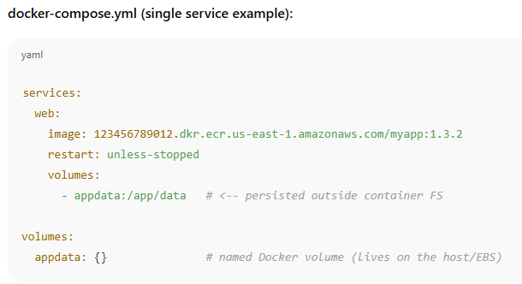
Mount to EBS volume
Safe deployment (Example):
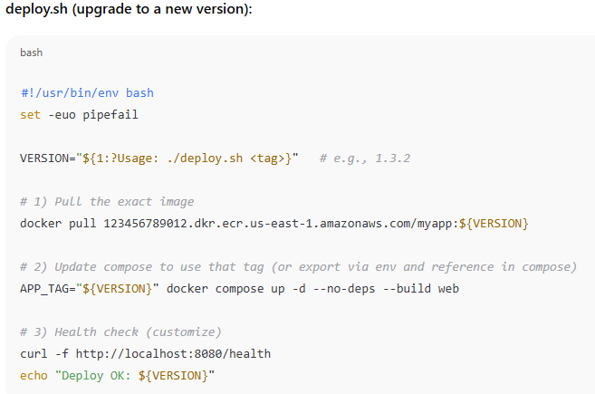

Rollback (Example):
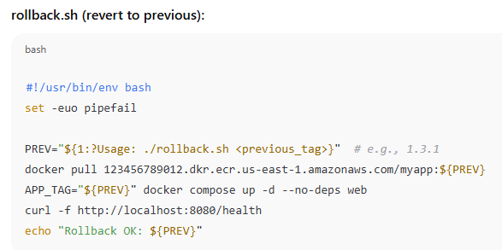
Verification (Example):
