Game Design Document

Fill up the following document

1. Write the title of your project.

Planet-0192093

1. What is the goal of the game?

Finding a rare element only seen in this planet.

1. Write a brief story of your game.

Our Scientists has dicovered a rare element worth billions on another planet and the hero of the game volunterrs to get that element. It is not an easy task as the element is guarded with dangerous aliens and return back.The player has three lives and 6 minutes of time to complete the game.

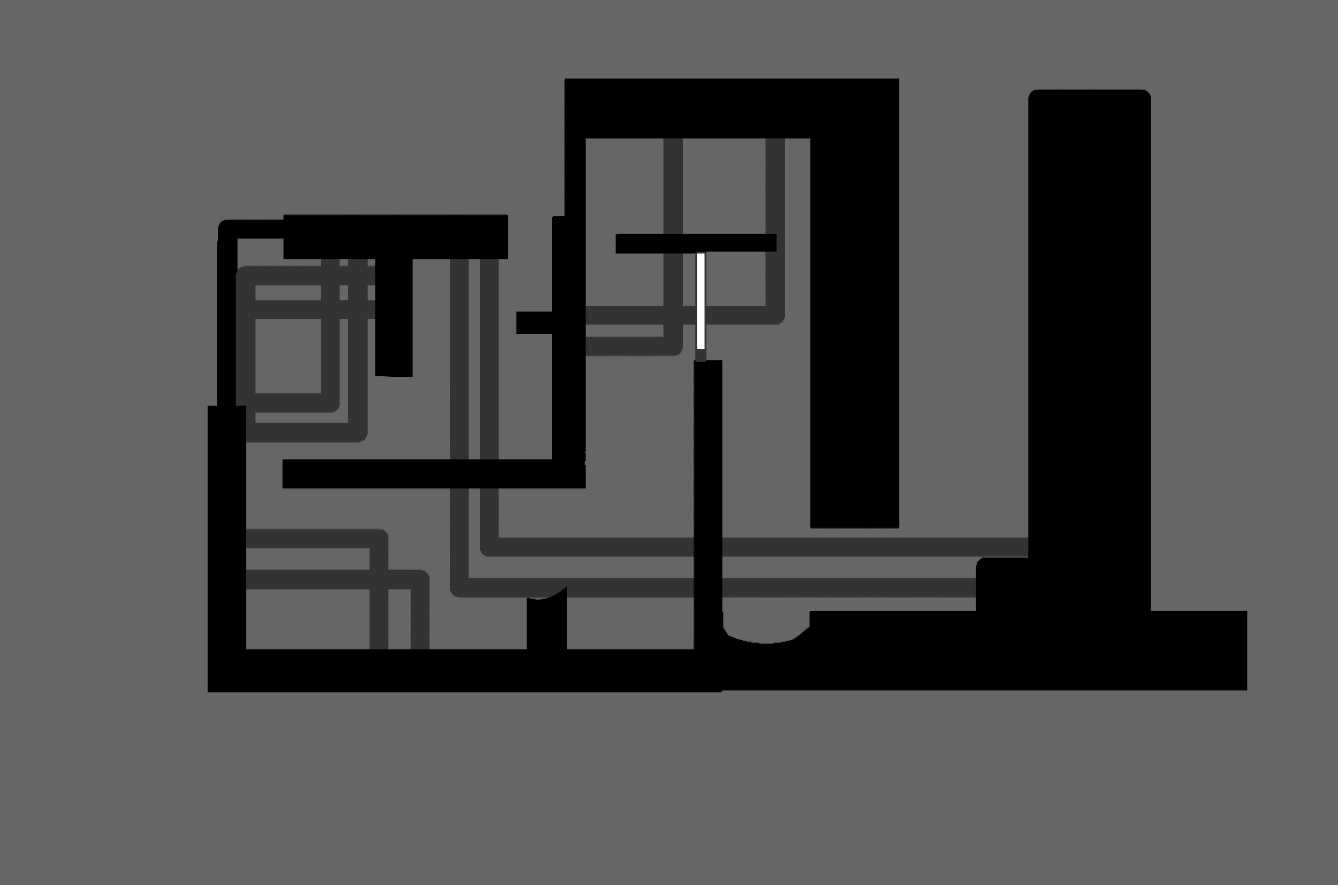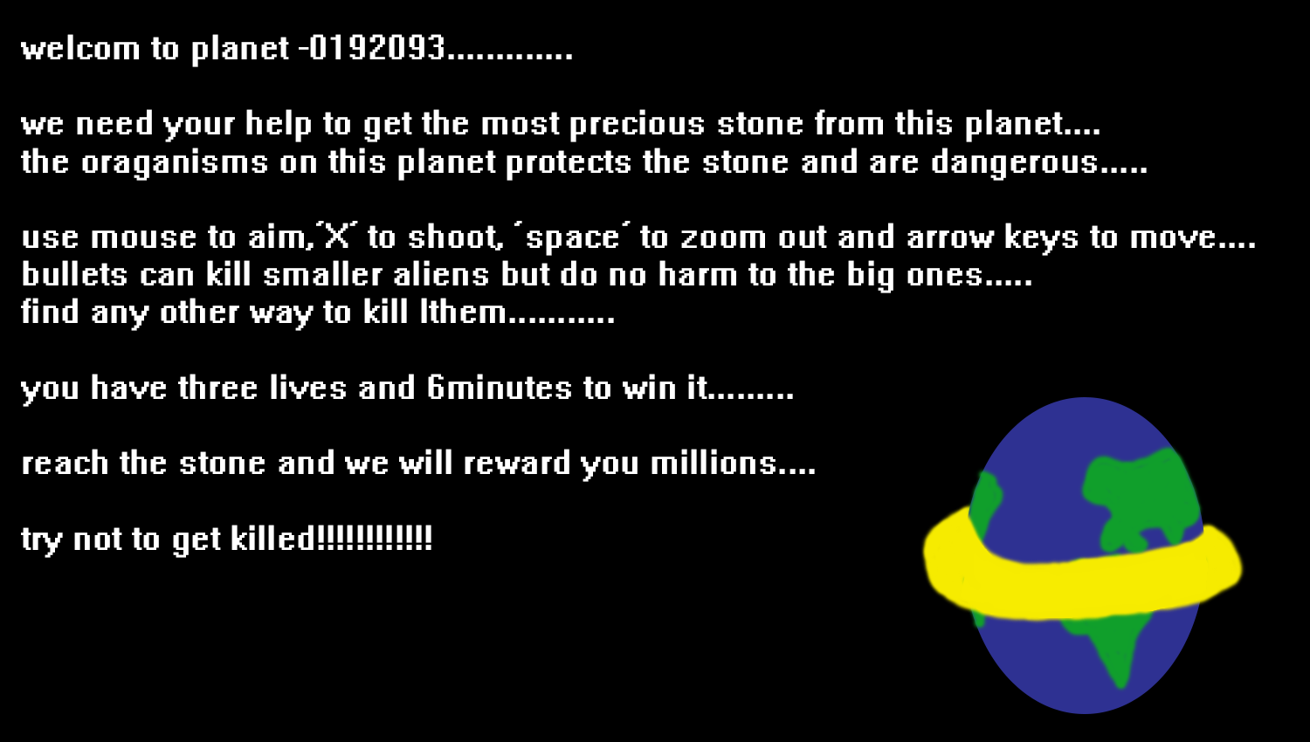

1. Which are the playing characters of this game?

* Playing characters are the ones who respond to the user based on the input from the user.
* Cars, monkeys, dinos, wizards, etc., are the playing characters in the game.

|  |  |  |
| --- | --- | --- |
| Number | Character Name | What can this character do? |
| 1 | Hero | Has a gun.He can move and jump. |
| 2 | Gun | Can shoot bullets but cannot kill the Giant Aliens directly. It can kill small aliensbut. |
| 3 |  |  |
| 4 |  |  |
| 5 |  |  |
| 6 |  |  |
| 7 |  |  |
| 8 |  |  |

s

1. Which are the Non-Playing Characters of this game?

* Non-Playing characters are the ones that don't have an action or behavior when the user interacts with the game.
* Hurdles, stones, bananas, coins, etc., are non-playing characters in the game.

|  |  |  |
| --- | --- | --- |
| Number | Character Name | What can this character do? |
| 1 | Giant Aliens | Kills hero on sight.Spawned on the way to the element. |
| 2 | PlatForms | For the player to stand on. |
| 3 | Heavy Objects | Can be made to fall with the bullets to kill the aliens |
| 4 | Rare elements | Objective of the game |
| 5 | Small Aliens | Kills hero on sight.Spawned on the return. |
| 6 | SpaceShip | The game finishes when the player reaches back to the ship. |
| 7 | Lifts | Helps the player to move up |
| 8 | Fire | Kills the hero. |

Draw your imagination of this game. What does this game look like?

* Draw the game either on your computer or on paper.
* Add images of the game scenes to show each of the playing and non-playing characters at least once.

**1.Player**

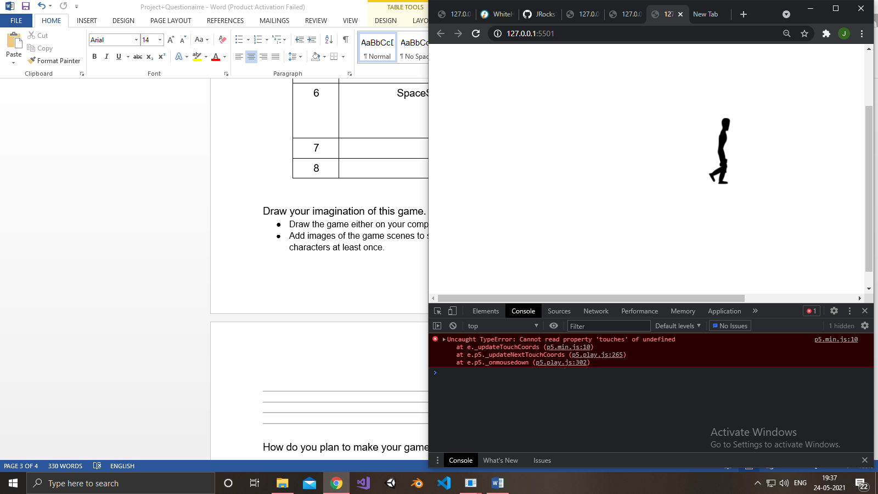

2.Rare Element

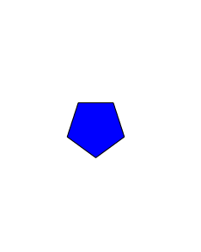

3.Small Alien

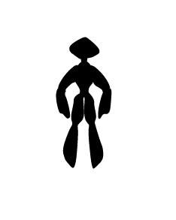4.Fire

5.Lift

How do you plan to make your game engaging?

By making the game difficult but not impossible.As it is an adventure game, I hope that it will be engaging.