**Jacob Rodriguez’s**

**Personal Website**

**Design Document**

1. Some Examples:

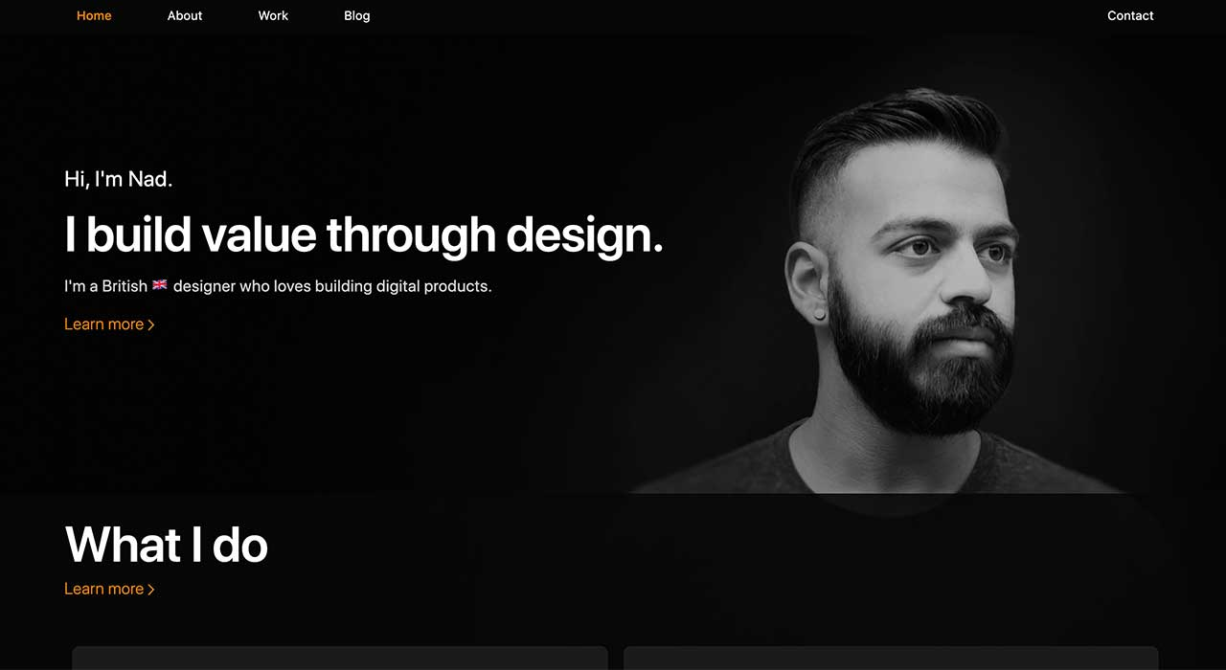

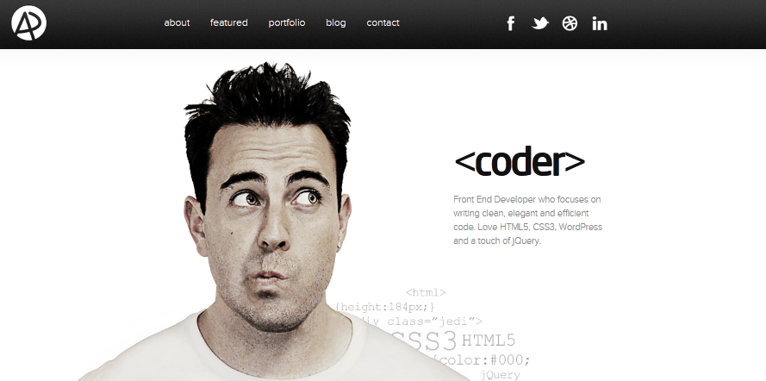

1. GOALS
   1. Showcase my portfolio
   2. Learn web development
   3. Impress potential employers
2. MILESTONES
   1. Basic page up and running
      1. Display information (contacts, resume information)
      2. Profile pictures (professional)
   2. Portfolio Video/Gifs
      1. Include descriptive information underneath
   3. Nice formats
      1. Professional looking
   4. Accessible Online
      1. Domain Name
   5. Feedback and Revisions
3. SCOPE
   1. Pages
      1. Home Page – a page to introduce myself and describe my skillset.
      2. Portfolio page – a page to show videos of my completed projects with descriptions underneath.
   2. Features
      1. Image display of me at the front page
      2. Video elements of each of my projects
      3. Top bar to switch from home page to portfolio page