**Error Generator**

We want to inverse the output when a switch is on but not when it is off.

Error Generator truth table:

|  |  |  |
| --- | --- | --- |
| Input | Error | Out |
| 0 | 0 | 0 |
| 0 | 1 | 1 |
| 1 | 0 | 1 |
| 1 | 1 | 0 |

Can be created using Tri-State buffers and NOT gates:

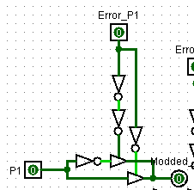

Alternatively, we can use a XOR gate to be more efficient (?)

**“0, C, E” Hex Display using OR (C1,C2,C3,C4) and P5**

Hex Display truth table:

|  |  |  |  |  |  |  |
| --- | --- | --- | --- | --- | --- | --- |
| OR(C1,C2,C3,C4) | P | Hex4 | Hex3 | Hex2 | Hex1 | Hex Representation |
| 0 | 0 | 0 | 0 | 0 | 0 | 0 |
| 0 | 1 | 1 | 1 | 0 | 0 | C |
| 1 | 0 | 1 | 1 | 1 | 0 | E |
| 1 | 1 | 1 | 1 | 0 | 0 | C |

For simplification: OR = OR (C1,C2,C3,C4) and P = P5

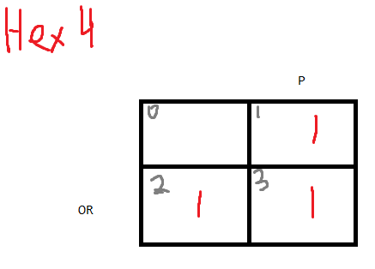

Hex 4 = OR + P

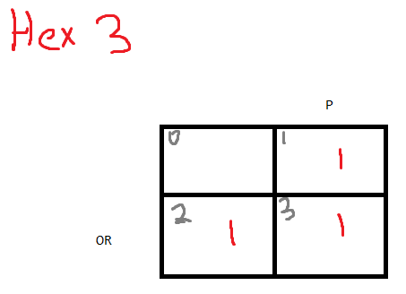

Hex 3 = OR + P

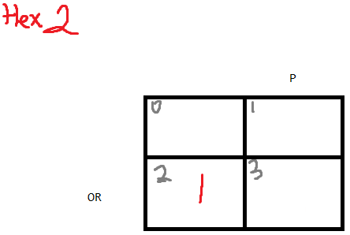

Hex 2 = OR AND P’

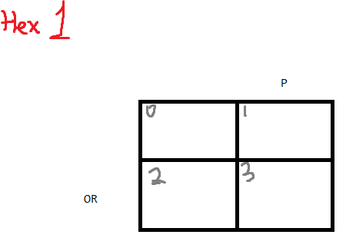

Hex 1 = 0 = Ground

Converted Bits:

