Vulnerability - belief in climate change

Laura

4/12/2021

##exploring how vulnerability varies depending on responses to a few questions regarding belief in climate change and harms that may come from it ##figures saved in vulnerability folder

#load data #need to have run vulnerability code before this

#color paletes  
  
pal3<-pnw_palette(name="Sailboat",n=3,type="discrete")  
pal4<-pnw_palette(name="Sailboat",n=4,type="discrete")  
pal5<-pnw_palette(name="Sailboat",n=5,type="discrete")  
pal6<-pnw_palette(name="Sailboat",n=6,type="discrete")  
pal7<-pnw_palette(name="Sailboat",n=7,type="continuous")

##varibility in vulnerability depending on if you think climate change is happening or not

responses$believecat = responses$believe  
  
responses <- responses %>%   
 mutate(believecat = case_when(  
 believecat == "strongly_agree" ~ "agree",  
 believecat == "somewhat_agree" ~ "agree",  
 believecat == "neutral" ~ "neutral",  
 believecat == "somewhat_disagree" ~ "disagree",   
 believecat == "strongly_disagree" ~ "disagree"))  
  
#components of vulnerability and belief in climate change  
responses %>%  
 group_by(believecat) %>%  
 dplyr::summarise(meanex = mean(indv_exposure, na.rm = TRUE),  
 sdex = sd(indv_exposure, na.rm = TRUE),  
 meansen = mean(indv_sensitivity, na.rm = TRUE),  
 sdsen = sd(indv_sensitivity, na.rm = TRUE),  
 meanac = mean(indv_ac, na.rm = TRUE),  
 sdac = sd(indv_ac, na.rm = TRUE),  
 meanvuln = mean(indv_vulnerability_euc, na.rm = TRUE),  
 sdvuln = sd(indv_vulnerability_euc, na.rm = TRUE),  
 count = n())

## # A tibble: 3 x 10  
## believecat meanex sdex meansen sdsen meanac sdac meanvuln sdvuln count  
## <chr> <dbl> <dbl> <dbl> <dbl> <dbl> <dbl> <dbl> <dbl> <int>  
## 1 agree 0.752 0.218 0.551 0.214 0.425 0.167 1.12 0.248 107  
## 2 disagree 0.543 0.149 0.319 0.191 0.490 0.142 0.831 0.180 26  
## 3 neutral 0.641 0.211 0.534 0.140 0.443 0.186 1.04 0.201 29

belief_vuln<-ggboxplot(responses, x = "believecat", y = "indv_vulnerability_euc",  
 color = "believecat", palette = pal3,  
 order = c("disagree", "neutral", "agree"),  
 ylab = "vulnerability", xlab = "I believe climate change is occuring")  
  
ggsave(plot = belief_vuln, file = paste0("../figures/vulnerability/belief_vuln.png"))  
  
belief_vuln

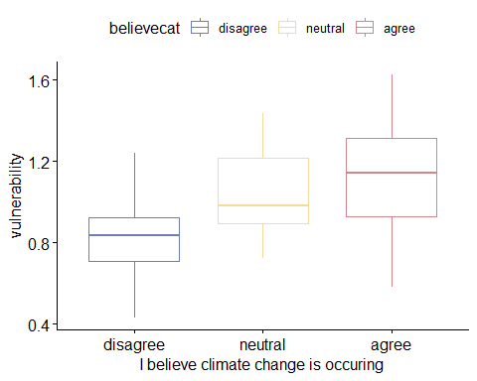 #investigating differences in vulnerability

#anova  
beliefvuln_aov<-aov(indv_vulnerability_euc ~ believecat, data = responses)  
summary(beliefvuln_aov)

## Df Sum Sq Mean Sq F value Pr(>F)   
## believecat 2 1.668 0.8341 15.58 0.000000685 ***  
## Residuals 155 8.300 0.0535   
## ---  
## Signif. codes: 0 '***' 0.001 '**' 0.01 '*' 0.05 '.' 0.1 ' ' 1  
## 4 observations deleted due to missingness

#tukey HSD of vulnerability  
beliefvuln_tukey<-TukeyHSD(beliefvuln_aov)  
beliefvuln_tukey

## Tukey multiple comparisons of means  
## 95% family-wise confidence level  
##   
## Fit: aov(formula = indv_vulnerability_euc ~ believecat, data = responses)  
##   
## $believecat  
## diff lwr upr p adj  
## disagree-agree -0.29049234 -0.41417479 -0.16680988 0.0000003  
## neutral-agree -0.07829022 -0.19622681 0.03964638 0.2613115  
## neutral-disagree 0.21220212 0.05857512 0.36582912 0.0037866

#test for assumptions about anovas  
#this is the only place this is coded but should be added where ever the stats may be used outside of exploration  
  
#are the variances homogenous?  
plot(beliefvuln_aov, 1)

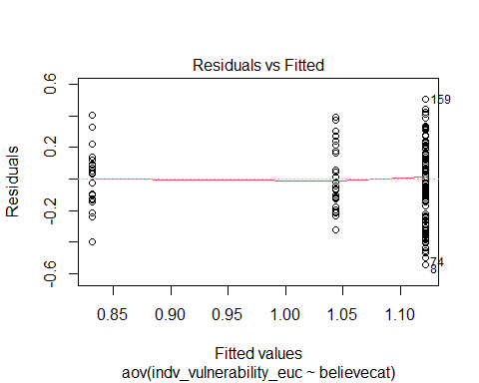

leveneTest(indv_vulnerability_euc ~ believecat, data = responses)

## Levene's Test for Homogeneity of Variance (center = median)  
## Df F value Pr(>F)   
## group 2 3.5189 0.03202 *  
## 155   
## ---  
## Signif. codes: 0 '***' 0.001 '**' 0.01 '*' 0.05 '.' 0.1 ' ' 1

#if not, use welch one way test  
  
oneway.test(indv_vulnerability_euc ~ believecat, data = responses)

##   
## One-way analysis of means (not assuming equal variances)  
##   
## data: indv_vulnerability_euc and believecat  
## F = 21.734, num df = 2.000, denom df = 52.112, p-value = 0.0000001368

#pairwise t.test with no assumption of equal variances  
pairwise.t.test(responses$indv_vulnerability_euc, responses$believecat,  
 p.adjust.method = "BH", pool.sd = FALSE)

##   
## Pairwise comparisons using t tests with non-pooled SD   
##   
## data: responses$indv_vulnerability_euc and responses$believecat   
##   
## agree disagree  
## disagree 0.00000011 -   
## neutral 0.09163 0.00034   
##   
## P value adjustment method: BH

#is the data normally distributed?  
plot(beliefvuln_aov, 2)

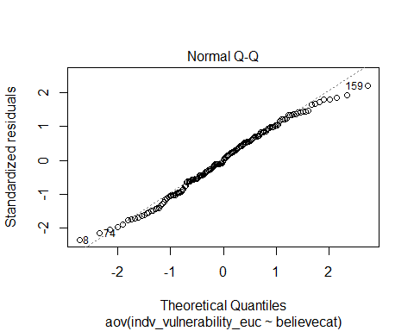

#confirm with shapiro-wilk test on anova residuals  
  
# Extract the residuals  
aov_residuals <- residuals(object = beliefvuln_aov )  
# Run Shapiro-Wilk test  
shapiro.test(x = aov_residuals )

##   
## Shapiro-Wilk normality test  
##   
## data: aov_residuals  
## W = 0.9881, p-value = 0.2

kruskal.test(indv_vulnerability_euc ~ believecat, data = responses)

##   
## Kruskal-Wallis rank sum test  
##   
## data: indv_vulnerability_euc by believecat  
## Kruskal-Wallis chi-squared = 25.807, df = 2, p-value = 0.000002489

pairwise.wilcox.test(responses$indv_vulnerability_euc, responses$believecat,  
 p.adjust.method = "BH")

##   
## Pairwise comparisons using Wilcoxon rank sum test with continuity correction   
##   
## data: responses$indv_vulnerability_euc and responses$believecat   
##   
## agree disagree  
## disagree 0.0000039 -   
## neutral 0.0989 0.0005   
##   
## P value adjustment method: BH

#can use the kruskal-wallis test if normality assumption is not met  
#repeat for any stats that will appear in results  
  
#anova exposure  
beliefex_aov<-aov(indv_exposure ~ believecat, data = responses)  
summary(beliefex_aov)

## Df Sum Sq Mean Sq F value Pr(>F)   
## believecat 2 0.970 0.4849 11.18 0.0000292 ***  
## Residuals 155 6.725 0.0434   
## ---  
## Signif. codes: 0 '***' 0.001 '**' 0.01 '*' 0.05 '.' 0.1 ' ' 1  
## 4 observations deleted due to missingness

#tukey HSD of exposure  
beliefex_tukey<-TukeyHSD(beliefex_aov)  
beliefex_tukey

## Tukey multiple comparisons of means  
## 95% family-wise confidence level  
##   
## Fit: aov(formula = indv_exposure ~ believecat, data = responses)  
##   
## $believecat  
## diff lwr upr p adj  
## disagree-agree -0.20860221 -0.31993009 -0.097274331 0.0000516  
## neutral-agree -0.11045406 -0.21661003 -0.004298091 0.0393354  
## neutral-disagree 0.09814815 -0.04013313 0.236429426 0.2162568

#agree different than both, neutal and disagree not different  
  
leveneTest(indv_exposure ~ believecat, data = responses)

## Levene's Test for Homogeneity of Variance (center = median)  
## Df F value Pr(>F)   
## group 2 4.1277 0.01793 *  
## 155   
## ---  
## Signif. codes: 0 '***' 0.001 '**' 0.01 '*' 0.05 '.' 0.1 ' ' 1

#exposure fails variance assumption, run one way test  
  
oneway.test(indv_exposure ~ believecat, data = responses)

##   
## One-way analysis of means (not assuming equal variances)  
##   
## data: indv_exposure and believecat  
## F = 16.084, num df = 2.000, denom df = 51.174, p-value = 0.000003805

#is the data normally distributed?  
plot(beliefex_aov, 2)

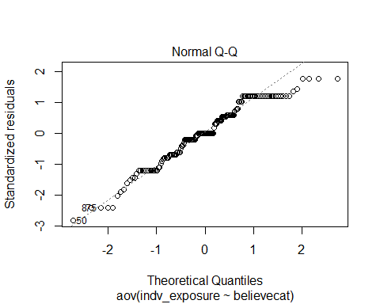

#confirm with shapiro-wilk test on anova residuals  
  
# Extract the residuals  
aov_residuals <- residuals(object = beliefex_aov )  
# Run Shapiro-Wilk test  
shapiro.test(x = aov_residuals )

##   
## Shapiro-Wilk normality test  
##   
## data: aov_residuals  
## W = 0.95823, p-value = 0.0001097

#normality is violated, run kruskal-wallis  
kruskal.test(indv_exposure ~ believecat, data = responses)

##   
## Kruskal-Wallis rank sum test  
##   
## data: indv_exposure by believecat  
## Kruskal-Wallis chi-squared = 22.558, df = 2, p-value = 0.00001264

pairwise.wilcox.test(responses$indv_exposure, responses$believecat,  
 p.adjust.method = "BH")

##   
## Pairwise comparisons using Wilcoxon rank sum test with continuity correction   
##   
## data: responses$indv_exposure and responses$believecat   
##   
## agree disagree  
## disagree 0.000028 -   
## neutral 0.017 0.112   
##   
## P value adjustment method: BH

#anova of sensitivity  
beliefsen_aov<-aov(indv_sensitivity ~ believecat, data = responses)  
summary(beliefsen_aov)

## Df Sum Sq Mean Sq F value Pr(>F)   
## believecat 2 1.142 0.5712 14.39 0.0000018 ***  
## Residuals 159 6.310 0.0397   
## ---  
## Signif. codes: 0 '***' 0.001 '**' 0.01 '*' 0.05 '.' 0.1 ' ' 1

#tukey HSD of sensitivity  
beliefsen_tukey<-TukeyHSD(beliefsen_aov)  
beliefsen_tukey

## Tukey multiple comparisons of means  
## 95% family-wise confidence level  
##   
## Fit: aov(formula = indv_sensitivity ~ believecat, data = responses)  
##   
## $believecat  
## diff lwr upr p adj  
## disagree-agree -0.23169782 -0.33475143 -0.12864421 0.0000010  
## neutral-agree -0.01665951 -0.11533164 0.08201263 0.9158617  
## neutral-disagree 0.21503831 0.08774323 0.34233340 0.0002878

#neutral and agree the same, both different than disagree  
  
#check assumptions  
leveneTest(indv_sensitivity ~ believecat, data = responses)

## Levene's Test for Homogeneity of Variance (center = median)  
## Df F value Pr(>F)   
## group 2 3.3075 0.03914 *  
## 159   
## ---  
## Signif. codes: 0 '***' 0.001 '**' 0.01 '*' 0.05 '.' 0.1 ' ' 1

#is the data normally distributed?  
plot(beliefsen_aov, 2)

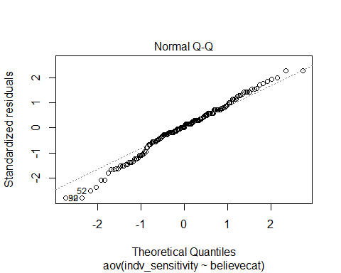

#confirm with shapiro-wilk test on anova residuals  
  
# Extract the residuals  
aov_residuals <- residuals(object = beliefsen_aov )  
# Run Shapiro-Wilk test  
shapiro.test(x = aov_residuals )

##   
## Shapiro-Wilk normality test  
##   
## data: aov_residuals  
## W = 0.98515, p-value = 0.08147

#sensitivity doesnt home homogeneous variance but is normally distributed  
  
kruskal.test(indv_sensitivity ~ believecat, data = responses)

##   
## Kruskal-Wallis rank sum test  
##   
## data: indv_sensitivity by believecat  
## Kruskal-Wallis chi-squared = 25.033, df = 2, p-value = 0.000003665

pairwise.wilcox.test(responses$indv_sensitivity, responses$believecat,  
 p.adjust.method = "BH")

##   
## Pairwise comparisons using Wilcoxon rank sum test with continuity correction   
##   
## data: responses$indv_sensitivity and responses$believecat   
##   
## agree disagree   
## disagree 0.0000084 -   
## neutral 0.26 0.0000273  
##   
## P value adjustment method: BH

#anova of adaptive capacity  
beliefac_aov<-aov(indv_ac ~ believecat, data = responses)  
summary(beliefac_aov)

## Df Sum Sq Mean Sq F value Pr(>F)  
## believecat 2 0.090 0.04476 1.609 0.203  
## Residuals 159 4.423 0.02782

#tukey HSD of ac  
beliefac_tukey<-TukeyHSD(beliefac_aov)  
beliefac_tukey

## Tukey multiple comparisons of means  
## 95% family-wise confidence level  
##   
## Fit: aov(formula = indv_ac ~ believecat, data = responses)  
##   
## $believecat  
## diff lwr upr p adj  
## disagree-agree 0.06515097 -0.02112254 0.15142448 0.1773510  
## neutral-agree 0.01825295 -0.06435252 0.10085841 0.8603254  
## neutral-disagree -0.04689803 -0.15346579 0.05966974 0.5520752

#check assumptions  
leveneTest(indv_ac ~ believecat, data = responses)

## Levene's Test for Homogeneity of Variance (center = median)  
## Df F value Pr(>F)  
## group 2 1.4552 0.2364  
## 159

#is the data normally distributed?  
plot(beliefac_aov, 2)

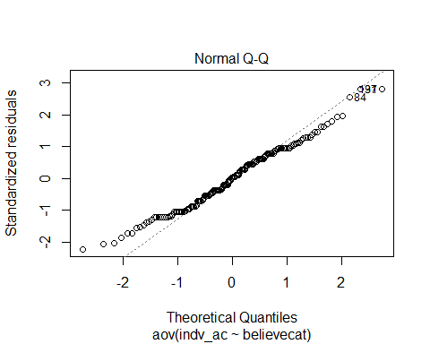

#confirm with shapiro-wilk test on anova residuals  
  
# Extract the residuals  
aov_residuals <- residuals(object = beliefac_aov )  
# Run Shapiro-Wilk test  
shapiro.test(x = aov_residuals)

##   
## Shapiro-Wilk normality test  
##   
## data: aov_residuals  
## W = 0.98432, p-value = 0.06445

#ac meets assumptions  
  
kruskal.test(indv_ac ~ believecat, data = responses)

##   
## Kruskal-Wallis rank sum test  
##   
## data: indv_ac by believecat  
## Kruskal-Wallis chi-squared = 3.2861, df = 2, p-value = 0.1934

pairwise.wilcox.test(responses$indv_ac, responses$believecat,  
 p.adjust.method = "BH")

##   
## Pairwise comparisons using Wilcoxon rank sum test with continuity correction   
##   
## data: responses$indv_ac and responses$believecat   
##   
## agree disagree  
## disagree 0.20 -   
## neutral 0.59 0.54   
##   
## P value adjustment method: BH

#rideline plots of belief and compoents of vulnerability

be<-ggplot(responses, aes(x = indv_exposure, y = believecat, fill = believecat)) +  
 geom_density_ridges(rel_min_height = 0.01, scale = 2.5) +  
 scale_fill_manual(values = pal3)+  
 xlim(0,1) +  
 theme_ridges() +   
 ggtitle("Exposure")+  
 theme(legend.position = "none", axis.title = element_blank())  
  
bs<-ggplot(responses, aes(x = indv_sensitivity, y = believecat, fill = believecat)) +  
 geom_density_ridges(rel_min_height = 0.01, scale = 2.5) +  
 scale_fill_manual(values = pal3)+  
 xlim(0,1) +  
 theme_ridges() +   
 ggtitle("Sensitivity")+  
 theme(legend.position = "none", axis.title = element_blank())  
  
bac<-ggplot(responses, aes(x = indv_ac, y = believecat, fill = believecat)) +  
 geom_density_ridges(rel_min_height = 0.01, scale = 2.5) +  
 scale_fill_manual(values = pal3)+  
 xlim(0,1) +  
 theme_ridges() +   
 ggtitle("Adaptive Capacity") +  
 theme(legend.position = "none", axis.title = element_blank())  
  
bv<-ggplot(responses, aes(x = indv_vulnerability_euc, y = believecat, fill = believecat)) +  
 geom_density_ridges(rel_min_height = 0.01, scale = 2.5) +  
 scale_fill_manual(values = pal3)+  
 xlim(0,2) +  
 theme_ridges() +   
 ggtitle("Vulnerability")+  
 theme(legend.position = "none", axis.title = element_blank())  
  
bc<-grid.arrange(be, bs, bac, bv, nrow = 2)

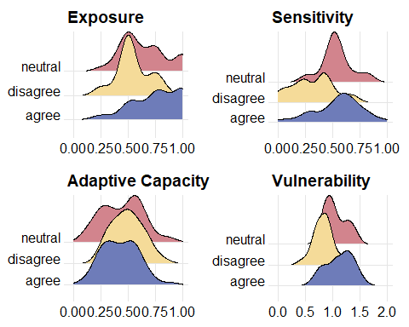

ggsave(plot = bc, file = paste0("../figures/vulnerability/belief_components.png"))

#does belief in climate change vary by fishery?

## cps dungycrab gf hake hms salmon scallops urchin shrimp squid other  
## agree 4 44 25 3 35 73 2 16 9 3 27  
## disagree 1 11 7 0 12 15 0 1 0 0 4  
## neutral 2 9 7 0 6 23 0 0 2 2 6

##   
## Pearson's Chi-squared test  
##   
## data: believe_fishery  
## X-squared = 18.868, df = 20, p-value = 0.5304

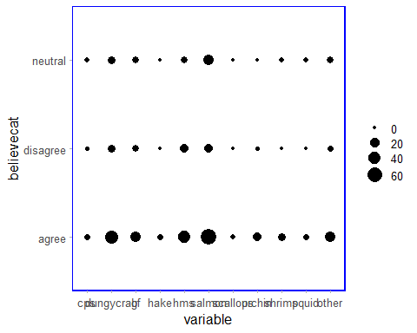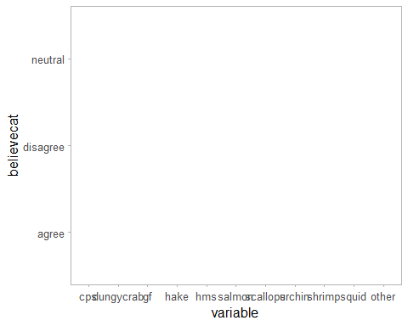

#density plots of overall perceived vulnerability and by responses to I believe that climate change is occuring #plots for tnc talk 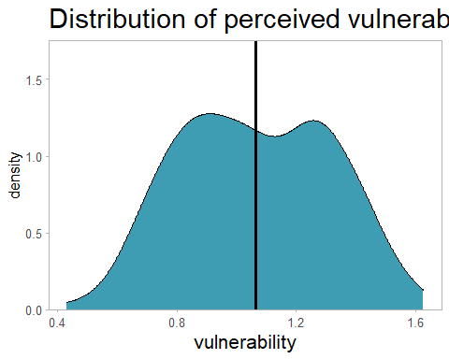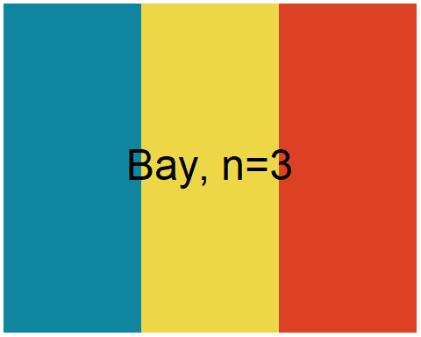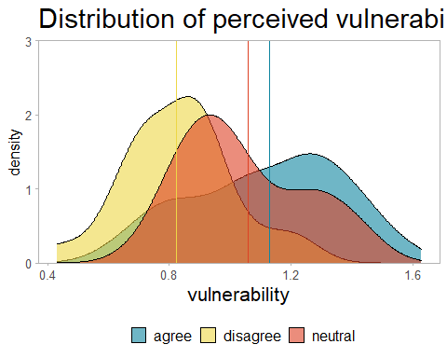

##likert questions about climate and future of fishing ##group by how they responded to first question about believing in climate change

## Group  
## 1 agree  
## 2 agree  
## 3 agree  
## 4 agree  
## 5 agree  
## 6 agree  
## 7 disagree  
## 8 disagree  
## 9 disagree  
## 10 disagree  
## 11 disagree  
## 12 disagree  
## 13 neutral  
## 14 neutral  
## 15 neutral  
## 16 neutral  
## 17 neutral  
## 18 neutral  
## Item  
## 1 Climate change will harm me personally  
## 2 Climate change will harm future generations  
## 3 If I had a choice I would leave fishing  
## 4 It is a big risk to move into a new fishery  
## 5 There is no point in preparing for climate change since we don't know exactly what is going to happen  
## 6 There will not be enough fish to continue to operate in my main fishery in 20 years  
## 7 Climate change will harm me personally  
## 8 Climate change will harm future generations  
## 9 If I had a choice I would leave fishing  
## 10 It is a big risk to move into a new fishery  
## 11 There is no point in preparing for climate change since we don't know exactly what is going to happen  
## 12 There will not be enough fish to continue to operate in my main fishery in 20 years  
## 13 Climate change will harm me personally  
## 14 Climate change will harm future generations  
## 15 If I had a choice I would leave fishing  
## 16 It is a big risk to move into a new fishery  
## 17 There is no point in preparing for climate change since we don't know exactly what is going to happen  
## 18 There will not be enough fish to continue to operate in my main fishery in 20 years  
## low neutral high mean sd  
## 1 11.214953 18.691589 70.09346 3.981308 1.0987240  
## 2 6.542056 4.672897 88.78505 4.429907 0.8913859  
## 3 58.878505 12.149533 28.97196 2.327103 1.5158017  
## 4 13.084112 14.953271 71.96262 3.971963 1.1611473  
## 5 71.962617 10.280374 17.75701 2.149533 1.2270823  
## 6 33.644860 18.691589 47.66355 3.177570 1.4262570  
## 7 76.923077 23.076923 0.00000 1.769231 0.8152395  
## 8 69.230769 30.769231 0.00000 1.807692 0.8952868  
## 9 65.384615 11.538462 23.07692 2.153846 1.6417627  
## 10 15.384615 19.230769 65.38462 3.807692 1.2655190  
## 11 7.692308 30.769231 61.53846 3.846154 1.1896994  
## 12 69.230769 11.538462 19.23077 2.076923 1.3541958  
## 13 10.344828 79.310345 10.34483 3.068966 0.6508804  
## 14 17.241379 62.068966 20.68966 3.068966 0.7036149  
## 15 68.965517 17.241379 13.79310 2.000000 1.2817399  
## 16 10.344828 17.241379 72.41379 3.965517 0.9813532  
## 17 10.344828 55.172414 34.48276 3.310345 0.8905636  
## 18 34.482759 41.379310 24.13793 2.793103 1.3196133

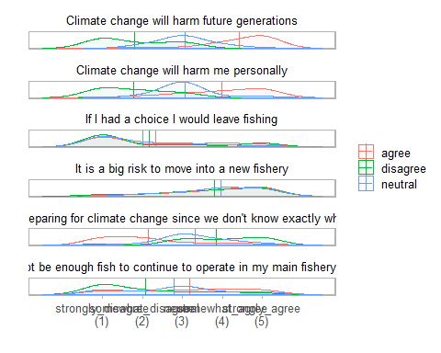

##scatterplot of vulnerability depending on your belief in climate change 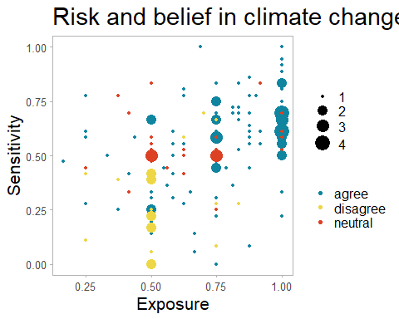

##   
## Call:  
## lm(formula = risk_euc ~ indv_ac, data = responses, subset = believecat ==   
## "agree")  
##   
## Coefficients:  
## (Intercept) indv_ac   
## 1.1821 -0.5442

##   
## Call:  
## lm(formula = risk_euc ~ inverse_ac * believecat, data = responses)  
##   
## Coefficients:  
## (Intercept) inverse_ac   
## 0.6379 0.5442   
## believecatdisagree believecatneutral   
## -0.1386 0.1071   
## inverse_ac:believecatdisagree inverse_ac:believecatneutral   
## -0.2497 -0.3505

## Analysis of Variance Table  
##   
## Response: risk_euc  
## Df Sum Sq Mean Sq F value Pr(>F)   
## inverse_ac 1 1.2307 1.23073 27.1989 0.0000005912 ***  
## believecat 2 1.4562 0.72810 16.0907 0.0000004586 ***  
## inverse_ac:believecat 2 0.0948 0.04738 1.0472 0.3534   
## Residuals 152 6.8779 0.04525   
## ---  
## Signif. codes: 0 '***' 0.001 '**' 0.01 '*' 0.05 '.' 0.1 ' ' 1

## believecat inverse_ac.trend SE df lower.CL upper.CL  
## agree 0.544 0.124 152 0.299 0.789  
## disagree 0.294 0.306 152 -0.311 0.900  
## neutral 0.194 0.228 152 -0.257 0.644  
##   
## Confidence level used: 0.95

## contrast estimate SE df t.ratio p.value  
## agree - disagree 0.250 0.331 152 0.755 0.7308   
## agree - neutral 0.351 0.260 152 1.350 0.3700   
## disagree - neutral 0.101 0.382 152 0.264 0.9624   
##   
## P value adjustment: tukey method for comparing a family of 3 estimates

##varibility in vulnerability depending on if you think you will be harmed by climate change personally

responses$harmcat = responses$harm_me  
  
responses <- responses %>%   
 mutate(harmcat = case_when(  
 harmcat == "strongly_agree" ~ "agree",  
 harmcat == "somewhat_agree" ~ "agree",  
 harmcat == "neutral" ~ "neutral",  
 harmcat == "somewhat_disagree" ~ "disagree",   
 harmcat == "strongly_disagree" ~ "disagree"))  
  
#components of vulnerability and belief in climate change  
responses %>%  
 group_by(harmcat) %>%  
 dplyr::summarise(meanex = mean(indv_exposure, na.rm = TRUE),  
 sdex = sd(indv_exposure, na.rm = TRUE),  
 meansen = mean(indv_sensitivity, na.rm = TRUE),  
 sdsen = sd(indv_sensitivity, na.rm = TRUE),  
 meanac = mean(indv_ac, na.rm = TRUE),  
 sdac = sd(indv_ac, na.rm = TRUE),  
 meanvuln = mean(indv_vulnerability_euc, na.rm = TRUE),  
 sdvuln = sd(indv_vulnerability_euc, na.rm = TRUE),  
 count = n())

## # A tibble: 3 x 10  
## harmcat meanex sdex meansen sdsen meanac sdac meanvuln sdvuln count  
## <chr> <dbl> <dbl> <dbl> <dbl> <dbl> <dbl> <dbl> <dbl> <int>  
## 1 agree 0.809 0.190 0.599 0.192 0.389 0.160 1.20 0.212 78  
## 2 disagree 0.556 0.136 0.341 0.186 0.497 0.164 0.851 0.183 35  
## 3 neutral 0.625 0.232 0.492 0.194 0.477 0.160 0.992 0.220 49

harm_vuln<-ggboxplot(responses, x = "harmcat", y = "indv_vulnerability_euc",  
 color = "harmcat", palette = c("#00AFBB", "#E7B800", "#FC4E07"),  
 order = c("disagree", "neutral", "agree"),  
 ylab = "vulnerability", xlab = "Climate change will harm me personally")  
  
harm_vuln

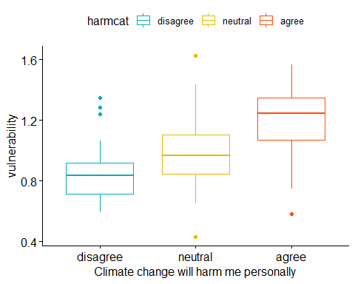

ggsave(plot = belief_vuln, file = paste0("../figures/vulnerability/harm_vuln.png"))  
  
#anova of vulnerabilty  
harmvuln_aov<-aov(indv_vulnerability_euc ~ harmcat, data = responses)  
summary(harmvuln_aov)

## Df Sum Sq Mean Sq F value Pr(>F)   
## harmcat 2 3.225 1.6125 37.06 0.0000000000000699 ***  
## Residuals 155 6.743 0.0435   
## ---  
## Signif. codes: 0 '***' 0.001 '**' 0.01 '*' 0.05 '.' 0.1 ' ' 1  
## 4 observations deleted due to missingness

#tukey HSD of vulnerability  
harmvuln_tukey<-TukeyHSD(harmvuln_aov)  
harmvuln_tukey

## Tukey multiple comparisons of means  
## 95% family-wise confidence level  
##   
## Fit: aov(formula = indv_vulnerability_euc ~ harmcat, data = responses)  
##   
## $harmcat  
## diff lwr upr p adj  
## disagree-agree -0.3489912 -0.4504268 -0.2475555 0.0000000  
## neutral-agree -0.2082105 -0.2999705 -0.1164506 0.0000008  
## neutral-disagree 0.1407806 0.0291470 0.2524142 0.0092125

#each group is different  
  
#anova exposure  
harmex_aov<-aov(indv_exposure ~ harmcat, data = responses)  
summary(harmex_aov)

## Df Sum Sq Mean Sq F value Pr(>F)   
## harmcat 2 1.896 0.9480 25.34 0.0000000003 ***  
## Residuals 155 5.798 0.0374   
## ---  
## Signif. codes: 0 '***' 0.001 '**' 0.01 '*' 0.05 '.' 0.1 ' ' 1  
## 4 observations deleted due to missingness

#tukey HSD of exposure  
harmex_tukey<-TukeyHSD(harmex_aov)  
harmex_tukey

## Tukey multiple comparisons of means  
## 95% family-wise confidence level  
##   
## Fit: aov(formula = indv_exposure ~ harmcat, data = responses)  
##   
## $harmcat  
## diff lwr upr p adj  
## disagree-agree -0.25338963 -0.3474502 -0.15932908 0.0000000  
## neutral-agree -0.18427198 -0.2693603 -0.09918367 0.0000026  
## neutral-disagree 0.06911765 -0.0343994 0.17263469 0.2573073

#agree different than both, neutal and disagree not different  
  
#anova of sensitivity  
harmsen_aov<-aov(indv_sensitivity ~ harmcat, data = responses)  
summary(harmsen_aov)

## Df Sum Sq Mean Sq F value Pr(>F)   
## harmcat 2 1.630 0.8150 22.25 0.00000000301 ***  
## Residuals 159 5.823 0.0366   
## ---  
## Signif. codes: 0 '***' 0.001 '**' 0.01 '*' 0.05 '.' 0.1 ' ' 1

#tukey HSD of sensitivity  
harmsen_tukey<-TukeyHSD(harmsen_aov)  
harmsen_tukey

## Tukey multiple comparisons of means  
## 95% family-wise confidence level  
##   
## Fit: aov(formula = indv_sensitivity ~ harmcat, data = responses)  
##   
## $harmcat  
## diff lwr upr p adj  
## disagree-agree -0.2577330 -0.34984477 -0.1656212 0.0000000  
## neutral-agree -0.1069394 -0.18946971 -0.0244090 0.0071675  
## neutral-disagree 0.1507937 0.05059433 0.2509930 0.0014117

#neutral and agree the same, both different than disagree  
  
#anova of adaptive capacity  
harmac_aov<-aov(indv_ac ~ harmcat, data = responses)  
summary(harmac_aov)

## Df Sum Sq Mean Sq F value Pr(>F)   
## harmcat 2 0.385 0.19243 7.413 0.000835 ***  
## Residuals 159 4.127 0.02596   
## ---  
## Signif. codes: 0 '***' 0.001 '**' 0.01 '*' 0.05 '.' 0.1 ' ' 1

#tukey HSD of vulnerability  
harmac_tukey<-TukeyHSD(harmac_aov)  
harmac_tukey

## Tukey multiple comparisons of means  
## 95% family-wise confidence level  
##   
## Fit: aov(formula = indv_ac ~ harmcat, data = responses)  
##   
## $harmcat  
## diff lwr upr p adj  
## disagree-agree 0.10793651 0.03038697 0.18548605 0.0034830  
## neutral-agree 0.08843537 0.01895249 0.15791826 0.0084645  
## neutral-disagree -0.01950113 -0.10385965 0.06485738 0.8482015

#most demographics dont seem to matter, how does fishery impact feeling like you may be harmed by climate change?

##   
## Pearson's Chi-squared test  
##   
## data: harm_fishery_sum  
## X-squared = 16.724, df = 20, p-value = 0.6708

#density plots of overall perceived vulnerability and by belief of being harmed by climate change 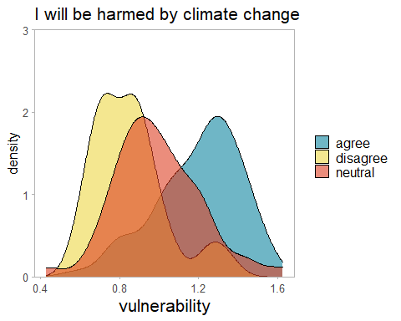

##so what are the differences between those that think they will be harmed by climate change and the whole group?

#is there a difference in the mean vulnerability of the agree believe group and the will be harmed group?  
aa<- responses %>%  
 select(harmcat, believecat, indv_vulnerability_euc)  
  
ab<- aa %>%  
 filter(harmcat =="agree")  
  
ac<- aa%>%  
 filter(believecat == "agree")  
  
t.test(ab$indv_vulnerability_euc, ac$indv_vulnerability_euc)

##   
## Welch Two Sample t-test  
##   
## data: ab$indv_vulnerability_euc and ac$indv_vulnerability_euc  
## t = 2.3051, df = 178.22, p-value = 0.02231  
## alternative hypothesis: true difference in means is not equal to 0  
## 95 percent confidence interval:  
## 0.01125572 0.14517126  
## sample estimates:  
## mean of x mean of y   
## 1.199984 1.121770

#subset of those who feel they will be harmed by climate change  
harmed<- responses%>%  
 filter(harmcat == "agree")   
  
responses$harm_binary = responses$harmcat  
  
responses <- responses %>%   
 mutate(harm_binary = case_when(  
 harmcat == "agree" ~ "1",  
 harmcat == "neutral" ~ "0",  
 harmcat == "disagree" ~ "0"))  
  
#summary of age by response all 3 categories  
table(responses$harmcat, responses$age)

##   
## 30-40 40-50 50-60 60-70 70+ U30  
## agree 12 8 14 22 17 5  
## disagree 2 6 11 9 6 1  
## neutral 5 7 8 13 14 2

#visualize above  
ggplot(responses) +  
 aes(x = harmcat, fill = age) +  
 geom_bar() +  
 scale_fill_hue() +  
 theme_minimal()

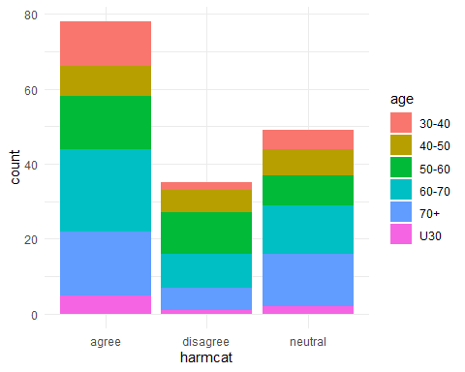

#chi squared test, is there difference in ages between responses  
age_test<-chisq.test(table(responses$harmcat, responses$age))  
age_test

##   
## Pearson's Chi-squared test  
##   
## data: table(responses$harmcat, responses$age)  
## X-squared = 7.79, df = 10, p-value = 0.6493

#no difference  
  
#if its just harm vs both others  
#summary of age by response all 3 categories  
table(responses$harm_binary, responses$age)

##   
## 30-40 40-50 50-60 60-70 70+ U30  
## 0 7 13 19 22 20 3  
## 1 12 8 14 22 17 5

#visualize above  
ggplot(responses) +  
 aes(x = harm_binary, fill = age) +  
 geom_bar() +  
 scale_fill_hue() +  
 theme_minimal()

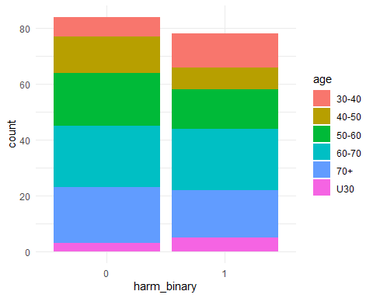

#chi squared test, is there difference in ages between responses  
age_test2<-chisq.test(table(responses$harm_binary, responses$age))  
age_test2

##   
## Pearson's Chi-squared test  
##   
## data: table(responses$harm_binary, responses$age)  
## X-squared = 3.7901, df = 5, p-value = 0.58

#state that they live in?  
table(responses$harmcat, responses$state_code)

##   
## CA OR WA  
## agree 21 13 44  
## disagree 5 9 21  
## neutral 10 9 30

state_test<-(chisq.test(responses$harmcat, responses$state_code))  
state_test

##   
## Pearson's Chi-squared test  
##   
## data: responses$harmcat and responses$state_code  
## X-squared = 3.0284, df = 4, p-value = 0.5531

state_test2<-(chisq.test(responses$harm_binary, responses$state_code))  
state_test2

##   
## Pearson's Chi-squared test  
##   
## data: responses$harm_binary and responses$state_code  
## X-squared = 2.1029, df = 2, p-value = 0.3494

#region they fish in?  
#need to maybe get this to be one region instead of list  
table(responses$harmcat, responses$listofregions)

##   
## Cen Cal Cen Cal, So Cal Columbia River Columbia River, OR coast  
## agree 2 1 8 2  
## disagree 0 0 4 1  
## neutral 1 0 6 1  
##   
## Columbia River, OR coast, Cen Cal  
## agree 0  
## disagree 0  
## neutral 1  
##   
## Columbia River, OR coast, Nor Cal, Cen Cal Nor Cal Nor Cal, Cen Cal  
## agree 1 1 2  
## disagree 0 1 2  
## neutral 1 1 0  
##   
## OR coast OR coast, Nor Cal OR coast, Nor Cal, Cen Cal  
## agree 9 1 3  
## disagree 4 1 0  
## neutral 6 0 0  
##   
## OR coast, So Cal Puget Sound SJF Puget Sound SJF, Cen Cal, So Cal  
## agree 0 16 1  
## disagree 0 7 0  
## neutral 1 7 1  
##   
## Puget Sound SJF, Columbia River  
## agree 1  
## disagree 0  
## neutral 1  
##   
## Puget Sound SJF, Columbia River, OR coast Puget Sound SJF, OR coast  
## agree 1 1  
## disagree 0 1  
## neutral 0 0  
##   
## Puget Sound SJF, WA coast Puget Sound SJF, WA coast, Columbia River  
## agree 1 2  
## disagree 3 1  
## neutral 2 1  
##   
## Puget Sound SJF, WA coast, Columbia River, OR coast So Cal WA coast  
## agree 1 4 3  
## disagree 0 1 5  
## neutral 0 0 10  
##   
## WA coast, Columbia River WA coast, Columbia River, OR coast  
## agree 3 4  
## disagree 0 1  
## neutral 3 2  
##   
## WA coast, Columbia River, OR coast, Nor Cal  
## agree 1  
## disagree 2  
## neutral 0  
##   
## WA coast, Columbia River, OR coast, Nor Cal, Cen Cal  
## agree 0  
## disagree 0  
## neutral 1  
##   
## WA coast, Columbia River, OR coast, Nor Cal, Cen Cal, So Cal  
## agree 1  
## disagree 0  
## neutral 0  
##   
## WA coast, OR coast WA coast, OR coast, Nor Cal  
## agree 8 0  
## disagree 1 0  
## neutral 1 1  
##   
## WA coast, OR coast, Nor Cal, Cen Cal  
## agree 0  
## disagree 0  
## neutral 1

region_test<-(chisq.test(responses$harmcat, responses$listofregions))  
region_test

##   
## Pearson's Chi-squared test  
##   
## data: responses$harmcat and responses$listofregions  
## X-squared = 52.916, df = 58, p-value = 0.6643

region_test2<-(chisq.test(responses$harm_binary, responses$listofregions))  
region_test2

##   
## Pearson's Chi-squared test  
##   
## data: responses$harm_binary and responses$listofregions  
## X-squared = 29.436, df = 29, p-value = 0.4425

#something about this doesnt work with knitr but the code works

#more tests

#income from outside fishing?  
table(responses$harmcat, responses$income)

##   
## 10-25 25-50 50+ none U10  
## agree 6 5 20 27 20  
## disagree 2 3 11 13 6  
## neutral 2 6 15 18 8

income_test<-(chisq.test(responses$harmcat, responses$income))  
income_test

##   
## Pearson's Chi-squared test  
##   
## data: responses$harmcat and responses$income  
## X-squared = 3.8618, df = 8, p-value = 0.8694

income_test2<-(chisq.test(responses$harm_binary, responses$income))  
income_test2

##   
## Pearson's Chi-squared test  
##   
## data: responses$harm_binary and responses$income  
## X-squared = 3.4427, df = 4, p-value = 0.4867

#years fishing?  
table(responses$harmcat, responses$yrs_fishing)

##   
## 0-5 15-25 25+ 5-15  
## agree 2 9 51 16  
## disagree 3 5 24 3  
## neutral 5 4 33 7

(chisq.test(responses$harmcat, responses$yrs_fishing))

##   
## Pearson's Chi-squared test  
##   
## data: responses$harmcat and responses$yrs_fishing  
## X-squared = 6.2996, df = 6, p-value = 0.3905

(chisq.test(responses$harm_binary, responses$yrs_fishing))

##   
## Pearson's Chi-squared test  
##   
## data: responses$harm_binary and responses$yrs_fishing  
## X-squared = 5.1027, df = 3, p-value = 0.1644

#industry role?  
table(responses$harmcat, responses$captain)

##   
## 0 1  
## agree 13 65  
## disagree 3 32  
## neutral 12 37

(chisq.test(responses$harmcat, responses$captain))

##   
## Pearson's Chi-squared test  
##   
## data: responses$harmcat and responses$captain  
## X-squared = 3.6588, df = 2, p-value = 0.1605

#who are the people that believe in climate change but dont think they’ll be harmed

#add column, 1 for those who believe in climate change but don't think they will be harmed by it  
responses$bnh = as.numeric(NA, length(nrow(responses)))  
  
responses <- responses %>%   
 mutate(bnh = case_when(  
 harmcat != "agree" & believecat =="agree" ~ "1",  
 harmcat == "agree" ~ "0",  
 believecat == "neutral" ~ "0",  
 believecat == "disagree" ~ "0"))  
  
#do they just think they're better able to adapt?  
t.test(responses$indv_vulnerability_euc ~ responses$bnh)

##   
## Welch Two Sample t-test  
##   
## data: responses$indv_vulnerability_euc by responses$bnh  
## t = 3.9943, df = 53.782, p-value = 0.0001985  
## alternative hypothesis: true difference in means is not equal to 0  
## 95 percent confidence interval:  
## 0.08789454 0.26508411  
## sample estimates:  
## mean in group 0 mean in group 1   
## 1.1000108 0.9235214

t.test(responses$indv_ac ~ responses$bnh)

##   
## Welch Two Sample t-test  
##   
## data: responses$indv_ac by responses$bnh  
## t = -3.0719, df = 48.937, p-value = 0.003469  
## alternative hypothesis: true difference in means is not equal to 0  
## 95 percent confidence interval:  
## -0.15983077 -0.03341175  
## sample estimates:  
## mean in group 0 mean in group 1   
## 0.4198718 0.5164931

#summary of age by response all 3 categories  
table(responses$bnh, responses$age)

##   
## 30-40 40-50 50-60 60-70 70+ U30  
## 0 14 17 27 34 31 7  
## 1 5 4 6 10 6 1

#visualize above  
ggplot(responses) +  
 aes(x = bnh, fill = age) +  
 geom_bar() +  
 scale_fill_hue() +  
 theme_minimal()

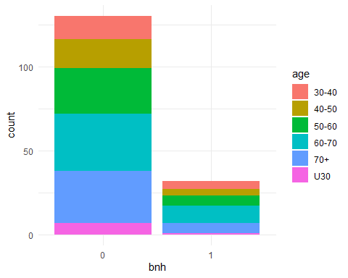

#chi squared test, is there difference in ages between responses  
age_test<-chisq.test(table(responses$bnh, responses$age))  
age_test

##   
## Pearson's Chi-squared test  
##   
## data: table(responses$bnh, responses$age)  
## X-squared = 1.3773, df = 5, p-value = 0.9268

#state that they live in?  
table(responses$bnh, responses$state_code)

##   
## CA OR WA  
## 0 27 26 77  
## 1 9 5 18

state_test<-(chisq.test(responses$bnh, responses$state_code))  
state_test

##   
## Pearson's Chi-squared test  
##   
## data: responses$bnh and responses$state_code  
## X-squared = 0.921, df = 2, p-value = 0.631

#region they fish in?  
#need to maybe get this to be one region instead of list  
table(responses$harmcat, responses$listofregions)

##   
## Cen Cal Cen Cal, So Cal Columbia River Columbia River, OR coast  
## agree 2 1 8 2  
## disagree 0 0 4 1  
## neutral 1 0 6 1  
##   
## Columbia River, OR coast, Cen Cal  
## agree 0  
## disagree 0  
## neutral 1  
##   
## Columbia River, OR coast, Nor Cal, Cen Cal Nor Cal Nor Cal, Cen Cal  
## agree 1 1 2  
## disagree 0 1 2  
## neutral 1 1 0  
##   
## OR coast OR coast, Nor Cal OR coast, Nor Cal, Cen Cal  
## agree 9 1 3  
## disagree 4 1 0  
## neutral 6 0 0  
##   
## OR coast, So Cal Puget Sound SJF Puget Sound SJF, Cen Cal, So Cal  
## agree 0 16 1  
## disagree 0 7 0  
## neutral 1 7 1  
##   
## Puget Sound SJF, Columbia River  
## agree 1  
## disagree 0  
## neutral 1  
##   
## Puget Sound SJF, Columbia River, OR coast Puget Sound SJF, OR coast  
## agree 1 1  
## disagree 0 1  
## neutral 0 0  
##   
## Puget Sound SJF, WA coast Puget Sound SJF, WA coast, Columbia River  
## agree 1 2  
## disagree 3 1  
## neutral 2 1  
##   
## Puget Sound SJF, WA coast, Columbia River, OR coast So Cal WA coast  
## agree 1 4 3  
## disagree 0 1 5  
## neutral 0 0 10  
##   
## WA coast, Columbia River WA coast, Columbia River, OR coast  
## agree 3 4  
## disagree 0 1  
## neutral 3 2  
##   
## WA coast, Columbia River, OR coast, Nor Cal  
## agree 1  
## disagree 2  
## neutral 0  
##   
## WA coast, Columbia River, OR coast, Nor Cal, Cen Cal  
## agree 0  
## disagree 0  
## neutral 1  
##   
## WA coast, Columbia River, OR coast, Nor Cal, Cen Cal, So Cal  
## agree 1  
## disagree 0  
## neutral 0  
##   
## WA coast, OR coast WA coast, OR coast, Nor Cal  
## agree 8 0  
## disagree 1 0  
## neutral 1 1  
##   
## WA coast, OR coast, Nor Cal, Cen Cal  
## agree 0  
## disagree 0  
## neutral 1

region_test<-(chisq.test(responses$harmcat, responses$listofregions))  
region_test

##   
## Pearson's Chi-squared test  
##   
## data: responses$harmcat and responses$listofregions  
## X-squared = 52.916, df = 58, p-value = 0.6643

region_test2<-(chisq.test(responses$harm_binary, responses$listofregions))  
region_test2

##   
## Pearson's Chi-squared test  
##   
## data: responses$harm_binary and responses$listofregions  
## X-squared = 29.436, df = 29, p-value = 0.4425

#number of fisheries they're in?  
#table(responses$bnh, responses$num_fisheries)  
  
#num_test<-(chisq.test(responses$bnh, responses$num_fisheries))  
#num_test  
  
#plot this one to visualize residuals  
  
#mosaic(~ bnh + num_fisheries,  
 # direction = c("v", "h"),  
 #data = responses,  
 #shade = TRUE)  
  
#income from outside fishing?  
table(responses$bnh, responses$income)

##   
## 10-25 25-50 50+ none U10  
## 0 6 9 40 47 28  
## 1 4 5 6 11 6

income_test<-(chisq.test(responses$bnh, responses$income))  
income_test

##   
## Pearson's Chi-squared test  
##   
## data: responses$bnh and responses$income  
## X-squared = 6.2605, df = 4, p-value = 0.1805

#years fishing?  
table(responses$bnh, responses$yrs_fishing)

##   
## 0-5 15-25 25+ 5-15  
## 0 6 13 91 20  
## 1 4 5 17 6

(chisq.test(responses$bnh, responses$yrs_fishing))

##   
## Pearson's Chi-squared test  
##   
## data: responses$bnh and responses$yrs_fishing  
## X-squared = 4.5955, df = 3, p-value = 0.2039

#industry role?  
table(responses$bnh, responses$captain)

##   
## 0 1  
## 0 20 110  
## 1 8 24

(chisq.test(responses$bnh, responses$captain))

##   
## Pearson's Chi-squared test with Yates' continuity correction  
##   
## data: responses$bnh and responses$captain  
## X-squared = 1.0562, df = 1, p-value = 0.3041

#fishery  
table(responses$bnh, responses$salmon)

##   
## 0 1  
## 0 39 91  
## 1 12 20

(chisq.test(responses$bnh, responses$salmon, correct = F))

##   
## Pearson's Chi-squared test  
##   
## data: responses$bnh and responses$salmon  
## X-squared = 0.66963, df = 1, p-value = 0.4132

table(responses$bnh, responses$dungeness_crab)

##   
## 0 1  
## 0 84 46  
## 1 14 18

(chisq.test(responses$bnh, responses$dungeness_crab, correct = F))

##   
## Pearson's Chi-squared test  
##   
## data: responses$bnh and responses$dungeness_crab  
## X-squared = 4.6779, df = 1, p-value = 0.03055

bnh_exploration<-responses%>%  
 select(CPS, dungeness_crab, groundfish, hake, HMS, salmon, scallops, urchin, shrimp, squid, other, bnh)  
  
fish_bnh <-bnh_exploration %>% group_by(bnh) %>%  
 summarise(  
 cps = sum(CPS),  
 dungycrab = sum(dungeness_crab),  
 gf = sum(groundfish),  
 hake = sum(hake),  
 hms = sum(HMS),  
 salmon = sum(salmon),  
 scallops = sum(scallops),  
 urchin = sum(urchin),  
 shrimp = sum(shrimp),  
 squid = sum(squid),  
 other = sum(other))  
  
fish_bnh_melted<-melt(fish_bnh)  
  
p <- ggplot(fish_bnh_melted, aes(x =variable, y = bnh))   
p+geom_point( aes(size=value))+theme(panel.background=element_blank(), panel.border = element_rect(colour = "blue", fill=NA, size=1))

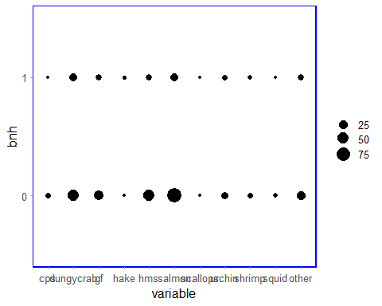

##bar plots of belief in climate change by geopgraphy or age ##moved from data exploration ##use likert package to view by percentage

##Belief in climate change by State

##Believe that climate change will harm them by State

##Believe that climate change will harm future generations by State

##Belief in climate change by age

##Believe that climate change will harm them by age

##Believe that climate change will harm future generations by age